Health Promoting Churches Initiative

STUDENT WORKBOOK

Produced by the
Adventist Health Department
South Pacific Division

“Dear friend, I pray that you may enjoy good health and that all may go well with you, even as your soul is getting along well” - 3 John 2 (NIV)
TOPIC | PAGE
Pacific Health challenges | 2
Pacific Health challenges – crossword puzzle | 6
Disease trends in the South Pacific | 8
Church, culture and health in the Pacific | 10
Diabetes | 12
Overweight and Obesity | 24
Overweight and Obesity find-a-word | 29
Coronary Heart Disease | 30
High Blood Pressure | 36
CHD and Hypertension – Crossword Puzzle | 40
Cancer | 42
Cancer – crossword puzzle | 51
Texts, Quotes and Questions | 52
Assignment or Discussion Questions | 55
Smoking | 56
Kava | 63
Betel Nut | 66
Marijuana | 72
Rest and Sleep | 78
Sunlight | 83
Water | 85
Alcohol | 90
Salt | 97
Communicable Diseases | 100
Personal, Domestic and Community Hygiene | 105
Sanitation | 113
Drainage | 122
Solid Waste Management | 124
Housing Quality | 125
Common Human Parasites - South Pacific | 133
Questionnaire to Determine Health of Village | 139
Crossword - Communicable Diseases | 143
Texts and Quotes | 144
10 Ways to Love | 146

Pacific Health Challenges
The two major disease challenges in the South Pacific:
- _____________________________.
- This refers to diseases caused by ___________________________. These include ___________________, _____________________ and _____________________
- Up until recent time’s communicable diseases have been our major health burden.
- They will remain a major threat for a long time to come due to the disregard of __________________________________________________________________by individuals, families and communities.
- The major causes of these diseases are:
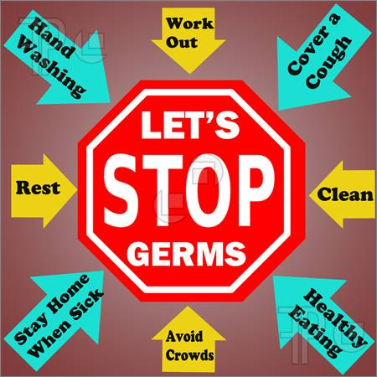
  - ________________________________
  - ________________________________
  - ________________________________
  - ________________________________
  - ________________________________
  - ________________________________
  - ________________________________
  - ________________________________
- Some examples of Communicable diseases common in the South Pacific today include: ______________________________________________________________________________________________________________________________________________________________________________________________________

THE PROBLEM AREAS
- _______________________________ are found everywhere in the Pacific Island region. These can impair growth and development in children and cause anaemia (lack of blood).
- Each year _______________ new cases of ________________________ are reported.
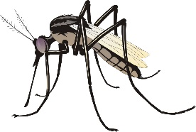
- Although ______________ numbers remain quite low, it is still a concern. It is important that countries continue to stress ___________________________and medical professionals continue to improve the ______________________________ of HIV patients.
- ______________________________ and __________________________ continue to be the major causes of death in many countries of the Pacific.
- A virus transmitted by the _______________ mosquito causes ____________ ___________. It is a common problem in may island countries of the Pacific and has caused major epidemics and deaths in the region.
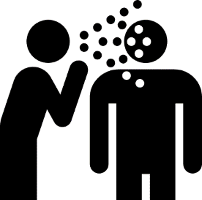
- ________________________________ causes _______________________ This germ comes from ___________________________. This dangerous disease is very common in the Pacific Islands with some of the highest rates in the world. Control depends on _____________________ and public __________________________ in hand and foot hygiene.
- ______________________________________ is carried by animals such as _____________ and _______________ and is transmitted through the skin of people exposed to contaminated ________________________________
- A new disease to the Pacific is ____________________. Caused by a germ called __________________ ____________ and spread through ____________________ and_______________, this disease results in ________________ which leads to dehydration and sometimes even __________________.
- ________________ is a common and deadly disease. Drug resistance is a concern and although newer drugs are now available, the long-term effects and benefits are still not known.
- Over the last 25-30 years over 30 new diseases have appeared in the world. All infectious and all dangerous. These include
_____________________________________________________________

Now more than ever it is time to take care of our health. We must remember that God will bless our efforts as we strive to keep our bodies strong and open to His Spirit.
Remember Romans 12:1 ____________________________________________
_________________________________________________________________
_________________________________________________________________

- _____________________________.
- These illnesses are also called “__________________________” The major NCD’s that impact the Pacific include: _________________, ______________________, _________________________, __________________, ____________________, ______________________________ and ________________________________
- The South Pacific region is seeing a shift from _____________________________ to ___________________________________ with the increased consumption of ______________, _______________ and _______________________ along with the increased use of ____________________ and _________________________
- Nearly ___________________________ people in the Western Pacific region are affected by _____________________________. There are predictions that this number could _________________ over the next _________________________
- __________________________ (High blood pressure) and other circulatory diseases are also _________________________________________ because people are adopting a western lifestyle and their diets are therefore high in _______________________________, ______________________________ and _____________. People are relying on these less healthy foods as sources of _______________________________ and _________________________ rather than the traditional _______________________ and _______________________.
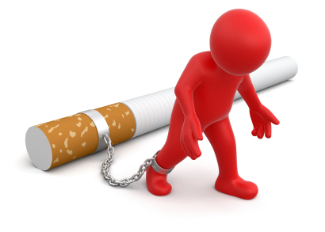
- Non Communicable Diseases are not able to be passed on to another person, i.e. are not ___________________________ and are related directly to the following lifestyle factors:
  - _____________________________
  - _____________________________
  - _____________________________
  - _____________________________
- NCD’s are fast becoming the leading cause of _______________ (Sickness) and ___________________ (Death) in our South Pacific region. In fact more than ______ of the deaths in our region are completely preventable and unnecessary diseases based on our __________________. That’s nearly _________ out of every ________ deaths that don’t need to happen. Very sad isn’t it!

1 Corinthians 6:19, 20 ____________________________________________________________________________________________________________________________________________________________________________________________________________________________________________________________
_______________________________________________________________
Fill in the verse:
- The major risk factors driving this epidemic include:
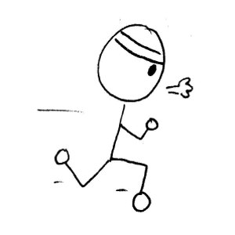
        - ________________________________________
        - ________________________________________
        - ________________________________________
        - ________________________________________
        - ________________________________________
        - ________________________________________
        - ________________________________________

Some things that I can do to make sure I never suffer from a Non-Communicable Disease include:
        - _______________________________________
        - _______________________________________
        - _______________________________________
        - _______________________________________
        - _______________________________________
        - _______________________________________
        - _______________________________________
        - _______________________________________
        - _______________________________________

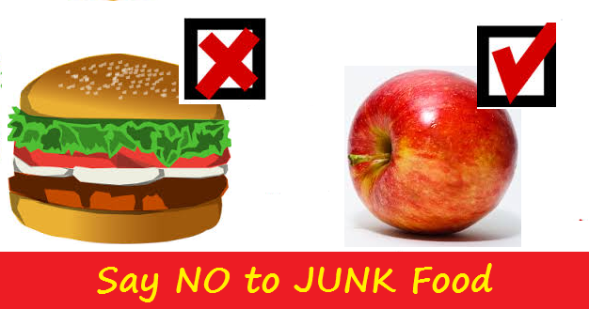

PACIFIC HEALTH CHALLENGES
Complete the crossword below

Name: ________________________________

Across | Down
- Diarrhoea causes this and it can lead to death. | - A common but potentially deadly disease in the Pacific.
- A lifestyle choice that reduces the risk of NCD's | - A type of 'germ'.
12. A relatively new but deadly disease. | - The Aedes Agypti mosquito causes this disease.
- A major cause of Communicable diseases. | - 1,600 new cases of this disease are reported each year.
- An example of a Communicable disease. | - A major risk factor for NCD's
- Leptospirosis is carried by this animal. | - Caused by a germ found in Human Faeces.
- Paul calls us to offer our bodies as a living__________ to God. | - NCD's are not __________
- Something that can cause anaemia. | - It's best to eat traditional root crops to have plenty of this.
- Our bodies are God's ____________ | - The worst food choice!
- If this was improved, Communicable diseases would improve. | - A major cause of death in many Pacific Countries.
- Communicable diseases are caused by these. | 13. How many deaths, out of ten, are preventable?
 | 16. Another word for Non-Communicable diseases
 | - Another word for Morbidity
 | - A diet high in this can cause High blood Pressure.

Disease Trends in the South Pacific

Solomon Islands
Niue
Vanuatu
Cook Islands
Papua New Guinea
Tonga
Nauru
Fiji
Kiribati
Samoa
Tokelau
Tuvalu

.
Non-Communicable Disease
Communicable Disease
Transition Point

DISCUSSION QUESTIONS
- What do you think the graph might look like in 10 years’ time? Why?
- Name the countries that have passed the ‘transition point’ – why do you think they have?
- What can the government, communities, families, and churches do to ensure their place of influence addresses this dangerous health trend.
- Discuss the statement “The Countries on the left of the graph are healthier than the ones on the right”.

Study the table “Top 10 Causes of Death in 2002” and answer the following questions:
- What were the top killers in your country? Are you surprised? Why or why not?
- Which country has the most NCD’s? Why do you think that might be?
- Which diseases are common to all countries?
- Which disease is listed as the major killer for the most countries?
- Why do you think pulmonary diseases are so common?
- Measles used to be a big killer – why do you think it has decreased so dramatically?
- Can you see any diseases that might be linked?
- Were you surprised that Cancer is only listed for one country? Do you think this may change in the future – why or why not?
- Obesity has been called the ‘Common Denominator for disease’ – Why? What country’s obesity rate surprises you? Why?
- Obesity is often called the ‘common denominator’ of lifestyle disease – is there anything in this graph that supports that?
- If you were in Government for one year, what single change would you make in the hope that the health of your country might improve.

Top 10 Causes of Death in 2002
Measles 1  2  3  Measles 4 | PNG | Solomon Is | Vanuatu | Kiribati | Tuvalu | Fiji | Tonga | Samoa | Tokelau | Nauru | Cook Is | Niue
Asthma |  |  |  | 7 |  | 8
Cancer |  |  |  |  |  |  |  |  |  | 10
Cirrhosis of Liver |  |  |  | 10 |  |  |  |  |  | 7
Congenital abnormalities |  | 7
Diabetes |  | 8 | 6 | 3 | 6 | 5 | 4 | 4 | 4 | 4 | 4 | 6
Diarrhoeal diseases | 5 | 1 |  | 5 | 8 |  | 10 |  | 10
Endocrine disease |  | 6 | 10 | 4 | 9 | 9 | 8 |  | 9 |  | 9 | 9
Heart Attack | 2 | 3 | 2 |  | 2 | 1 | 2 | 2 | 2 | 1 | 2 | 2
Hepatitis B |  |  |  |  |  |  |  |  |  | 9
Hypertension | 8 | 9 | 3 | 9 | 4 | 4 | 3 | 3 | 3 | 2 | 3 | 4
Lower respiratory infection | 3 | 5 | 5 | 6 | 3 | 3 | 6 | 6 | 7 | 6 | 6 | 3
Malnutrition | 10 |  |  | 8
Measles | 9
Nephritis + Nephrosis |  |  | 8 |  | 7 | 6 | 7 | 7 | 8 | 5 | 7 | 8
Perinatal conditions | 1 | 4 | 7 | 2 | 10 | 7 | 9 |  |  |  | 8 | 7
Pulmonary disease | 7 | 10 | 4 |  | 5 | 10 | 5 | 5 | 5 | 8 | 5 | 5
Road traffic Accidents |  |  |  |  |  |  |  |  |  |  | 10 | 10
Stroke | 6 | 2 | 1 | 1 | 1 | 2 | 1 | 1 | 6 | 3 | 1 | 1
Tuberculosis | 4 |  | 9
OBESITY rates | 16% | 30% | 60% | 74% | 62% | 55% | 91% | 80% | 63% | 95% | 91% | 82%

CHURCH, CULTURE AND HEALTH IN THE PACIFIC
What ways is food used in the Pacific Culture? (E.g. A feast to welcome visitors)
___________________________________________________________________________
___________________________________________________________________________
___________________________________________________________________________
___________________________________________________________________________
While the ‘food culture’ may have remained, the foods served at these events has changed radically. Where once they had been grown in the garden and included _________________ ___________________________________________________________________________, now, due to a rise in our socioeconomic status and improved __________________________ and _______________________ the foods served are no longer healthy. The home grown, highly nutritious fruits and vegetables are being replaced with ________________________ ___________________________________________________________________________
___________________________________________________________________________
Read the quote below from Ken Ferraro, a professor of sociology at Purdue University, and comment on whether you think it applies to your church family?
“ Most Christian religions encourage restraint from participating in injurious behaviours, such as heavy drinking and smoking, however, overeating is not considered a great sin – it has become the accepted vice……. Many religious activities are rooted in food. From the bung lunches after weekly services to picnics, these foods unfortunately tend to be high in fat, sugar and salt. Instead, religious leaders need to model and encourage physical health as an important part of a person’s spiritual well-being.”
______________________________________________
______________________________________________
______________________________________________
______________________________________________
Memorise
____________________________________________________________________________________________________________________________________________________________________________________________________________________________________________________________________Patriarch and Prophets, p. 562

OTHER BEHAVIOURS IN THE PACIFIC THAT INFLUENCES HEALTH
- Big is Beautiful
- In certain cultures in the Pacific “Big” in terms of body size is considered desirable or even beautiful because:
  - Being fat _______________________ a girl’s development. This means that she can _________________________________________________________.
  - People believe that a woman’s size reflects the care of her husband. For example
________________________________________________________________________________________________________________________________

  - Similarly is comments on the care she is receiving from her parents; ________________________________________________________________
________________________________________________________________

  - Size becomes a mark of ____________________________________________
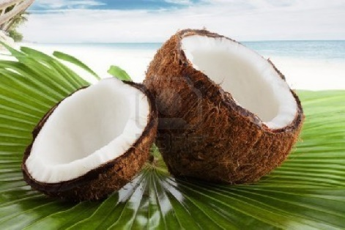
- Coconut – “The Tree of Life”
- The coconut has many uses such as
______________________________________
______________________________________
______________________________________
______________________________________

- Some Pacific countries celebrate the “Week of the Coconut” which is a time set aside to ______________________________________________________ the many good things about coconuts.
- Unfortunately, __________________________ is used in excess in many villages and communities throughout the Pacific. Since we are moving less and NCD’s are rising rapidly, it is important to realise that while ___________________________ is an important food ingredient, it must only be used in ________________________
- Coconut cream and oil is a ______________________________________ and when used in excess can contribute to __________________________________________.
- District Meetings and other church gatherings
Many church leaders are struggling with their health, and tragically many have perished prematurely “while serving the Lord” because of one particular food culture. The idea that when he/she visits the house of a member _____________________________________.

Obviously the leader doesn’t want to offend the member and so gratefully accepts and eats the food provided. What if he/she visits several homes that day? To compound this problem, often only the very _______________ food is offered. This may mean the richest and most damaging to his/her health.
DIABETES
Diabetes is a major lifestyle disease – and a VERY expensive one! It is estimated that there are _______________________ diabetics worldwide with an annual health care bill of ______________________ needed for treatment. One person dies from diabetes every ___________________ in a worldwide epidemic that continues to worsen. This means that Diabetes kills ________________ people every year. Diabetes has now become a major killer in the South Pacific region.
What is Diabetes?
- All foods are broken down in the digestive system. Foods such as _________________ _____________________ belong to a food group called ________________________ These foods are digested into _______________________________________ called _________________. Glucose then makes its way through the ________________ into the bloodstream and heads for the ___________________________. The body is made up of approximately ___________________________, and these cells need energy for growth and function – this energy comes from _________________________________.
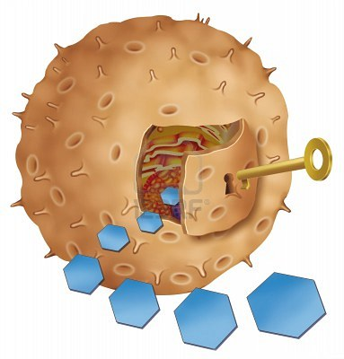
- Glucose however cannot enter cells without _________________ a special hormone produced in the _________.
Insulin

Glucose (sugar)
- After a meal, the level of the glucose in the blood __________. This causes the ____________ to automatically release extra quantities of_____________ into the blood stream to help move the ________________ into the ______________. This lowers the glucose levels in the ___________________ to a safe or normal level. This happens every time we eat. Now imagine if for some reason the ‘key’ (______________) wasn’t there (or wasn’t working properly) – this would mean that the glucose would ________________ _______________________________ which would result in a very _____________________________. This could lead to many serious complications.
- Diabetes is a long-term chronic disease that arises when:
- _________________________________________________________________
- _________________________________________________________________
- _________________________________________________________________
There are 3 main types of Diabetes
Diabetes Definition Definition
__________________________________________________________________________________________________________________________________________________________________________________________________________________
- ___________________________. This usually starts in _______________________ but it can occur at any age and accounts for ____________________ of all diagnosed cases of diabetes. People with type 1 diabetes produce _____________________________ and therefore must use injectable insulin daily to control their blood sugars.
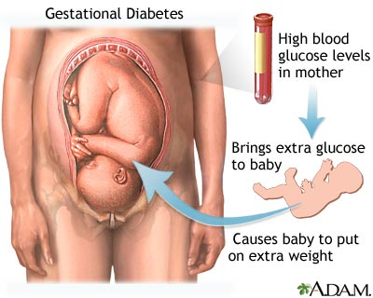
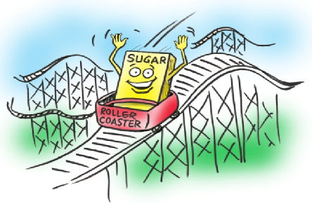
- ____________________________. This is much more common and accounts for ____________________ of all cases. It usually starts in Adulthood but, due to a rise in childhood ______________ is being diagnosed at much younger ages now. Many people with Type 2 Diabetes don’t know they have it. People with this type of Diabetes are _______________________ to the insulin the body makes, and their _______________ _______________________________________________________________________ Over time the Pancreas loses the ability to ____________________________________ and may result in a little or no __________________ The good news is that Type 2 Diabetes can often be controlled by _________________, but often patients will choose to rely on ______________. This is the most common form of diabetes in _______________.
- ______________________________
This diabetes forms when a woman is pregnant and usually goes away after the baby is born. The woman is however at a very high risk for developing _____________ later in life – and during another pregnancy.
Symptoms of Diabetes
- ______________________________________________________________________________________________________________________________________________
- ______________________________________________________________________________________________________________________________________________
- ______________________________________________________________________________________________________________________________________________
- ______________________________________________________________________________________________________________________________________________
- ______________________________________________________________________________________________________________________________________________
- ______________________________________________________________________________________________________________________________________________
- ______________________________________________________________________________________________________________________________________________
- ______________________________________________________________________________________________________________________________________________
- ______________________________________________________________________________________________________________________________________________

Diabetes – A Disease of Many Complications
Diabetes by nature, destroys small and medium sized ________________________ throughout the body. This naturally leads to a reduction in ____________________ to many organs and tissues. Diabetes is a major risk factor for: _______________________________
___________________________________________________________________________
___________________________________________________________________________.
- _____________________ Diabetes affects the heart by damaging the blood vessels supplying the heart muscle – which is called __________________. Cardiovascular disease or _____________________ is the major cause of death for people with _____________, accounting for __________ or more of all diabetes deaths.
- ____________________. A Stroke occurs when the supply of blood to the ____________________ gets interrupted and oxygen can’t reach the brain. There are two ways diabetes contributes to a stroke:
- Diabetes damages the _____________ in the brain leading to blood vessel _____________________ resulting in a _________________. This is known as ___________________. (see diagram to the right)
- An important co-existing problem for diabetics is high blood pressure; or ______________________. This is a major factor for _____________. Normal blood pressure ranges from _______ to ________. Anything above this would be considered ____________. Uncontrolled severe hypertension can cause the __________ of a blood vessel in the brain. This will lead to a sudden _______________ in the ______________ to the ____________________ which will lead to a kind of stroke called _________________ (see diagram on the right).
Stroke commonly presents in the following ways:
  - __________________________________________________________________
  - __________________________________________________________________
  - __________________________________________________________________
  - __________________________________________________________________
  - __________________________________________________________________
Those that survive the initial attack will take a very long time to ______________
- ___________________________ (Diabetic nephropathy) Diabetes can cause total _________________________ and hence the need for ___________________ or ______________. We have neither of these services available in the _____________.
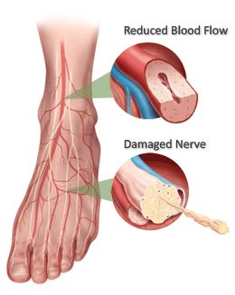
- _________________ (Diabetic neuropathy) Diabetes leads to ____________________ in the extremities leading to loss of _____________. The reason is that there is damage to the ___________________ supplying nerves to the extremities. This can lead to ______________________________ and serious _________________________ - sometimes requiring _________________________ of a toe, foot or leg. Loss of feeling can allow foot injuries to _________________________________________.
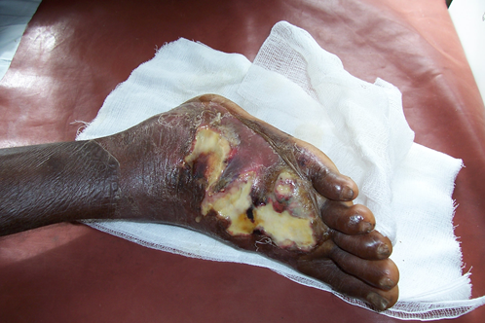
- ______________________________ (Diabetics foot sepsis). Diabetics are prone to ____________________ especially of the extremities. Diabetic _______________ is a very common problem in the South Pacific.

This is diabetic foot sepsis. The tissues are dead due to lack of blood supply to the feet. There is serious infection with a very high chance of infection spreading to other parts of the body.
Picture: C. Kuma
- _______________________________ (Diabetic retinopathy). This is characterized by ___________________________________________ of the eye which can lead to __________________________________ or ________________________________.
- Women with _____________________ often give birth to ______________________ babies who may develop significant health problems after birth.

Diabetes used to be rare in the South Pacific. What was it that protected our people from this deadly disease in the past?
- __________________________________________________________________
- __________________________________________________________________
- __________________________________________________________________
- __________________________________________________________________
- __________________________________________________________________
- __________________________________________________________________
- __________________________________________________________________
- __________________________________________________________________

75% OF OUR DISEASES ARE LIFESTYLE DISEASES – THIS MEANS THEY ARE COMPLETELY PREVENTABLE! They are killing more people in the age category 30-60 than any other disease.

Why has Diabetes reached epidemic proportions in the Pacific?
- ______________________________________________
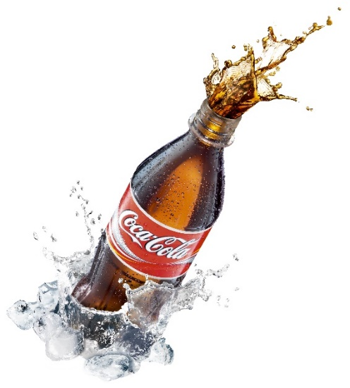
- ______________________________________________
- ______________________________________________
- ______________________________________________

UNDERSTANDING THESE REASONS
DIET AND NUTRITION
- We are eating _________________ wholesome foods, and _________________ highly _____________________ foods (WHO STEP research)
- Processed or refined foods such as ________________________________________ __________________________________ have become staple foods in the Pacific. Not only do they _________________________ but are always ________________ and very ________________________. These foods have replaced much healthier foods on our tables and is one of the main reasons for the sudden rise in _______________ currently being seen in the Pacific.
- ________________________ tastes a lot nicer than boiled foods. We love the taste of ___________________. Foods high in fat and taken too often are a major risk factor for Diabetes. High fatty meals can lead to ____________________ __________________. These are major risk factors for diabetes and __________________________________.
- Meats such as ____________________________ are now common in the Pacific Islands. These meats are ___________________________________ - a significant risk factor for lifestyle disease.
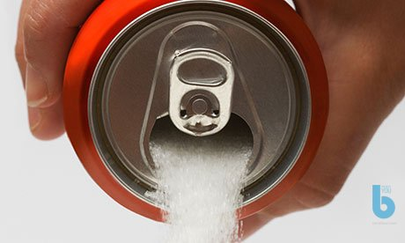
- Many Islanders love _________________________ such as _____________________ _____________________________. Many are ignorant to the dangers of these foods. ______________________________________________________________________.
- _____________________ consumption is rising dramatically. These drinks are LOADED with ____________. In fact each 500ml can contains around ______________ of sugar!

PHYSICAL ACTIVITY AND EXERCISE
- Overall physical activity is only about _______________ or less of what it used to be. ______________________ and __________________________ reached our shores not that long ago and brought with it a _______________________. Whereas in the past we ____________________________________ and made gardens, today we drive cars, bikes or ride in taxis or buses. We find ourselves sitting in front of __________________ during the day and then ________________ at night (while we nibble on fatty, salty snack such as _____________).
- We must make time for ________________________________________ - like going for an afternoon walk or an early morning run. Inactivity is _________________________________________________.
OVERWEIGHT AND OBESITY
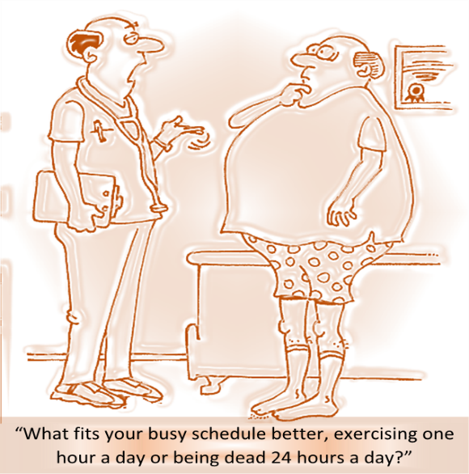
According to statistics, the South Pacific region is the most overweight region in the world and we’re unfortunately reaping the consequences of that, including:
- ___________________________________
- ___________________________________
- ___________________________________
- ___________________________________
- ___________________________________
- ___________________________________
- ___________________________________
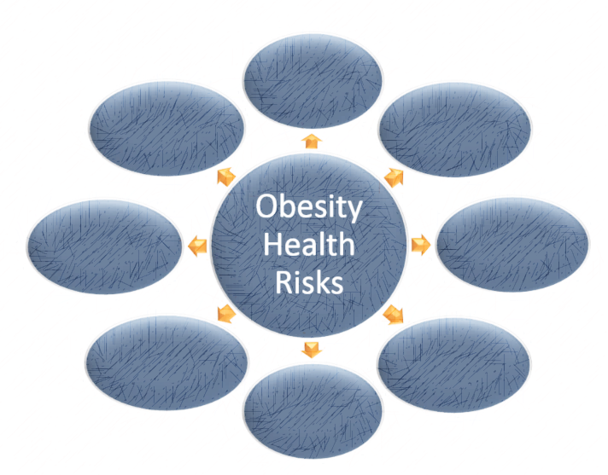
Complete the graphic on the left.
Overweight and obesity presents a major risk for all lifestyle diseases
Note:
NIDDM stands for _______________ ________________________.

READ THE INFORMATION BELOW AND ANSWER THE QUESTIONS
Preventative Steps to Avoid Diabetes and other Lifestyle Diseases
You might like to consider the following recommendations:
- Know your background
If you have a family member with a particular lifestyle disease, the chances are you may be at risk of developing that same disease. Understanding your background should help you make healthier choices in your life.

- Make healthy food choices
Choose to eat healthy foods. A healthier choice would be to include more of our traditional foods in your diet. Include more root crops such as taro, cassava and sweet potato in your diet as sources of energy instead of eating white rice every day. Brown rice is much healthier than white rice. The advice is to choose the healthier option and don’t be distracted by taste and convenience. Eat more fruits and vegetables because they contain heaps of protective nutrients. The different colours on fruits and vegetables represent protective nutrients called phytochemicals and antioxidants. These protect us from many different diseases. If you take meat, choose lean meat (meat with less fat on it). Avoid processed meats such as sausage or corned beef – processed meats are loaded with fats and cancer causing chemicals and not safe for human consumption. Steaming, grilling and boiling are healthier ways of cooking than frying, barbecuing or sizzling.
It makes a lot of sense to decide on healthier choices with foods - and the more you do it - the easier it becomes. In fact, you will live longer and experience less disease by doing so.
Choose healthy foods for good health and longevity. Eat mostly plant-based foods.

- Be Active
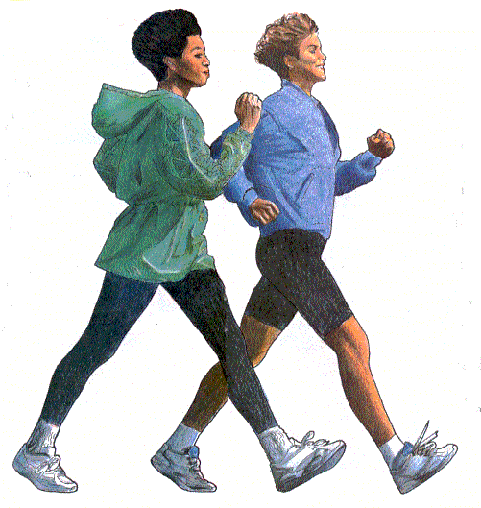
Active physical activity or exercise has a powerful and a very positive influence on health. In fact it is just as important to us as a good, healthy diet. Unfortunately, our lifestyle today allows no time or makes no provision for such simple yet profoundly beneficial blessing to our health and wellbeing. Exercise protects you from Diabetes because it helps the body cells respond better to insulin.

There is so much benefit in being active – A 30 minute walk every day can do you a lot of good.

See: http://www.womensheart.org/content/exercise/ starting a walking program.asp
- What are the lifestyle diseases that are present in your immediate family (mum, dad, brothers, sisters and grandparents on both sides)?
______________________________________________________________________________________________________________________________________________________________________________________________________________________________________________________________________________________________________________________________________________________________
Understand that you are at a higher risk of contracting any of these diseases and take action NOW to prevent them!

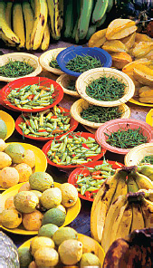
- List the processed food snacks you have eaten in the last week. What could you have replaced them with to reduce the risk of a lifestyle disease?
________________________________________________
________________________________________________
________________________________________________
________________________________________________
________________________________________________

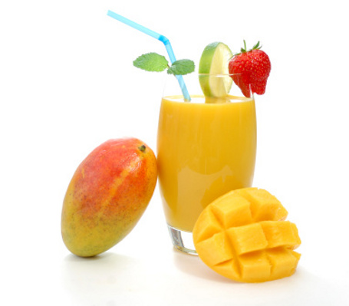
- How many serves of fruits (1 piece) and vegetables (1 Cup) would you average a day? The recommended intake is 2 fruit and 5 veg – do you achieve that? If not, offer some suggestions as to where you might be able to increase your intake.
_______________________________________________
________________________________________________
________________________________________________
________________________________________________
________________________________________________
- List 5 ways you could increase the amount of exercise/activity you do in your day.
___________________________________________________________________________________________________________________________________________________________________________________________________________________________________________________________________________________________________________________________________________________________________

- Read the following statements from Mrs White. Summarise her main points regarding health habits:
- “Tea, coffee, tobacco, and alcohol we must present as sinful indulgences. We cannot place on the same ground, meat, eggs, butter, cheese, and such articles placed upon the table. These are not to be borne in front, as the burden of our work. The former - tea, coffee, tobacco, beer, wine, and all spirituous liquors - are not to be taken moderately, but discarded.” 3 Selected Messages, p. 287
- "It is for their own good that the Lord councils the remnant church to discard the use of flesh foods, tea, and coffee, and other harmful foods." Manuscript 71, 1908
- “If Seventh-day Adventist practiced what they professed to believe, if they were sincere health reformers, they would be a spectacle to angels and to man.” Councils on Health, p. 575
________________________________________________________________________________________________________________________________________________________________________________________________________________________________________________________________________________________________________________________________________________________________________________________________________________________________________________________________________________________________________________________

BENEFITS OF PHYSICAL ACTIVITY OR EXERCISE

- _____________________________________________________________________
- _____________________________________________________________________
- _____________________________________________________________________
- _____________________________________________________________________
- _____________________________________________________________________
- _____________________________________________________________________
- _____________________________________________________________________
- _____________________________________________________________________
- _____________________________________________________________________
- _____________________________________________________________________
- _____________________________________________________________________
- _____________________________________________________________________
- _____________________________________________________________________

REMEMBER
Exercise comes after non-smoking as the behaviour that contributes positively to ________________________________________________. 80% OF HEART DISEASE, STROKE, DIABETES AND OVER A THIRD OF CANCERS COULD BE PREVENTED BY ELIMINATING THE RISK FACTORS OF ___________________________________________________________________________.

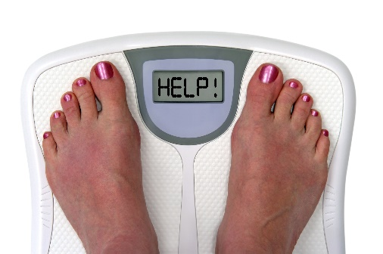
OVERWEIGHT AND OBESITY
According to a survey performed by the World Health Organization in
2007; the South Pacific is the world’s most overweight region. Sadly, most Pacific Island countries have made no real effort to deal with this major public health crisis.
Overweight/obesity is defined as
______________________________________________________________________________________________________________________________________
___________________________________________________________________
SOME STARTLING OBESITY STATISTICS
- _____________________________________________________________________________
- _____________________________________________________________________________
- _____________________________________________________________________________
- _____________________________

- ________________________________________________

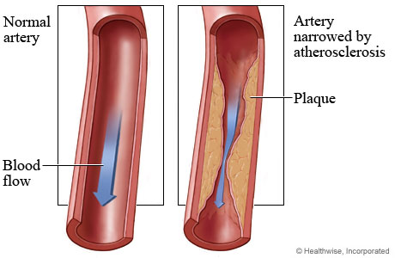
This picture illustrates a clean, healthy artery and an artery of which the walls are lined with fat causing it to narrow down significantly.

Ignorance says: ____________________________________________________. The truth is, foods such as ___________________________________________________ have been stripped of their vitamins, minerals, fibre and phytochemicals that the body desperately needs for good health and are simply _________________________________________. If these foods are taken in excess on a regular basis, the fats in these foods are stored in the body and the excess sugar is converted into more fats.
Consider these equations:
- Eating highly processed fast foods + low physical activity = overweight/ obesity
- Overeating (too much food) + low physical activity = overweight/obesity
- Eating too much late in the night = overweight/obesity

Are you at risk of any of these? How about your family members?
What about school friends?
NOTE: Any of these trends WILL lead to an increased risk of lifestyle disease
Circle the answer to the following questions:
 | Fast food alone will not cause obesity. | TRUE / FALSE
 | If I do my 30 minutes exercise every day I can eat junk food often. | TRUE / FALSE
 | You can overeat on ‘good food’ too. TRUE / FALSE | TRUE / FALSE
 | The food we eat just before we go to bed is stored as fat. | TRUE / FALSE
 | I can eat a lot more if I am doing a lot of hard exercise. | TRUE / FALSE
 | Our native root crops like taro and sweet potato are far superior to white rice. | TRUE / FALSE
 | It is important to eat foods of different colours at each meal. | TRUE / FALSE
 | Soft drinks and juices are a healthy source of water/fluid. | TRUE / FALSE
 | Being overweight is only a social/emotional problem. | TRUE / FALSE

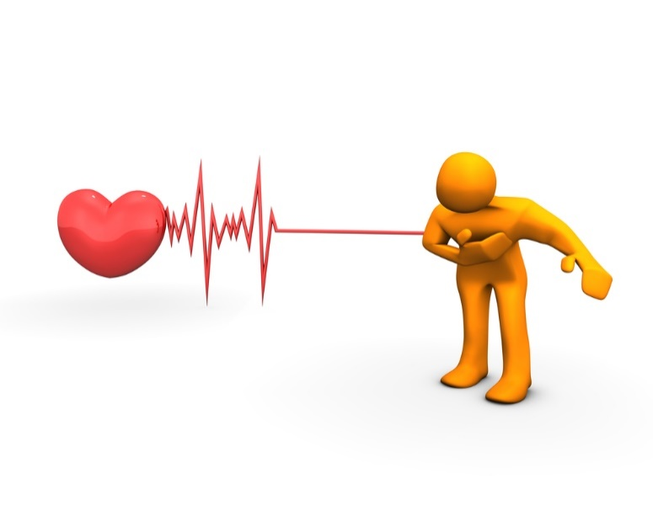
PROBLEMS ASSOCIATED WITH OBESITY
- HEART DISEASE
If you are overweight you have an _____________________________.
A heart attack usually presents with a ________________________ that
is described as ______________ and ________________. This pain often goes down the _____________________________________________________________________ and is associated with nausea and shortness of breath. TOO OFTEN THE FIRST SIGN OF A HEART ATTACK IS SUDDEN COLLAPSE AND DEATH.
- DIABETES
Being overweight is a major risk factor for Diabetes. Common diseases related to Diabetes include _____________________________________________________________________
- HIGH BLOOD PRESSURE
High blood pressure (also called ________________________________) is a common complication of being ______________________________. It is a dangerous condition that can lead to ______________________________________________________________.
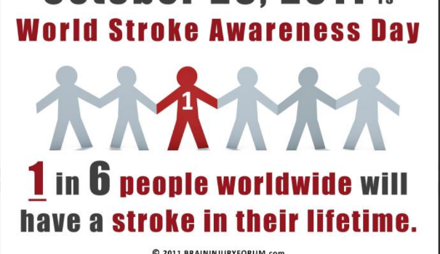
- STROKE
Overweight/obesity is an important risk factor for stroke.
The ________________ and ________________ levels can easily lead to ____________________ in the brain leading to blood vessel ___________ and therefore a ______________.
- METABOLIC SYNDROME
This syndrome consists of a number of conditions existing together and include: ______________________________________________________________________________________________________________________________________________________
- HIGH CHOLESTEROL
Cholesterol is actually an essential nutrient. This means the body ______________ cholesterol for some very important functions. We get cholesterol in our body by two main ways; first _____________________________________ and second ___________________________. Only foods of animal origin have cholesterol. E.g. ___________________________________ Cholesterol is basically ______________________ and too much of it will give rise to disease.
- CANCER
Being overweight or obese is a risk factor for the following cancers:
___________________________________________________________________________
___________________________________________________________________________

- SLEEP APNOEA
This is a potentially serious form of _______________________ in which breathing ___________ for ____________________ to a ___________________ and repeated up to _______, ______ or even ____________ times during the night. Sleep apnoea occurs when the walls of the throat ___________________________ during sleep, blocking the airway. There is usually a lot of ____________________ involved as well. This situation can be especially bad for the ____________ because the oxygen level can drop significantly in a short space of time. People suffering from sleep apnoea are at risk of developing _________________________ _________________________________________. Other associated problems include ___________, _____________________ and lack of ________________________ due to lack of sleep. The best treatment for sleep apnoea is __________________________________.
- GALL BLADDER DISEASE
In overweight people, the gall bladder becomes __________________ and can have ________ forming in it. These stones are commonly _______________________. Poor diet (high in ___________________ and low in ___________) contributes to gall bladder stone formation. Women are _____________________________ more affected than ____________.
- GYNAECOLOGIC PROBLEMS
Being overweight or obese can lead to problems in women such as irregular monthly periods, __________________________ or the ___________________________________________
- ERECTILE DYSFUNCTION AND SEXUAL HEALTH ISSUES
This is a male problem and is due to deposits of ___________ blocking or narrowing the __________ to the genitals.
- NON-ALCOHOLIC FATTY LIVER DISEASE
This is where ____________________ in the liver fat and can cause __________________________ or scarring of the ___________________________.
- ARTHRITIS
Excess weight can cause _____________ and ___________________ on the ______________ and _______________. This arthritis can be very _________________ and affect ____________________.

- SKIN PROBLEMS
Problems with the skin can include poor ____________________________ after injury.
- DEPRESSION
When a person is overweight their overall ___________________________ will suffer. They may not be able to _______________________________________ as easily as they would like. They may have trouble _______________________ in family activities. They may ____________________ public places and even encounter ____________________________ that can lead to depression. Other weight related issues that may affect the quality of life include ___________________________________________________________________________.
WAYS TO AVOID OVERWEIGHT AND OBESITY:
- _______________________________________________________________________
- _______________________________________________________________________
- _______________________________________________________________________
- _______________________________________________________________________
- _______________________________________________________________________
- _______________________________________________________________________
- _______________________________________________________________________
- _______________________________________________________________________
- _______________________________________________________________________
- _______________________________________________________________________
- _______________________________________________________________________
- _______________________________________________________________________
- _______________________________________________________________________
- _______________________________________________________________________
- _______________________________________________________________________
- _______________________________________________________________________
- _______________________________________________________________________
- _______________________________________________________________________
- _______________________________________________________________________
- _______________________________________________________________________
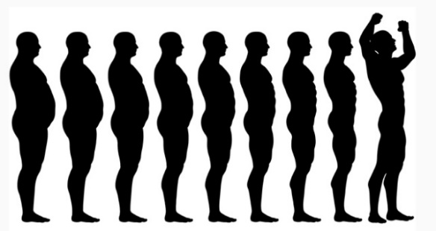
- _______________________________________________________________________

OVERWEIGHT AND OBESITY
A T H E R O S C L E R O S I S H G C L G
K C A T T A T R A E H K K E G Y V I I N
D E P R E S S I O N N F N L J P V W A I
M K A F E W I Y C I L O B A T E M A R T
A O C U F X T T R D T Q Q W R R K T T A
E E D A G E E D I S E Q N D V T M E E E
O P T E I U T R T R P A I O E E E R R R
N S E R R F R H C W H S T H C N P P Y E
P J A I O A H E E I E T V H N S Z L N V
A V S S S Q T X D A S T R L A I D A O O
J O G G I N G I S D L E W A L O I N I H
E K O R T S O E O P A T F A A N A T T P
A C T I V I T Y R N A L H P B G B B C R
H D O O F E G O Y P A R B C H S E A I E
X E B I X O C N P C J E E L R W T S D N
Y D A C C E V E I H S Y V C L I E E D C
G U E L S G T S V L X G N J N A S D A R
Z S R S T I Y S U G A R C Z U A G I J C
S D E B T H J S T M W E G G U R C C S E
Y D V E P Y T I S E B O H Y Z Q L G W U

Find all of these words relating to this topic in the puzzle above
ACTIVITY
ADDICTION
APNOEA
APPETITE
ARTERY
ARTHRITIS
ATHEROSCLEROSIS
BALANCE
CANCER
DEATH
DEPRESSION
DIABETES
EXCESS
EXERCISE
FATS
FOOD
GALLBLADDER
HEALING
HEALTH

HEALTHCRISIS
HEARTATTACK
HYPERTENSION
JOGGING
LIVERDISEASE
METABOLIC
MODERATION
OBESITY
OVEREATING
PHYSICAL
PLANTBASED
PROCESSED
SOFTDRINKS
STONES
STROKE
SUGAR
VARIETY
WATER

CORONARY HEART DISEASE
The heart is an important organ in the human body. It is located _______________________ and is a __________________________. Its main function is to _____________________________________. Blood transports _____________________________________ to all body cells. These nutrients are used by the body cells to carry out their work and to ________________________________________.
ROMANS 12:1
_________________________________________________________________________________________________________________________________________________________________________________________________________________

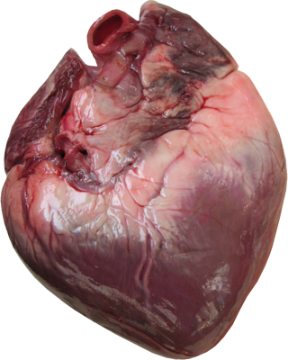
This is what the actual heart looks like. It is an amazing organ. It is made up of muscles and its main function is to pump blood throughout the body.

SOME AMAZING ‘HEART FACTS’
- The average adult heart beats approximately 72 times a minute, 100,000 times a day, 3.6 million times a year, and 2.5 billion times during a lifetime. TAKE YOUR PULSE FOR ONE MINUTE AND RECORD THE NUMBER HERE _______________. If this is your average pulse rate, how many times will your heart beat in the next hour? _________________ (multiply by 60).
- Though weighing only 300 grams on average, a healthy heart pumps 7500 litres of blood through approximately 100,000 kilometres of blood vessels each day.
- The volume of blood pumped by the heart can vary over a wide range, from five to 30 litres per minute. During an average lifetime, the heart will pump nearly 5.7 million litres of blood. A kitchen tap would need to be turned on fully open for at least 45 years to equal the amount of blood pumped by the heart in the average life time of a person.
- The heart pumps blood to almost all of the body’s 100 trillion cells. Only the corneas in your eyes receive no blood supply.
- The heart does the most physical work of any muscle during a lifetime.
- The heart begins beating at four weeks after conception and does not stop until death.
- We all have only one heart each... so take good care of it.
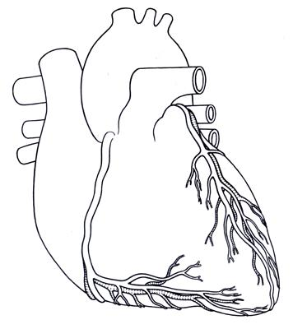
BLOOD SUPPLY TO THE HEART
The heart receives its blood supply through the coronary arteries. There are two coronary arteries – the right coronary artery, and the left coronary artery.
As you can see, they are not big arteries, they are actually quite small, but vital! They supply blood to one of the most important organs in the human body – the heart.
(COLOUR THE AORTA AND THE LEFT AND RIGHT CORONARY ARTERY RED – and label each.)

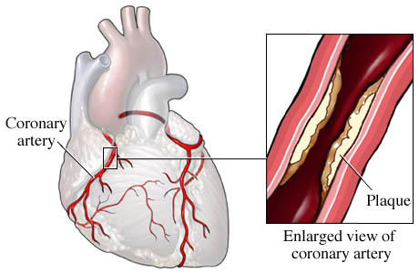
CORONARY HEART DISEASE (CHD)
CHD occurs when a person’s coronary arteries is clogged with fatty material called _____________. This is the build-up of ____________ and _____________________ on the inner linings of the arteries. As plaque builds up, the artery gets __________________________. This does not happen overnight – it usually occurs silently over _______________________. In fact, this process begins early on in life and __________________ plays a major part in it.

RISK FACTORS FOR CHD
The build-up of cholesterol plaque thickens the arteries, making it difficult for blood to ______________________________________. The primary factors that cause this build-up are lifestyle and behavioural patterns such as ___________________________________ _______________________. __________________________ and ____________________ are also major risk factors for coronary heart disease.
- ________________________________________. Too much fatty food can lead to an increase in cholesterol levels in the blood and can lead to CHD. Dietary cholesterol comes from ________________________________________.
- Lack of physical exercise: Calories not used by physical activity can lead to increased __________________________________ in the blood. This can cause blood vessel ____________________ and plaque _____________________. Exercise helps us burn these excess calories from the food we eat and thereby ________________________ from heart disease.
- ________________________ damages the ______________________ of the arteries.
- Diabetes - or high blood sugar levels damages the ___________________________. This predisposes them to __________________________________.
- Obesity – People who are overweight run the risk of developing CHD (______________________ ______________________) because of the high levels of ______________________ in the body. They are also prone to developing diseases such as ___________________________ and _________________ which are also major risk factors for CHD.
- _____________________ causes blood vessel damage, and ______________ the bad cholesterol called “Low density Lipoprotein” (LDL) which is a major risk factor for CHD.
- _____________________ intake increases fat levels in the blood. It can also lead to increased ________________________________ and it also damages the ____________________________________.
- A strong family history of CHD provides a __________________ risk of dying from CHD.
- _____________. Males have an increased risk of developing ___________ than females.
- Age above ________ years. The older you get, the _____________________ the risk.
HOW PLAQUE DEVELOPS INSIDE THE CORONARY ARTERIES
This is a normal coronary artery. There is no evidence of any narrowing and the blood is ________________ freely as shown by the arrow.
There is a plaque (accumulation of ____________ and other substances) developing in this coronary artery. This process is ___________ and develops over several years. The plaque is formed by cholesterol and blood components. This artery is now significantly ________. The person may feel perfectly well even at this stage.
Plaque

As the plaque develops further, it reaches a point where it _______________. This happens suddenly and without warning! There is bleeding with ________________. The clot completely blocks the artery obstructing _____________________ to the heart muscle and the person suddenly collapses. This is what is often referred to as a ________________________.
Plaque ruptures
(with clot formation)

CHOLESTEROL
- The body ______________________ Cholesterol.
- The problem comes when MORE cholesterol is ________________________________.
- Dietary cholesterol comes from eating ______________________________________.
- In the blood, cholesterol is transported by special carrier particles called ___________.
- There are _______ types of Lipoproteins. 1. ______________________________ (LDL) 2. ______________________________________ (HDL)
- For the sake of simplicity, Cholesterol is classified as LDL cholesterol – which means the cholesterol is transported by ____________________________ and HDL cholesterol – which means the cholesterol is transported by ________________________________.

The difference between the two is SIGNIFICANT!
- LDL cholesterol – (think of ‘______________________’) promotes serious health problems including _______________________________ and _______________ by depositing cholesterol in _____________________________. LDL cholesterol promotes ____________________________________________ in arteries in the heart, brain and other parts of the body. Because of this they are described as _____________________________________________.
SOURCES OF LDL
______________________________________________________________________________________________________________________________________________________________________________________________________
- HDL cholesterol – (think of ‘____________________________________’) on the other hand __________________ cholesterol from within the walls of the arteries and ______________ it back to the _______________ for removal from the body. By doing this, HDL cholesterol protects us from ___________________________ and other diseases. This is why it is called the ____________________________. Those with _________________ of HDL Cholesterol seem to have fewer problems with CHD, while those with low HDL cholesterol levels have __________________ rates for heart disease and strokes.
SOURCES OF HDL
______________________________________________________________________________________________________________________________________________________________________________________________________

HOW TO PREVENT CHD
- _______________________ Physical inactivity is the _____________ leading risk factor for global death, after _______________, ________________ and _________________.
Some startling numbers for you:
- _________________ deaths per year due to inactivity.
- _________________ premature deaths (people aged under 60 years) due to physical inactivity.
- Lack of physical activity is estimated as being a cause of _____________________, ____________ of diabetes and ____________ of CHD.
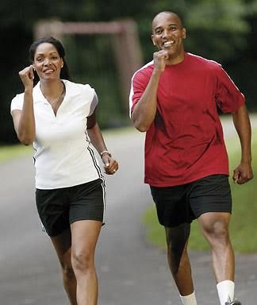
30 minutes of brisk walking benefits your health.
Regular exercise: __________________________________
________________________________________________
________________________________________________

It also burns excess calories and allows you to maintain ____________________________________ which is important in preventing not only Coronary Heart Disease (CHD) but all other lifestyle disease as well.

- ____________________________________________
Alcohol ______________ blood cholesterol levels and can damage arteries leading to _______________________ and CHD. Alcohol has been implicated in the development of ____________________________________________________________________.
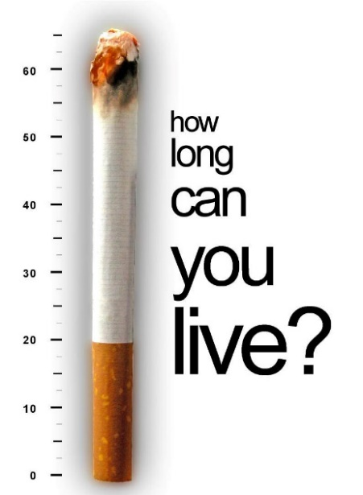
- ________________________________: This is a major risk factor for CHD and many different __________________. Smoking can damage ____________________, lead to ___________________ and __________________________. It also limits how much _________________________ reaches the _________________________ and other body tissues.

- ______________________________________________.
Animal flesh is the main source of ______________________. Lamb flaps and chops especially are full of fats and therefore should be taken only in very small amounts (if at all!) ___________ all visible fat prior to cooking, but BEWARE – there is still much fat lurking in the tissues of the animal! Processed meats such as ____________________________________________ are particularly dangerous – not only because of their high ______________________________ but also because of a high amount of _________________________________ found in them.
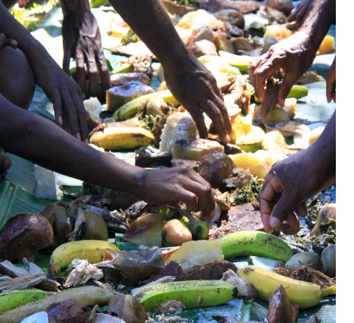
- _________________________________________. These foods are full of protective elements that the body needs to ________ itself from ____________. The best advice: ___________________________ ______________________________. This diet was full of ___________________________________. Avoid __________________________________ as these are high in ___________________________.

- _______________________________ Overweight/Obesity are major risk factors not only for CHD but for __________________ as well.
- ______________________________. Ask God to help you choose a healthier lifestyle. Only God through His Spirit can help you and I make the necessary changes to turn our life around.
Write out Philippians 3:18-21: __________________________________________________
___________________________________________________________________________
___________________________________________________________________________
___________________________________________________________________________
___________________________________________________________________________

HIGH BLOOD PRESSURE (HYPERTENSION)
High blood pressure is sometimes referred to as the _____________________________ because it may have no outward symptoms for years. In fact _________ in ___________ people with hypertension don’t even know they have it. ___________________, it can quietly damage the _____________________________________________________________ if left untreated.
WHAT IS BLOOD PRESSURE?
- Blood pressure is the force of blood pressing against the ________________ of your arteries when your ______________________.
- Each time the heart beats and blood flows, a certain amount of _______________________ is creased within the _______________________.
- This pressure helps to ________________ blood through the big arteries, small arteries and then on to very tiny arteries called _____________________________ so that cells can receive __________________ and _______________________________.
- The Blood pressure must be kept at a certain _____________ level at all times – it mustn’t go too high OR too ______________.
- ______________________________ (“HIGH BLOOD PRESSURE”) can cause many major health problems.
- ______________________________ (‘HYPOTENSION”) means the blood becomes ______________ and cannot flow to the cells and a person can die as a result of this.
- Blood pressure changes throughout the day. It is at its lowest when you are __________ and rises when you get up. It can also rise when you are __________________________ _______________________________.
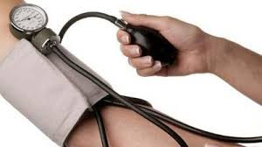
- Doctors or nurses use a special instrument called a _____________________________ to record blood pressure readings.
- Your blood pressure is at its highest when _______________________________ and the pressure created is called the _____________.
- When the heart is at rest (between beats) your blood pressure falls – this is called the _____________. Both readings are important.

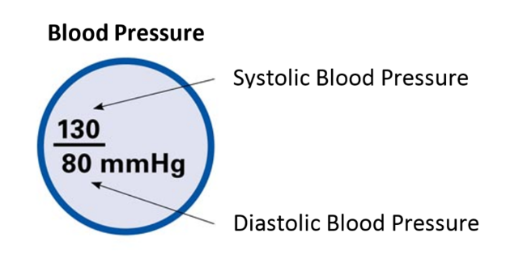
Normal blood pressure ranges between 90/60 to 120/70. Any reading over 130/80 (either number) and sustained over a long period of time is considered a sign of hypertension.

THE SILENT KILLER
Many people with hypertension fail to undergo ___________________________________ and so are unaware of it. The only way to find out about your blood pressure is to have it checked ___________________________ by a health professional such as a nurse or doctor.
Untreated hypertension KILLS by causing ________________________________________.
SOME PEOPLE may experience vague symptoms such as _____________________________ _____________________________________________. Often the first sign may be a ______________________________________. By this time, it may be too late to do anything.
CAUSES OF HIGH BLOOD PRESSURE
- _________________. If others in your family have it then your risk increases dramatically.
- ________________. Dark skinned people are more likely to develop ____________________.
- ________________. Usually occurs in people older than _______________ and chances of developing the disorder increases with age.
- ______________________________. People who are active and who do regular exercise have a healthier __________________________________________________.
- ______________________________. Being overweight or _______________ is a MAJOR risk factor for high blood pressure. Being overweight places a strain ________________________ and increases your risk of hypertension dramatically. The advice is to ____________________ and ___________________________ and increase ______________________________ and ___________________. Losing just a few kilograms can make a ________________________. A slender or thin person is much less likely to develop _______________________________.
- _______________________________. __________________________, which is the major component of salt can raise blood pressure by causing the body to ____________________. This leads to a greater burden on the _____________________. You should only have about a ____________________ of salt a day. But remember this isn’t just the salt you add to your food through the salt shaker. Large amounts of salt is also _____________________________ in many popular foods such as ________________________ ___________________________.
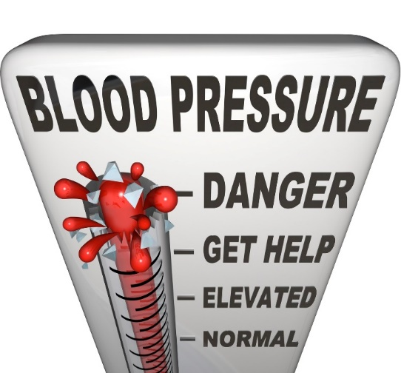
- ______________. Like cigarette smoking, this damages the heart and blood vessels and so increases the risk of high blood pressure. _________________________________ from alcohol is the most sensible thing to do.
- ___________________. Nicotine found in cigarettes have been shown to increase blood pressure.
- ____________________. This destroys blood vessels in major organs thus increasing the overall blood pressure.
COMPLICATIONS OF HIGH BLOOD PRESSURE
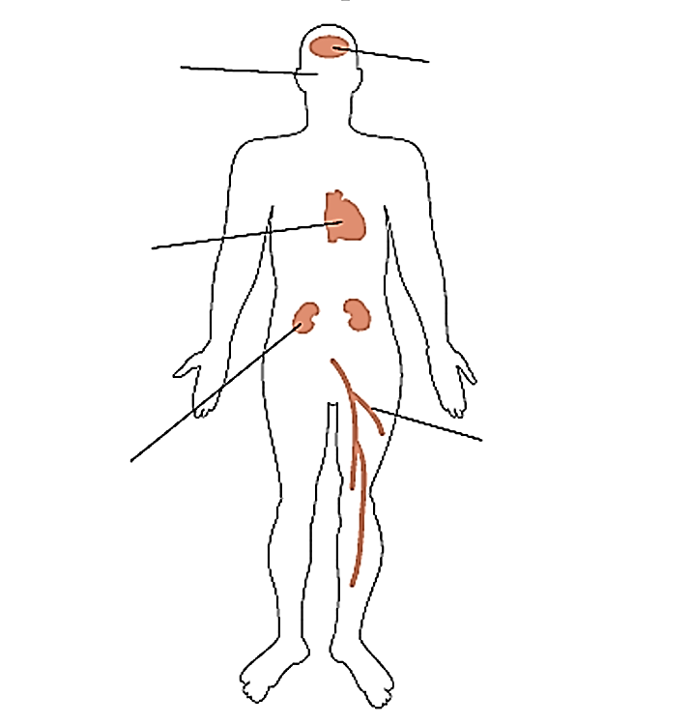
High blood pressure can lead to serious health problems. Over time, uncontrolled high blood pressure increases the risk of disease in the heart, arteries (blood vessels), brain, eyes and the kidneys. With high blood pressure, the heart works harder, your arteries take a real beating, and your chances of a stroke, heart attack, and kidney failure are much greater.
____________________________________________________________________________________________________________________________________________________________
Galatians 5:22,23

ISCHAEMIC HEART DISEASE: High blood pressure damages the heart and _______________.
STROKE: Remember a Haemorrhagic stroke is caused by the __________________ of a blood vessel. The chances of this happen increase when the pressure is increased.
KIDNEY FAILURE: Each person has ________ kidneys. They work to ________________ or clean the blood from excess _______________________ and ______________________ generated by the body. This process depends on ________________________ within the kidneys. High blood pressure can significantly injure blood vessels in the kidneys and can cause serious kidney disease leading to __________________________________.

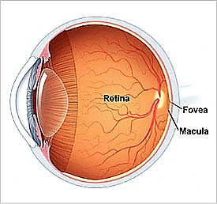
BLINDNESS: Hypertension can cause major damage to an area at the back of the eye called the _____________________. This is the part inside the eye that ____________________. The damage to the retina can be serious and lead to blindness if the high blood pressure remains untreated.
This picture illustrates damage created by high blood pressure to the retina. The retina has white and red discolouration all over. These represent inflammation. This patient’s vision or eyesight would be poor.

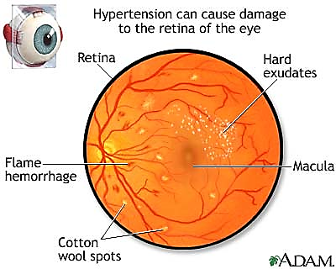
CONCLUSION
Many people in the South Pacific have high blood pressure. It is a serious health problem in our region. High blood pressure should be taken seriously because it is a major killer and because it is mostly silent in its effect on the body and causes very little symptoms, millions of people do not even know they have it. High blood pressure affects people of all ages, race and ethnic groups.

DISCUSSION QUESTION:
Blood pressure can increase when you worry about things. As Christians we are given many promises that should combat that. For example Matt 6:34, John 14:1, Proverbs 29:25, Phil 4:6.
Then discuss this statement:
‘CHRISTIANS SHOULD NEVER HAVE HIGH BLOOD PRESSURE’: _________________________ _____________________________________________________________________________________________________________________________________________________________________________________________________________________________________________________________________________________________________________________________________________________________________________________________________________________________________________________________________________________________________________________________________________________________________________________________________________________________________________________________________________________________________________________

CHD and HYPERTENSION
Complete the crossword below

_________________________
Name

Across | Down
4. Increased fat levels in the blood can do this to blood vessels. | 1. The common blockage in an artery.
7. Symptom of high blood pressure. | 2. Eating too much of this can lead to Hypertension.
9. Something that damages the heart muscle directly. | 3. Hypertension can damage this part of the eye.
10. Body part possibly effected by high blood pressure. | 5. Very overweight.
12. Blood transports this. | 6. Found in all animal products and no plant products.
13. The pressure when the heart beats. | 7. What damages the internal lining of arteries?
15. The most dangerous form of meat. | 8. Haemorrhagic stroke can occur once this happens to a blood vessel.
17. Recommended dosage of alcohol. | 11. Low blood pressure.
20. What week of pregnancy does the heart start beating? | 14. High blood pressure is often called the silent______.
21. Particles that transport cholesterol in the blood. | 16. The likelihood of this disease in increased if you have hypertension.
23. Where the heart is located. | 17. The major artery that leaves the heart.
26. The 'Bad cholesterol'. | 18. Risk factor for CHD.
27. The 4th leading risk factor for global death. | 19. Where dietary cholesterol comes from.
 | 22. The heart is a muscular ________.
 | 24. The 'Good cholesterol'.
 | 25. Philippians tells us that for many people, this is their god.

CANCER
Just the mention of the word cancer brings so much fear to the hearts of many people and rightfully so. Cancer is a terrible disease to have. Cancer has killed millions of people around the world and yet we still do not know exactly how it starts and why it behaves the way it does.
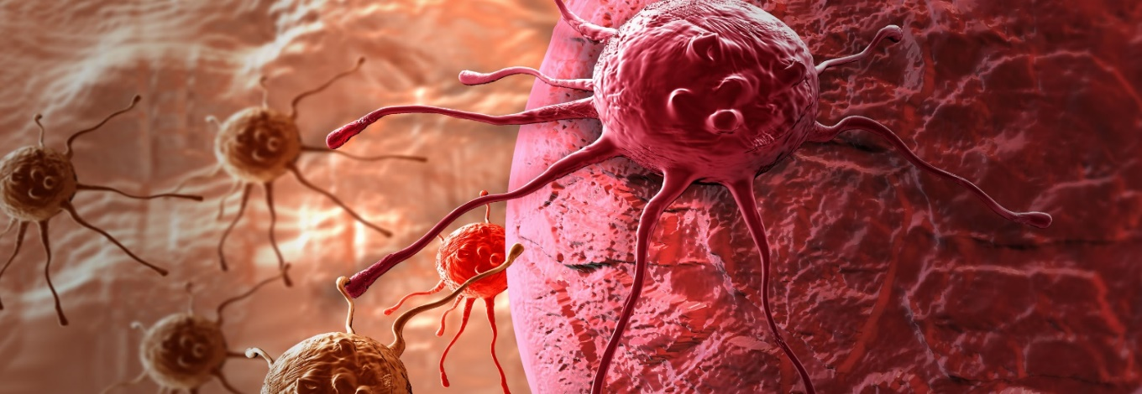
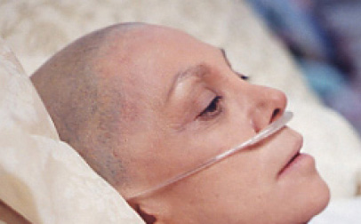
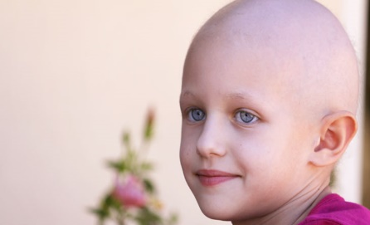
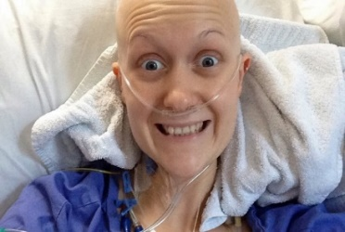
Cancer is a name used for a big group of diseases that can affect any part of the body. Other names used for cancer are malignant ______________________ or ___________________. One defining feature of cancer is its ability to grow rapidly, growing beyond their boundaries and spreading to other parts of the body – a cancer characteristic known as _____________.
Cancer is a leading cause of death worldwide accounting for 7.6 million deaths in 2008 alone. Below is some information about cancer:
- Lung, stomach, liver, colon and breast cancer cause the most cancer deaths each year
- The most frequent types of cancer differ between men and women. About 30% of cancer deaths are due to the five leading behavioural and dietary risks:
  - Overweight/obesity
  - Low fruit and vegetable intake
  - Lack of physical activity
  - Tobacco use
  - Alcohol use
- Tobacco use is one of the most important risk factor for cancer causing 22% of global cancer deaths and 71% of global lung cancer deaths.
- About 70% of all cancer deaths in 2008 occurred in low- and middle-income countries like the countries of the South Pacific.
- Deaths from cancer worldwide are projected to continue rising, with an estimated 13.1 million deaths in 2030.
It is clear that cancer is a growing problem worldwide.
UNDERSTANDING CANCER
To understand cancer, one must understand the tiny cell which is the basic ______________ of the human body. The human body contains approximately _________________________ cells. Examples include _______________________________________________________ ___________________________________________________________________________.

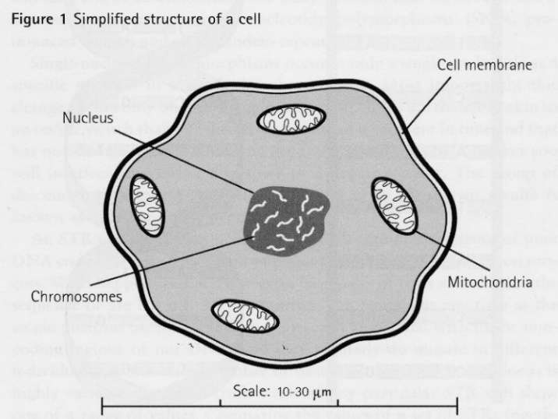
Note the various structures that make up a cell. These structures work together to enable the cell to _______________ _________________________________ ________________________________. Cells __________________ to replenish themselves and in this process, old cells die and new ones __________________. This process is always carried out in an orderly and coordinated way. Cells may differ in size and shape but they all have similar ______________ ____________.

CELL NUCLEUS
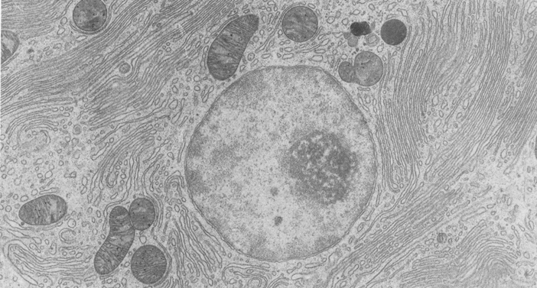
All cells have a control centre called the nucleus. The nucleus directs all ________________. Placed within the cell nucleus is the genetic material called __________________________ or DNA for short. The DNA has in it all the information that is required by the cell to do its work and to _________________________. Think of the cell nucleus and the DNA inside it as the ____________________________. Sometimes the DNA can be damaged or changed due to injury. When the DNA is damaged, normal cell growth and division can be seriously affected and this can lead to the uncontrolled cell growth called ___________________.
Nucleus
This picture of a human cell shows the cell nucleus. The nucleus contains the genetic material, DNA. Any injury or damage to the nucleus or the DNA can lead to the development of cancer. This explains the fact that all cancers begin in the cell when there is damage to the DNA.
Normal cells: Normal cells are arranged in a neat and orderly manner. Each cell fits into its right space and respects its neighbouring cell. Below is a diagram that shows how normal cells make up the tissues in the body. Appreciate the orderly way in which the cells are arranged. It is amazing how God created each one of us - scripture tells us that we were created so “fearfully and wonderfully”.
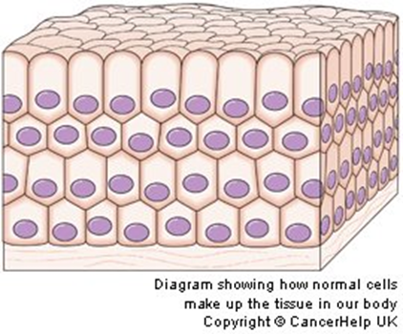
Note the neat arrangements of the cells of this particular tissue. Also note that each cell has a nucleus – the “brain” of the cell that controls its function and reproduction.

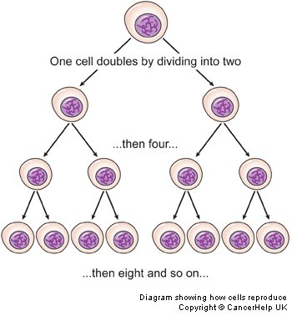

Under the careful control of the DNA, cells divide and multiply at the right time and stop dividing and multiplying at the right time.

Normally, cells grow and divide to form new cells ______________________________. Old cells die, and new cells are formed to take their place. There is an inbuilt _____________________________ that safeguards this very important process. Sometimes however, this _________________ process goes wrong and new cells are formed when the body does not need them. These news cells tend to grow ___________________________, dividing and multiplying at their own will and disregarding all control mechanisms. This is basically what ___________________ means – a cell or groups of cells disregarding the body’s control mechanism and growing out of control.
Example: When there is a cut on the skin, the cells at the site of injury start growing, dividing and multiplying. The aim is to fill and close the gap or the wound that has been created. One cell doubles by dividing into two and then four and then eight and then 16 and so on until the gap is completely filled. There is an inbuilt mechanism in each cell designed by God that tells it to stop growing and multiplying when the gap in the wound is completely filled and the wound has healed. This process can take days, weeks or months depending on the size and the type of the wound.
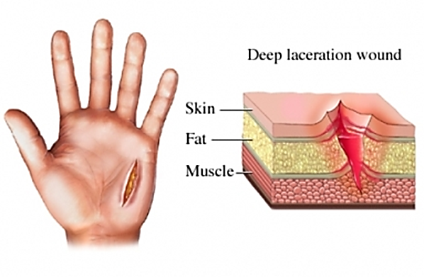
Cells at the area of the injury start dividing, growing and multiplying to close the gap created and heal the wound.

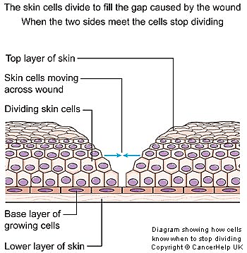
The diagram on the left illustrates a healing wound. There is a deep cut in the skin as illustrated, and the cells from the two sides and the base of the wound begin dividing and multiply to close the gap and heal the wound. In the normal situation cells stop growing and multiplying when the wound has healed.

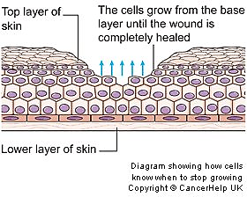
This next diagram illustrates the same healing wound as above. Cells have started growing from the bottom upwards and from the sides inwards. Cells stop growing when the healing process is complete. There is an inbuilt mechanism within the cells that tells them to stop growing when healing is complete. This mechanism is lost with cancer cells and so they keep growing and growing causing destruction and death.

Cancer starts in the cell when there is damage to the DNA
Cancer starts in the cell – it may be in one cell or a group of cells. This happens long before a person feels sick. Cancer starts when there is ______________________________________ in the DNA of a cell. The cell affected by cancer behaves in a totally ____________________ way. It does not listen to the rest of the body. It grows and grows, destroying normal cells and eventually kills by starving the body of essential ______________________. Below are some of the characteristics of cancer cells:
- ______________________________________________________________________________________________________________________________________________
- ______________________________________________________________________________________________________________________________________________
- ______________________________________________________________________________________________________________________________________________
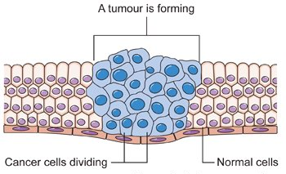
This diagram shows cancer cells (in blue) growing, multiplying, expanding and invading normal cells. This is how cancer cells form tumours or a hard mass for example in the abdomen, liver, chest or in other parts of the body. Note that the cells are bigger and abnormal looking and irregular in size and shape.

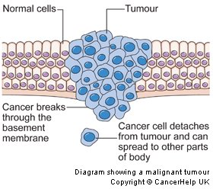
This diagram illustrates cancer cells (coloured blue) growing and expanding and breaking through normal boundaries as shown at the top and bottom section of the diagram.
Note a cancer cell breaking away from the rest. This cancer cell can travel to any part of the body and keep growing there. This is the commonest way cancer kills people. A cancer cell spreading to other parts of the body is called “metastasis”.
This diagram illustrates cancer cells (coloured blue) growing and expanding and breaking through normal boundaries as shown at the top and bottom section of the diagram.
Note a cancer cell breaking away from the rest. This cancer cell can travel to any part of the body and keep growing there. This is the commonest way cancer kills people. A cancer cell spreading to other parts of the body is called “metastasis”.
WHY?
Short answer – We don’t know why cancer behaves the way it does.
But, because of the vast amount of research that has been done, we do know certain __________________________ that increases the chances that a person will develop cancer.
A risk factor here is anything that increases the chances of ___________________________ that may lead to cancer. This means anything that damages the cell nucleus and the DNA.
RISK FACTORS FOR CANCER:
- ____________________________. The chances of developing cancer when a person is young is much lower than when a person reaches middle age or older.
- ____________________________. Compared with non-smokers, cigarette smoking increases the risk of men developing lung cancer by ________________ and in women by __________________. Cigarette smoking is responsible for many cancers including:
    - ________________________
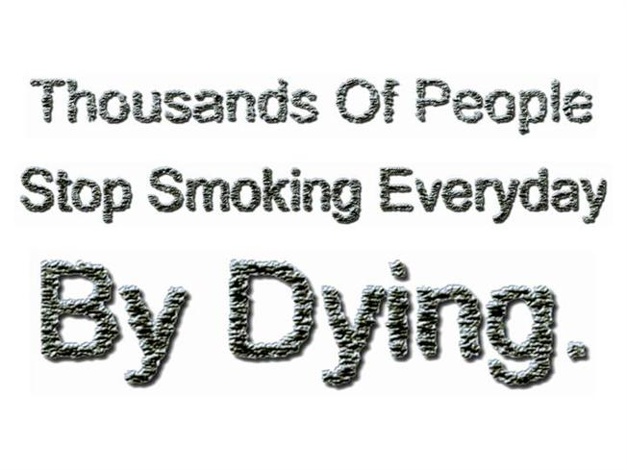
    - ________________________
    - ________________________
    - ________________________
    - ________________________
    - ________________________
    - ________________________
    - ________________________
    - ________________________
    - ________________________
    - ________________________
One cigarette contains _____________________ different poisons that can cause serious damage to lung cells. There are _______________ major cancer-causing chemicals in ________ cigarette. These cancer-causing chemicals are referred to as _____________________________________.
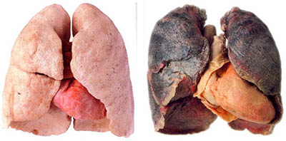
This photo shows a set of health, cancer free lungs (left) and lungs affected by lung cancer (right).

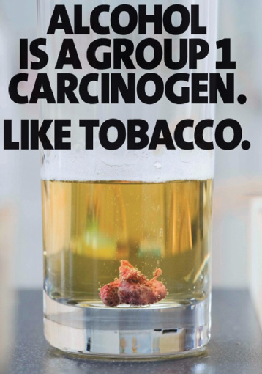
- _____________________________ - is a dangerous drug and responsible for several major cancers in the human body:
    - ____________________________________
    - ____________________________________
    - ____________________________________
    - ____________________________________
    - ____________________________________
    - ____________________________________
    - ____________________________________
    - ____________________________________
    - ____________________________________
Alcohol is a dangerous carcinogen (______________________________). It causes cancer by damaging the cell nucleus of many cells in the body.
- ______________________________. Like cigarette and alcohol, betel nut is a major risk factor for ________________________. The mixture of betel nut with lime called the “______________” causes continuous irritation of the lining of the mouth, leading to cell damage and the development of _______________________. This is a very common problem in ________________________. In most cases, the cancer will present either as __________________________ __________________________.
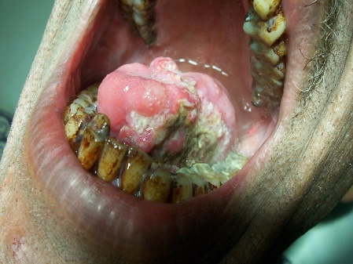
This is mouth cancer from betel nut chewing. Note the ulcer on the tongue. This tongue is stuck and cannot move because cancer cells have invaded normal surrounding cells and tissues.
In most cases, cancer presents either as an ulcer, a lump or a mass.
- _________________________________. Exposure to ____________, _____________, ______________, _______________ or _____________________ in the workplace can cause cancer. The rule is to avoid _________________________________________ from these chemicals as they are all ______________________________.
- __________________________. This refers to a type of radiation created by x-ray equipment in medicine, radioactive substances like nuclear materials, rays that enter the ______________________ from outer space like the ___________ and other sources. At high doses, ionizing radiation increases ___________________ inside cells and can lead to damage to the DNA which increases susceptibility to ____________________.
- ___________________. Certain types of virus cause cancer. The two most common are the _____________________________________________ (HIV) (Commonly causes Kaposi Sarcoma in patients) and the ________________________________ (HPV) (Most important cause of _________________________ in women). These viruses damage the _______________________ and cause cancer.
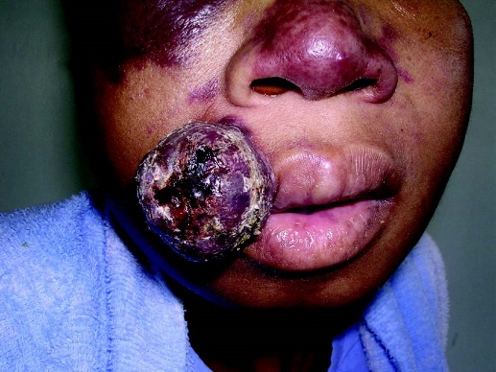
This is Kaposi Sarcoma in a patient suffering from AIDS.

- ________________________________. Many people have someone in their family who has had cancer. It is not uncommon for more than one member of a family to have cancer. Cancer can occur in families:
- __________________________________________________________________
- ____________________________________________________________________________________________________________________________________
- ____________________________________________________________________________________________________________________________________
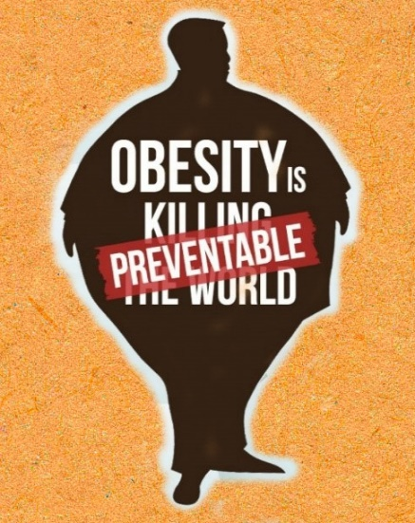
- _________________________. This presents an increased risk for the following types of cancer and possibly others as well:
- ______________________________________
- ______________________________________
- ______________________________________
- ______________________________________
(2nd major killer of women in the South Pacific)
- ______________________________________
- ______________________________________
- ______________________________________
- ______________________________________
- _______________________. The World health organization has reported that dietary factors account for at least _______of all cancers in Western countries and _______ in developing countries. Poor diet such as those _____________________ ____________________ can lead to cancer by causing inflammation in tissues damaging the cell and its nucleus. A Healthy diet on the other hand, rich in fruits and vegetables have been shown to reduce cancer risk and other chronic diseases.

There are many advantages in eating plant foods, these are:
- __________________________________________________________________ __________________________________________________________________
- ____________________________________________________________________________________________________________________________________
- __________________________________________________________________
- ____________________________________________________________________________________________________________________________________
- ______________________________________________________________________________________________________________________________________________________________________________________________________
- _______________________________. Lack of exercise is a _______________ risk for cancer. There is now convincing evidence that increased physical activity decreases the risk for _______ _______________________________. Several studies have also reported links between physical activity and a reduced risk of cancers of the _______ _______________________________.

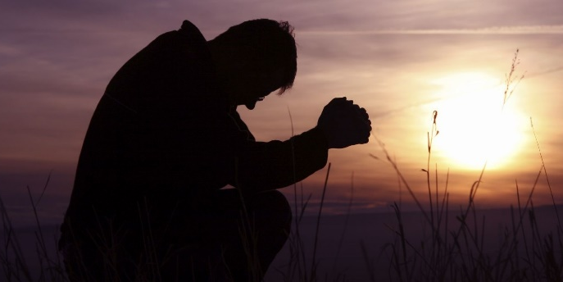
SO HOW DO WE REDUCE THE RISK OF CANCER?
There is no magic syrup, cocktail or tablet that can protect us from all the diseases found in our world today. However God in His love has given us some _________________________ as a means of protecting us.
These include:
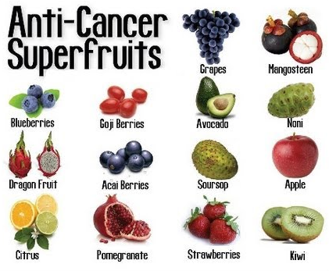
- ________________________________
- ________________________________
- ________________________________
- ________________________________
- ________________________________
- ________________________________
- ________________________________

CANCER
_________________________
Name
Make up the best questions to match the following answers - then share the puzzle with a friend or parent.
Created by Puzzlemaker at DiscoveryEducation.com

Across | Down. Down
1. chromosomes  4. betelnut  7. nutrients  8. mass  11. smoking  12. abnormal  16. neoplasm  19. divides  20. DNA  21. phytochemicals  23. alcohol  25. inactive | 2. obesity 20. damage  3. fumes 22. god  5. carcinogens 24. cell  6. viruses  8. membrane  9. quid  10. brain  13. noni  14. meat  15. trillion  17. orderly  18. metastasis

See if you can remember any of these quotes and texts by using the words in the
Texts, Quotes and Questions
“WORD BANK” to fill in the blanks

- “Medical missionary work is the _________________ hand of the gospel. It is necessary to the advancement of the __________________ of God. As through it men and women are led to see the importance of right ____________________ of living, and the saving power of the truth will be made known... as the right hand of the ______________ angels message, God’s methods of treating ________________________ will open doors for the entrance of present truth.
- I ______________________ you therefore, brethren, by the _______________ of God, that ye present your bodies a living ___________________, holy, acceptable unto God, which is your ___________________________ service. (Romans 12:1)
- What? Know ye not that your body is the ________________ of the Holy Ghost which is in _______________, which ye have of God, and ye are not your ________________? For ye are bought with a ______________________: therefore _________________ God in your body, and in your ______________________, which are God's. (1 Corinthians 6:19)
- Know ye not that ye are the temple of ______________, and that the Spirit of God dwelleth in you? If any man _____________________ the temple of God, him shall God destroy; for the temple of God is _________________, which temple ye are. (1 Corinthians 3:16, 17)
- “If Seventh-day Adventists practiced what they ____________________ to __________________, if they were sincere ___________________ reformers, they would be a ____________________ to ____________________ and to man”. (Councils on Health p 575)
- “True temperance teaches us to dispense _____________ with everything ____________________ and to _____________ judiciously that which is _________________________”. (Patriarch and Prophets, p. 562 (1890)
- “Tea, _____________________, tobacco, and ___________________ we must present as ___________________ indulgences. We cannot place on the same ground, _______________, eggs, butter, ___________________, and such articles placed upon the table. These are not to be borne in front, as the _______________ of our work. The former – tea, coffee, ___________________, beer, wine, and all spirituous liquors- are not to be taken moderately, but _______________________________________.” (3 Selected Messages, p. 287)

defile | burden | angels | god | price | discard
entirely | coffee | you | professed | healthful | tobacco
sacrifice | hurtful | bodies | own | believe | coffee
beseech | health | alcohol | reasonable | mercies | glorify
sinful | disease | use | cause | spirit | meat
temple | habits | right | cheese | spectacle | holy

CHRISTS OBJECT LESSONS, P. 59
___________________________ Work is the _____________________ of the gospel. It is necessary to the advancement of the cause of god. As through it men and women are ______________________the importance of ____________________ of living, and the saving power of the truth will be made known … as the right hand of the third angel’s message, god’s methods of treating disease will ____________ for the entrance of present __________.

Possible Questions for Discussion or Assignment Tasks
- Over 150 years ago, the Adventist church was given a powerful and unique health message. Have we paid enough attention to it? What might have been?
- What is the most powerful way for the church to use this health message?
- Many modern day foods and habits weren’t around in Mrs White’s days. What habits do you think she would address if she were here today – can you see the foundation of your arguments in any other of her quotes?
- Containing 8 out of the top 10 fattest countries IN THE WORLD, the South Pacific has a health crisis on their hands. What can be done to stop or even better – reverse - this?
- It has been said that Jesus healed more than he preached. How should that fact impact us as His disciples?
- What habits do you have now, or can you see might be a weakness of yours, that may lead to a Non-communicable disease? What steps can you take to change that outcome!
- Many verses tell us that our body is God’s temple. What exactly does that mean? What was/is the temple used for and how can that be likened to our physical body?
- Make up an acronym to cover the major lifestyle components that need to be addressed for a healthy, balanced, lifestyle. (You may already know one, but be creative and see if you can create a different one).
- WHO (World Health Organisation) recently said that the South Pacific is the ‘Epicentre’ of diabetes. Why? What impact would it be having on these countries? How can we change it?
- Write a letter to the Prime Minister of your country or the principal of your school on a NCD topic of your choice. What would you like to highlight to him? What suggestions would you like to make?

Cigarette smoking kills between ___________ people around the world each year. Manufacturers of cigarettes are very clever as they mostly target young people, because they know that if they can get the young _________________ on the habit, they will have them for ___________ (and therefore they will keep making money from them!). Cigarette smoking is a major problem in the South Pacific. It is destroying the lives of thousands of people.
Listed below are some data on cigarette smoking in our region
- In Kiribati around 70% of males between the ages of 30 and 54 are regular smokers. 32% of young males aged 15-19 smoke (2005 census). The overall smoking rate is 45%. The gift of tobacco (Mweaka) remains closely tied to spiritual beliefs in the Outer Islands and, in urban areas, a gift of tobacco is considered polite
- In Fiji, the overall prevalence rate of smoking is approximately 37.65 % of the population
- In Nauru 48.2% of both genders smoke daily
- In Samoa 40% of the total population are smokers: 56.3% of males and 21.8% of females
- In Tokelau, 59.3% of the population smoke daily
- In Papua New Guinea, approximately 45% of the population smoke
- In Solomon Islands, approximately 45% of the population smoke
- In Tonga, approximately 40% of the population smoke
- In Tuvalu, approximately 41% of the population smoke
- In Vanuatu, approximately 30% of the population smoke
- In Niue, approximately 40% of the population smoke
- In Samoa, 41% of the population smoke.

DISCUSSION
- Have you ever been tempted to smoke? Why?
- What needs to be changed in YOUR country to help minimize the number of young people taking up smoking?
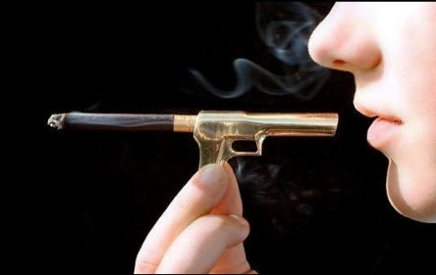
- What is the picture to the right telling you? How does it make you feel? Is it worth the risk?
- If someone smokes 5 cigarettes a day, what is the cost to them over a year? What would you like to buy with that money?
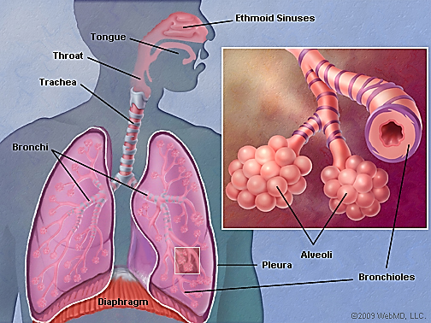
We have two lungs. They are located in the chest. Their main function is exchange of _________________ - ________________ and ______________________. The body cannot survive without oxygen. Oxygen in the air enters the blood and the cells through the ___________. Carbon dioxide is waste gas that is generated by the cells of the body. This gas must be _____________ from the body. This important work is carried out by the lungs.

The lungs have many different parts some of which are shown below. The alveoli which are the round structures in the picture below are the sites where gas exchange takes place.

How Gas Exchange Takes Place
The diagram (see below) illustrates how _________________________ takes place in the lungs. When we breathe in air during ____________________, oxygen (O₂), the good air, passes through the air passages and reaches the ________________. When oxygen reaches the alveoli it passes through the thin wall of the alveoli and enters the _________________. Capillaries are _____________ blood vessels that __________________ blood. In the capillaries are _______________________. Oxygen from the lungs enters the red blood cells in the capillaries and gets distributed throughout the _____________. Carbon dioxide (CO₂) or bad air comes from the ______________ of the body. It has to be removed from the body. The body forces carbon dioxide out of the capillaries into the ______________ and we remove it from the lungs every time we _____________________. This is the process that is called __________________________.

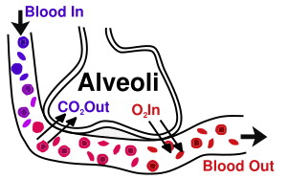
The diagram illustrates how Oxygen represented by the symbol O2 enters the blood from the lungs (alveoli) and how carbon dioxide represented by the symbol CO2 leaves the blood and enters the alveoli to be removed by the lungs.
Any rubbish or dirt in the lungs can interfere with this very important work and lead to lung tissues damage. Cigarette smoking introduces rubbish in the form of tar, dangerous chemicals and poisons into the lungs. These chemicals interfere with gas exchange by destroying the air passage and alveoli and can lead to lung diseases with numerous complications.

What is in Cigarette Smoke?
There are approximately ________________ different poisons and irritants in one cigarette alone. Out of these, there are 43 cancer causing substances. Found also in cigarette smoke is a deadly gas called ___________________________. Nicotine is the addictive component of cigarette.

Some examples of different poisonous chemicals found in cigarettes:
Acetone Urethane Mercury Arsenic
Lead Phenol Nicotine Formaldehyde
Cadmium DDT Carbon Monoxide Tar
Hydrogen Cyanide Ammonia Benzene Preservatives
More than 600 additives

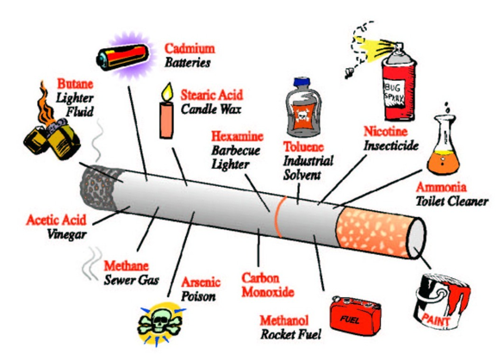

Nicotine

Nicotine is a powerful ___________________________ found in cigarettes. One cigarette contains approximately ______________________ of nicotine. Approximately ___________________ of nicotine is inhaled from one cigarette every time a person smokes. Fifty to sixty milligrams of nicotine can ____________________________.

Some important facts about nicotine are:
- _______________________________________________________________________
- _____________________________________________________________________________________________________________________________________________________________________________________________________________________
- _____________________________________________________________________________________________________________________________________________________________________________________________________________________
- ______________________________________________________________________________________________________________________________________________
- ______________________________________________________________________________________________________________________________________________
- _______________________________________________________________________
- _______________________________________________________________________
Because nicotine causes blood vessels to constrict or narrow down, it can lead to:
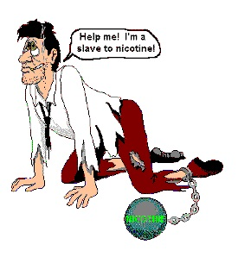
- __________________________________________
- __________________________________________
- __________________________________________
- __________________________________________

Nicotine also causes cholesterol buildup in the blood vessel wall causing narrowing of the blood vessels and a decrease in blood flow to the important tissues of the body.

Carbon Monoxide
Some important facts about carbon monoxide are:
- _______________________________________________________________________
- _______________________________________________________________________
- _______________________________________________________________________

Tar
Some important facts about tar in cigarette smoke are:
- Male smokers are ________________________ more likely to develop lung cancer than those who have never smoked.
- Female smokers are __________________________ more likely to develop lung cancer than those who have never smoked.
- A person who smokes an average of 20 cigarettes a day for one year takes up to ______________________ into his lungs
- Much of this tar remains, leading to ___________________________________ and the increased risk of lung cancer.
- This is a clean, healthy lung. This person had never smoked in his life.

This is a clean, healthy lung. This person had never smoked in his life.
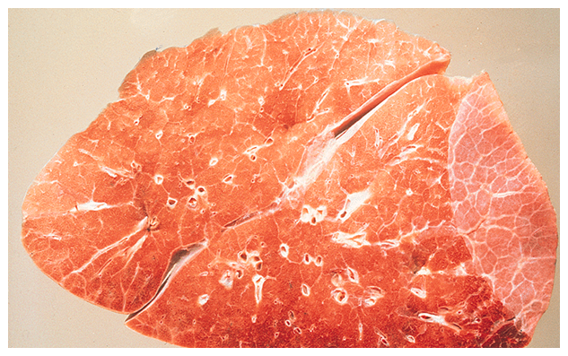
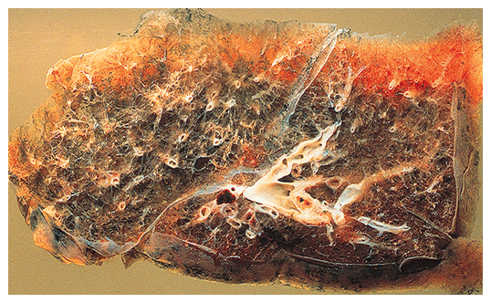
This lung is filled with tar. Notice the difference between this lung and the clean lung. Cigarette smoking destroys your lungs.
This lung is filled with tar. Notice the difference between this lung and the clean lung. Cigarette smoking destroys your lungs.

What Happens to Smoke in the Human Body?
As the smoke is sucked down it moves in a whirling spiral and particles are deposited on the _________ of the air passage. As this happens, smoke fills the _______________________. As a result of this, small ______________ lining the throat and airways called ______________, cannot work properly to keep the air passage _______________ and ____________________.

Some important facts about the cilia in your air ways are:
- Cilia are small hairs that line the airways. They clear the air passage of _____________ _________________________.
- Repeated smoke stops the cilia _____________________________________ properly.
- Small _________________________ often develop on the lining of airways.
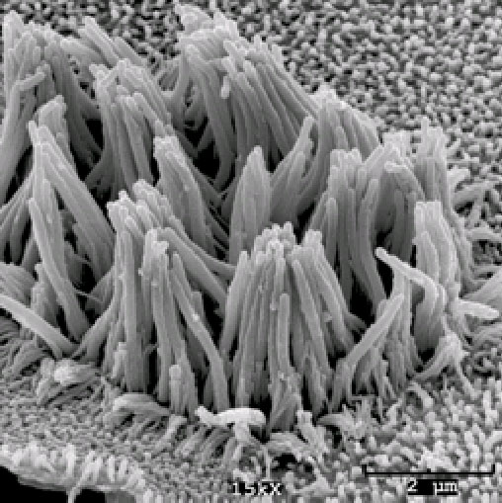
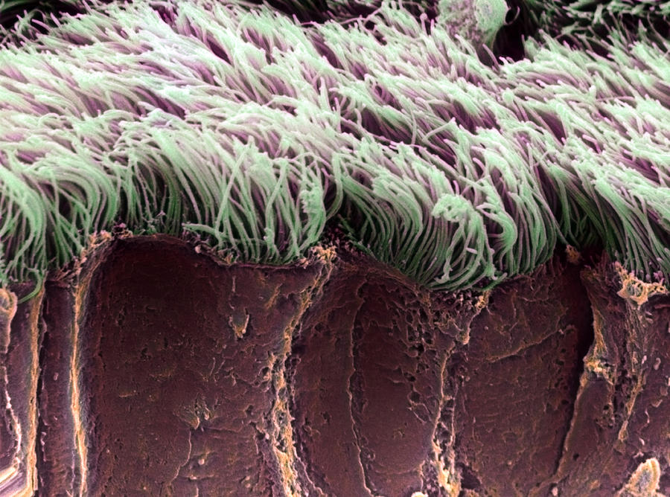
- Repeated and long term _________________________ lead to chronic bronchitis and emphysema (air trapping) because all the cilia are _______________________.

Cilia are hair like structures that line the airways. Their main function is to remove dirt and dust from the airways and protect us from lung diseases like asthma and cancer. Cigarette smoking destroys the cilia.

Effects on Airways
Some important facts about the effect of smoke on your air ways are:
- Smoking increases __________________________ in the large airways leading to more ________________________________.
- It leads to _______________________________ and then _______________________ and narrowing of the small airways.
- It can lead to more ____________________, more __________________________ and reduced lung function.

Effects on Lung Cells
Some important facts about the effect of smoke on your lung cells are:
- Smoking leads to more inflamed cells. The lung tissue becomes _______________ with tar.
- The lung is less able to _________________________ its work.
- The lung is less able to _______________________ infection.
- The lung tissue is ______________________.

Overall Effects of Smoking on the Body
With all the effects of smoking discussed above, cigarette smoking causes far more damage to the body than many smokers realise:

Examples of diseases caused by smoking
- _________________________. (Myocardial infarction) and sudden death. Cigarette blocks blood vessels in the body including those in the heart
- _________________________. Cigarette smoking is a major cause of stroke because it blocks blood vessels in the brain
- ________________________. (Mainly legs/feet/toes) called gangrene. This is because smoking destroys blood vessels and blocks blood flow to the legs, feet and toes
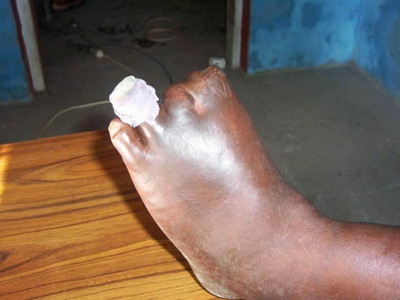
Dead toes due to cigarette smoking. The blood vessels supplying the toes have been destroyed by smoking cigarettes. - Photo: C Kuma

- It leads to _________________________
such as chronic bronchitis and emphysema and results in severe shortness of breath.

Cigarettes cause Cancer
Some important facts about the effects of smoking and cancer:
- _______________________________________. Cigarette smoking is the number one cause of lung cancer in the World. This is because of all the poisons that it contains and their effects on the airways and the lung tissue.
- ______________________________________________________________________
- Cigarette smoking ______________________________________________ – the tube connecting the mouth to the stomach.
- Cigarette smoking causes _________________________________________________.
- Cigarette smoking causes _________________________________________________.
- Cigarette smoking causes _________________________________________________.
- Cigarette smoking causes _________________________________________________.

Smoking can kill your unborn baby
Smoking in pregnancy can lead to some major complications:
- ______________________________________________________________________
- ______________________________________________________________________
- ______________________________________________________________________
- ______________________________________________________________________
- ______________________________________________________________________
- ______________________________________________________________________

Effects of smoking remains after birth
- ______________________________________________________________________
- ______________________________________________________________________
- ______________________________________________________________________
- ______________________________________________________________________

PASSIVE SMOKING
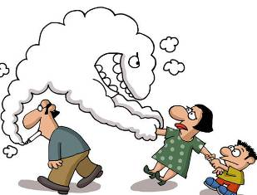
Side smoke – or passive smoking – occurs when non-smokers are exposed to cigarette smoke. In the Pacific Islands context, this commonly occurs in ___________________, at home or while using _________________. Such as ______________________________. Passive smoking is _____________________ because the chances of developing lung and other smoking related __________________ can be very ___________________________.

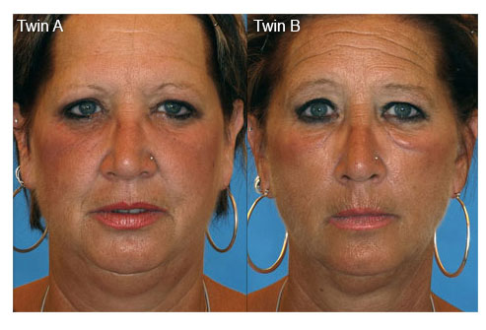
The twin on the right smoked ½ a pack of cigarettes a day for 14 years. See how many difference you can pick!

KAVA

Kava (Piper Methysticum) is a plant native to the Western Pacific Islands that is used to produce a drink popular among the Pacific cultures in Polynesia, Melanesia and even parts of Australia (kava is a member of the pepper family ‘piperceae’). Those growing this shrub distribute it by _____________, with about _____ years elapsing from planting until harvest. Its active elements are a series of ___________________, which are found in the ____________. As well as these psychoactive (___________ ______________) chemicals, kava is rich in potassium, nitrogen, phosphorus and magnesium. It is also known as Yungona in Fiji.
Traditionally kava had great ____________________ across many parts of the Pacific. A gift of Kava _____________________________ and fostered good relationships, families shared plants for use on special occasions and no discussion of council began without ritual Kava drinking. First the presiding ___________________ took a few sips, then a server offered the drink to the other chiefs in order of _________________________, and when the bowl was empty the talking began.
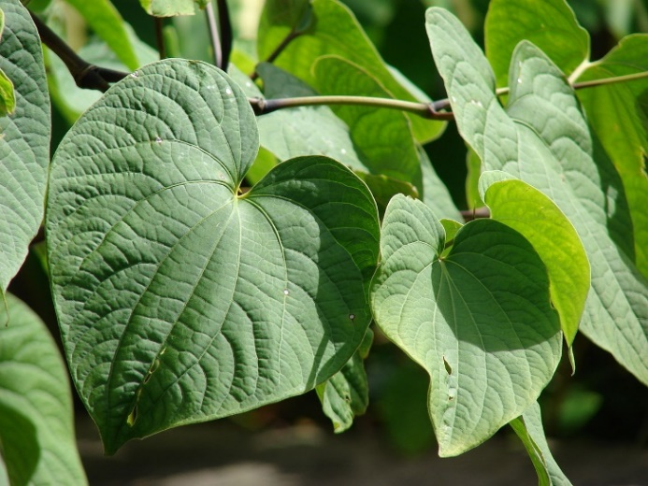
The use of Kava is spreading throughout the Pacific and is now grown in countries where Kava was never an issue in the past (such as _______________________________ and
_________________________________).
For kava to be effective, its roots must be mixed in ___________, _____________ or _______ to release the natural ingredients. More water is then added to make a murky, ____________ beverage with a _________ taste. Modern kava, prepared by pounding or grinding has _______ ______________ effect then the traditional chewed version.
Kava is a psychoactive drug, meaning that it is a chemical substance that can ______________________ ______________________. This can result in changes in ______________, _____________, _____________, ___________ (learning) and ____________________. When Kava is used in small quantities it produces a state of _______________ and __________________. The drinker is never unpleasant or even quarrelsome. If consumption is excessive the limbs are tired, muscles fail to respond, the drinker looks sleepy and tired and finally falls asleep for a long time before waking grudgingly.
John 10:10
“The thief comes only to ______ and ________ and ____________ but I came that they might have _______ and have it ___________________
A strong intake of kava often causes _____________ before the rapid collapse into deep sleep. This is because kava affects the brain leading to a reduction in spinal activity. Kava also affects the ______________ of the______________ and how it beats. It also affects ______________. It first stimulates more ___________ breathing then then it slows breathing down. In fact, it has been likened to _______________ intoxication, with the noticeable difference that mental clarity and alertness is maintained.
________________________ (100 – 150 ml.) of kava can put a kava drinker into a dreamless sleep within _________________. Kava is prepared for drinking from freshly pounded drinks, or by adding water to powdered dry rootstock. It does not depend at all on fermentation. Heavy Kava drinkers usually suffer from apathy that prevents them from _________________, and they sometimes have ___________ ____________ and __________________.
WARNING: __________ + ______________ = ________________
NEVER DISSOLVE KAVA IN ALCOHOL OR METHYLATED SPIRITS!

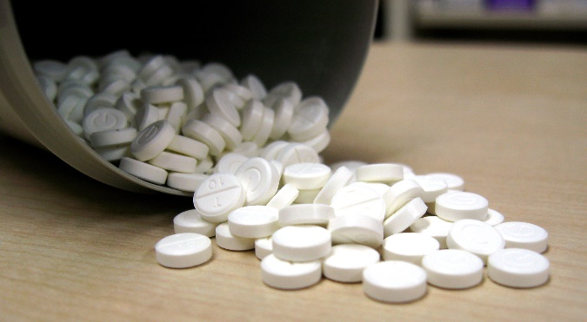
SIDE EFFECTS OF KAVA
- _____________ has been promoted as being the most common side effect. Kava consumed in ______________ as a health supplement has been proven to lead to severe _________ _____________ and even __________ ___________. Because of these side effects it has been banned in various European nations such as __________________, ____________ and the __________. The Liver damage is only experienced by those who take Kava in _______________________ as opposed to those using the beverage prepared in the traditional way. This is because the drink is made from the _______________ whereas the tablets are prepared from the ________ and the ________________ which contain a dangerous chemical called _______________________. The liver-related side effects experienced among the Pacific communities are __________ and ____________ and include ___________ __________ and a rise in ___________ ___________.
- Most, if not all, Kava users are adversely affected by _____________________. Regular kava consumers normally develop a _______, __________ ________________.
- Another side effect includes _______ ____________ and __________ to ___________. This particular side effect is quickly corrected once one ______________________. These side effects will be felt by those taking Kava tablets AND drinking traditionally prepared Kava.
- ____________________________ can occur.
- Other possible side effects of Kava include slow ___________ _______________ and an increased ______________________________. This makes it dangerous for kava consumers to _______________ ____________________ or ________________ since their impaired motor reflexes pose a threat to themselves and to others around them!

The internet promotes “Kava” as “The Ancient Mystical Drink – to control your stress.” It promotes kava as a 100% natural, healthful, sociable drink. It said, “Just steep in water and acquire a taste for relaxation!” ____________________________________. With so many young people using the Internet to shop, some serious kava problems could be just ahead!

As Christians we have spiritual resources for handling stress and the “golden rule” to keep us kind and reasonable in our dealings with others. We should not need to rely on _____________________ to feel happy and relaxed, especially where over-use can be harmful. We must continue to be positive in promoting a healthy, balanced lifestyle, free of any _______________ _______________.

It is important to realize that _______________________________ threatens _____________ and ________________________ and offers users a false sense of security in place of their _______________________________ on __________________, which brings true ____________ and ________________________.

CONCLUSION ____________________________________________________

Abstinence from alcohol and tobacco has always been required for SDA church membership. It should be the same for _______, _________ and _____________. These are not good for our health. Our members should be given information about it and warnings as to the effect it can have on health and spirituality, and they should be urged to _________________. If we can foster a positive attitude to the thought that we are the “temple of God, and that the spirit of God dwells in us” so that we are not to “defile the temple of God” (1 Cor.3:16, 17 and 2 Cor. 6:16) it may help our people make wise decisions on this delicate issue.

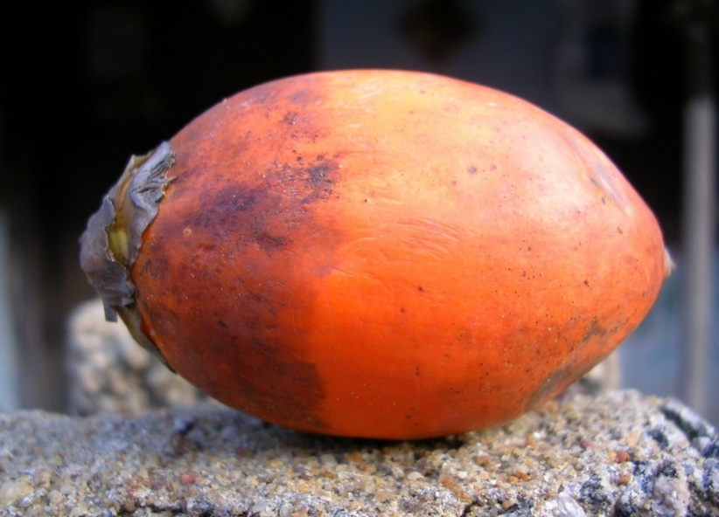
BETEL NUT

The betel nut is the seed of the __________________________ (Areca catechu), a very common plant in the Pacific, Asia, and parts of east Africa. Chewing the mixture of Betel nut and betel leaf is a tradition which dates back thousands of years. It is not known how and when the areca nut and the betel leaf were combined together into one ________________ _______________.
In Papua New Guinea and the Solomon Islands, fresh areca nut, betel leaf or 'fruit leaf' ("daka" in PNG) and __________________ are sold almost everywhere. Betel nut chewing has recently been introduced into ___________________ where it is growing in popularity, especially in the northern islands. In ________________, betel and areca nut chewing is a social pastime and used as a means of extending friendship, and can be found in many, if not most, large gatherings as part of their food display.

Chemical Composition
Betel nut contains several strong chemicals including ________, _______ __________, a fixed oil gum, terpineol, ___________, various saline substances and three main alkaloids: ______________ _________________ and _______________. These chemicals can cause narrowing of the blood vessels by stimulating the contraction of the muscular wall of the blood vessels like an ___________________. These chemicals alone can have significant side effects on the body.
The only safe course is to touch not, taste not, handle not, tea, coffee, wines, tobacco, opium and alcoholic drinks. The redeemer of the world came from heaven to help man in his weakness, that, in the power which Jesus came to bring him, he might become strong to overcome appetite and passion, and might be victor on every point.”
(3 Testimonies, pp 485-488)
Steps used in chewing the betel nut
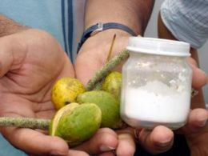
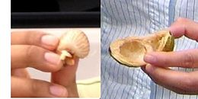
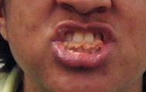
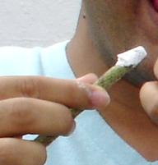
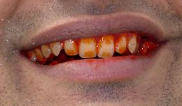
Step 1
Ingredients are collected. This includes the green betel nut (buai), a jar of lime powder (kambang) and a bean-like green fruit called mustard (daka) or mustard leaf.

Step 2
The betel nut husk is opened with the teeth and the inside flesh is removed from the shell and chewing commences.

Step 3
The betel nut is chewed for 2-5 minutes or until it forms a wad in the mouth.

Step 4
The mustard seed is now introduced. It is moistened with saliva and dipped into a jar of lime powder.

Step 5
The betel nut wad is moved to the side of the mouth and a piece of the mustard seed with the lime on it is introduced into the mouth. Direct contact of the inner lining of the mouth with lime will cause a burning sensation. As the mixture is chewed a chemical reaction takes place that makes the teeth and the lips go red and gives rise to a mild high.
Immediate Effects of Betel Nut Chewing
The effects of betel nut can be seen after chewing begins and can last for a __________ of _________. The effects appear to depend on the amount being chewed and whether the person is an _______________ or a _______________ chewer. It is generally chewed to help _________ ________________, produce a feeling of wellbeing and facilitate social interactions. What people do not understand is that chemicals from the nut enter the __________ and actually ___________ __________ ___________. This results in a change in _______________, ____________, ________________, and even ______________________. This makes betel nut a _________________.
Some of the reported immediate effects of chewing areca nut and betel quids include:
- ____________________________________
- ____________________________________
- ____________________________________
- ____________________________________
- ____________________________________
- ____________________________________
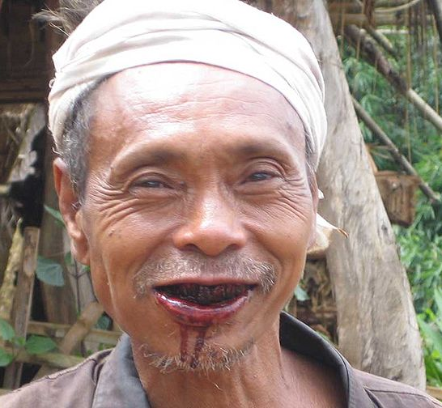
Other effects of betel nut chewing include:
- ____________________________________
- ____________________________________
- ____________________________________
- ____________________________________
- ____________________________________
- ____________________________________
- ____________________________________
- ____________________________________

It has been claimed that chewing betel nut suppresses feelings of hunger, stimulates the appetite, aids digestion, reduce feelings of nausea and acts as an anti-diarrhoeal. The truth is, ________________________________________________________________________.

“Now may the God of ___________ Himself sanctify you ____________; and may your whole spirit, soul, and ____________ be preserved _________________ at the coming of our Lord Jesus Christ”.
1 Thessalonians 5:23

Long-Term Effects
Excessive and long-term use of betel nut and lime had been associated with a number of significant health-related problems. These include:

- _______________________________________________________________________
- _______________________________________________________________________
- _______________________________________________________________________
- _______________________________________________________________________
- _______________________________________________________________________
- _______________________________________________________________________

Betel Nut and Cancer
The chemicals involved with Betel Nut chewing can cause _____________________ (these are _________________________). A carcinogen is any substance that is involved in causing cancer. Regular chewers of betel nut with lime carry a significant risk of damaging ________
___________________________________________________________________________
rendering them more susceptible to developing ____________________________________
____________________________________________________. Studies have also found that tobacco and lime ________________ the risk of cancer from the betel nut preparations (quids).

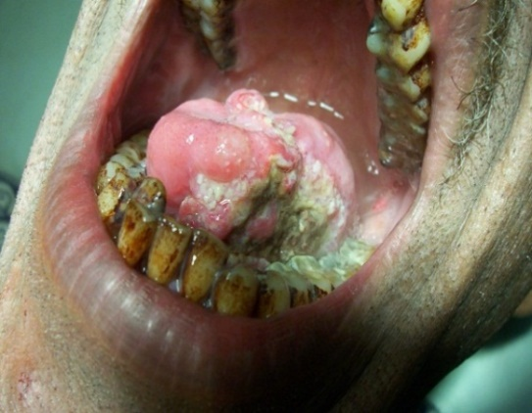
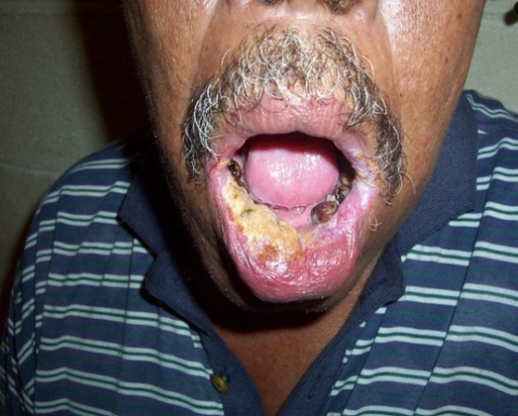
This patient had been a betel nut chewer for 10 years. He had developed a white lesion or patch on his lower lip. This is called “Leukoplakia”. Leukoplakia is a pre cancer lesion. The lesion will go away if the chewer stops chewing betel nut but if he continues, cancer will develop. Photo: C. Kuma

This patient was a betel nut chewer for many years. He has end stage mouth cancer affecting the tongue and the floor of the mouth on the left side. There was also history of associated cigarette smoking. Photo: C. Kuma

People who chew large amounts of betel nut on a regular basis may become dependent on it and may experience withdrawal symptoms if they stop chewing. The withdrawal symptoms are generally mild and include:
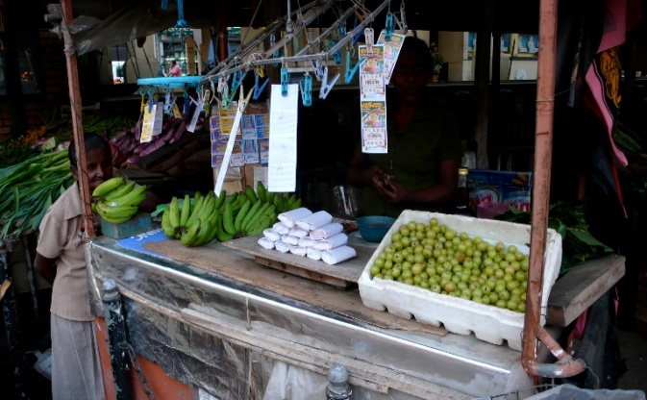
- ______________________________
- ______________________________
- ______________________________
- ______________________________
- ______________________________
- ______________________________

Betel Nut and Diabetes
Many Pacific Islanders believe that betel nut helps control ______________. A study conducted in Papua New Guinea in 2002 revealed that Betel nut in actual fact, ______________________________________ in those who suffer from the disease. Based on the balance of evidence, betel nut is a contributing factor to ___________________________ control in diabetic patients and may even contribute towards the _____________________________ of diabetes in chewers.

Death from Betel nut chewing
Betel nut chewing is a _____________ _________________. Mouth cancer from betel nut chewing kills approximately __________ people every year in Papua New Guinea according to the PNG Medical Society. In the Solomon Islands, mouth cancer cases are on ________________. Statistics reveal that approximately _____ people die from mouth cancer every year in the _______________ ____________. Mouth cancer from betel nut chewing is now the ____________ ________________ cancer affecting the male population in both Papua New Guinea and Solomon Islands.
Apart from its significant contribution to the development of _______________, ____________ and ______________ __________, betel nut chewing with lime contributes to _______________________, ___________ of the ____________ and ___________ and ____________of the ______________ and _____________________. It also contributes to the development of acute ______________ and ___________________________________ (stomach ulcer) in chewers.

Betel nut chewing and Public Health and hygiene
Betel nut chewing is a major health issue not only as it relates to specific clinical diseases but also in terms of public ________________________________. The betel nut spit from chewers significantly contributes to a ____________________________________________. Red stains along streets, on walkways, and walls of building convey a very unsightly picture of our towns and communities and reflect an ______________ of _____________________. Additionally, rubbish from betel nut dumped around urban centers, in homes and villages contribute to the spread of ____________________________________.

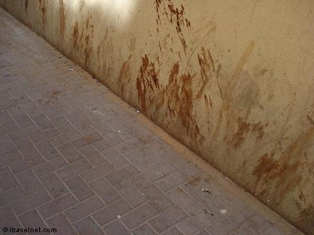
Betel nut chewing is a dirty habit. Chewers spit all the time and are not conscious of where they spit. A lot of our streets in towns and cities are stained by the red betel nut stain. This situation paints a negative picture about people’s attitude towards cleanliness and the environment. Photo: C. Kuma

Conclusion
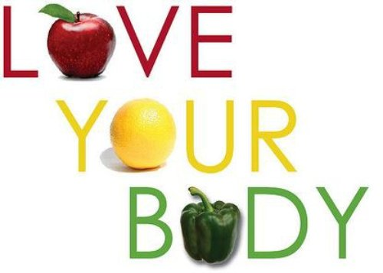
Scripture clearly states that our body is the ____________________ (1 Corinthians 3:16, 17). We are to take good care of it and not introduce ___________________ into it that can cause damage. Betel nut chewing is often regarded as a cultural practice. What we need to be reminded of is the fact that there are certain cultural practices in the South Pacific that are clearly _________ ____________________ and should be ______________________. Betel nut chewing is one such practice. We are responsible for the maintenance of our ________________ and God will hold us ______________________ for how we care for and respect our body and our environment (1 Corinthians 6:19, 20)

MARIJUANA
Marijuana is an illegal and a dangerous drug made from the plant called __________________ and it is available almost everywhere in the Pacific. Marijuana contains _____________ _______________________, 61 of which are found in _______________________ ____________________. Delta-9-tetrahydrocannabinol (THC) is the main ingredients or chemical which is believed to be responsible for the _______________ __________________ that marijuana gives. Others include Cannabidiol and Cannabinol (CBN).
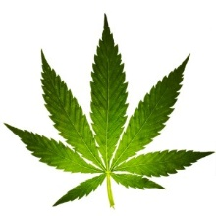
Other Chemicals in Marijuana
- ___________________________________
- ___________________________________
- ___________________________________
- ___________________________________
- ___________________________________
- ___________________________________
- ___________________________________
- ___________________________________
- ___________________________________
- ___________________________________

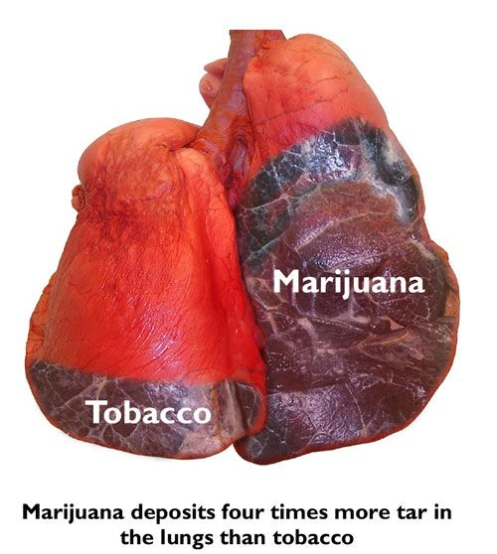
EFFECTS OF MARIJUANA
The prolonged use of Marijuana has serious effects on the body systems including the organs of the body. ______________ is usually the end result.
- __________________________: Marijuana suppresses or __________________ the body’s ______________ __________________. It interferes with the ________________ ____________ that destroys _______________________________. Therefore users are vulnerable to ___________ such as ________________, __________________, etc.

Marijuana deposits more tar in the lungs than tobacco because users breathe deeper to inhale the smoke and hold their breath longer.
- ______________________________________: It interferes with the ______________ _____________________________ of the respiratory system by destroying tiny hair like structures called ______________ lining the ______________________. Because of this marijuana users are vulnerable to lung problems such as ___________________. Also, marijuana contains more than ______________ complex hydrocarbons some of which are known to cause _____________________________ in the lungs. With continued irritation these growths can result in ___________________________.
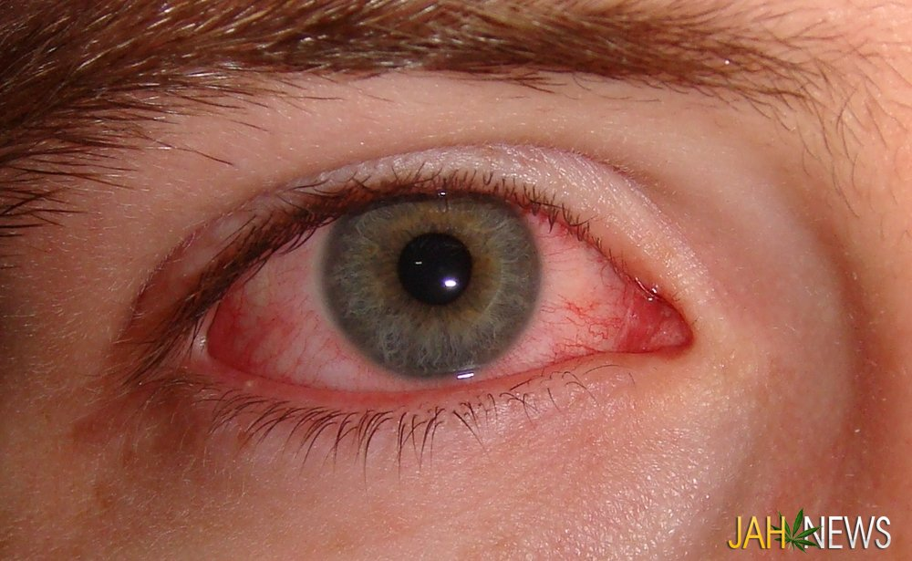
- _________________________________: Marijuana increases the ________ _______. This increased stress on the heart can cause severe ________ _________ in those with narrowed __________ ______________. If you have, ________ _________ ________, _____________________, or a family history of ________________, marijuana is risky for you. It also ____________, or enlarges the ______ _________________, resulting in a decrease in _________ ___________. This is specially seen in the user’s ____________ _______, because the tiny blood vessel in the eyes ___________ and become large enough to be ____________ - that is why some marijuana users try to hide their eyes by wearing sunglasses. It also increases blood pressure and causes an __________________._______________________.
Blood shot eyes of a Marijuana user
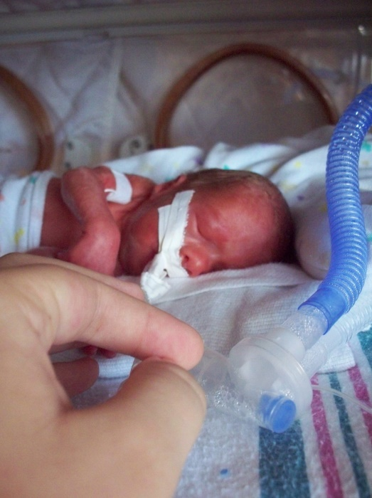
- ___________________________________:
- In males, Marijuana reduces the male sex hormone called ________________ and can affect sexual function and _________________________. It reduces the number of sperm produced by the __________________. Sperm will not be as _____________ (active) as the normal sperm cell and will not be capable of ____________ an egg. The likelihood of _______ ________________ is greater in Marijuana users because of the risk of ______________ __________________.
- In females Marijuana seems to reverse the effect it has on men - _____________ ________________. This causes women to develop body ___________, _______ __________ and ______________. It also disrupts normal __________ ________ and may interfere with ___________________. It also can interfere with the development of the _______________. There are high chances of birth defects and _____ ____________ _____________ babies and a greater chance of ____________________. Breast feeding mums can pass active Marijuana poisons in pure form to their infants and __________ _________ _____ ______.
A drug effected premature baby.
Marijuana affects the nervous system in a big way
Marijuana has serious effects on the brain by interfering with the function of the brain cells called the __________________________. It therefore affects how we _______________ and ____________________________.
Marijuana impacts our ________________________________________________________.
Behaviour
Appearance becomes _________________. Start missing school or work. You will back away from your ______________________________________, and become isolated. Your thinking becomes _________________. You don’t care much about anyone or anything.

Performance
Your skill on the job slips. Your boss wonders why your work is full of mistakes. You have trouble __________________ __________________. You can’t seem to make passing grades in school. Your reactions slows considerably, and you become a danger to others. _______________________ _________________________________.

Personality
You become _________________ and _______________ of others. Your moods swing widely from _________________________________. Often, you are _________________________. You lose the ability to deal with everyday problems. Now and then, you suffer a ________________________. Your ________________________, ______________________ and _____________ all slip away. You are now a marijuana burnout.

DISSCUSS the real life article on the next page, found in the Baltimore. Although humorous to read, how frightening must it have been for Binns! What does this sort of insight do for those who choose to smoke weed to ‘be cool’ or to ‘look tough’? Do you know of any stories that support the above points?

MR. BINNS TRIES HASHEESH
From the Baltimore Sun, March 6
A well-dressed young man, who gave the name of Binns, came to the City Hospital. He yielded to a strange desire to enjoy a dose of hasheesh, a drug that produces curious results. He told the doctor that he had some doubts as to the locality of his face, which to him seemed situated at least two feet from where it really was. Then he was dubious whether he had any legs or was simply walking on his chin. The latter idea seemed to have a firm hold on him, for he stamped his feet on the ground a dozen times. His request to be relieved was pitiful. He feared that someone would steal an arm or leg from him. After medical treatment Binns began to feel better.
How to stop Using Marijuana (for marijuana users)
- First __________________________________________. No matter how popular marijuana is, it is still an _________ ___________. Don’t tempt yourself - __________ ______________________________________________________________________.

- ___________________________________. Talk with a drug counselor, or a mental health professional about quitting marijuana and developing some healthy patterns in your life. Work through _______________________________________________ _____________________________________________________________________

- Getting off Marijuana will be difficult and uncomfortable. _____________________ ___________________________________________, but you should expect to suffer _____________________________, ___________________, ___________________, ___________________, ______________________ and _______________________. Because the active ingredients of marijuana are stored in the body fat, it will take a long time for your body to clean out the effects of marijuana use. You will slowly feel healthy again if you stop. ________________________________________________ ___________________. Clear unclouded thinking may take up to ________________ or so to return.

IT MAY BE HARD, BUT DO NOT GIVE UP HOPE – YOU CAN BEAT MARIJUANA
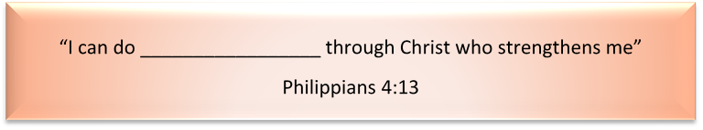

How to keep away from Marijuana
__________________________________. Stay away from people who ______ __________________ marijuana. Don’t get into situations where you think marijuana will be ___________________ – certain parties, some music concerts and particular gathering spots.

Get involved with, ____________________________. Talk openly with them about marijuana use and how to avoid it. Promise yourself and _____________________________________ in your life that you will not use marijuana ever again. You will learn better ways to deal with problems and difficulties you face. Develop _____________________________________ or activities that don’t allow room for marijuana use.

DRAW A STRAIGHT LINE IN PENCIL FROM THE CLUE ON THE LEFT TO THE ANSWER ON THE RIGHT
(Be careful, there may be more than one correct answer!)

Clue | Answer
Waste generated by cells | Infertile
Where gas exchange occurs in the body | Death
Carcinogen | Carbon Monoxide
Addictive compound | Oesophagus cancer
Found in Cigarettes and the sewer | Temple
Hypertension | Psychoactive drug
Marijuana often leaves men | 1 cup
Cilia | Narrowing of blood vessels
Smoking increases this | Kava tablets
A disease caused by smoking | Dilates
Smoking is the numbers one cause of this | Lung Cancer
Also causes lung cancer | Passive smoking
Kava is a | High blood pressure
Kava + Alcohol = | Alveoli
Common problem for a Kava drinker | Depression
May lead to Liver failure | Mucous
Betel nut can cause | Small hairs that line the airways
Immediate effect of chewing Betel nut | Increased blood pressure
A long term effect of chewing Betel nut | Nicotine
Found in cigarettes | Cancer forming substance
Our body is a | Methane
Number of chemicals in Marijuana | Neurons
A chemical usually found in Marijuana | Acetone
Part of the body attacked by Marijuana | Immune system
Marijuana does this to blood vessels | Death of limbs
How much tar an average smoker inhales/year | Carbon Dioxide
Brain cells destroyed by Marijuana | 421
A common withdrawal complaint | Eye problems
SEE ALTERNATIVE
In the table below, in the MATCH column, write the number from A, next to Column 1 that matches with the number from B next to Column 2.
A | Statement – Column 1 | MATCH A with B | B | Item – Column 2
 | Waste generated by cells | 7 |  | Infertile
 | Where gas exchange occurs in the body | 14 |  | Death
 | Carcinogen | 20 |  | Carbon Monoxide
 | Addictive compound | 19 |  | Oesophagus cancer
 | Found in Cigarettes and the sewer | 21 |  | Temple
 | Hypertension | 13 |  | Psychoactive drug
 | Marijuana often leaves men | 26 |  | 1 cup
 | Cilia | 17 |  | Narrowing of blood vessels
 | Smoking increases this | 16 |  | Kava tablets
 | A disease caused by smoking | 25 |  | Dilates
 | Smoking is the numbers one cause of this | 11 |  | Lung Cancer
 | Also causes lung cancer | 12 |  | Passive smoking
 | Kava is a | 6 |  | High blood pressure
 | Kava + Alcohol = | 2 |  | Alveoli
 | Common problem for a Kava drinker | 28 |  | Depression
 | May lead to Liver failure | 9 |  | Mucous
 | Betel nut can cause | 8 |  | Small hairs that line the airways
 | Immediate effect of chewing Betel nut | 18 |  | Increased blood pressure
 | A long term effect of chewing Betel nut | 4 |  | Nicotine
 | Found in cigarettes | 3 |  | Cancer forming substance
 | Our body is a | 5 |  | Methane
 | Number of chemicals in Marijuana | 27 |  | Neurons
 | A chemical usually found in Marijuana | 23 |  | Acetone
 | Part of the body attacked by Marijuana | 24 |  | Immune system
 | Marijuana does this to blood vessels | 10 |  | Death of limbs
 | How much tar an average smoker inhales/year | 1 |  | Carbon Dioxide
 | Brain cells destroyed by Marijuana | 22 |  | 421
 | A common withdrawal complaint | 15 |  | Eye Problems

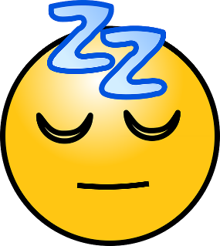
REST AND SLEEP
- Life is busy! Every day seems to come with new demands and problems. Often we find that there is little time to just sit back and relax.

My favourite way to relax is: ____________________________________________________
- Rest and relaxation is very important. In fact, it is ______________________________.
- Rest can come as a short break from hard labour, relaxing in the outdoors or as ___________________________________________ of restful sleep at night.
- Rest replaces weariness, exhaustion and fatigue with ___________________________.
“Come to __________ all you who are ____________ and ____________________ and I will ____________________. Matt 11:28
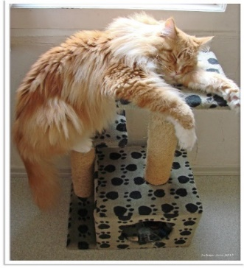
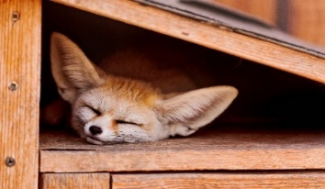
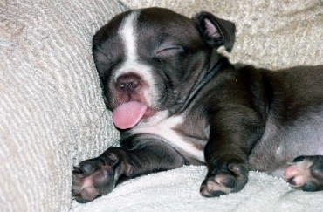

Jesus knew we needed our rest!

What Happens in the Body When We Sleep?
When we sleep, the body __________ __________. In fact, it has been discovered that the ___________________________ actually triggers the type of sleep best for healing. Called “_________________” or ____________________________ it is the deep, restful sleep you need to awaken feeling _____________ and _____________. During this stage of sleep, the body releases a special chemical called __________________. Growth hormone stimulates the growth, repair and replacement of damaged tissues and cells of the body. Growth hormone also stimulates the formation of ____________________ (white blood cells) which are needed to fight disease causing germs - an important step in healing brought about by the immune system. Listen to your body; when you start to feel tired, it may be your immune system signalling the need for healing sleep.

Let us summarize what Sleep is
Sleep is an important form of rest. Sleep has a number of stages to it:
- ____________________ - this is the first ____________________ of light sleep when one is drifting off to sleep from being awake.
- ____________________ - this period lasts ____________________ where a person goes into deeper sleep but bodily movements continue. We lose awareness of our surroundings, the ____________ ____________ ____________ and the brain is doing _________ ___________ ___________________.
- Stage_________________ and ___________________ - these are types of deep sleep.
- Deep sleep is the part of sleep that our body and brain needs to _____________ from _______________. It is sometimes called ____________________ after the delta waves the brain generates. We don't dream during this time. During this stage the body temperature and blood pressure ____________________. This is when the body makes repairs needed by releasing the chemical, growth hormone.
- ____________________ - rapid eye movement (REM) sleep.
After about ______________ rapid eye movement (_________) sleep begins. During this stage there is increase in the contraction of eye muscles, _____________ _______ and _______________________________. Breathing, blood pressure, and temperature all _____________ ____________________. It is during this stage that you may wake up, sometimes remembering a dream. Most dreams occur during this stage. REM or Rapid Eye Movement sleep ___________ the ______________. In this stage, brain activity is __________ __________. During a normal night, people usually cycle through these last stages ___________ _________.

Diagram: Stages of Sleep
Move to stage 2 after ten minutes

Move into stage 5 of sleep 90 minutes after first feeling sleepy
Sleep enters stage 3+4 (after 15 minutes), which is the stage of deep sleep
The sleep cycle

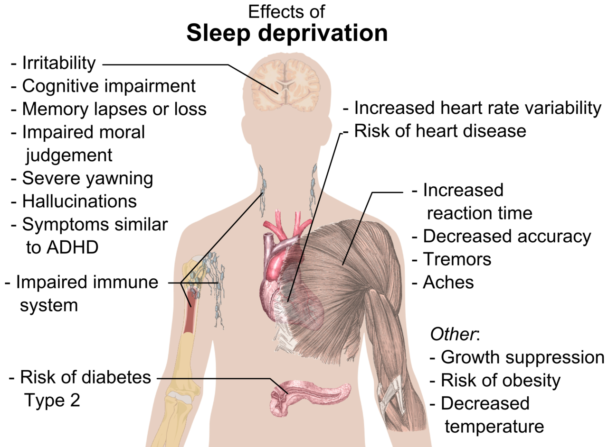

Look at the diagram above. What diseases might someone be diagnosed with that may in fact simply be a lack of good quality sleep? ___________________________________________
___________________________________________________________________________
___________________________________________________________________________
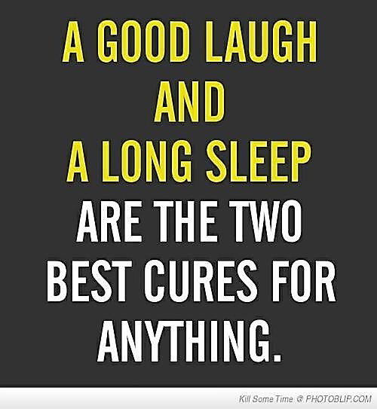
Other complications due to lack of sleep include: _______________ _________________, __________________________ and _____________________________________. Because the ___________________ is affected, a person could develop ________________________, _______________________________ and _________________. Persistent lack of sleep can ultimately lead to ____________________.
Research shows that those who regularly slept 7 – 8 hours each night had lower death rates than those who averaged less than 7 hours or who slept longer. During the day our body experiences “wear and tear” as a result of the work we do. This means tissues and cells in the body get broken down and need replacing. Having adequate rest enables the body to replace the dead cells and injured tissues and rejuvenate itself.

Tips to having better sleep:
- ______________________________________________________________________________________________________________________________________________
- _______________________________________________________________________
- ______________________________________________________________________________________________________________________________________________
- ______________________________________________________________________________________________________________________________________________
- _______________________________________________________________________
- _______________________________________________________________________
- _______________________________________________________________________
- _______________________________________________________________________
How much sleep are you getting each night??
Eight hours of restful sleep each night is strongly recommended
Seven hours is acceptable

God and Rest
It is interesting that God, at the time of creation created light and separated light from darkness and He called the light day and darkness night (Genesis 1: 3 – 5). It is no secret that God wants us to enjoy work and the blessings of labour during the day and enjoy rest during the night and all the benefits that comes with that. And then to bring it all together, He created the Sabbath where we can all ___________________________________________. Rest is indeed a marvellous blessing from God.
Genesis 2: 1 – 3 NIV says: “Thus the heavens and the earth were completed and all their vast array. By the seventh day God had finished the work He had been doing; so on the seventh day He rested from all his work. And God blessed the seventh day and made it holy, because on it He rested from all the work of creating that He had done”.
Section Source: Adventist Health HPCI Documentation (South Pacific Division) 2012

Sunlight
Human beings and plants cannot survive without the beneficial effects of sunlight.
In fact without sunlight, there would be no _____________ or ______________ on planet earth. ____________________ from the sun, _________ ________________ from the air and ____________________ from the environment help plants produce __________________ and _________________ that we need every day. This process known as ____________________ takes place in all green leaves.

The Benefits of Sunlight:
- _______________________________________. The sun can actually alter your mood chemically, alleviate stress and even prevent ______________________________.
- ___________________________________. Sunlight helps our body generate ____________________. This vitamin strengthens our bones and muscles and helps protect us against many diseases by strengthening our body’s defence system.
- ____________________________. Sunlight not only kills germs on our skin, but it also kills germs on your clothes, bedding, mats, mattresses and cushions that you put out in the sun to dry. Germs like growing in dark, dirty, damp places – so _____________________________________________ and let the sunshine in!
- __________________________________________. The ________________ gland is a small part of the brain that produces chemicals called ____________________. One type of tryptamine is called ____________________ and this keeps the body clock working properly so that we know when it is night and when it is day – it gives us a sense of the time and seasons. This is all due to the suns actions on the brain.
- _________________________________. It’s almost as good for the heart as exercise! Both lowers the _________________________________. Sun also tends to normalise ____________________ and helps the blood carry more _______________________. Sunlight enhances the ________________ ________________ and increases the number of white blood cells that protect us.
- _______________________________________. Not only does sunlight kill germs, but it even helps to prevent certain types of ____________________.

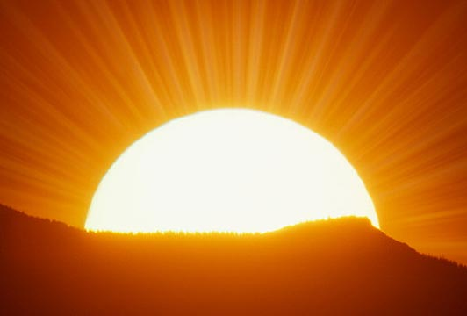
Dangers of Too Much Sunlight
We are blest in the Pacific Islands with generous amounts of sunlight to keep us healthy and strong. Too much sunlight on the other hand can be bad for you. It is important to realise that as with everything else, too much of one thing can make a person sick.
Problems that can develop due to too much exposure to sunlight
- ____________________ – sunburn occurs quite frequently in fair-skinned people such as Caucasians and Polynesians. It is rare in dark skinned people
- ____________________ – when the sun is too hot, people can faint and fall. Heat stroke is not uncommon
- ____________________ – excessive exposure to sunlight increases the risk of a person developing skin cancer especially in fair skinned people such as Caucasians / Europeans. Skin cancer is a very common cancer in countries like Australia. Skin cancer is fortunately rare in the countries of the South Pacific
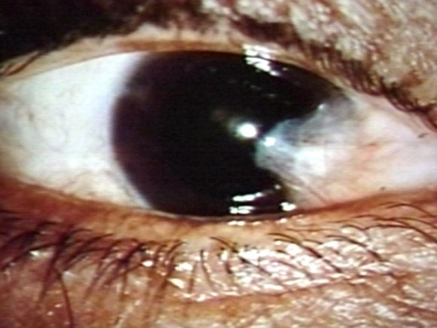
- ____________________ - exposure to too much sunlight increases the risk of a person developing cataracts - the world’s leading cause of blindness. A cataract is a cloudy or opaque area in the lens of the eye
Pterygium
http://www.tedmontgomery.com/the_eye/eyephotos/Pterygium.html

- ____________________ - is a fleshy tissue that grows in a triangular shape over the front of the eye ball. It may grow large enough to interfere with vision. This is a very common problem in the Pacific Islands because of our exposure to excessive sunlight.

Water

We often hear people say “drink plenty of water every day.” We read health posters saying “drink 8 glasses of water every day” and we might wonder why they are saying to drink that much water! The answer is simple: water is critical to life. Water is a complex substance that is vital for our physical existence. Without water, life as we know it ______________________________________________.
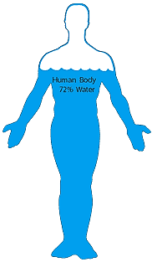
The
body is
approx-
imately
72%
water

Water is one of the most abundant elements in nature. The surface of the earth is approximately _____% _______________. The human body is approximately ______% ____________________. This translates into approximately ______________________________ and slightly less in a female. A loss of just _____% of _______________ through diarrhoea for example, can kill a person. That is how important water is to all of us.

Water’s effect on the body
- Water contributes to the overall ________and ________________________________. A dehydrated man would have ___________________. ____________________ _________________________ and would be sick looking.
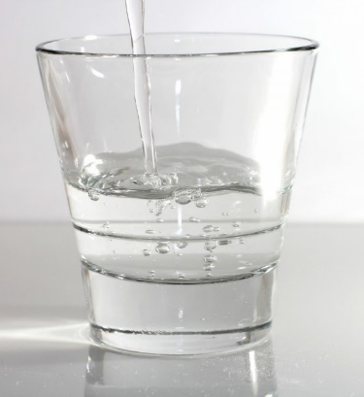
- Water is the main ____________________ medium of the body. _____________, _______________________ and important body chemicals are all transported throughout the body through water found in the _______________. In fact, Blood is _____% __________. Nutrients such as _________, ____________, ______________, and __________________ are absorbed into the blood from the digestive system and are transported to all the ____________________. Waste or unwanted products produced by the body are transported to the _______________ in the same way and are removed ______________________________.
- Numerous lifesaving ___________ _______________ that occur in the body occur in the ____________________. These chemical reactions keep us ____________. Without water, these chemical reactions could not take place. Lack of adequate amount of water in the body can seriously affect or hinder these important chemical processes from taking place. This can lead to __________________ and even _______________.
- ____________________________________________. Water transports heat from the _______________ of the body to the _________________ where it can be released into the external environment through ____________.
- _____________________________. Water helps in the breakdown of foods into small particles that can be _______________ and then absorbed into the blood. In addition, water aids in ____________________ and helps prevent ____________________.
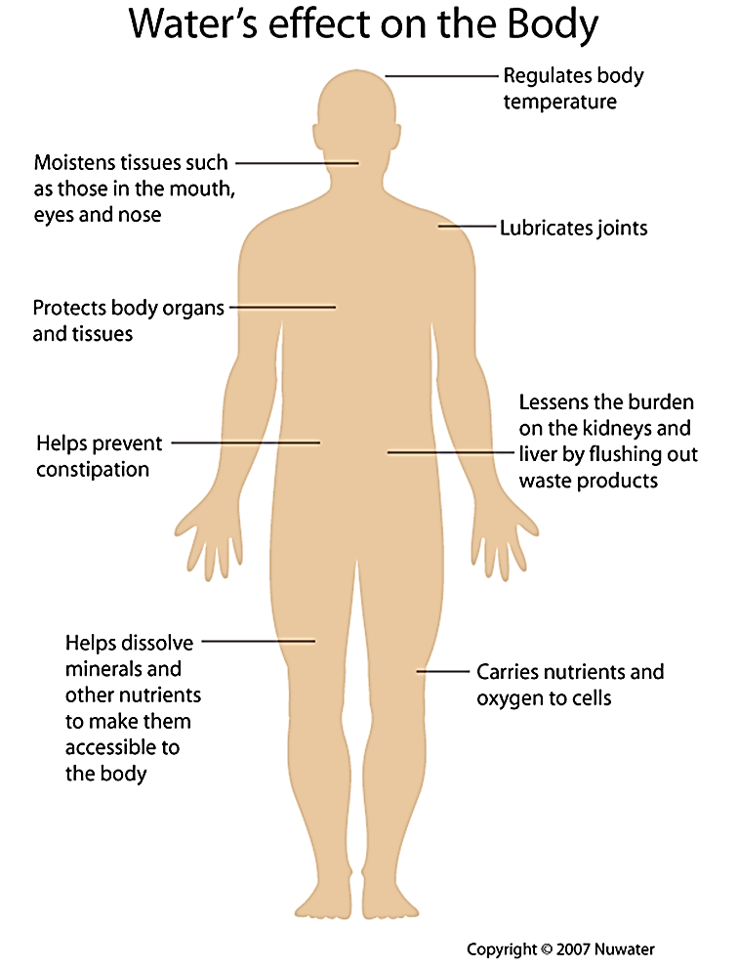
- Water helps to __________ __________ for easy, free ____________________. Water in the brain called “Cerebral spinal fluid” __________________________ and “amniotic fluid” (water in the pregnant uterus) protects the ____________________ in the mother’s womb. In addition, water moistens tissues such as _________, __________ and ____________.
Ministry of Healing p237
“In health and in sickness, pure water is one of heaven’s choicest blessings. Its proper use promotes health”

Water is vital in all body functions - http://www.nuwater.ca/

Internal use
Drinking
Our body is 70% water. Water cleanses our _________________________, it helps to transport and remove __________________________________ it enables important _______________________ to take place and enables the blood to ____________________ through the action of the heart. A loss of 5% body water can make a person very sick. A loss of 10% body water can kill a person. An average person needs to drink at least ____________________ every day to maintain normal hydration. Lack of an adequate amount of water in the body is called ____________________. Common causes of dehydration include: ____________________________________________________________________.
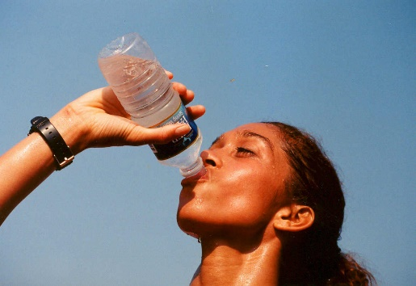
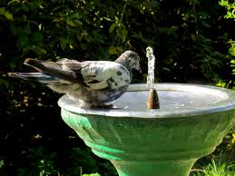
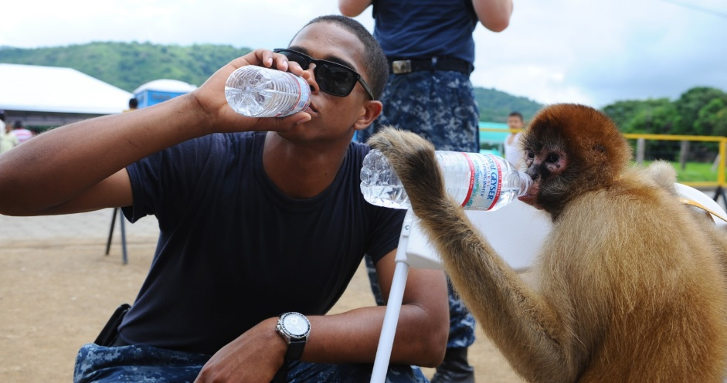
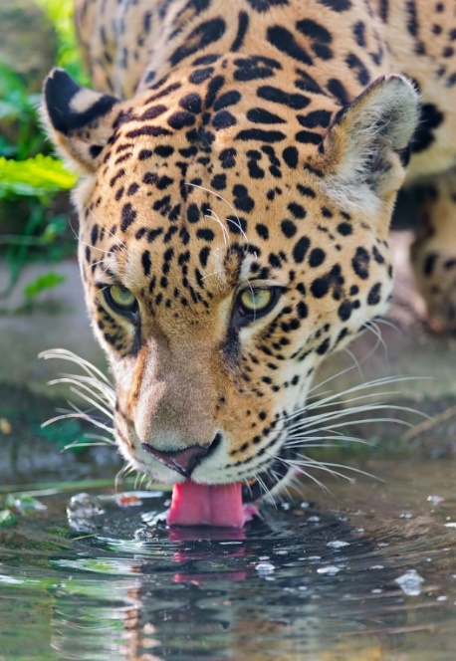
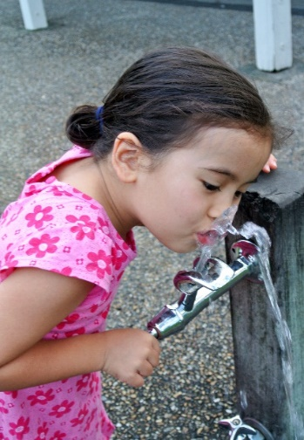
Nothing beats a cup of cool refreshing water. Unfortunately many people today replace water with _______________________________________________________. Water is the juice of life. Pure, clean water ______________________________________. Make water your favourite beverage because water is what your body really needs.
All of God’s creatures need water to survive

External uses
Bathing/Shower
It is important that we have a shower at least ____________________ in the morning and evening. Regular cleansing of the body protects us from all kinds of ____________________ including ____________ and _____________ diseases and ensures that you smell right. Cleanliness is important. Keep your ________________, _____________, ______________, _____________________________. A clean body and environment promotes health.
- ____________________ - water is used for cleaning and washing purposes. Clothes need to be washed with soap ______________. Eating and cooking utensils should be ___________, ____________ and ________________ or covered after every meal. Unwashed eating utensils can ____________ _________________. Anything that is dirty can be washed with water for cleansing. These are good practices that help to ____________________ us from a wide range of diseases.
- ____________________ - water is used for cooking purposes. It is essential that clean water is used at all times.
- ____________________ - water is a good ____________________ and can be used in many ways to help alleviate illness. For head ache sufferers, put your feet in a nice ____________________. A cold wet face cloth placed on the ____________________ and forehead at the same time as having the foot bath is helpful. Continue topping up the footbath with hot water until head ache eases. Finish by pouring a ____________________________________ over your feet before drying.
Daily water loss
We constantly lose water every day. This is called “daily water loss”. It is lost through the following ways:
- Through Skin: ____________________.
- When we breathe in and out (respiration) ____________________.
- Through Urine ____________________.
- Through Sweat ____________________.
- In faeces ____________________.
When we add the numbers up we get to a figure of ____________________. This is the total amount of water we lose over a 24 hour period. We replace this loss by drinking adequate amount of water.
How much water should we drink?
The best way to maintain the balance is to drink at _________________________________ – the cup used should hold at least 250mls of water.
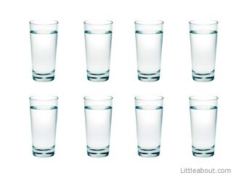
- 2 cups of water an hour before breakfast
- 2 cups of water before lunch (10am)
- 2 cups of water at around mid-afternoon (3pm)
- 2 cups of water before going to bed.

One simple way of checking whether you are taking enough water is to look at the ____________________________________________ - if it is clear and you are passing good volume of urine then your hydration is good, but if it is brownish in colour and you are passing only small amounts than you need to drink more water because you may be dehydrated.
The Need for Extra Water
The body needs extra water when there is excessive loss:
- The body needs extra fluids or water in situations where there is excessive sweating. This may be due to ____________________ or ____________________. In both these situation there can be excessive loss of body water.
- Anyone who has _________________ or _____________________ can lose a lot of body water. Children are particularly prone. Anybody with diarrhoea must drink plenty of water. If a person does not drink enough water, and is vomiting at the same time then they must be taken to the hospital for an intravenous drip – which is water being introduced straight into the ____________________ in the form of a saline solution.
- Vomiting is a common medical problem but it can be a sign of some important underlying disease processes both in children and adults. A lot of body water and some special minerals from the body called ____________________ are lost when a person vomits or has diarrhoea. Replacing the water is crucial.
Healthy Tips

Alcohol
Alcohol is everywhere - in shops, in little canteens and even in very remote villages of the South Pacific. There are many reasons why people drink alcohol…they say it makes them ____________________ or it makes them _________________________________________. Some even take it thinking that it is good for their health; THEY COULDN’T BE MORE WRONG! The truth of the matter is alcohol is a powerful addictive ______________ and it ______________. In fact, Alcohol kills about ____________________ around the world every year. It kills through ____________________ and by _________________________________.
What is Alcohol?
In order to understand alcohol's effects on the body, it is helpful to understand the nature of alcohol as a chemical, so let's take a look:
Here are several facts:
- Alcohol is a clear drink that is made from _____________________________________.
- Alcohol is produced by several methods but the most popular is ___________________.
- Alcohol is a ________________________________________________.
- It is less dense and evaporates at a lower temperature than water (this property allows it to be ____________________. By heating a water and alcohol mixture, alcohol evaporates first).
- Alcohol ____________________ easily in water.
- Alcohol is ____________________ (so flammable that it can be used as fuel).

The alcohol found in alcoholic drinks is _______________ __________________ or ____________________ the molecular structure of ethanol looks like this:
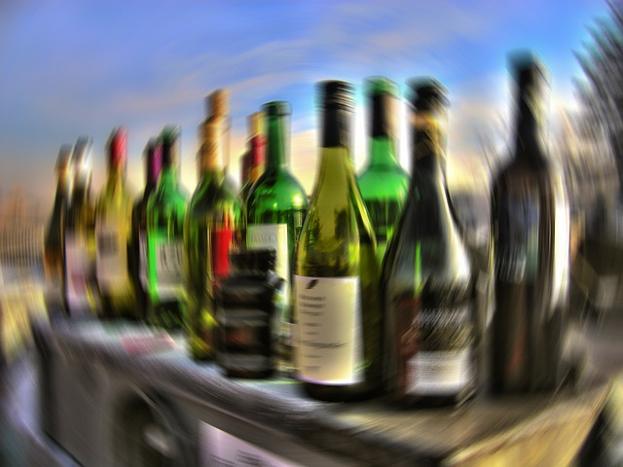
____
______________ ____

Alcoholic drinks come in various categories and with various brand names. Examples include _________________________________________. They all contain ethanol in different _____________________________________.
For example:
Beer contains approximately 4% to 6% of ethanol (average of about 4.5%)
Wine = 7% to 15% (average of about 11%)
Champagne = 8% to 14% (average of about 12%)
Distilled spirits (e.g. rum, gin, vodka, whiskey) = 40% to 95%.
In the South Pacific, illegally brewed alcoholic drinks such as “home brew” and “Kwaso”, developed from fermentation of yeast are found almost everywhere. These are considered to be illegal and dangerous.
How Alcohol enters the Body
When a person takes alcohol, about ____________________ of it is absorbed into the blood from the ____________________ and about ____________________ from the small intestines. How fast the alcohol is absorbed depends on several things:
- _____________________________________________ in the drink - the greater the concentration, the faster the absorption.
- ________________________________________ - carbonated beverages tend to speed up the absorption of alcohol.
- ________________________________________ - food slows down alcohol absorption.
When alcohol is absorbed, it enters the bloodstream and the blood carries the alcohol throughout the body. Alcohol in the blood then enters the tissues of the body. Once inside the tissues, alcohol exerts its effects on the body.
How Alcohol leaves the body
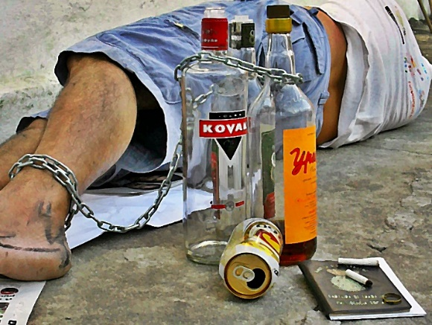
Once absorbed into the bloodstream, alcohol leaves the body in three ways:
- The __________________ eliminates _____ of alcohol in the urine
- The __________________ exhale _____ of alcohol when breathing out
- The _________________ chemically breaks down the remaining __________ of alcohol into carbon dioxide and water.

The Effects of Alcohol
The observed effects of alcohol depend directly on the ___________ ___________________ ________________________ (BAC), which is related to the amount of alcohol a person drinks.
Most of us have seen someone who has had too much to drink and we notice the way they perform and behave. The body responds to alcohol in stages, and that corresponds to an increase in blood alcohol concentration (BAC):
- Euphoria (BAC = 0.03% to 0.12%)
- They become more self-confident or daring
- Their attention span shortens
- Their judgement is not as good - they may say the first thought that comes to mind, rather than an appropriate comment for the given situation
- They have trouble with fine movements, such as writing or signing their name.
- Excitement (BAC = 0.09% to 0.25%)
- They become sleepy
- They have trouble understanding or remembering things
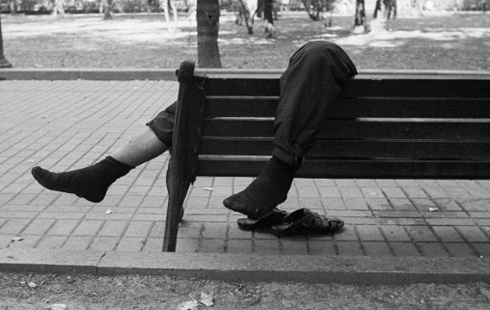
- They do not react to situations as quickly (if they spill a drink they may just stare at it)
- Their body movements are uncoordinated
- They begin to lose their balance easily
- Their vision becomes blurry
- They may have trouble sensing things (hearing, tasting, feeling, etc.).
- Confusion (BAC = 0.18% to 0.30%)
- They are confused - might not know where they are or what they are doing
- They are dizzy and may stagger
- They may be highly emotional - aggressive, withdrawn or overly affectionate
- Their ability to make right choices and decisions is severely affected
- They cannot see clearly
- They are sleepy
- They have slurred speech
- They have uncoordinated movements (trouble catching an object thrown to them)
- They may not feel pain as readily as a sober person.

- Stupor (BAC = 0.25% to 0.4%)
- They can barely move at all
- They cannot respond to stimuli
- They cannot stand or walk
- They may vomit
- They may lapse in and out of consciousness.
- Coma (BAC = 0.35% to 0.50%)
- They are unconscious
- Their reflexes are depressed (i.e. their pupils do not respond appropriately to changes in light)
- They feel cool (lower-than-normal body temperature)
- Their breathing is slower and more shallow
- Their heart rate may slow.
- They may die.
- Death (BAC more than 0.50%) - The person usually stops breathing and dies.

DISCUSSION QUESTIONS: (Share your thoughts on these with the class)
  - In Australia, the limit Blood Alcohol Concentration limit for driving is 0.05%. Would you agree that it is safe to drive at that limit? If you could, would you raise that limit? Why or why not?
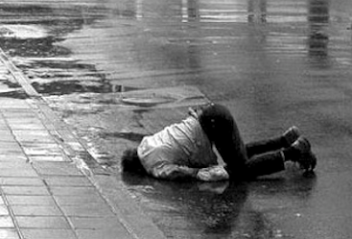
  - Have you seen a very drunk person? Which BAC level do you think they were operating at?
  - I once witnessed a young lady who had drunken too much alcohol stand up at a train station and urinate. As the urine was running down her legs and pooling around her nice, quite expensive shoes, I asked myself: ‘if people drink because they think it makes them look and act cool, did it work for this poor lady’? Have you seen anyone act in a terrible way when they were drunk that would disgust them if they were sober? Remember these when you are tempted to follow the crowd into having alcohol to drink and choose to stay in control!
  - Looking at the side effects of the different BAC levels, why do you think it’s important as a Christian to stay away from Alcohol?

Problems Caused by Alcohol
Alcohol impairs ____________________ and ____________________ functions
Alcohol is clearly both ____________________ and ____________________. There are many adverse ____________________ and ____________________ effects resulting from exposure to alcohol. The following are a few examples:

____________________.
Alcohol can lead to serious liver damage called cirrhosis of the liver. Prolonged alcohol consumption is usually the cause of this.
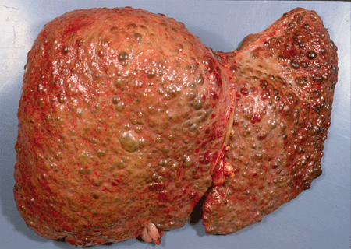
http://www.olympus-sis.com/en /6900_6927.htm
Alcohol destroys liver cells and gives rise to a very hard and irregular liver tissue. Patients with cirrhosis of the liver are very sick people.

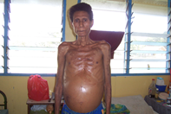
Patients with alcoholic liver cirrhosis lose a lot of weight, develop big swollen abdomen and yellow eyes because the liver cannot perform its work effectively. Photo: C. Kuma

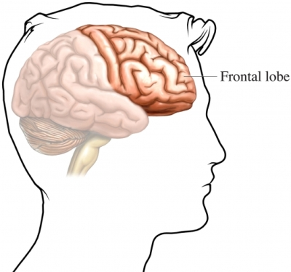
Alcohol’s Effect on the Brain
Alcohol interferes with the function of the __________ ________ and eventually ____________________ them. Especially affected are the _________________________. The frontal lobes enable us to make ________________, _____________, __________________ and ________ ____________________. The brain is the seat of our _______________________________________________. It is also regarded as our ____________________ centre. Alcohol interferes with all these important functions.

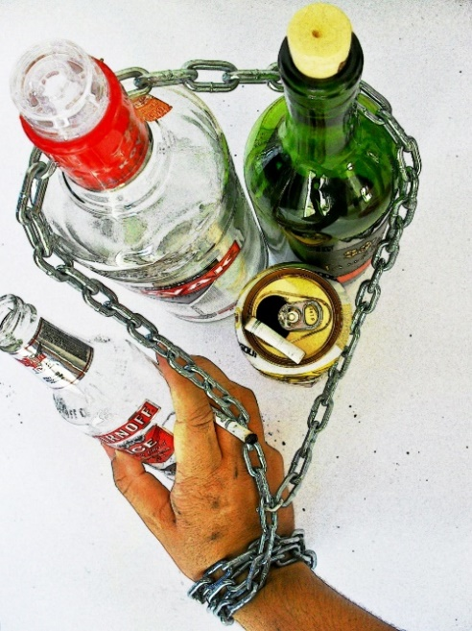
Drinking alcohol can lead to confusion, disorganization, lack of inhibition, impaired ability to learn new things, memory loss and permanent brain damage.
“Wine is a ____________________ strong drink is ____________________ and whosoever is deceived thereby is ____________________.
Proverbs 20:1
Stomach and Intestines: _________________________
_____________________________________________
_____________________________________________
Alcohol and the Heart: __________________________
_____________________________________________
_____________________________________________
_____________________________________________
_____________________________________________
Alcohol and the male Sex-cell (sperm):
___________________________________________________________________________
Alcohol and the developing foetus: _____________________________________________
___________________________________________________________________________
___________________________________________________________________________
Alcohol and Nutrition: ________________________________________________________
___________________________________________________________________________
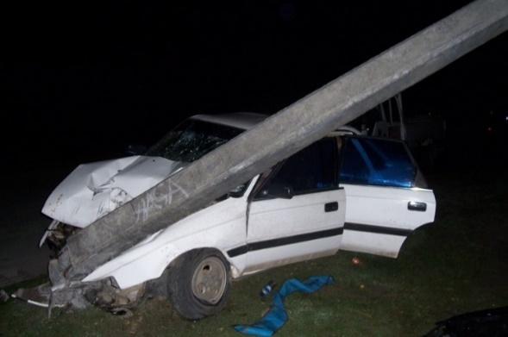
Alcohol and Accidents: ___________________
Photo: C Kuma
______________________________________
______________________________________
______________________________________
______________________________________
______________________________________
______________________________________
Alcohol and Cancers: _________________________________________________________
___________________________________________________________________________
Social Impact of Alcohol: ______________________________________________________
___________________________________________________________________________
___________________________________________________________________________
PAY ATTENTION!!
Alcohol is one of Satan’s most powerful weapons to destroy lives today. He makes it look so attractive with the aim of enticing people into the habit of drinking. He gets them addicted, breaks up their family, steals their money, robs them of their integrity and eventually lands them in a hospital bed either as a result of an accident or a diseased liver, heart or cancer. Alcohol can snap out a life so suddenly. DON’T LET IT BE YOURS!!!
Ellen White Comments on Social Impact of Alcohol
“Every year millions upon millions of gallons of intoxicating liquors are consumed. Millions upon million are spent in buying wretchedness, poverty, disease, degradation, crime and death. For the sake of gain the liquor dealer deals out to his victims that which corrupts and destroys mind and body.” Temperance p28
Alcohol abuse has destroyed more lives, broken apart more families, caused more diseases and contributed to more auto car accident fatalities than any other drug in the world. And it is the major contributing factor in the growing epidemic of domestic violence.

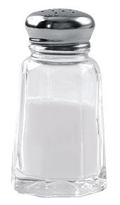
Salt
Most people love salt. We use salt every day – in our cooking. Salt is one of the ___________________________ and the most important _________________________________________ in human history.
What is Salt?
Salt comes in different forms but the most common is ___________ ______________. This means that iodine is added to the salt you buy from the store and every time you add salt to your food, you’re taking in salt plus some ____________________ which protects you from developing ___________ or ________________________________.
Chemically, salt is comprised of two important electrolytes or ions namely _________ (_____). and _______________ (_____). Both these electrolytes are needed, in only ______________ by all living creatures including humans. They are responsible for several important body functions including __________________________ and ____________________ in the body.
How much salt does the body need on a daily basis?
The body only needs a ____________________ of salt on a daily basis. To be more specific, the body only requires about ____________________ of salt a day – not two or three ….only one teaspoon of salt! But BEWARE: Most of the salt you intake will be __________ in the food you eat. Sauces, processed foods, soups, stocks and takeaway foods are all commonly _________________________________________________.
What are some risks associated with salt?
Salt raises the _______________________________. Too much salt can give rise to high blood pressure or ____________________. How much salt are we consuming today? The answer is about ____ or _____ times ___________________________. We are seeing a huge increase in _______________, _____________ and ______________________________ as a direct result of this behaviour.
- Did you know that ____________________ eating a ____________________ will develop high blood pressure before they are considered to be ________? This is because the western diet uses a lot of salt! Almost all processed foods we buy from the shops have ____________________________. Evidence shows that eating a low salt diet ________________________________.
- High blood pressure, caused by salt, contributes to ____________________ because of the harm it does to blood vessels. Once kidney damage has occurred, high blood pressure accelerates further damage and can lead to ____________________.
- High salt intake may play an important part in the development of ____________________. A High salt diet irritates the lining of the stomach and can result in long term ____________________ and the development of stomach cancer
- A high salt diet can lead to the _________________________________________.
- Having too much salt can contribute to ____________________________ a condition known as ____________________________________________.
- Obesity: When we eat too much salt, we can get very ____________________. Where thirst is relieved with ___________________________________________________, it will also contribute to weight gain.
How does salt increase blood pressure? As the salt content of our blood increases, kidneys retain more water to try to keep the salt concentration balanced. This extra water increases the volume of blood in the blood vessels resulting in increased or high blood pressure.

Why is this so bad for our Health?
- High blood pressure puts a lot of strain on the ______________________________ and can lead to significant damage to these structures. This can lead to ____________________ and can increase our risk of having a _______________ or _________________.
- High blood pressure ____________ the size of the blood vessels. Because of the increased pressure, ____________________ become ____________________ and ____________________. When this happens, the blood flow is ____________________ and organs receive less ____________________. Ongoing high blood pressure is the leading risk factor for ____________________. . High blood pressure is also the second leading cause of chronic ___________________________________.

Ideas to reducing your salt intake
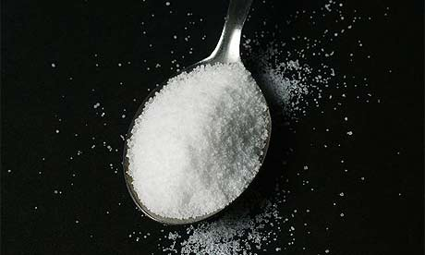
- __________________________________________
Your body only needs about one teaspoon of salt a day.
__________________________________________
- __________________________________________
__________________________________________
- __________________________________________
______________________________________________________________________
- ______________________________________________________________________
- ______________________________________________________________________
- ______________________________________________________________________
- ______________________________________________________________________
COMMUNICABLE DISEASES
Achieving Good Health
Good health is not merely the absence of disease; it includes the _________________, ____________ and _______________________ of individuals and communities. Thus, to achieve the goal of providing health for all, health improvements in a community should not simply be targeted at reducing disease, but also to address ___________________________________________________________________________.

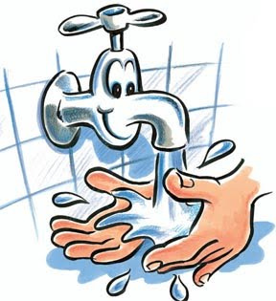
Factors that Influence Health
Factors that influence health can be grouped as follows:
- ___________________________________________.
- ___________________________________________.
- ___________________________________________.
- ___________________________________________.
- ___________________________________________.

Environment - The environment includes both the ____________________ we live in and the _________________________ of the community - both significantly ____________________ health. The physical environment plays an important role in many ways. For example a clean environment can prevent the _______________________________ and may even re and ____________________ all benefit health by removing disease risks from human contact. A dirty environment, by contrast, ______________ the spread of disease and may also adversely influence the __________________________________________________ of individuals.

Equally important is the _________________________. When the home environment is dirty, ____________________ can still easily spread through a family and on through the rest of the village. Poor housing quality can lead to ______________________________ resulting in early _______________________ or ____________________ resulting in ____________________. The ____________________ environment also has a major impact on health. If people are marginalized because of __________________________ they are more likely to be prone to ____________________ and ____________________, and to suffer other mental health problems. In particular, the status of women in the community is important. In communities where women are ____________________ they are more likely to suffer both physical and mental ill health. By contrast, in communities that live in ____________________ accept differences and promote ____________________ through dialogue, the people would usually be healthier.
DISCUSSION QUESTIONS
- How do you feel when your belongings are unorganised and messy? Does it affect you or your performance at school at all?
- When a group of people ignore you (such as family, friends, church family, or sporting team), how does it make you feel? If it continued, could you imagine it impacting your health? How?
- Are you good at conflict resolution? What do you think is the hardest thing about it? What’s the most successful way that you have found to stop or resolve a fight?
- Have you ever been a subject of discrimination? (You may have been discriminated against because of your race, sex, age, religion etc.) How did it make you feel? How did you respond? Is discrimination inevitable? Are there any forms of discrimination you think are ok? Discuss.
LINKS BETWEEN FACTORS THAT AFFECT HEALTH
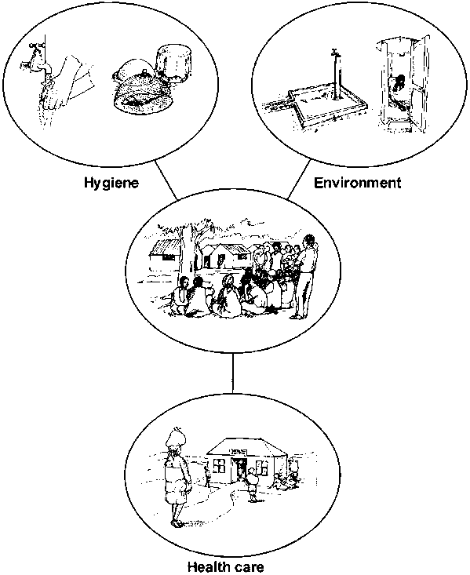
Community cooperation
Our environment (e.g.: standard of water supply, and sanitation), hygienic practices, health care and community participation and cooperation, all impact on health in a significant way.

Awareness of health issues - The awareness of individuals about health is important to promoting a ____________________. If people do not understand the causes of ill-health or sickness and how they can improve their health, they cannot make decisions about ___________________________________ to improve their village. Such awareness should be developed in all areas that influence health because the different influences are often ________________________________. Unless people accept the fact that they need an __________________ __________________________ and ___________________________, investments aimed at improving health may have only ____________________. It is also essential that community members are aware that improvements in their environment such as hygienic practices need to be ____________________ to achieve long-term benefits. Both community leaders and governments play an important role in developing this awareness.

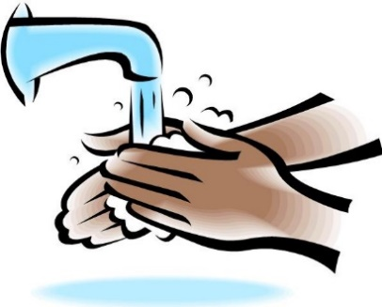
Personal hygiene - Personal hygiene is ____________________ for improving health. For example, if injuries and minor cuts are not __________________ they may become ____________________ and lead to further ____________________. And even though water supplies and sanitation facilities may be constructed in a community, unless people use these facilities properly and ____________________, __________________________, _________________________, _______________________ diseases caused by poor water and sanitation may still exist.

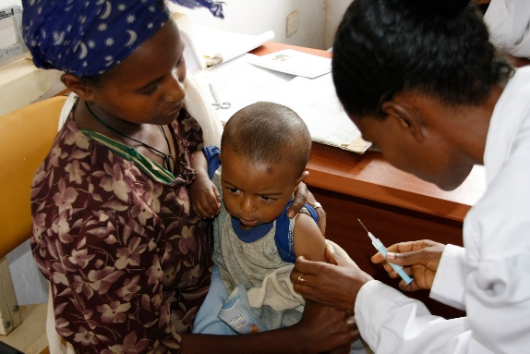
Health care – All people suffer from diseases at some point in their lives and may need to seek _________________ and ____________. Small children in particular may be prone to illnesses that can be ____________________. . In all cases, health outcomes are profoundly affected by whether ____________________ are available to the people. _______________________________________ should therefore lobby national and regional service providers to establish health care facilities as ____________________ to the communities as possible.
Vaccinations are an easy and very important way to prevent diseases in a community.

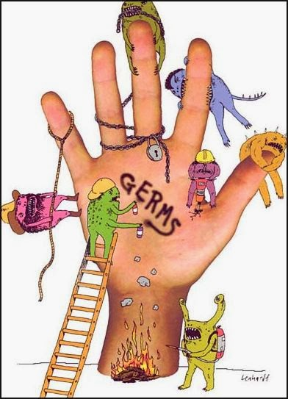
Faecal–oral diseases – Many diseases are caused by ____________________________ that are contaminated by _______________________. Human waste (faeces) is usually one of the main sources of ____________________. Diseases caused by these germs are called ____________________ because _________________________________________. Some of these diseases include ____________________, ______________, _______________ and _____________ __________________. These are responsible for much sickness and deaths each year. Many infectious diseases are spread through _____________________________________________ and many epidemics start with the consumption of _____________________________________ or from drinking ____________________. Good quality water and good personal hygiene helps with ____________________ and are therefore of utmost importance in preventing the spread of these diseases.
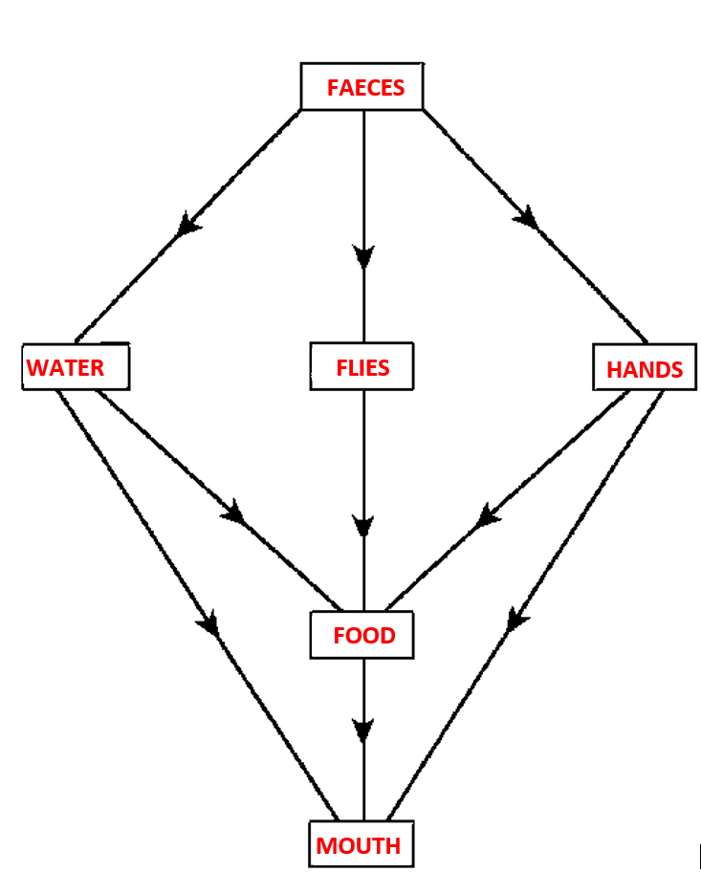
We don’t always realise how easily contaminating human faeces can be. Our hands, our water supply and eventually our food can be very easily contaminated with faeces, and flies which are everywhere, can be a constant source of faecal contamination of unprotected food. This diagram illustrates the faecal-oral route of disease transmission.

Vector–borne diseases – Vector borne diseases are diseases spread by __________________ such as ____________, ___________, ______________, ______________ and ___________. In the south pacific, vector borne diseases include ______________, ___________, ______________, ______________ and _______________. These diseases place a heavy burden on individuals as well as ____________________ and are often closely linked to the ____________________, their ____________________ (e.g. sleeping without a mosquito net) and their ____________________________________________________. Communities can make substantial contributions towards making their villages healthy by properly ______________________________________________ and by using simple vector control principles such as ____________________________, ___________________________ and ____________________.
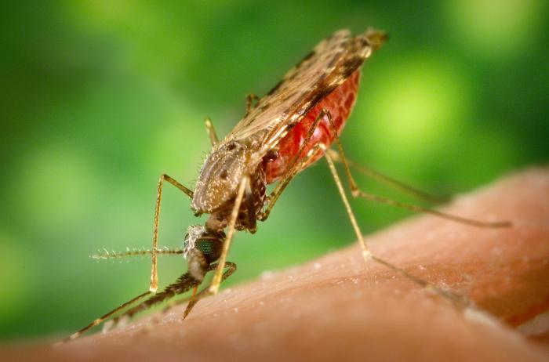
Malaria is an important vector-borne disease in the South Pacific. It is transmitted by the anopheles mosquito. This is a picture of the anopheles mosquito.
See: http://www.mustreads. info/10-deadliest-insects/.

Source
- Healthy villages: A guide for communities and community health © World Health Organization 2002.
- www.who.int/water_sanitation_health/hygiene/.../healthvillages/en/

Personal, Domestic and Community Hygiene
Looking at the pictures below, describe how each item can and must be used to benefit the health of an individual, family or/and community.
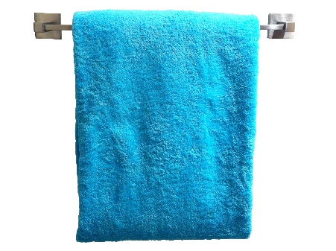
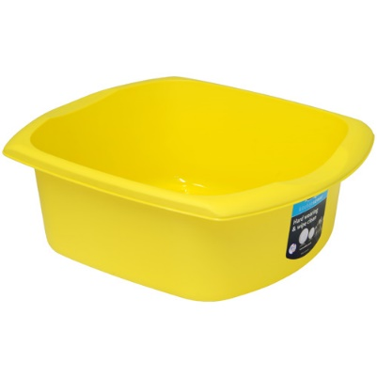
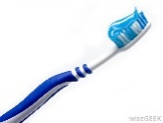
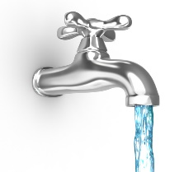
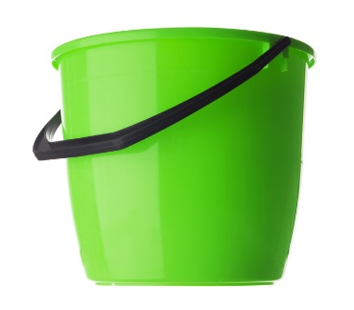
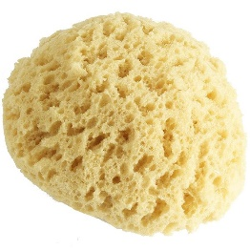

Good hygiene is an important barrier to many infectious diseases. Let’s look at the different ways we can improve our Hygiene.

Personal and domestic hygiene
Handwashing
Proper hand washing is one of the most _____________ ways of preventing the __________________________. Germs cannot be __________ on hands, and _______________ is not always sufficient to remove them. Soap is a _____________ and _______________ agent when used with water and can be used to kill germs on ____________________. Correct technique: Lather your hands with soap for the time it takes to sing your local “birthday song” (about 15 seconds) and then rinse with clean water. Dry hands with clean cloth if available (moist hands can breed bacteria – but so can a dirty towel/cloth. Paper towel that is discarded after one use is ideal).
Wash your hands with soap and water:
- ______________________________________________.
- ______________________________________________.
- ______________________________________________.

All education programs need to make sure the community ____________________ how important it is to keep clean.
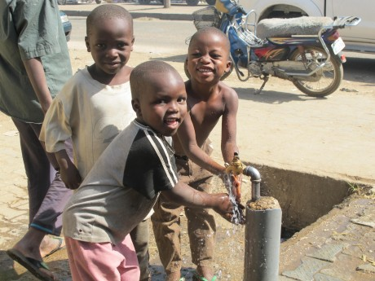
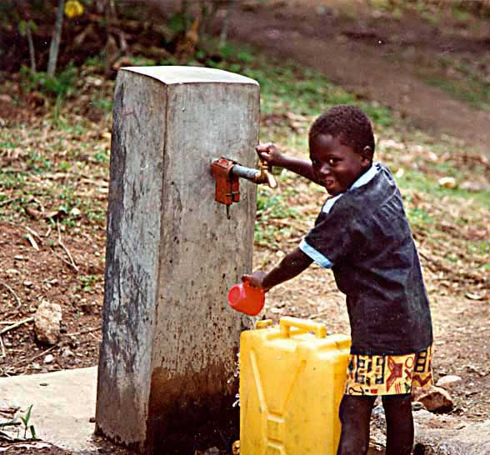
One way to encourage regular hand washing is by providing suitable hand washing facilities located near toilets and kitchens where they will be needed most.
Water stand pipes located near toilets can encourage people to wash their hands after using the toilet.

If running water is available, the facilities should include ______________________________. If running water is not plentiful, a bucket fitted with a tap is a simple way of providing hand washing facilities; the larger the container, the less frequently it will need filling. Another approach involves a suspended container that, when tipped, pours water onto the hands of the user. The system can easily be made from plastic cooking oil containers. Soap itself can be kept clean by _______________________________________________________________.

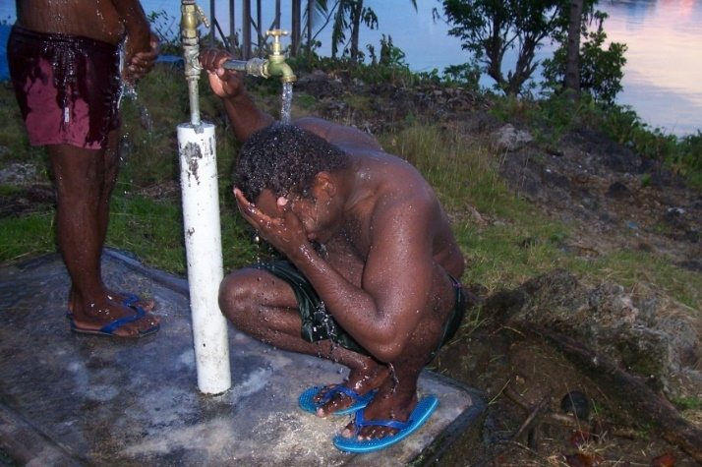
Bathing
Regular ___________ and ____________ of __________________are important practices for cleanliness and good personal appearance and hygiene. They also help prevent poor hygiene-related diseases such as ___________________, __________________________________. Health promotional activities can encourage people bathing more and washing their clothes more regularly. However, ______________________________________ of washing facilities and locating them conveniently may be an effective improvement.
Bathing with ____________________ is an important means of preventing the transmission of disease. For people to bathe thoroughly they must use ____________________ , but it may be difficult to promote the use of more water for washing if water supplies are _______________ and water must be collected by hand. Also, traditional bathing practices do not use water ________________ and ensuring cleanliness may be difficult. By changing existing practices, such as encouraging the use of ___________________________________ it may be possible to improve the efficiency of water use.
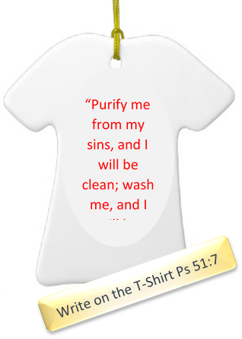
A lot of water can be wasted by using the method of bathing illustrated in the picture above. Using a bucket can lessen water wastage. This is especially important in areas where water is scarce. Photo: C. Kuma

Laundering (washing of clothes)
To promote regular washing of clothes and bedding, ____________________________ can be constructed near water points. They should be large enough to wash bedding and other bulky items and be situated so that water ____________________ from the laundry area and away from the water source. In many villages in the Pacific, laundering is done in nearby rivers or streams and that is fine as long as it does not con-taminate_____________________________________.
The important thing to remember is that regular washing of clothes is important for ________________________.
Community Hygiene
Some corrective health measures can be undertaken only by the community as a whole; these include:
- ______________________________________________.
- ______________________________________________.
- ______________________________________________.
- ______________________________________________.
- ______________________________________________.
- ______________________________________________.

Individual community members can play an important role in community hygiene, and have a responsibility to their ____________________ and to the __________________________ to promote ____________________ and a ______________________________. For example:
- Everyone in the village must keep their _________________________________ because one dirty house can affect many health conscious neighbours and contribute to the _________________________________.
How do you think this would happen? _____________________________________
_____________________________________________________________________
_____________________________________________________________________
_____________________________________________________________________
- Community leaders can promote cleanliness in the home by ____________________ on village households and by using rules (____________________) to encourage household ____________________.
What sort of rules do you think community leaders should enforce? List five of the most important ones. ________________________________________________ __________________________________________________________________________________________________________________________________________________________________________________________________________________________________________________________________________________________________________________________________________________________________________________________________________________________________________
Markets
Markets often represent a health hazard because foodstuffs may not be stored properly and the markets may lack the basic services to ensure a hygienic safe environment.
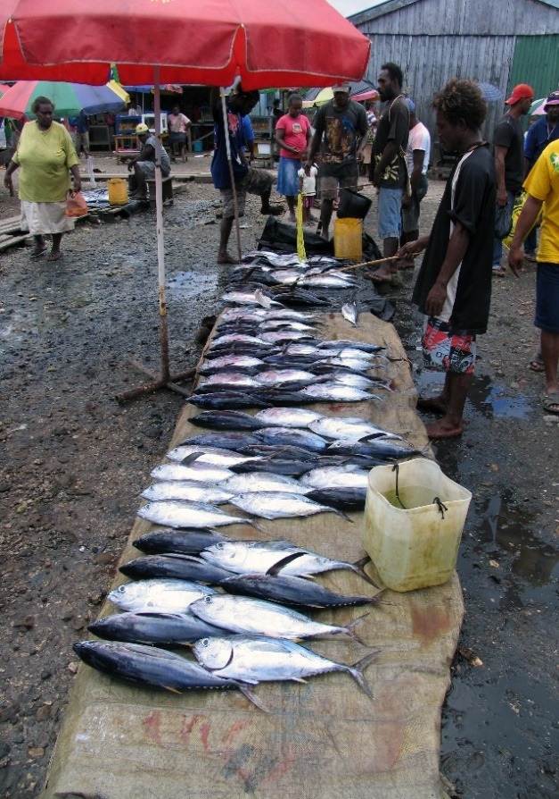
- Several ___________ should be available to provide traders and customers with ready access to ____________________ and _____________________________.
- Sufficient toilets need to be provided; both ____________________________.
- Food sold at the markets should be inspected ________________ by health officials. This is particularly important for ________________________________.
- To prevent ______ and ______________ from feeding and breeding, solid waste needs to be ____________________. This needs to be done at least ____________________. Strategically located ____________________ or even concrete bunkers, can make this more effective. Market areas also need to be properly _________________ to prevent ______________ and __________________________________.
- Markets function most effectively when they have a ____________________ that runs and coordinates them. With proper legal status and recognition from the village council, markets can ______________________ and attract ____________________. Money collected as fees can be used for ___________________________ within the market itself. If markets are held regularly, community members should seek advice and support from local health staff on issues such as___________________, _________________ ______________________ and the ____________________ for those who break rules.

Animal rearing
In many communities animal rearing is a means of ____________________ and for generating __________________________________. However, if it is not practised safely, animal rearing can have ____________________ effects on the health of the community.

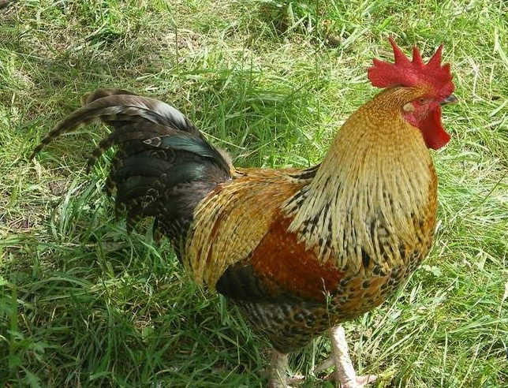
- Animals should always be kept in ______________, at least __________ from households and ____________________ areas, and _______ from _______________ sources, since their wastes contain ________________ that can contaminate food and water
- Animal waste should be ____________________ away from homes and water sources
- It is also best that animals are ____________________ away from households and ____________________________ since animal wastes may introduce contamination
- Animals can transmit disease. ____________________ for example, can transmit germs that can ____________________ and other parts of the body.

Food hygiene
Contaminated food represents one of the greatest health risks to a population.
It is a leading cause of disease ____________________________. Food that is kept too long can __________ and generate ___________________________ and food items that are eaten raw, such as fruits or vegetables, can be contaminated by _________________________. Food not properly prepared can also cause ____________________. For example, cassava leaf that has not been properly pounded and cooked may contain dangerous levels of ______________. To promote good health, food should be properly ____________________.

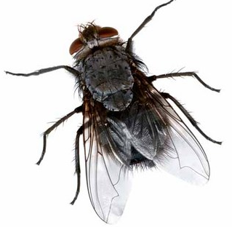
Flies
Flies ____________________. They are attracted to almost anything – good or bad. Flies have many __________ __________ and when they land on dirty things like human faeces, tiny portions of faeces and ________ ____________ get stuck on the hairs on their body. When they land on ____________________________________ such as the _______________ both faeces and germs are deposited. Germs are introduced into the _____________________________ when contaminated food is eaten and the person infected can develop serious illness.
Food preparation in the home
As most food is likely to be prepared in the home, it is important that the family understands the principles of hygiene and know how to prepare food safely.

- Before preparing food, _____________________________________. Raw fruit and vegetables should not be eaten unless they are first ______________ or _____________ with clean water. It is also important to cook food properly, particularly _____________. Both cattle and pigs have tapeworms that can be transferred to humans through half cooked meat; for this reason, _________________________________________.
- Eggs, too, must be cooked properly before eating, since they may contain salmonella: a ___________________________________.
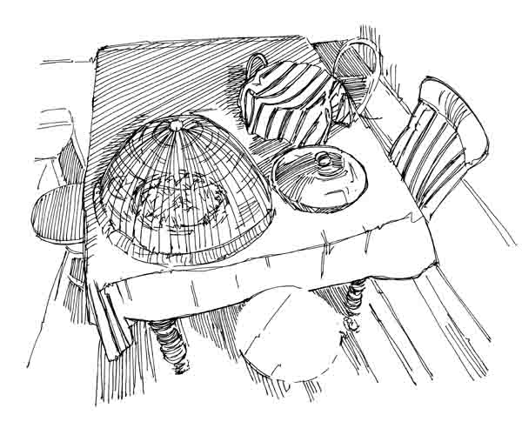
- The kitchen itself should be kept ____________ and waste food disposed of _______________ to avoid attracting ____________________. Keeping food preparation surfaces clean is important because germs can grow on these surfaces and ___________________________.
Always protect your food from flies and insects.

- Fresh meat should be cooked and eaten on the ____________________ unless it can be stored in a ____________________ if not, it should be thrown away.
- Cooked food should be eaten while it is ____________________ and should not be left to stand at ____________________ for long periods of time, since this provides a good environment for disease-causing germs ____________________. Food that is ready to be eaten should be ____________________ to keep flies away and should be thrown away if not eaten within ____________________. If food must be stored after cooking, it should be kept covered and in a ____________________ such as a refrigerator. Food that is already prepared, or food that is to be eaten ________________ must not come into ____________________ with raw meat because meat contains bacteria that can contaminate ____________________.

Some of the riskiest behaviours to personal, family and community health include:
- ______________________________________________.
- ______________________________________________.
- ______________________________________________.
- ______________________________________________.

It is important that the community understands the importance of proper disposal of faeces, washing of hands with soap and water after defecating and the safe storage of food and water. Remember, faeces, dirty hands, flies and dirty or contaminated water are the most common ways in which germs are transmitted.

Source:
- Healthy villages: A guide for communities and community health © World Health Organization 2002.
- www.who.int/water_sanitation_health/hygiene/.../healthvillages/en/
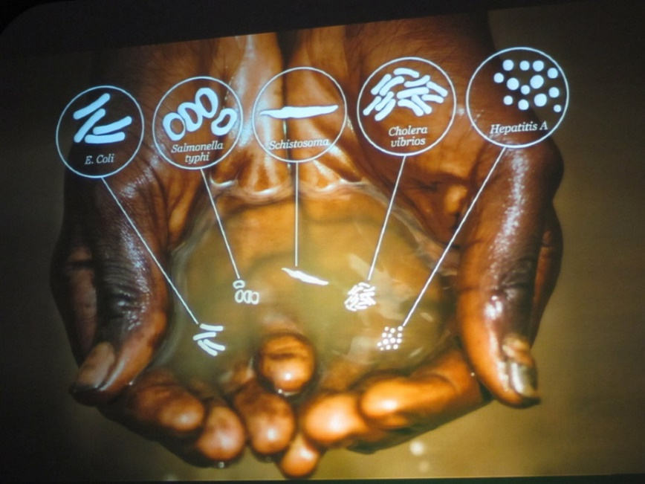

“Dirty water kills more people every year than all forms of violence
including war”
(UN Secretary – General Ban Ki-moon)
Sanitation
What is Sanitation, and Why Does it Matter?
Sanitation is any system that promotes _____________________________________. It includes systems to manage _______________, _________________, _________________ and __________________ and it also includes ensuring that people have _________________ and enough water for ____________________.
What do we mean by "good sanitation"?
Good sanitation refers to the appropriate behaviour and practices of the people living in a specific environment. The people must:
- ______________________________________________________________________.
- ______________________________________________________________________.
Why does good sanitation matter?
Disease epidemics such as __________, _______________ and ____________________ has focused attention on the importance of good sanitation in breaking the cycle of these diseases spread by human excreta.
Poor sanitation
- Promotes the ______________________ - including chronic ____________________, ______________, _______________, _______________ and ____________________. These can lead to malnutrition and stunting, especially in small children.
- Has a major negative impact on the ____________________________ of people within a community.
Sanitation matters for a range of other reasons:
- ___________________________________________________________
- ____________________, through reducing vulnerability to disease and allowing low-income people to ________________________________.
For all these reasons good sanitation is an essential part of community development.
What is needed to achieve improved sanitation?
- Good sanitation is achieved when everyone in a community understands the importance of safe excreta disposal, and takes the necessary practical steps to promote good personal hygiene and public health. This includes access to, and consistent use of, a safe and hygienic toilet
- A sanitation improvement programme starts with a strong local health team that can identify local sanitation-related health problems and work with the community to remedy them
- Key issues are poor hygiene practices, such as open defecation; contamination of water sources; malnutrition caused by worms or ongoing diarrhoea, lack of safe and hygienic toilet facilities, lack of facilities for hand washing and inadequate waste removal
- It is crucial to promote understanding of the linkages between water, sanitation, hygiene and health.

What are the advantages of good sanitation behaviour?
- ______________________________________________________________________
- ______________________________________________________________________
- ______________________________________________________________________
- ______________________________________________________________________
- ______________________________________________________________________

Sanitation, Health and Hygiene
There are six key tasks that face any community setting out to promote improved sanitation:
- _______________________________________ and developing a plan to address them.
- Ensuring effective collaboration between the _________________________________ who have traditionally managed sanitation.
- Ensure that the environmental health service has the ____________________ to work with in communities.
- Often government officers appointed to assist a community with sanitation needs do not have _______________________ and this severely limits their ability to be effective.
- Identifying and organising ________________________________. This includes training in sanitation promotion and in new skills such as community education and research. Visiting successful sanitation projects in other areas is an excellent way of learning.
- Ensuring that ___________________________________________ - either by providing training for village health leaders and other community level workers.

What is health and hygiene promotion?
Without safe hygiene practices, health benefits from better water and sanitation services will be limited. Hygiene promotion has a positive impact on health even without improvements in _____________________________. Hygiene promotion is mostly about changing people’s hygienic behaviour, a difficult and often slow process. It begins with working with local communities to understand their _____________, _______________ and _______________, and raising awareness of the impact of ________________________________. Communities must work with support teams from the local government to plan appropriate remedies.

Hygiene behaviours can be divided into five main areas:
- ______________________________________________________________________
- ______________________________________________________________________
- ______________________________________________________________________
- ______________________________________________________________________
- ______________________________________________________________________

Education about how to maintain and care for toilets is an important part of hygiene education.

Key elements of a good hygiene promotion programme include:
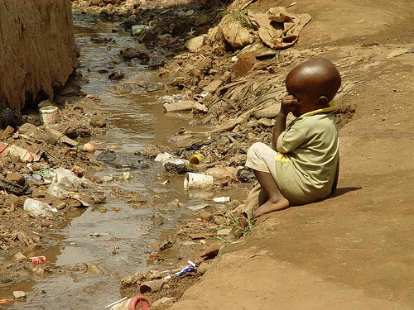
- Close interaction between ________ ____________________ and support teams from the ____________________ to identify a specific local problem as the priority target e.g: poor toilet usage
A child in Uganda next to an open sewage drain.
- ______________ ___________________ in identifying problems and needs and in finding solutions for those problems and needs.
- Development of an ____________________ or ____________________ campaign.
- ____________________ of the programme.

The Problem
Safe disposal of human waste (faeces) is very important for ____________________. This prevents environmental ____________________ including our ____________________ and our ____________________. This can be accomplished in several ways, some requiring ____________________ others requiring little or none. Regardless of the method, the safe disposal of human faeces is one of the most important ways of breaking the ___________________________________________________.
Plans for locating _______________________________ and for ____________________ and ____________________ waste, must consider ____________________ issues, particularly as sanitation is usually focused on the household. Human waste (excreta) disposal may be a difficult subject for a community to discuss because:

- ______________________________________________________________________
- ______________________________________________________________________
- ______________________________________________________________________
- ______________________________________________________________________

Proper use of the sanitation facilities can lead to _____________________________. The danger is: toilet use may be abandoned if its construction or location does not meet the social and cultural views of the community and if they are too expensive to build. Within a community, several different sanitation options may be required. This will depend on ___________________________________________________________.

The Solution
Methods for Proper Disposal of Human Faeces
In this chapter will look at a few different methods used in the Pacific Islands to safely dispose of human waste. Each have their advantages and disadvantages so it will be up to the various communities to decide which better suits their wants and needs.

- Simple Pit Latrine
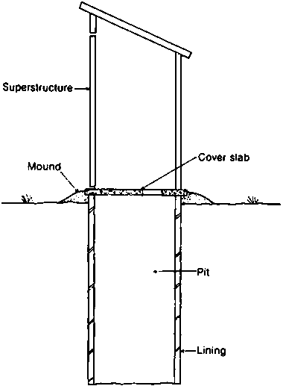
The simplest form of pit latrine is a hand dug pit that is unlined and covered with a series of wooden logs strapped together allowing the user to defecate into the pit.

Seehttp://helid.digicollection .org/en/d/Jh0210e/3.2.2.html

Advantages | Disadvantages

Other types of simple pit latrines
Raised Latrines - When the _______________________________________ or the ground is ____________________ to excavate by hand there is a case for using a raised pit latrine (other latrine types can also be raised although it is more common for simple pit latrines to be raised). One major disadvantage is the __________________________________________ afforded to the users of the latrines.
Slab type – Many types of slabs that can be used for a latrine, each with different benefits. The purpose of the slab is to _______________________________ of the user over the pit, ________________________________ for the user’s feet and _________________________ into the squat hole. A variety of materials can be used such as timber, reinforced concrete and un-reinforced concrete slabs.
Cover – ______________________________ can be the biggest problems associated with simple pits which can be controlled to some extent with a drop-hole cover or stopper.
- Ventilated Improved Pit (VIP) Latrine
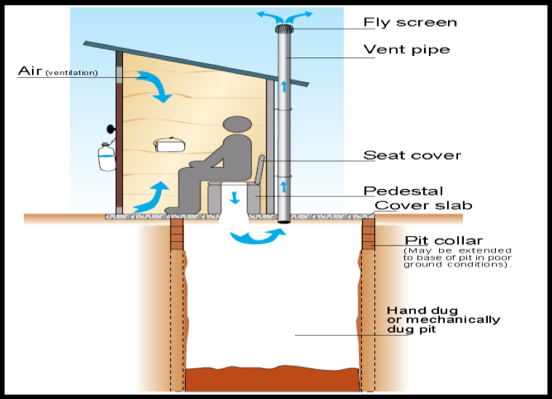
The VIP latrines are similar to simple latrines but the big difference is they have a vent or a chimney that allows bad smell to escape so that the toilet is almost smell free. There are two main reasons for this design and that is to address the problem of flies and smell. VIP latrines enable the flow of air through the system.

http://www.thevossfoundation.org /sanitation-technology-ventilated-improved-pit-vip-latrines/

Advantages | Disadvantages

- Pour-flush Latrine
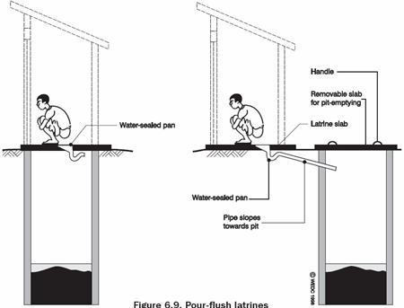
Where water is more widely available or traditionally used for anal cleansing a pour flush latrine may be appropriate and can bring a number of further benefits on top of simple or VIP latrines. A water-seal is created by a plastic u-bend which prevents bad odour and flies affecting the user. The system only requires a few litres of water and so should not put a strain on water resources.
(Source: Harvey et al, 2002)
A pour-flush latrine set over a pit latrine (left) and discharging to an offset pit (right)

Advantages | Disadvantages

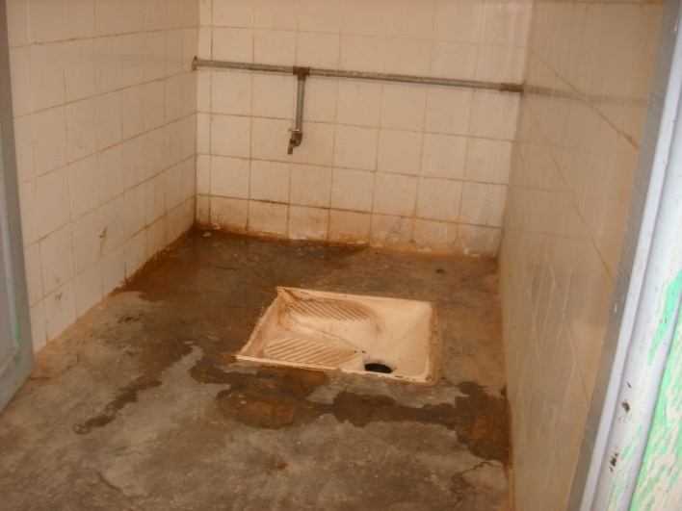
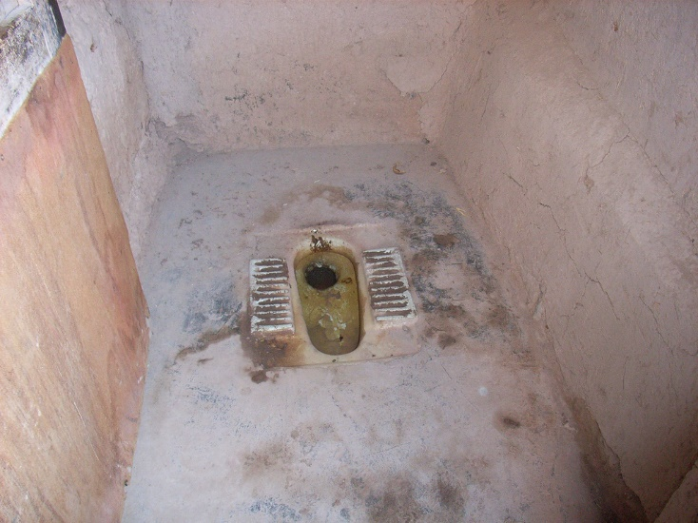

- Septic Tanks
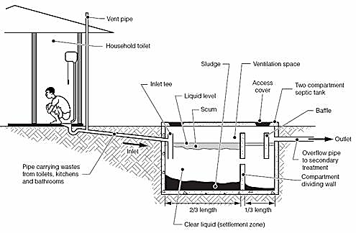
(Source: Harvey et al, 2002)
A septic tank is a water tight tank that typically receives waste from a flush toilet. They are useful in areas with a high water table and when a reliable water supply is present. The system provides some level of treatment to the waste through the separation of solids. The tank will need emptying if full to ensure wastes does not contain unsafe levels of germs and that the wastes does not occupy too high a proportion of the tank. Ideally the effluent from the septic tank should be attached to a sewerage system.
Advantages | Disadvantages
- .

Drainage
There are many reasons why stagnant water and household water needs to be successfully and constantly removed.
- ______________________________________________________________________
______________________________________________________________________
- ______________________________________________________________________
______________________________________________________________________
- ______________________________________________________________________
_____________________________________________________________________
- _____________________________________________________________________
______________________________________________________________________
______________________________________________________________________
- ______________________________________________________________________
______________________________________________________________________

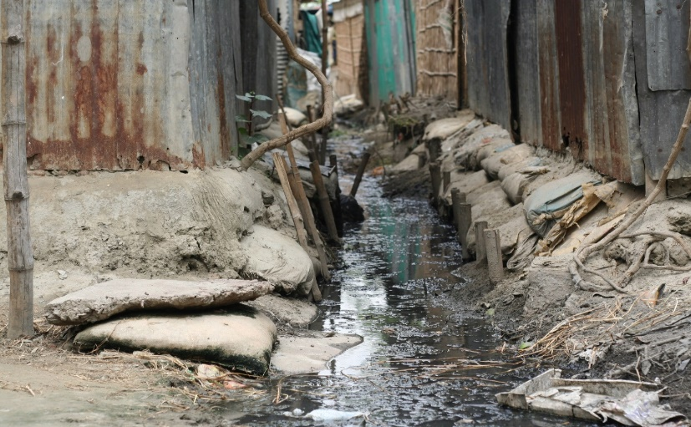

The Solution
- The best drainage system ensures that water flows away __________________.
- Drainage installed by one community should never create __________________________________ for _________________________________.
- __________________________________ should be given adequate attention when planning for drains.
- It is important to know where __________________ occur, or have occurred in the past.
- Storm water drains should collect water from ________________________________ which then leads to a main drain, which then empties itself ______________________.
- The size of the drain should be calculated on the amount of water it would be expected to carry _______________________________.
- Stormwater drains are best constructed using a ___________________________. Earth drains are more likely to become ____________________ and ____________________
- which will cause problems during minor floods. This can lead to the formation of _________________________________ and result in breeding sites for disease carrying insects, like ____________________.
- The drains ____________________ be properly ____________________ and ____________________. It is common to find that new drains become dumps for ____________________ or even ____________________ because of inadequate maintenance. Someone therefore needs to be chosen to be responsible for the maintenance of the drains. However, the best solution is for the community members themselves to ________________________________.
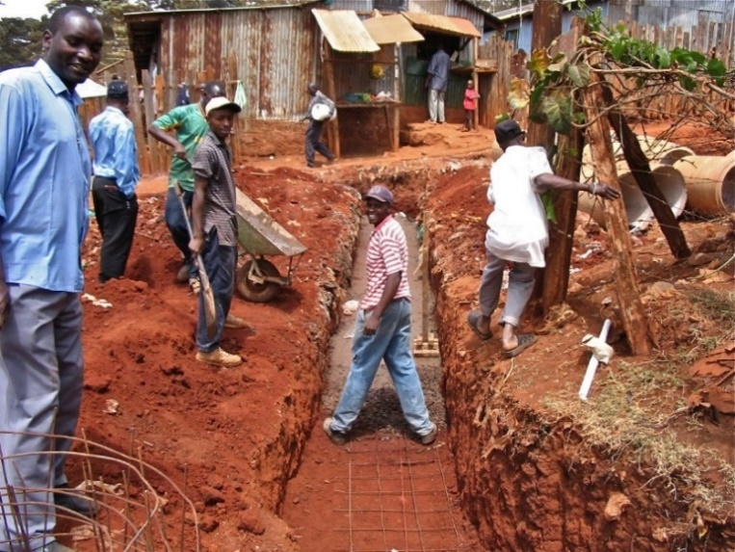
- Village folk may agree to clean the drains in front of their houses ___________________ with ____________________ to be carried out ____________________ a week – Maintaining the drains needs to become part of the daily routine for responsible community members.
Notice community participation in drain construction. Com-munity participation is even more crucial in the upkeep of the drainage system in any village or community.

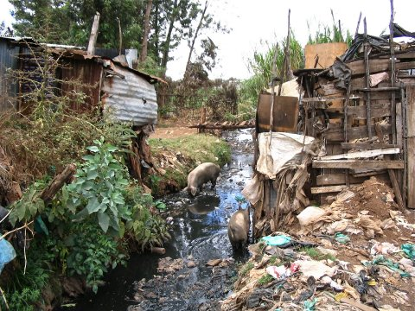
DISCUSSION QUESTIONS
Take a good look at the picture (right).
- What needs to change in this village?
- Why?
- What does it say about those that live in the village?
- In your discussion think about the leaders, the families, the community members, the government, and any church groups.
- Make a list of concerns that need to be addressed.
(NOTE: The small buildings next to the drain are toilets)

Solid Waste (rubbish) Management
Solid waste management
Solid waste means ___________________________________________________________.
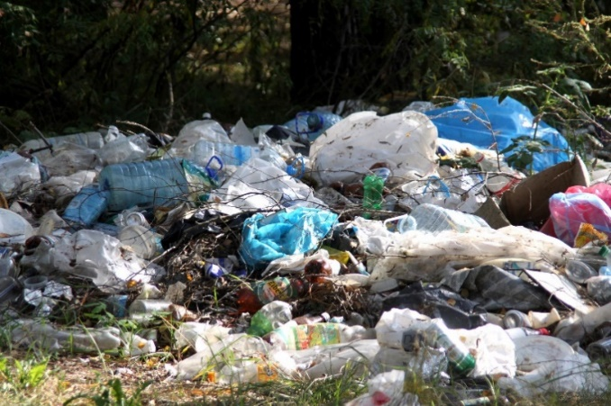
- To keep the household and village environment clean and to reduce health risks, solid waste or rubbish should be disposed of properly.
- Rubbish lying around everywhere is unsightly and smelly and destroys both the quality of the environment and the quality of life in the community. It also provides breeding ground for disease carrying pests such as mosquitoes, flies and rats
- If waste is not properly disposed of, animals can bring it close to the home where children and adults can come into contact with germs
To be effective
- ______________________________________________________________________
______________________________________________________________________
- ______________________________________________________________________
______________________________________________________________________
- ______________________________________________________________________
List the common things in rubbish that can be:
Recycled: ___________________________________________________________________
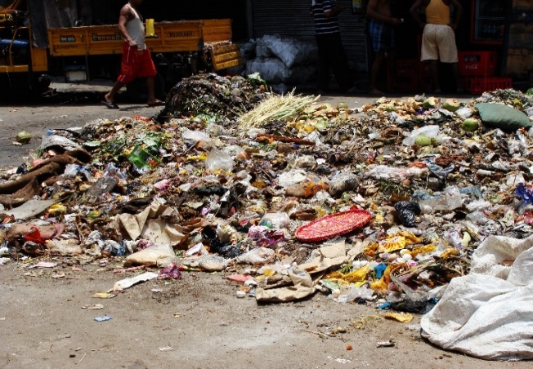
Composted: _________________________________________________________________
Buried: _____________________________
__________________________________
Burned: ____________________________
___________________________________
___________________________________

Housing Quality
Look at the two pictures below. List all the improvements you can see in the second picture in the space provided:
HOME 1
__________________________________________________________________________________________________________________________________________________________________________________________________________________________________________________________________________________________________________________________________________________________________________________________________________________________________________________________________________________________________________________________________________________________________________________________________________________________________________________________________________________________________________________________________________________________________________________________________________________________________________
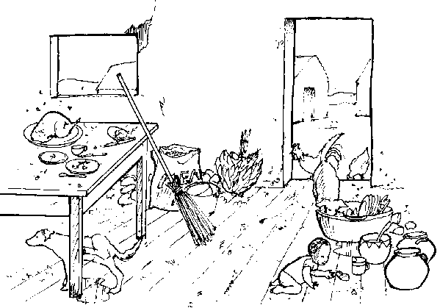
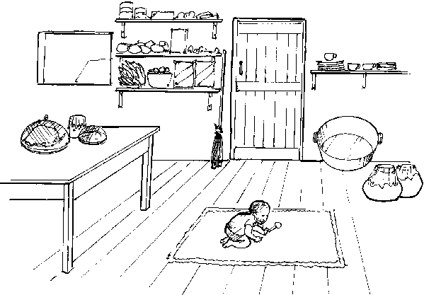
HOME 2

Housing Quality
Good-quality housing promotes ____________________. Poor housing can lead to many health problems, and is associated with ____________________ (such as tuberculosis), ____________________ and ____________________. Everyone should therefore have access to good-quality housing and a pleasant home environment that makes them ____________________________________________.

Characteristics of a dirty house
- ______________________________________________________________________
- ______________________________________________________________________
- ______________________________________________________________________
- ______________________________________________________________________
- ______________________________________________________________________
- ______________________________________________________________________
- ______________________________________________________________________
- ______________________________________________________________________

Characteristics of a clean house
- ______________________________________________________________________
- ______________________________________________________________________
- ______________________________________________________________________
- ______________________________________________________________________
- ______________________________________________________________________
- ______________________________________________________________________
- ______________________________________________________________________
- ______________________________________________________________________

COMMON PROBLEMS ASSOCIATED WITH POOR HOUSING
- ______________________________________________________________________
- ______________________________________________________________________
______________________________________________________________________
- ______________________________________________________________________
_____________________________________________________________________
- _____________________________________________________________________
______________________________________________________________________
- ______________________________________________________________________

SOME SOLUTIONS
- Ventilation
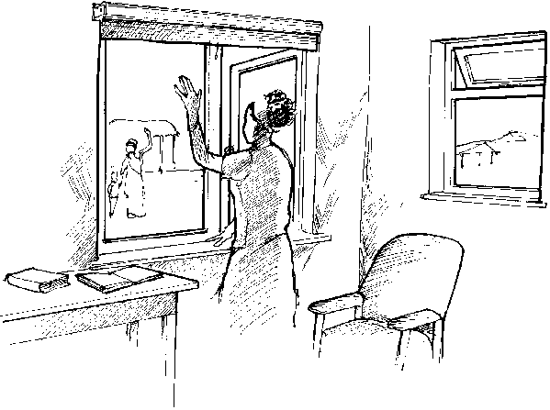
Adequate home ventilation is particularly important where ____________________ are used for ___________________________ since these fuels give off smoke that contains ___________________________. This can lead to ____________________________ like ______________ and ________________, and make tuberculosis transmission easier. Women and small children are particularly at risk from poor ventilation if they spend long periods within the home or around cooking areas. Where cooking is done indoors, it is essential that smoke and fumes be removed from the house ____________________. Ventilation may be improved by constructing houses with sufficient number of _________________________________ particularly near cooking areas. Sleeping with fresh air circulating through the house is very important. It is the time when your body is renewing and recharging and ____________________________ plays a big part in this process.

- Lighting
Poor lighting in a house can lead to ____________________ and increased ____________________. Sufficient natural light, through large, well placed windows, ____________________ and improves the cleanliness of the house (it’s hard to see dust and dirt in a dark home!). Wherever possible windows should be covered with screens for added protection.
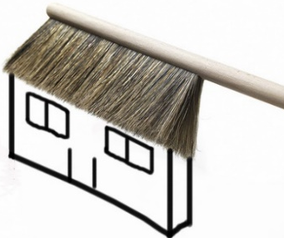
- Clean homes
- Insects like flies and mosquitos can be reduced by _______ _____________ and properly disposing of ______________. A Mosquito net should be used at night if needed.
- Clearing and maintaining __________________ near and around the house will reduce insects ____________________ and entering the house.
- Grass needs to be kept short around the house to reduce ___________, __________, __________, ________, ___________, and ______________. All of which can cause sickness to a family.
- Bed bugs are common in the South Pacific and found in homes that are not ___________________________. They are parasites that feed on _____________. Their bites are irritating and people can develop _________________________ to it. Careful cleaning of the home – scrubbing the floor and bed frames (including all cracks and crevices) and washing, scrubbing and sunning the linen can help _____________________________ this insect.
- Germs like to live in _____________________________ places so keep your home cleaned, dusted, swept, dry and well aired – this will give your family the best chance of great health.

- Overcrowding in homes
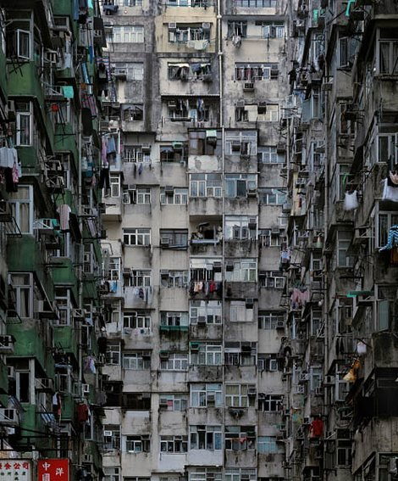
Overcrowding promotes _______ ____________. This is because it makes ________________ easier and contributes to a lot of _________. Disease such as _______________________ spreads very quickly in crowded homes. Overcrowding is related to __________________________ and the __________ often have little choice but to live in cramped conditions. In principle, increasing the number of __________ in a house should improve the ______________ of the people who live there, but increasing house size is often difficult. Careful planning of ______________ _____________ will help in reducing overcrowding. Providing more _________________ to build houses can also allow everyone to have access to houses adequate for their family size.
The Pacific Islands isn’t the only place that struggles with overcrowding. This is a picture of apartments in Hong Kong.
Healthy Village
Many factors determine the health of individuals and the communities in which they live. These factors include:
- _________________________________________
- _________________________________________
- _________________________________________
- _________________________________________
- _________________________________________
- _________________________________________

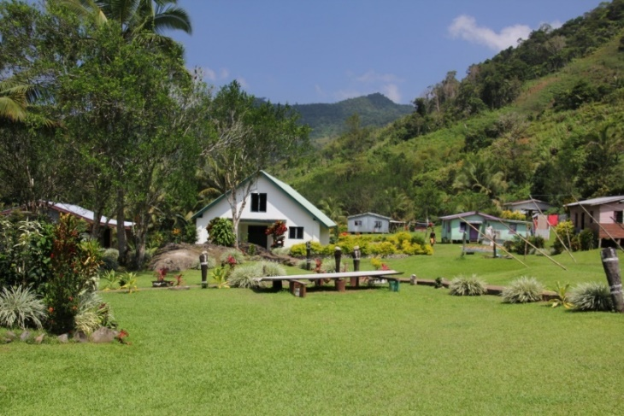
What is a Healthy Village?
A village or a community can be considered healthy when the number of people suffering from diseases is __________ when community members have access to basic services such as _____________ _______________ and _________________________ when the community lives in a ______________ environment and when the people live in harmony with _____________________.
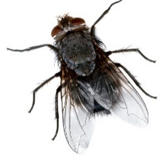
A healthy village is a clean village and where people love to live harmoniously together. There is co-operation and people are willing to work together with their leaders to ensure the community is a clean and healthy place to live. Photo: C. Kuma

Characteristics of a Healthy Community
- ________________________________________________________. A clean environment helps prevent ____________________ E.g.: _______________________________________________________________________ all remove the agents that spread disease like __________________________________ _______________________________________________________________________
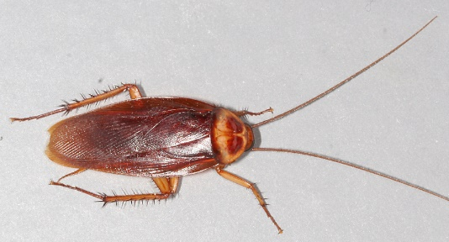

- ______________________________________________________________________. A healthy village should have in place the basic services that people need to be healthy. This includes: __________________________________________________________.
______________________________________________________________________
- The environment promotes social harmony.
There needs to be no discrimination due to ____________________________________ ____________________________________________as this leads to increased anxiety, depression and mental health problems.
- ______________________________________________________________________. This will lead to a community that is motivated to seek answers and solutions to the needs.
- ______________________________________________________________________. An important indication of a healthy community is ____________________. A healthy community _________________________ and ____________________ in identifying solutions to addressing local needs. Working together and reducing the need for depending on others for handouts, strengthens the community’s pride and ownership of their village.
- ______________________________________________________________________.
Every single person can contribute something worthwhile towards their community. Most communities would have people skilled in different trades such as carpentry, mechanical skills, painting, nursing, chain saw operating and farming etc. These people can be of a great assistance to the community.
Make a list of people who live in your area (village or local neighbourhood) that have important skills that impact you or your family. (Remember to thank them!!)
____________________________________________________________________________________________________________________________________________________________________________________________________________________________________________________________________________________________
- _______________________________________________________________________
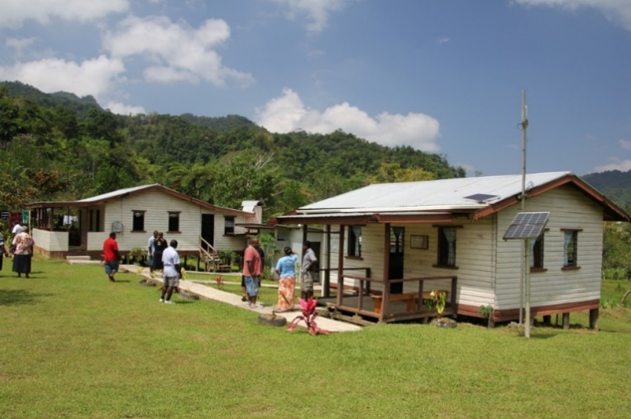
_______________________ to a __________________________ such as an Aid-post or health clinic is vitally important. It is important that the nurse is always available at the clinic to treat patients.
This is a rural health clinic in a village. Notice the clean and healthy surroundings. Photo: C. Kuma
- _______________________________________________________________________
Every community has its own ______________________________________________. These help ___________________________________________________ that are of relevance to that particular community. Most importantly these entities create for the community its __________________________________________________________.
- _____________________________.
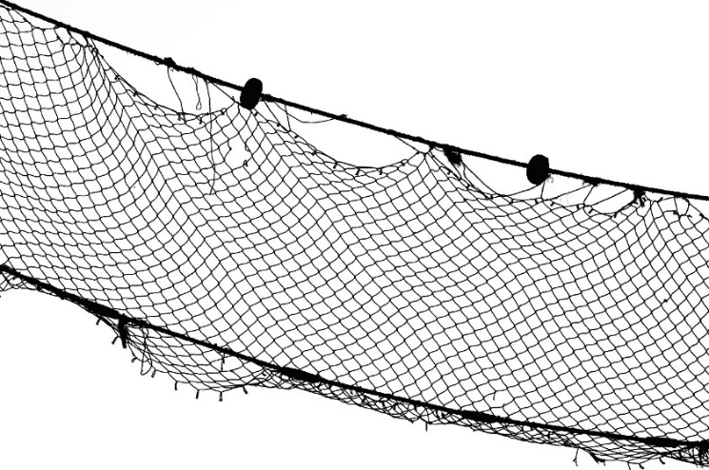
Earning a good income in a rural setting can be challenging, but is vital! The following are income generating projects that have proven successful in many villages and communities in the South Pacific:
- _______________________
- _______________________
- _______________________
- _______________________
- _______________________
- _______________________
- _______________________
A HEALTHY COMMUNITY USES ITS RESOURCES IN A SUSTAINABLE WAY.
EXCESSIVE USE OF RESOURCES, ESPECIALLY NATURAL RESOURCES CAN LEAD TO DISASTROUS EFFECTS ON COMMUNITY HEALTH.

Below are some examples.
- Example one - over-fishing has led to the depletion of fish resources in many areas of the Pacific. One contributing factor is the uncontrolled use of fishing nets in reefs resulting in over harvesting and fish depletion
- Example two - unsustainable logging activities as in Melanesian countries are depleting trees for local use and trade. Also, land and rivers are destroyed through soil erosion and flash floods due to logging. Logging activities create community infightings and arguments over land rights and ownership. This has the potential of destroying relationships and harmony in a community
- Example three - water is always a valuable commodity in many communities. Its use must be guarded especially during periods of low rainfall in areas where water is scarce

- Example four - Rural health clinics in isolated communities often run out of medical supplies and drugs. This could be due to problems of transport or too many people becoming sick due to an unhealthy village environment. Strictly adhering to personal hygiene, drinking clean water and cleaning up the village can prevent many people becoming sick. This can lessen the burden on the clinic and its medical supplies.
ASSESSMENT
Choose one of the above examples and construct a poster, poem, song, or skit to warn your school about it. Display it or share it at a school or local community gathering.

- ______________________________.
It is important to know that health is a principle that comes from God. It is God’s greatest desire that we should all be ___________________________________________________.

When we love God
- We will be motivated to __________________________ – there will be social harmony
- We will see the importance of _______________________________________ together
- We will understand that our body is the ____________________________________ and that we will want to take good care of it
- We will understand the importance of ______________________________________ our villages clean and healthy
- We will appreciate the importance of our ___________________________________ and that we will endeavour to take good care of it.

Common Human Parasites in the South Pacific
Parasite 1 | Description | Prevention | Pictures
HOOK WORM | - Most common worm infection __________________ _____________________.  - Are ____________________ ________________ worms that affect nearly ____________________ million people worldwide.  - Widespread where people defecate on ________________________________________.  - Hookworms have _________________________ that grip on to the _________________________ - this allows them to _____________________ __________________ from the intestines.  - Through the faeces (human waste) ____________ __________________ are left on the soil. These hatch and the larvae matures and penetrates the ________________________________________.  - Hookworm is therefore mainly acquired by walking _________________________________ on ______________________________________ | - __________________________.  __________________________  - __________________________.  __________________________  - __________________________.  __________________________  - __________________________.  __________________________  - __________________________.  __________________________  - __________________________.  __________________________  (And treat them with a worming tablet regularly if possible.) | An adult hookworm (below, left) enters the body through the skin and causes irritation and itchiness (below right)  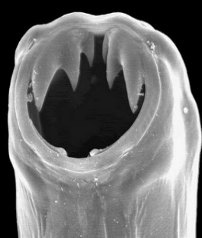  An adult hookworm with its mouth open. See the strong, sharp teeth used to attach itself to the intestinal wall.

Parasite 2 | Description | Prevention | Pictures
ASCARIES LUMBRICOIDES | - The ____________________ intestinal worm to infect humans.  - Can reach up to ____________________.  - Survive by eating food and water passed ________________________________________.  - When infected, people may complain of ________ __________ _________________ ____________  ________________________________________.  - Rarely deadly but can interfere with the ________________________________________.  - Very _______________________ in South Pacific, reflecting the _____________________________ a lot of people live in. | - __________________________.  __________________________  - __________________________.  __________________________  - __________________________.  __________________________  - __________________________.  __________________________  - __________________________.  __________________________  - __________________________.  __________________________ | This is a true picture of Ascaris Lumbricoides or the “giant round worm”. It is easily transmitted by hands, food and water contaminated with human faeces.  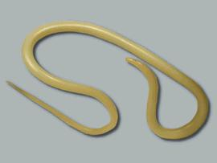

Parasite 3 | Description | Prevention | Pictures
ENTEROBIUS VERMICULARIS (PINWORM) | - The most common parasitic worm infection in ____________________.  - Pinworms are ____________________ from human to human through ____________________ and food and are particularly common in ____________________.  - Humans get infected by ____________________ or ____________ microscopic ______________ from human faeces.  - Once inside the ____________________ the larvae hatch from the eggs, move to the end of the ____________________ and mature.  - During ____________________ when the body temp is ____________________ and there is less ____________________ the female adult pushes out from the ____________________ and lays ____________________ on the outside. The eggs get stuck on ____________________ and survive for up to ____________________.  - This causes itchiness around the anus. | - __________________________.  __________________________  - __________________________.  __________________________  - __________________________.  __________________________  - __________________________.  __________________________  - __________________________.  __________________________  “God is more glorious than the moon; he shines brighter than the stars. In comparison, . . . . we mortals are mere worms” Job 25:5,6 | 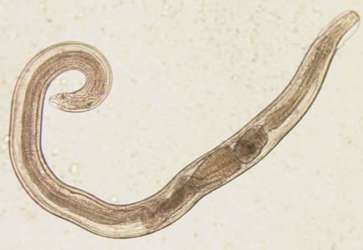  The main complication of Enterobius Vermicularis is itchiness around the anal region. This can be quite distressing especially for children.

Parasite 4 | Description | Prevention | Pictures
TRICHURIS TRICHIURA  (WHIPWORM) | - Whipworm infects ________________________ humans in tropical countries including the South Pacific Island countries.  - Female lays eggs in the large intestine.  - Eggs are passed out in ____________________.  - If this lands on __________________________ , after ________________________ the eggs have been fertilized and are ____________________ ready to be eaten.  - Eggs get inside you if you eat uncooked vegetables that are ____________________.  - Large numbers of Whipworm inside you will lead to ___________________ __________________  _____________________. _________________  _____________ __________________________ | - __________________________.  __________________________  - __________________________.  __________________________  - __________________________.  __________________________  - __________________________.  __________________________  - __________________________.  __________________________ | 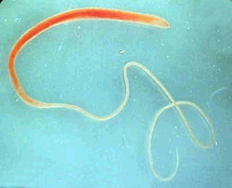  This is what a Whipworm looks like. These eggs are passed through faeces into the environment where they hatch into young worms. We get infected when we eat contaminated, uncooked vegetable.

Parasite 5 | Description | Prevention | Pictures
ENTAMOEBA HISTOLYTICA  (AMOEBIASIS) | - Causes _______________________________.  - Occurs in ____________________ and causes _____________________________________.  - Parasite is passed onto the soil through ____________________.  - We get infected by ingesting parasite through ______________________________________.  - ____________________ of infections can be serious and even cause death.  - Serious infections cause damage to the _______________________________________.  - Parasite can penetrate the __________________ _________________ and travel to organs such as the ____________________ causing _________ ________________________. . | - __________________________.  __________________________  - __________________________.  __________________________  - __________________________.  __________________________  - __________________________.  __________________________  - __________________________.  __________________________  - . __________________________ | 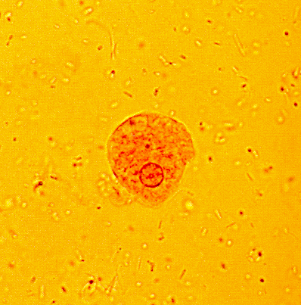  This picture shows the parasite Entamoeba Histolytica. It is spread though food, water or hands contaminated by human faeces.

Parasite 6 | Description | Prevention | Pictures
GIARDIA INTESTINALIS | - Can cause serious disease in the __________ _________________.  - Parasite attaches to the ____________________ of the intestines and survives on nutrients passing through them.  - Common where __________________________.  - Parasite is passed into environment by ____________________. It develops into tiny ____________________.  - We become infected when we ingest the cysts by eating __________________________________.  - Also spread through _____________ __________  ________________________________________  - People infected complain of _______________ ________________________________________.  - Children infected may lead to ________________ and the child may not grow well. | - __________________________.  __________________________  - __________________________.  __________________________  - __________________________.  __________________________  - __________________________.  __________________________  - __________________________.  - __________________________.  __________________________  - __________________________.  - __________________________.  __________________________ | 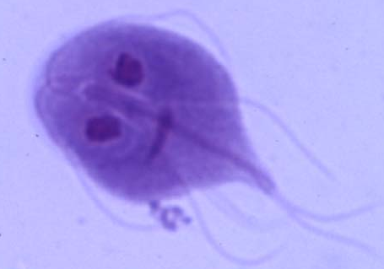  This is a picture of Giardia Lamblia. It is passed through ingestion of uncooked vegetables and food, water and hands contaminated by faeces.
What can you do around your village, community and home to ensure these parasites are kept under control? Think of how you can encourage cleanliness and increase awareness. BEWARE: Once these parasites are in a community it is very difficult to remove them unless the entire community becomes actively involved. Why is this? What would happen if only one family began to follow the prevention rules? What would happen if all but one family followed the prevention rules? If you could get your community to change one thing to ensure safety from these parasites, what would it be?

SAMPLE QUESTIONAIRE TO DETERMINE THE HEALTH OF YOUR VILLAGE (OR COMMUNITY)
Highlight the areas of concern. What needs to be done to make your home a “Healthy Village”?
(All of these questions may not apply to where you live. Put a line through irrelevant ones and brainstorm with your class to develop your own or add to these)

SAMPLE QUESTIONS | YES | NO | COMMENTS
- Is diarrhoea common among children?
- Are worm infections common?
- Are respiratory (breathing) problems common?
- Are eyesight problems common in women?
- Are eyesight problems common in men?
- Is Malaria common?
- Are other vector-borne diseases common?
- Do many people have fevers?
- Has there been recent outbreaks of disease lately?
- Are children undernourished?
- Are there health workers in the community?
- Do any children or adults have mental health problems?
- Is the water source protected/treated?
- Is water always available?
- Does everyone have access to water?
- Does the community know the quality of the water?
- Are there special places for bathing and laundry?
- Do households have some form of sanitation?
- Is there a toilet for every family?
- Are there separate facilities for women?
- Is solid waste disposed of (or does it build up?)
- Are there stagnant/still bodies of water?
- Is there a good system of drainage?
- Is there a market place?
- Is the market cleaned every day?
- Is the market area dirty?
- Is there meat sold at the market?
- Is the meat or fish fresh daily?
- Are people selling food careful with personal hygiene/ do they have clean hands?
- Does the market have toilets and fresh water?
- Do houses have many windows?
- Are houses kept in good condition?
- Is the village clean?
- Are animals fenced / kept separate from homes?
- Is food easily available in the village?
- Are mosquitoes, flies, cockroaches common?
- Are there many rats or mice?
- Are the same bodies of water used for washing, laundering and receiving human or animal waste?
- Is cooking fuel readily available?
- Is there a spirit of cooperation in the village?

Answers that contain two words are written with no space between.

ACROSS
2 An important practice for cleanliness. 6 A dangerous germ found in eggs. 7 A solution for the vast majority of intestinal worm problems. 11 This parasite might cause blood filled diarrhoea.
12 Giardia can be caused by eating unwashed
14 These grow on the legs of flies and trap germs. 16 A faecal-oral disease. 17 The largest intestinal worm to infect humans. 20 A good way to generate income. 21 A necessary place in a village that has the potential to be powerfully
good OR bad for your health. 22 In a healthy village there is none of this. 23 A common type of latrine.
24. These should be kept at least 100m from water sources. 25 A solid waste product that should be buried. 26 The major difference introduced into a VIP latrine.
27 A water tight tank that typically receives waste from a flush toilet
30 Poor drainage can lead to this. .

DOWN
1 Responsible for most worm infections and diseases such as cholera.
3 Food sold at markets should be inspected daily by
4 A clean environment can actually reduce this.
5 The lining of the best storm water drains.
8 One of the most effective ways of preventing the spread of disease.
9 Example of a solid waste product.
10 Good health is not merely the absence of this.
13 A vector-borne disease.
14 A personal responsibility that improves one’s health.
15 A factor that influences the health of an individual.
18 _______ for God will improve our health and that of our community.
19 Water that can lead to breeding mosquitos.
27 A cleansing and disinfecting agent.
28 Parasite with strong teeth that grips on to the intestinal wall. .
29 Heritage creates this in individuals and communities. .
30 Insects responsible for spreading disease. .
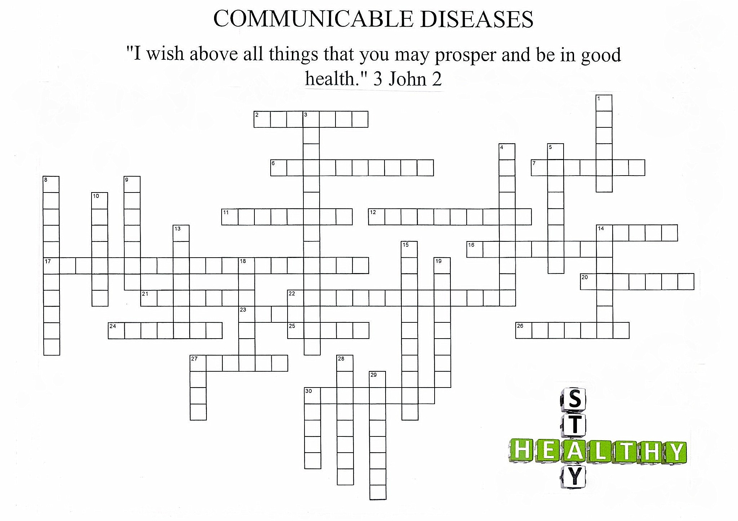
TEXTS + QUOTES

Over our journey to health we have read, discussed and memorized many powerful words from the Bible and Mrs White’s writings. See how many of them you can remember. Can you connect where they are found? They are indeed words to live by!
- Dear ______________, I ____________ that you may enjoy ___________ health and that all may go ___________ with you, even as your ____________ is getting along well.
- I beseech you therefore ___________________, by the ________________ of God, that ye present your bodies _______________________________________________, holy, acceptable ___________________________________________, which is your ______________________________________________________________________.
- What? Know ye not that your ________________ is the ________________ of the Holy Spirit which is in you, which ye have of ______________________, and ye are ____________________________? For ye are _________________________________: therefore glorify God in _____________, and in your __________________, which are God’s”
- True temperance teaches us to _________________________________________ with everything __________________ and to use _________________________________ that which is healthful.
- For, as I have often told you before and now tell you again _____________________ __________________, many live as ______________ of the _______ ______________. Their destiny is _______________, their god is their _______________, and their glory is in their _____________________. Their mind is set on __________________ __________________________. But our _______________________________ is in ___________________________. And we eagerly await a Saviour from there, the _________________________________, who by the power that enables Him to bring everything _______________________________, will __________ our lowly bodies so that they will be like ________________________________________.
- But the fruit of the spirit is ________________________________________________ ______________________________________________________________________. Against such there is _____________________________________________________.
- Medical missionary work _______________________________________________. It is necessary for the ______________________________________________. As through it men and women are led to see the _________________________________________ living, and the ___________________________________ or the truth will be ________ ______________________ . . . . . . as the __________________________ ___________, God’s methods of treating disease will ________________________________________ ______________________________________________________________________.
- The thief comes only to ______________________________ and destroy. I have come that they may ___________________ and have it _____________________________.
- The only safe course is to touch not, taste not, handle not; _______________________ _______________________________________________________________________. The redeemer of the world came from heaven to help man in his ___________________ that in the power which Jesus came to bring him, he might become strong to _________________________ and ____________________ and might be a victor on _________________________________.
- Now may the _______________________ Himself sanctify you ____________________ and may your whole spirit, soul _________________________________ be preserved ___________ at the coming of our __________________________________________.
- I can do _______________through Christ _____________________________________.
- Come to me all you who are weary ___________________________________, and _______ _______________________________________.
- Thus the heavens and the earth were completed and all their vast array. By the seventh day ___________________________________________________________; so on the seventh day ___________________________________________. And God blessed the seventh day and ____________________________, because on it He rested from all the work of creating that He had done
- In health and in sickness __________________________________ is one of heaven’s choicest blessings. It’s ____________________________________________________.
- Every year millions upon millions of gallons of _______________________________ are consumed. Millions upon million are spent in buying ___________________________ _______________________________________________________________________ For the sake of gain the liquor dealer deals out to his victims that which __________ _______________________________________.
- Purify me from my sins, and I will ____________________________; wash me, and I will ___________________________________________________.
- The Lord will guide you _______________________, He will satisfy your needs in a sun-scorched land and will strengthen your frame. You will be like a ____________________ _______________, like a spring whose waters _________________________________
Galatians 5:22, 23 Romans 12:1 Philippians 4:13 Christs Object Lessons p59
Matthew 11:28 3 John2 John 10:10 Patriarchs + Prophets p562
Philippians 3:18-21 Psalm 51:7 Temperance p28 1 Corinthians 6:19, 20
Genesis 2:1-31 Isaiah 58:11 3 Testimonies p485-488
Thessalonians 5:23 Ministry of Healing p237

