Health Promoting Churches Initiative

TEACHER’S MASTER COPY

Produced by the
Adventist Health Department
South Pacific Division
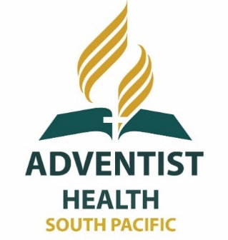

TOPIC | PAGE
Pacific Health challenges | 2
Pacific Health challenges – crossword puzzle | 6
Disease trends in the South Pacific | 8
Church, culture and health in the Pacific | 10
Diabetes | 12
Overweight and Obesity | 24
Overweight and Obesity find-a-word | 29
Coronary Heart Disease | 30
High Blood Pressure | 36
CHD and Hypertension – Crossword Puzzle | 40
Cancer | 42
Cancer – crossword puzzle | 51
Texts, Quotes and Questions | 52
Assignment or Discussion Questions | 55
Smoking | 56
Kava | 63
Betel Nut | 66
Marijuana | 72
Rest and Sleep | 78
Sunlight | 83
Water | 85
Alcohol | 90
Salt | 97
Communicable Diseases | 100
Personal, Domestic and Community Hygiene | 105
Sanitation | 113
Drainage | 122
Solid Waste Management | 124
Housing Quality | 125
Common Human Parasites - South Pacific | 133
Questionnaire to Determine Health of Village | 139
Crossword - Communicable Diseases | 143
Texts and Quotes | 144
10 Ways to Love | 146
“Dear friend, I pray that you may enjoy good health and that all may go well with you, even as your soul is getting along well” - 3 John 2 (NIV)

Pacific Health Challenges
The two major disease challenges in the South Pacific:
- Communicable Diseases.
- This refers to diseases caused by _germs_____________________. These include bacteria__________, ___viruses___________ and ___parasites_________.
- Up until recent time’s communicable diseases have been our major health burden.
- They will remain a major threat for a long time to come due to the disregard of _ basic principles of health and hygiene _____________________________by individuals, families and communities.
- The major causes of these diseases are:
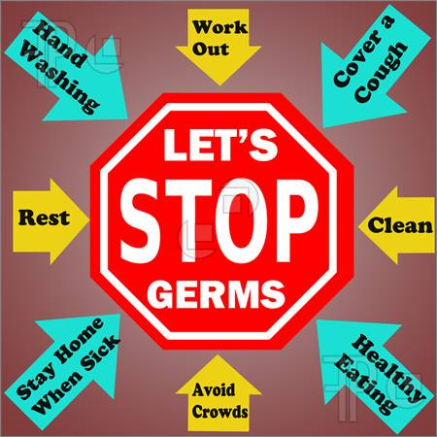
  - Poor housing
  - Inadequate living standards
  - Overcrowding
  - Lack of proper waste disposal systems
  - Inadequate drainage of stagnant water
  - Poor sanitation
  - Dirty villages
  - Lack of good clean water
- Some examples of Communicable diseases common in the South Pacific today include: ___ Tuberculosis, _________Hepatitis A, ________bacterial pneumonia, typhoid fever, malaria, dengue fever, gastroenteritis and dysentery

THE PROBLEM AREAS
- Soil transmitted worms ____ are found everywhere in the Pacific Island region. These can impair growth and development in children and cause anaemia (lack of blood).
- Each year __1600_________ new cases of _____Tuberculosis _______ are reported.

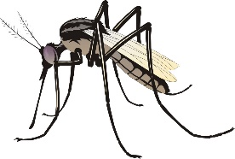
- Although _HIV__________ numbers remain quite low, it is still a concern. It is important that countries continue to stress __prevention____________________ and medical professionals continue to improve the __________care and treatment_____________ of HIV patients.
- _Respiratory__________________ and __lung infections_______________ continue to be the major causes of death in many countries of the Pacific.
- A virus transmitted by the Aedes Agypti____________________ mosquito causes _ Dengue Fever________________________. It is a common problem in may island countries of the Pacific and has caused major epidemics and deaths in the region.
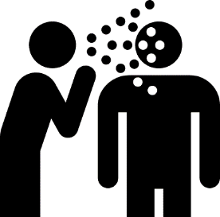
- Salmonella Typhi_______ causes Typhoid Fever___. This germ comes from Human Faeces_________________. This dangerous disease is very common in the Pacific Islands with some of the highest rates in the world. Control depends on safe clean water and sanitation_______________ and public Education___________ in hand and foot hygiene.
- Leptospirosis______________ is carried by animals such as _ rats__ and _pigs_ and is transmitted through the skin of people exposed to contaminated water or mud.___________
- A new disease to the Pacific is Cholera_________________. Caused by a germ called Vibrio Cholerae________________ ____________ and spread through poor hygiene and sanitation__, this disease results in diarrhoea_____________ which leads to dehydration and sometimes even death______________.
- Malaria_____________ is a common and deadly disease. Drug resistance is a concern and although newer drugs are now available, the long-term effects and benefits are still not known.
- Over the last 25-30 years over 30 new diseases have appeared in the world. All infectious and all dangerous. These include HIV/AIDS, Ebola Virus, SARS, Bird Flu, Swine Flu, Nipha Virus, etc.________________________________.

Now more than ever it is time to take care of our health. We must remember that God will bless our efforts as we strive to keep our bodies strong and open to His Spirit.
Remember Romans 12:1 _ I beseech you therefore, brethren, by the mercies of God, that ye present your bodies as a living sacrifice, holy, acceptable unto God, which is your reasonable service”

- Non Communicable Diseases (NCD’S).
- These illnesses are also called “__Lifestyle Diseases_______” The major NCD’s that impact the Pacific include: __Diabetes_______, Coronary Heart Disease (Heart Attack), Hypertension (High Blood Pressure), Stroke, Chronic Lung Disease (from smoking), Cancer and Depression.
- The South Pacific region is seeing a shift from __Communicable diseases_______ to ________non-communicable diseases____ with the increased consumption of high fat, _high salt_ and high sugar foods along with the increased use of alcohol and tobacco__.
- Nearly __30 million_________________ people in the Western Pacific region are affected by _diabetes_______________________. There are predictions that this number could __double___________________ over the next ________20 years_
- Hypertension__________________________ (High blood pressure) and other circulatory diseases are also ___on the rise___________________________ because people are adopting a western lifestyle and their diets are therefore high in __saturated fats and oils, processed sugar and added salt. People are relying on these less healthy foods as sources of ____carbohydrates______________ and protein__________________ rather than the traditional ___root crops____________________ and ____fish___________________.
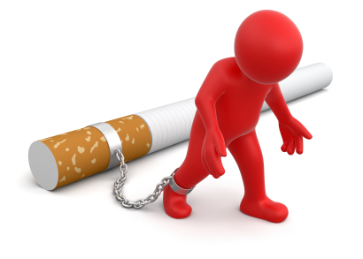
- Non Communicable Diseases are not able to be passed on to another person, i.e. are not _contagious________ and are related directly to the following lifestyle factors:
  - Diet and nutrition
  - Exercise
  - Cigarette smoking
  - Alcohol consumption

- NCD’s are fast becoming the leading cause of __morbidity____ (Sickness) and mortality_____________ (death) in our South Pacific region. In fact more than 75%_ of the deaths in our region are completely preventable and unnecessary diseases based on our _lifestyle choices_________. That’s nearly ____8____ out of every __10____ deaths that don’t need to happen. Very sad isn’t it!

1 Corinthians 6:19, 20 ______“What? Know ye not that your body is the temple of the holy ghost which is in you, which ye have of God, and ye are not your own? For ye are bought with a price: therefore glorify God in your body, and in your spirit, which are God’s”__________
Fill in the verse:
- The major risk factors driving this epidemic include:
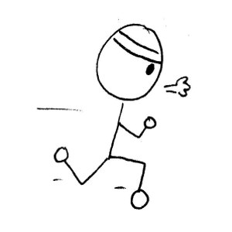
        - Poor food choices
        - Unhealthy eating habits
        - Junk foods
        - Inactivity or lack of exercise
        - Obesity
        - Cigarette smoking
        - Alcoholism

Some things that I can do to make sure I never suffer from a Non-Communicable Disease include: Get the students to think of things that apply to them. Could include things like:
        - drink water instead of soft drinks,
        - don’t snack between meals,
        - eat a healthy breakfast so I’m not hungry during the morning and snack on junk foods,
        - eat at least two pieces of fruit every day,
        - exercise every afternoon,
        - eat more vegetables,
        - go to bed early,
        - never smoke,
        - never drink alcohol,
        - and never drink kava or chew betel nut, etc..

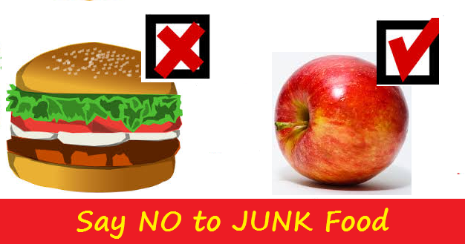

PACIFIC HEALTH CHALLENGES
Complete the crossword below

Name: ________________________________

Across | Down
- Diarrhoea causes this and it can lead to death. dehydration | - A common but potentially deadly disease in the Pacific. malaria
- A lifestyle choice that reduces the risk of NCD's exercise | - A type of 'germ'. fungi
12. A relatively new but deadly disease.  aids | - The Aedes Agypti mosquito causes this disease. Dengue fever
- A major cause of Communicable diseases.  overcrowding | - 1,600 new cases of this disease are reported each year. tuberculosis
- An example of a Communicable disease.  dysentery | - A major risk factor for NCD's alcoholism
- Leptospirosis is carried by this animal.  rats | - Caused by a germ found in Human Faeces.  Typhoidfever
- Paul calls us to offer our bodies as a living__________ to God. sacrifice | - NCD's are not contagious
- Something that can cause anaemia.  worms | - It's best to eat traditional root crops to have plenty of this. carbohydrates
- Our bodies are God's temple | - The worst food choice! junkfood
- If this was improved, Communicable diseases would improve. hygiene | - A major cause of death in many Pacific Countries. diarrhoea
- Communicable diseases are caused by these. germs | 13. How many deaths, out of ten, are preventable? eight
 | 16. Another word for Non-Communicable diseases lifestyle
 | - Another word for Morbidity sickness
 | - A diet high in this can cause High blood Pressure. salt

Disease Trends in the South Pacific

Solomon Islands
Niue
Vanuatu
Cook Islands
Papua New Guinea
Tonga
Nauru
Fiji
Kiribati
Samoa
Tokelau
Tuvalu

.
Non-Communicable Disease
Communicable Disease
Transition Point

DISCUSSION QUESTIONS
- What do you think the graph might look like in 10 years’ time? Why?
- Name the countries that have passed the ‘transition point’ – why do you think they have?
- What can the government, communities, families, and churches do to ensure their place of influence addresses this dangerous health trend.
- Discuss the statement “The Countries on the left of the graph are healthier than the ones on the right”.

Study the table “Top 10 Causes of Death in 2002” and answer the following questions:
- What were the top killers in your country? Are you surprised? Why or why not?
- Which country has the most NCD’s? Why do you think that might be?
- Which diseases are common to all countries?
- Which disease is listed as the major killer for the most countries?
- Why do you think pulmonary diseases are so common?
- Measles used to be a big killer – why do you think it has decreased so dramatically?
- Can you see any diseases that might be linked?
- Were you surprised that Cancer is only listed for one country? Do you think this may change in the future – why or why not?
- Obesity has been called the ‘Common Denominator for disease’ – Why? What country’s obesity rate surprises you? Why?
- Obesity is often called the ‘common denominator’ of lifestyle disease – is there anything in this graph that supports that?
- If you were in Government for one year, what single change would you make in the hope that the health of your country might improve.

Top 10 Causes of Death in 2002
2  3  Measles 4 | PNG | Solomon Is | Vanuatu | Kiribati | Tuvalu | Fiji | Tonga | Samoa | Tokelau | Nauru | Cook Is | Niue
Asthma |  |  |  | 7 |  | 8
Cancer |  |  |  |  |  |  |  |  |  | 10
Cirrhosis of Liver |  |  |  | 10 |  |  |  |  |  | 7
Congenital abnormalities |  | 7
Diabetes |  | 8 | 6 | 3 | 6 | 5 | 4 | 4 | 4 | 4 | 4 | 6
Diarrhoeal diseases | 5 | 1 |  | 5 | 8 |  | 10 |  | 10
Endocrine disease |  | 6 | 10 | 4 | 9 | 9 | 8 |  | 9 |  | 9 | 9
Heart Attack | 2 | 3 | 2 |  | 2 | 1 | 2 | 2 | 2 | 1 | 2 | 2
Hepatitis B |  |  |  |  |  |  |  |  |  | 9
Hypertension | 8 | 9 | 3 | 9 | 4 | 4 | 3 | 3 | 3 | 2 | 3 | 4
Lower respiratory infection | 3 | 5 | 5 | 6 | 3 | 3 | 6 | 6 | 7 | 6 | 6 | 3
Malnutrition | 10 |  |  | 8
Measles | 9
Nephritis + Nephrosis |  |  | 8 |  | 7 | 6 | 7 | 7 | 8 | 5 | 7 | 8
Perinatal conditions | 1 | 4 | 7 | 2 | 10 | 7 | 9 |  |  |  | 8 | 7
Pulmonary disease | 7 | 10 | 4 |  | 5 | 10 | 5 | 5 | 5 | 8 | 5 | 5
Road traffic Accidents |  |  |  |  |  |  |  |  |  |  | 10 | 10
Stroke | 6 | 2 | 1 | 1 | 1 | 2 | 1 | 1 | 6 | 3 | 1 | 1
Tuberculosis | 4 |  | 9
OBESITY rates  Measles 1 | 16% | 30% | 60% | 74% | 62% | 55% | 91% | 80% | 63% | 95% | 91% | 82%

CHURCH, CULTURE AND HEALTH IN THE PACIFIC
What ways is food used in the Pacific Culture? (E.g. A feast to welcome visitors)
Many possibilities – includes things like; Make peace with feasts, celebrate events (weddings, birthdays, graduations etc.) Say farewell._____________________________________________
While the ‘food culture’ may have remained, the foods served at these events has changed radically. Where once they had been grown in the garden and included _________________ taro, yam, sweet potato, sago, vegetables and fruits _________________________, now, due to a rise in our socioeconomic status and improved socioeconomic status_____ and transportation________ the foods served are no longer healthy. The home grown, highly nutritious fruits and vegetables are being replaced with high-fat and high sugar foods such as white rice, beef, chicken, noodles, sugar, cakes, soft drinks and cooking oils.___________________
Read the quote below from Ken Ferraro, a professor of sociology at Purdue University, and comment on whether you think it applies to your church family?

“Most Christian religions encourage restraint from participating in injurious behaviours, such as heavy drinking and smoking, however, overeating is not considered a great sin – it has become the accepted vice……. Many religious activities are rooted in food. From the bung lunches after weekly services to picnics, these foods unfortunately tend to be high in fat, sugar and salt. Instead, religious leaders need to model and encourage physical health as an important part of a person’s spiritual well-being.”
______________________________________________
______________________________________________
______________________________________________
______________________________________________
Memorise
“True temperance teaches us to dispense entirely with everything hurtful and to use judiciously that which is healthful.“_ Patriarch and Prophets, p. 562

Note for teacher:
Judiciously means to ‘use wise or good judgment’
Explain even the ‘good things’ can be over used or over eaten!

OTHER BEHAVIOURS IN THE PACIFIC THAT INFLUENCES HEALTH
- Big is Beautiful
- In certain cultures in the Pacific “Big” in terms of body size is considered desirable or even beautiful because:
  - Being fat speeds up a girl’s development. This means that she can get married earlier.
  - People believe that a woman’s size reflects the care of her husband. For example: big wife means that the husband is feeding her and treating her well. The husband is giving her everything he has.
  - Similarly is comments on the care she is receiving from her parents: A big girl means the parents are feeding and treating her well.
  - Size becomes a mark of status and prestige.

- Coconut – “The Tree of Life”
- The coconut has many uses such as:

    - A refreshing drink
    - The husk may be used for a brush, artefact, firewood etc.
    - The shell can be made into beautiful artefacts or an excellent fuel for fire
- Flesh is a great source of food
- cream used for all kinds of cooking
- copra a great cash crop
- Leaves for baskets or shelter and the
- fronds for a broom
- Trunk makes excellent timber

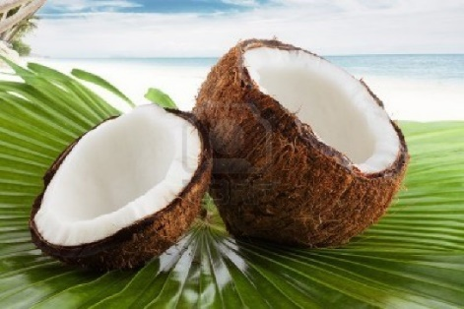
- Some Pacific countries celebrate the “Week of the Coconut” which is a time set aside to promote and celebrate the many good things about coconuts.
- Unfortunately, coconut cream is used in excess in many villages and communities throughout the Pacific. Since we are moving less and NCD’s are rising rapidly, it is important to realise that while _coconut cream_ is an important food ingredient, it must only be used in moderation.
- Coconut cream and oil is a saturated fat and when used in excess can contribute to obesity and lifestyle diseases.
- District Meetings and other church gatherings
Many church leaders are struggling with their health, and tragically many have perished prematurely “while serving the Lord” because of one particular food culture. The idea that when he/she visits the house of a member food must be served.
Obviously the leader doesn’t want to offend the member and so gratefully accepts and eats the food provided. What if he/she visits several homes that day? To compound this problem, often only the very best food is offered. This may mean the richest and most damaging to his/her health.
DIABETES
Diabetes is a major lifestyle disease – and a VERY expensive one! It is estimated that there are 366 million diabetics worldwide with an annual health care bill of 465 billion USD needed for treatment. One person dies from diabetes every _7 seconds_ in a worldwide epidemic that continues to worsen. This means that Diabetes kills _4.6 million_ people every year. Diabetes has now become a major killer in the South Pacific region.
What is Diabetes?
- All foods are broken down in the digestive system. Foods such as _rice, bread, sweet potato and taro belong to a food group called _carbohydrates_________. These foods are digested into simple sugars___________________________ called glucose__________. Glucose then makes its way through the _intestinal wall_ into the bloodstream and heads for the _cells of the body__________. The body is made up of approximately _100 trillion cells_________, and these cells need energy for growth and function – this energy comes from _glucose_.
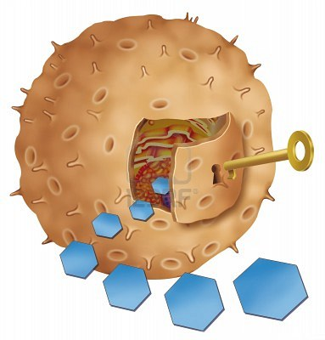
- Glucose however cannot enter cells without _insulin__ a special hormone produced in the _Pancreas__.
Insulin

Glucose (sugar)
- After a meal, the level of the glucose in the blood _goes up_. This causes the _pancreas_ to automatically release extra quantities of _insulin__ into the blood stream to help move the _glucose_ into the _cells_. This lowers the glucose levels in the _blood_ to a safe or normal level. This happens every time we eat. Now imagine if for some reason the ‘key’ (_insulin_) wasn’t there (or wasn’t working properly) – this would mean that the glucose would __never enter the cells of the body___ which would result in a very _high glucose level in the blood. This could lead to many serious complications.

- Diabetes is a long-term chronic disease that arises when:
- the pancreas does not produce any insulin or
- the pancreas does not produce the right quantity of insulin needed or
- for some reason the insulin that is produced by the pancreas is ineffective - a situation called “insulin resistance”.
Diabetes Definition Definition
____Diabetes is a disease where there is a lack of insulin or presence of ineffective insulin in the blood resulting in a very high blood glucose level____
There are 3 main types of Diabetes
- Type 1__. This usually starts in _childhood__ but it can occur at any age and accounts for _5-10%____ of all diagnosed cases of diabetes. People with type 1 diabetes produce little or no insulin_ and therefore must use injectable insulin daily to control their blood sugars.
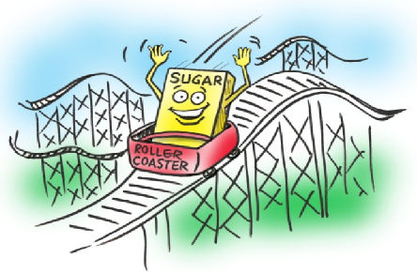
- Type 2__. This is much more common and accounts for _90-95% of all cases. It usually starts in Adulthood but, due to a rise in childhood _obesity_ is being diagnosed at much younger ages now. Many people with Type 2 Diabetes don’t know they have it. People with this type of Diabetes are _resistant_ to the insulin the body makes, and their pancreas may try to compensate by making more insulin___. Over time the Pancreas loses the ability to make enough insulin_ and may result in a little or no _insulin at all. The good news is that Type 2 Diabetes can often be controlled by _diet and exercise only_, but often patients will choose to rely on _oral medications or insulin__. This is the most common form of diabetes in _the South Pacific______________.
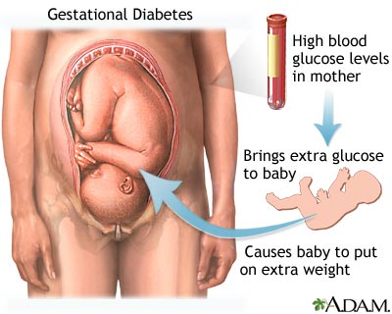
- Gestational Diabetes____________
This diabetes forms when a woman is pregnant and usually goes away after the baby is born. The woman is however at a very high risk for developing _Type 2 Diabetes_ later in life – and during another pregnancy.

Symptoms of Diabetes (Summarise the following)
- Frequent passing of urine
When there is too much glucose (sugar) in your blood you will want to pass a lot of urine. Passing urine 3-4 times in the night can be due to diabetes
- Increasing thirst
If you are urinating more than usual, you will feel thirsty and will need to replace that lost liquid and you will be drinking more than usual.
- Unusual weight loss
Because your body is not making insulin, it will seek out another energy source.
Muscle tissue and fat will be broken down for energy. This results in weight loss
- Increased tiredness
If your insulin is not working properly, glucose will not be entering your cells to provide energy. This lack of energy will make you feel tired
- Blurred vision
Prolonged diabetes can lead to major eye problems and even blindness if blood sugar is not controlled
- Cuts and bruises don't heal properly or quickly
When there is too much sugar (glucose) in your body, its ability to heal can be impaired
- Skin and/or fungal infections
When there is more sugar in the body, its ability to recover from infections is affected. Women with diabetes find it especially difficult to recover from bladder and vaginal infections
- Sexual dysfunction among men
If you are over 50 and experience frequent or constant sexual dysfunction (erectile dysfunction), it could be a symptom of diabetes
- Numbness or tingling, especially in your feet and hands
If there is too much sugar in your body, your nerves in the hands and feet could be damaged. You may experience tingling and/or numbness in your hands and feet.

Diabetes – A Disease of Many Complications
Diabetes by nature, destroys small and medium sized _blood vessels__________ throughout the body. This naturally leads to a reduction in _blood flow_________ to many organs and tissues. Diabetes is a major risk factor for: heart disease, hypertension, stroke, kidney disease, gangrene of extremities and infections_____________________________________
- Cardiovascular disease: Diabetes affects the heart by damaging the blood vessels supplying the heart muscle – which is called _Coronary Heart Disease. Cardiovascular disease or _heart attack____________________ is the major cause of death for people with _diabetes____________, accounting for __50%_____ or more of all diabetes deaths.
- Stroke_____________. A Stroke occurs when the supply of blood to the __brain gets________ interrupted and oxygen can’t reach the brain. There are two ways diabetes contributes to a stroke:
- Diabetes damages the _blood vessels_ in the brain leading to blood vessel _narrowing and blockage_ resulting in a _stroke_. This is known as _Ischemic Stroke___. (see diagram to the right)
- An important co-existing problem for diabetics is high blood pressure; or hypertension____________. This is a major factor for strokes_______. Normal blood pressure ranges from _100/60__ to _130/70___. Anything above this would be considered _hypertension_. Uncontrolled severe hypertension can cause the _rupture___ of a blood vessel in the brain. This will lead to a sudden stop________ in the _blood supply___ to the __brain tissue_______ which will lead to a kind of stroke called _Haemorrhagic stroke (see diagram on the right).
Stroke commonly presents in the following ways:
- sudden numbness, weakness, or paralysis of an arm, leg, or entire side of the body
- Sudden trouble seeing in one or both eyes
- Sudden difficulty speaking
- Sudden confusion, dizziness, or loss of consciousness
- Sudden severe headache
Those that survive the initial attack will take a very long time to _recover_____________
- Kidney Disease_____________________ (Diabetic nephropathy) Diabetes can cause total kidney failure and hence the need for __dialysis__ or _kidney transplants_. We have neither of these services available in the _South Pacific____________.
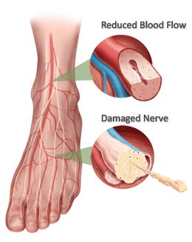
- Nerve Disease____ (Diabetic neuropathy) Diabetes leads to __death of nerves_______ in the extremities leading to loss of sensation_______. The reason is that there is damage to the _tiny blood vessels_ supplying nerves to the extremities. This can lead to ulcerations_______ and serious infections__________ - sometimes requiring the amputation__________ of a toe, foot or leg. Loss of feeling can allow foot injuries to __escape notice and treatment____________.
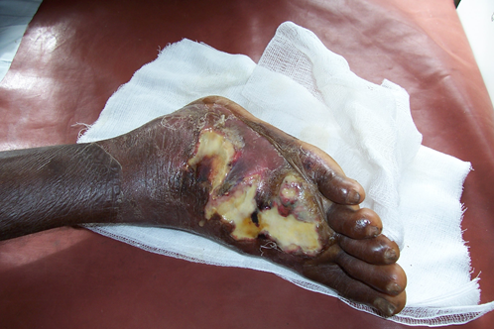
- Infection_____________________ (Diabetics foot sepsis). Diabetics are prone to infection_____________ especially of the extremities. Diabetic _foot sepsis___ is a very common problem in the South Pacific.

This is diabetic foot sepsis. The tissues are dead due to lack of blood supply to the feet. There is serious infection with a very high chance of infection spreading to other parts of the body.
Picture: C. Kuma
- Eye Disease__________________ (Diabetic retinopathy). This is characterized by damage to the retina_________________________ of the eye which can lead to _vision loss________________________ or ____complete blindness__________.
- Women with _Gestational Diabetes__ often give birth to ___large sized________ babies who may develop significant health problems after birth.
Diabetes used to be rare in the South Pacific. What was it that protected our people from this deadly disease in the past?
- Our people lived a simple lifestyle. Their traditional way of life protected them from diabetes and all the other lifestyle diseases.
- They ate locally grown foods like vegetables, fruits and root crops. They had no sugar, butter or white rice and all the highly processed foods that flood our shops and markets today. They did not have lamb flaps, lamb chops, beef and chicken back in those days. In coastal areas, fish was the main source of protein.
- Water was their main drink. There was no Coca-Cola or Sprite or all the sweet drinks one finds everywhere in the stores today.
- Walking was their main mode of transport. They walked everywhere they needed to go or alternatively they would paddle in their small canoes to reach their various destinations - that is - if they lived in coastal areas.
- A high degree of physical activity was part of everyday life. They worked hard in their gardens most days of the week and were ready to go to bed soon after night fall.________

75% OF OUR DISEASES ARE LIFESTYLE DISEASES – THIS MEANS THEY ARE COMPLETELY PREVENTABLE! They are killing more people in the age category 30-60 than any other disease.
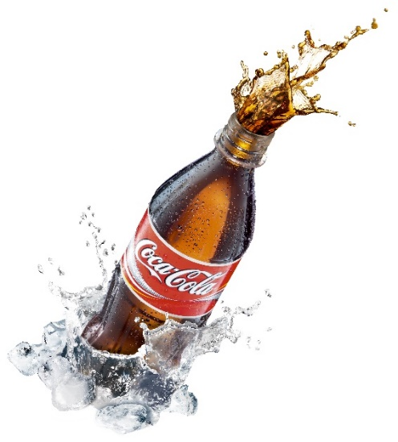
Why has Diabetes reached epidemic proportions in the Pacific?
- Poor Nutrition__________________________________
- Overweight / Obesity____________________________
- Lack of exercise / physical activity__________________
- Genetic Predisposition___________________________

UNDERSTANDING THESE REASONS
DIET AND NUTRITION
- We are eating _less____________ wholesome foods, and ___more__________ highly processed_________ foods (WHO STEP research)
- Processed or refined foods such as _sugar, white bread, white rice, white flour and noodles_______________________________________ _taste good_______________________ have become staple foods in the Pacific. Not only do they _taste good____, but are always ___available____ and very convenient____________. These foods have replaced much healthier foods on our tables and is one of the main reasons for the sudden rise in _diabetes______ currently being seen in the Pacific.
- Barbecued foods________ tastes a lot nicer than boiled foods. We love the taste of grease____________. Foods high in fat and taken too often are a major risk factor for Diabetes. High fatty meals can lead to _increased body weight and obesity.____. These are major risk factors for diabetes and _all other lifestyle diseases_____.
- Meats such as __lamb chops and lamb flaps are now common in the Pacific Islands. These meats are _full of saturated fats____________ - a significant risk factor for lifestyle disease.
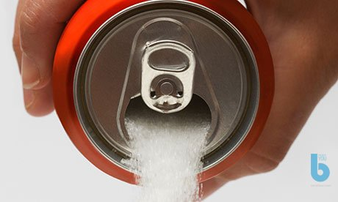
- Many Islanders love __processed meats__________ such as _sausage, corned beef _and luncheon meat______. Many are ignorant to the dangers of these foods. _Processed meats should be avoided____.
- Soft drink_____________ consumption is rising dramatically. These drinks are LOADED with _sugar______. In fact each 500ml can contains around _10 teaspoons_ of sugar!

PHYSICAL ACTIVITY AND EXERCISE
- Overall physical activity is only about ___25%____________ or less of what it used to be. __Modernisation_________________ and _development____________________ reached our shores not that long ago and brought with it a sedentary lifestyle._______________________ Whereas in the past we __walked, rowed, climbed___________________ and made gardens, today we drive cars, bikes or ride in taxis or buses. We find ourselves sitting in front of _computer_________ during the day and then ____TV at night (while we nibble on fatty, salty snack such as _CHIPS_______)
- We must make time for __active physical activity__________ - like going for an afternoon walk or an early morning run. Inactivity is a recipe for disease______.
OVERWEIGHT AND OBESITY
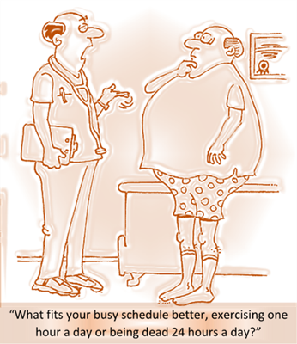
According to statistics, the South Pacific region is the most overweight region in the world and we’re unfortunately reaping the consequences of that, including;
- Type 2 diabetes
- Dyslipidaemia (abnormally high fat levels in the blood)
- Hypertension and stroke
- Heart disease – coronary artery disease ischaemic heart disease
- Liver disease
- Cancer risk
- Mood disorders
- Reproductive disorders
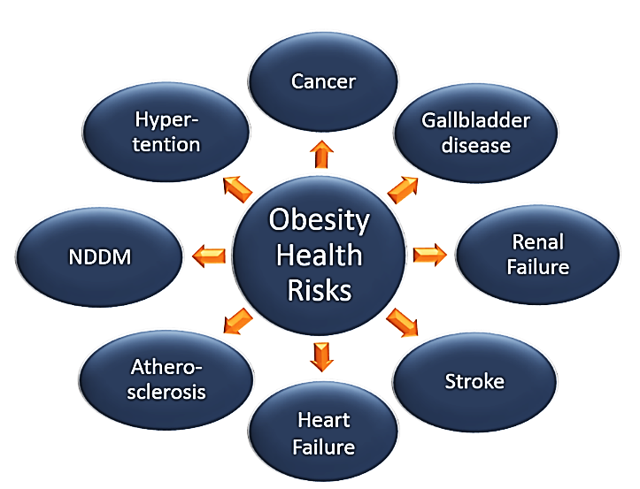
Complete the graphic on the left.
Overweight and obesity presents a major risk for all lifestyle diseases
Note:
NIDDM stands for ‘Non-insulindependant Diabetes-Mellitus’

READ THE INFORMATION BELOW AND ANSWER THE QUESTIONS
Preventative Steps to Avoid Diabetes and other Lifestyle Diseases
You might like to consider the following recommendations:
- Know your background
If you have a family member with a particular lifestyle disease, the chances are you may be at risk of developing that same disease. Understanding your background should help you make healthier choices in your life.

- Make healthy food choices
Choose to eat healthy foods. A healthier choice would be to include more of our traditional foods in your diet. Include more root crops such as taro, cassava and sweet potato in your diet as sources of energy instead of eating white rice every day. Brown rice is much healthier than white rice. The advice is to choose the healthier option and don’t be distracted by taste and convenience. Eat more fruits and vegetables because they contain heaps of protective nutrients. The different colours on fruits and vegetables represent protective nutrients called phytochemicals and antioxidants. These protect us from many different diseases. If you take meat, choose lean meat (meat with less fat on it). Avoid processed meats such as sausage or corned beef – processed meats are loaded with fats and cancer causing chemicals and not safe for human consumption. Steaming, grilling and boiling are healthier ways of cooking than frying, barbecuing or sizzling.
It makes a lot of sense to decide on healthier choices with foods - and the more you do it - the easier it becomes. In fact, you will live longer and experience less disease by doing so.
Choose healthy foods for good health and longevity. Eat mostly plant-based foods.

- Be Active
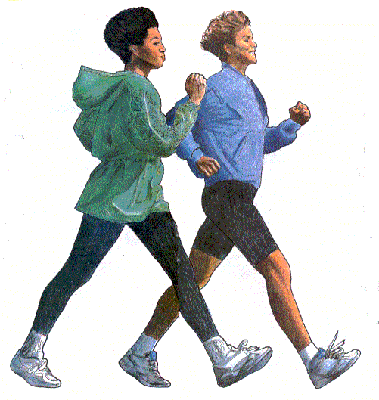
Active physical activity or exercise has a powerful and a very positive influence on health. In fact it is just as important to us as a good, healthy diet. Unfortunately, our lifestyle today allows no time or makes no provision for such simple yet profoundly beneficial blessing to our health and wellbeing. Exercise protects you from Diabetes because it helps the body cells respond better to insulin.

There is so much benefit in being active – A 30 minute walk every day can do you a lot of good.

See: http://www.womensheart.org/content/exercise/ starting a walking program.asp
______________________________________________________________________STUDENTS DO THIS PAGE BY THEMSELVES - EACH ONE WILL BE PERSONAL AND DIFFERENT ______________________________________________________________________
- What are the lifestyle diseases that are present in your immediate family (mum, dad, brothers, sisters and grandparents on both sides)?

Understand that you are at a higher risk of contracting any of these diseases and take action NOW to prevent them!

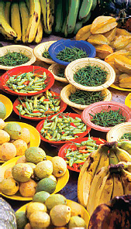
- List the processed food snacks you have eaten in the last week. What could you have replaced them with to reduce the risk of a lifestyle disease?
________________________________________________
________________________________________________
________________________________________________
________________________________________________
________________________________________________

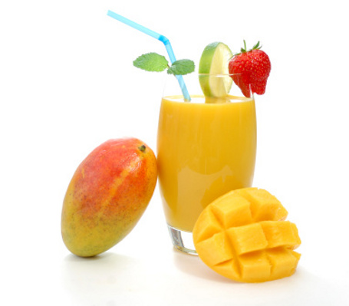
- How many serves of fruits (1 piece) and vegetables (1 Cup) would you average a day? The recommended intake is 2 fruit and 5 veg – do you achieve that? If not, offer some suggestions as to where you might be able to increase your intake.
________________________________________________
________________________________________________
________________________________________________
________________________________________________
________________________________________________

- List 5 ways you could increase the amount of exercise/activity you do in your day.
___________________________________________________________________________________________________________________________________________________________________________________________________________________________________________________________________________________________________________________________________________________________________

- Read the following statements from Mrs White. Summarise her main points regarding health habits:
- “Tea, coffee, tobacco, and alcohol we must present as sinful indulgences. We cannot place on the same ground, meat, eggs, butter, cheese, and such articles placed upon the table. These are not to be borne in front, as the burden of our work. The former - tea, coffee, tobacco, beer, wine, and all spirituous liquors - are not to be taken moderately, but discarded.” 3 Selected Messages, p. 287
- "It is for their own good that the Lord councils the remnant church to discard the use of flesh foods, tea, and coffee, and other harmful foods." Manuscript 71, 1908
- “If Seventh-day Adventist practiced what they professed to believe, if they were sincere health reformers, they would be a spectacle to angels and to man.” Councils on Health, p. 575
________________________________________________________________________________________________________________________________________________________________________________________________________________________________________________________________________________________________________________________________________________________________________________________________________________________________________________________________________________________________________________________

BENEFITS OF PHYSICAL ACTIVITY OR EXERCISE

- You will have lowered risk of heart and blood vessel disease
- You will have lowered (normal) blood pressure levels
- You will experience decreased risk of blood clots in the body
- You will have lowered heart rate and improved heart rhythm
- You will experience lowered risk of diabetes
- You will have improved glucose tolerance and control of diabetes
- You will have increased bone strength, decreased risk of osteoporosis (bone thinning) when you get old
- You will experience reduced risk of cancers
- You will have strengthened muscles with greater flexibility
- You will experience improved blood circulation and sleep
- You will experience improved management of body weight
- You will experience improved stress management
- You will experience improved mental outlook
- You will have a strengthened immune system

REMEMBER
Exercise comes after non-smoking as the behaviour that contributes positively to __every dimension of life. 80% OF HEART DISEASE, STROKE, DIABETES AND OVER A THIRD OF CANCERS COULD BE PREVENTED BY ELIMINATING THE RISK FACTORS OF _an unhealthy diet, physical inactivity, tobacco use and the harmful use of alcohol_____.

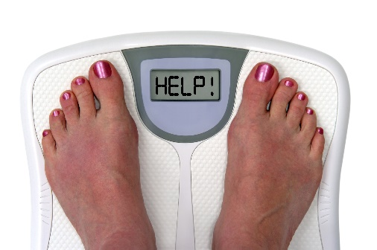
OVERWEIGHT AND OBESITY
According to a survey performed by the World Health Organization in
2007; the South Pacific is the world’s most overweight region. Sadly, most Pacific Island countries have made no real effort to deal with this major public health crisis.
SOME STARTLING OBESITY STATISTICS
Overweight/obesity is defined as
an abnormal or excessive accumulation of fat in the body with the potential of impairing or destroying a person’s health.
- Worldwide obesity has more than doubled since 1980.
- In 2008, more than 1.4 billion adults, 20 and older, were overweight. Of these over 200 million men and nearly 300 million women were obese.
- Today 65% of the world's population live in countries where overweight and obesity kills more people than underweight or malnutrition.
- More than 40 million children under the age of five were overweight in 2010.
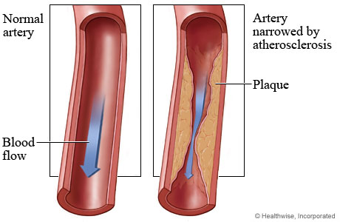
This picture illustrates a clean, healthy artery and an artery of which the walls are lined with fat causing it to narrow down significantly.

Ignorance says: _if it tastes good, then it must be good__. The truth is, foods such as _white rice, sugar, white bread, ice cream, butter, chips, oil and soft drinks___ have been stripped of their vitamins, minerals, fibre and phytochemicals that the body desperately needs for good health and are simply __highly refined, calorie dense, by-products. If these foods are taken in excess on a regular basis, the fats in these foods are stored in the body and the excess sugar is converted into more fats.

Consider these equations:
- Eating highly processed fast foods + low physical activity = overweight/ obesity
- Overeating (too much food) + low physical activity = overweight/obesity
- Eating too much late in the night = overweight/obesity

Are you at risk of any of these? How about your family members?
What about school friends?
NOTE: Any of these trends WILL lead to an increased risk of lifestyle disease
Circle the answer to the following questions:
 | Fast food alone will not cause obesity. | TRUE / FALSE
 | If I do my 30 minutes exercise every day I can eat junk food often. | TRUE / FALSE
 | You can overeat on ‘good food’ too. TRUE / FALSE | TRUE / FALSE
 | The food we eat just before we go to bed is stored as fat. | TRUE / FALSE
 | I can eat a lot more if I am doing a lot of hard exercise. | TRUE / FALSE
 | Our native root crops like taro and sweet potato are far superior to white rice. | TRUE / FALSE
 | It is important to eat foods of different colours at each meal. | TRUE / FALSE
 | Soft drinks and juices are a healthy source of water/fluid. | TRUE / FALSE
 | Being overweight is only a social/emotional problem. | TRUE / FALSE

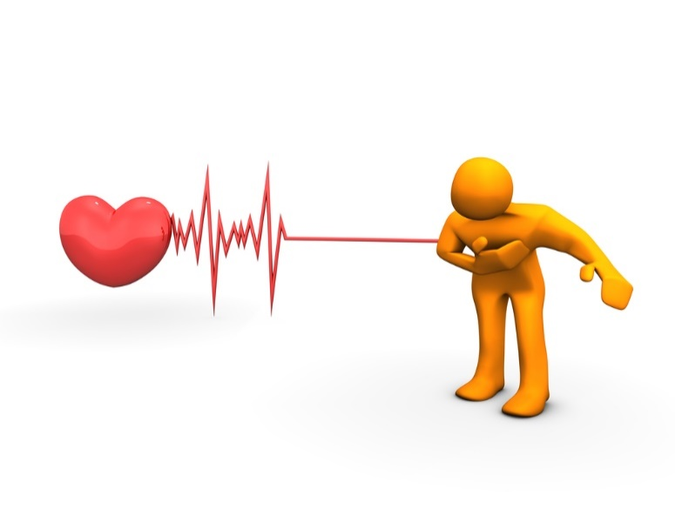
PROBLEMS ASSOCIATED WITH OBESITY
- HEART DISEASE
If you are overweight you have an __increased risk of having a heart attack._.
A heart attack usually presents with a __ left sided chest pain________ that
is described as _heavy______________ and ____constricting_____________. This pain often goes down the __left arm, shoulder, neck or upper abdomen__________________ and is associated with nausea and shortness of breath. TOO OFTEN THE FIRST SIGN OF A HEART ATTACK IS SUDDEN COLLAPSE AND DEATH.
- DIABETES
Being overweight is a major risk factor for Diabetes. Common diseases related to Diabetes include heart attacks, hypertension, kidney disease, stroke and gangrene.
- HIGH BLOOD PRESSURE
High blood pressure (also called _hypertension______) is a common complication of being overweight._________________________________. It is a dangerous condition that can lead to heart disease, stroke, kidney failure and blindness_.
- STROKE
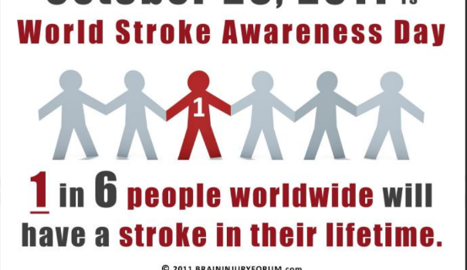
Overweight/obesity is an important risk factor for stroke.
The _hypertension______ and cholesterol__ levels can easily lead to __blood vessel damage____ in the brain leading to blood vessel __rupture___ and therefore a stroke____.
- METABOLIC SYNDROME
This syndrome consists of a number of conditions existing together and include: _being overweight, having high blood sugar levels, high blood pressure and high blood cholesterol or fat levels in the blood.
- HIGH CHOLESTEROL
Cholesterol is actually an essential nutrient. This means the body __requires____ cholesterol for some very important functions. We get cholesterol in our body by two main ways; first _our body makes it in the liver______ and second _is from the food we eat___. Only foods of animal origin have cholesterol. E.g. _meat, cream, cheese and eggs. Cholesterol is basically __fat _ and too much of it will give rise to disease.
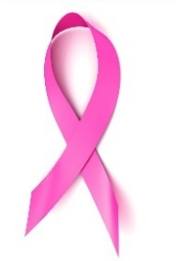
- CANCER
Being overweight or obese is a risk factor for the following cancers:
uterine, cervix, ovarian, breast, colon, rectum and prostate_____________
- SLEEP APNOEA
This is a potentially serious form of _sleep disorder__ in which breathing stops__ for __several seconds_ to a ___minute___ and repeated up to _30__, _40_ or even _100_____ times during the night. Sleep apnoea occurs when the walls of the throat _come together__ during sleep, blocking the airway. There is usually a lot of snoring__ involved as well. This situation can be especially bad for the _heart___ because the oxygen level can drop significantly in a short space of time. People suffering from sleep apnoea are at risk of developing _heart disease, hypertension, stroke and sudden death____. Other associated problems include _fatigue, tiredness____ and lack of _concentration____ due to lack of sleep. The best treatment for sleep apnoea is _losing weight_______.
- GALL BLADDER DISEASE
In overweight people, the gall bladder becomes _inflamed____ and can have _stones_ forming in it. These stones are commonly cholesterol. Poor diet (high in cholesterol____ and low in __fibre___) contributes to gall bladder stone formation. Women are __two times_______ more affected than ___men___.
- GYNAECOLOGIC PROBLEMS
Being overweight or obese can lead to problems in women such as irregular monthly periods, infertility_ or the ___inability to have children______
- ERECTILE DYSFUNCTION AND SEXUAL HEALTH ISSUES
This is a male problem and is due to deposits of __fat____ blocking or narrowing the __arteries to the genitals.
- NON-ALCOHOLIC FATTY LIVER DISEASE
This is where _fat builds up__ in the liver fat and can cause inflammation_ or scarring of the ___liver tissue____.
- ARTHRITIS
Excess weight can cause _pain____________ and ___swelling________________ on the knees____________ and _ankles______________. This arthritis can be very painful_______________ and affect __mobility__________________.

- SKIN PROBLEMS
Problems with the skin can include poor __wound healing__________________________ after injury.
- DEPRESSION
When a person is overweight their overall _quality of life___________ will suffer. They may not be able to _do things they would normally enjoy___ as easily as they would like. They may have trouble __participating________ in family activities. They may avoid_____________ public places and even encounter discrimination____________ that can lead to depression. Other weight related issues that may affect the quality of life include disability, physical discomfort, sexual problems, shame, and social isolation.
WAYS TO AVOID OVERWEIGHT AND OBESITY:
- Eat wholesome foods – fresh foods are much healthier than processed foods
- Eat more fruits and vegetables
- Replace white rice with taro, cassava or sweet potato
- Decrease your salt intake
- Decrease your sugar intake
- Beware of sugar/fizzy drinks – these drinks are loaded with sugar and can be fattening because of the high calories they contain
- Lean fresh meat is safer than lamb chops or lamb flaps. Avoid sausages and corned beef – these foods are high in fats and salt. Fresh fish is a better alternative to meat.
- Reserve ice cream, cakes and cream biscuits and other treats for only special occasions
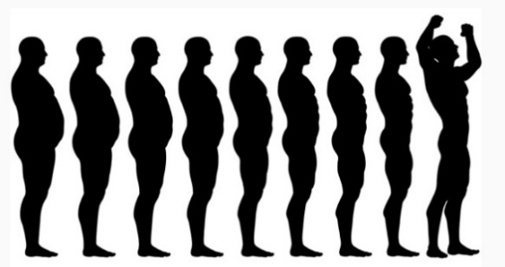
- Avoid overeating
- Learn to control your appetite
- A light dinner can help you lose weight
- Have an early dinner – don’t leave it too late
- Drink plenty of water
- Remember: “fast foods” can be very addictive and can lead to overeating.
- Remember the three keys of good Nutrition: Balance, Variety, Moderation
- Pray for strength to control addictions to food
- Be as active as you can – because the benefits are HUGE.

OVERWEIGHT AND OBESITY
A T H E R O S C L E R O S I S H G C L G
K C A T T A T R A E H K K E G Y V I I N
D E P R E S S I O N N F N L J P V W A I
M K A F E W I Y C I L O B A T E M A R T
A O C U F X T T R D T Q Q W R R K T T A
E E D A G E E D I S E Q N D V T M E E E
O P T E I U T R T R P A I O E E E R R R
N S E R R F R H C W H S T H C N P P Y E
P J A I O A H E E I E T V H N S Z L N V
A V S S S Q T X D A S T R L A I D A O O
J O G G I N G I S D L E W A L O I N I H
E K O R T S O E O P A T F A A N A T T P
A C T I V I T Y R N A L H P B G B B C R
H D O O F E G O Y P A R B C H S E A I E
X E B I X O C N P C J E E L R W T S D N
Y D A C C E V E I H S Y V C L I E E D C
G U E L S G T S V L X G N J N A S D A R
Z S R S T I Y S U G A R C Z U A G I J C
S D E B T H J S T M W E G G U R C C S E
Y D V E P Y T I S E B O H Y Z Q L G W U

ACTIVITY (1,13,E)
ADDICTION (19,17,N)
APNOEA (1,10,N)
APPETITE (11,13,SW)
ARTERY (19,3,S)
ARTHRITIS (14,11,NW)
ATHEROSCLEROSIS (1,1,E)
BALANCE (15,13,N)
CANCER (17,19,NW)
DEATH (10,5,SE)
DEPRESSION (1,3,E)
DIABETES (17,10,S)
EXCESS (6,14,SW)
EXERCISE (5,4,SE)
FATS (5,5,SW)
FOOD (5,14,W)
GALLBLADDER (17,18,NW)
HEALING (13,20,NW)
HEALTH (1,14,SE)
HEALTHCRISIS (8,8,SE)
HEARTATTACK (11,2,W)
HYPERTENSION (16,1,S)
JOGGING (1,11,E)
LIVERDISEASE (19,1,SW)
METABOLIC (17,4,W)
MODERATION (1,4,SE)
OVEREATING (20,10,N)
PHYSICAL (5,20,NE)
PLANTBASED (18,8,S)
PROCESSED (10,12,SW)
SOFTDRINKS (4,10,NE)
STONES (10,6,NE)
STROKE (6,12,W)
SUGAR (8,18,E)
VARIETY (2,10,NE)
WATER (18,3,S)
Find all of these words relating to this topic in the puzzle above

Sollution Key
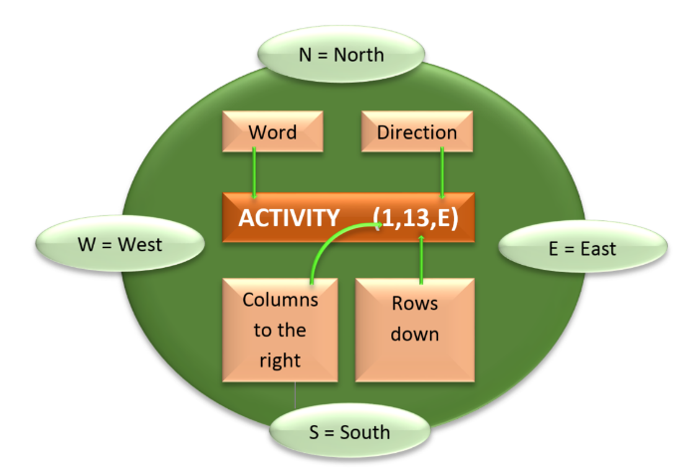

CORONARY HEART DISEASE
The heart is an important organ in the human body. It is located __in the chest_________ and is a muscular pump_________. Its main function is to _pump blood throughout the body______. Blood transports __oxygen and many important nutrients such as glucose (sugar)____ to all body cells. These nutrients are used by the body cells to carry out their work and to __keep us alive____.
ROMANS 12:1
I beseech you therefore, brethren, by the mercies of God, that ye present your bodies as a living sacrifice, holy and acceptable unto God, which is your reasonable service.

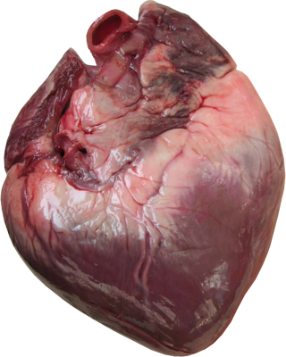
This is what the actual heart looks like. It is an amazing organ. It is made up of muscles and its main function is to pump blood throughout the body.

SOME AMAZING ‘HEART FACTS’
- The average adult heart beats approximately 72 times a minute, 100,000 times a day, 3.6 million times a year, and 2.5 billion times during a lifetime. TAKE YOUR PULSE FOR ONE MINUTE AND RECORD THE NUMBER HERE _______________. If this is your average pulse rate, how many times will your heart beat in the next hour? _________________ (multiply by 60).
- Though weighing only 300 grams on average, a healthy heart pumps 7500 litres of blood through approximately 100,000 kilometres of blood vessels each day.
- The volume of blood pumped by the heart can vary over a wide range, from five to 30 litres per minute. During an average lifetime, the heart will pump nearly 5.7 million litres of blood. A kitchen tap would need to be turned on fully open for at least 45 years to equal the amount of blood pumped by the heart in the average life time of a person.
- The heart pumps blood to almost all of the body’s 100 trillion cells. Only the corneas in your eyes receive no blood supply.
- The heart does the most physical work of any muscle during a lifetime.
- The heart begins beating at four weeks after conception and does not stop until death.
- We all have only one heart each... so take good care of it.
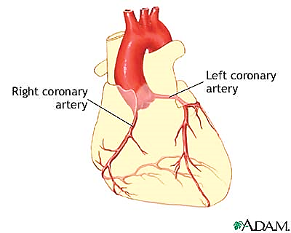
BLOOD SUPPLY TO THE HEART
Aorta
The heart receives its blood supply through the coronary arteries. There are two coronary arteries – the right coronary artery, and the left coronary artery.
As you can see, they are not big arteries, they are actually quite small, but vital! They supply blood to one of the most important organs in the human body – the heart.
(COLOUR THE AORTA AND THE LEFT AND RIGHT CORONARY ARTERY RED – and label each.)

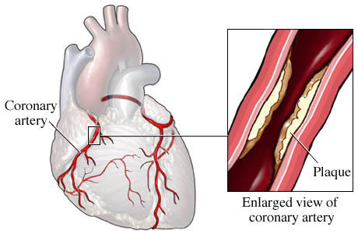
CORONARY HEART DISEASE (CHD)
CHD occurs when a person’s coronary arteries is clogged with fatty material called plaque_____________. This is the build-up of __cholesterol and fatty deposits___ on the inner linings of the arteries. As plaque builds up, the artery gets _narrower and narrower__. This does not happen overnight – it usually occurs silently over __many years_____________________. In fact, this process begins early on in life and __lifestyle________________ plays a major part in it.

RISK FACTORS FOR CHD
The build-up of cholesterol plaque thickens the arteries, making it difficult for blood to _get to the various parts of the heart____________________. The primary factors that cause this build-up are lifestyle and behavioural patterns such as _ eating a diet high in fat or being overweight or obese. Lack of exercise ___________________ and _cigarette smoking__ are also major risk factors for coronary heart disease.
- Diets high in fats________________________. Too much fatty food can lead to an increase in cholesterol levels in the blood and can lead to CHD. Dietary cholesterol comes from ______animal fats_______________________.
- Lack of physical exercise: Calories not used by physical activity can lead to increased fat levels_________________ in the blood. This can cause blood vessel damage___________ and plaque ___formation___. Exercise helps us burn these excess calories from the food we eat and thereby __protect us _______ from heart disease.

- Hypertension________ damages the _internal linings______ of the arteries.
- Diabetes - or high blood sugar levels damages the _arteries__________________. This predisposes them to _plaque formation in the coronary_.
- Obesity – People who are overweight run the risk of developing CHD (_Coronary Heart Disease_) because of the high levels of _fat_____________________ in the body. They are also prone to developing diseases such as _hypertension_____________________ and ___diabetes______ which are also major risk factors for CHD.
- Cigarette smoking____ causes blood vessel damage, and _increases_____ the bad cholesterol called “Low density Lipoprotein” (LDL) which is a major risk factor for CHD.
- Alcohol________ intake increases fat levels in the blood. It can also lead to increased blood pressure_________ and it also damages the __heart muscle directly___.
- A strong family history of CHD provides a _high______________ risk of dying from CHD.
- Male gender_____. Males have an increased risk of developing __heart disease_ than females.
- Age above _50 years_______ years. The older you get, the _____higher______ the risk.
HOW PLAQUE DEVELOPS INSIDE THE CORONARY ARTERIES
This is a normal coronary artery. There is no evidence of any narrowing and the blood is flowing__________________ freely as shown by the arrow.
There is a plaque (accumulation of fat_ and other substances) developing in this coronary artery. This process is __silent__ and develops over several years. The plaque is formed by cholesterol and blood components. This artery is now significantly __narrowed. The person may feel perfectly well even at this stage.
Plaque ruptures
(with clot formation)

Plaque

As the plaque develops further, it reaches a point where it _ruptures__. This happens suddenly and without warning! There is bleeding with _clot formation__. The clot completely blocks the artery obstructing bloodflow to the heart muscle and the person suddenly collapses. This is what is often referred to as a __heart attack.
CHOLESTEROL
- The body __makes_______________ Cholesterol.
- The problem comes when MORE cholesterol is ___also eaten___________________.
- Dietary cholesterol comes from eating __animal products (food that come from an animal)______.
- In the blood, cholesterol is transported by special carrier particles called __lipoproteins_
- There are ___2____ types of Lipoproteins. 1. _Low Density Lipoproteins_____ (LDL) 2. High Density Lipoproteins____________ (HDL)
- For the sake of simplicity, Cholesterol is classified as LDL cholesterol – which means the cholesterol is transported by ___low density lipoprotein particles_ and HDL cholesterol – which means the cholesterol is transported by _high density lipoprotein particles___.

The difference between the two is SIGNIFICANT!
- LDL cholesterol – (think of ‘___little devils________’) promotes serious health problems including __coronary heart disease_______ and ___stroke______ by depositing cholesterol in ____arterial walls___________. LDL cholesterol promotes ____plaque formation________________________ in arteries in the heart, brain and other parts of the body. Because of this they are described as bad cholesterol particles_________________.
SOURCES OF LDL
Animal products such as beef, chicken, lamb and processed meats, egg yolk and dairy products. ______________________________________
- HDL cholesterol – (think of ‘_heavenly darlings____________________’) on the other hand __remove__________ cholesterol from within the walls of the arteries and __transport___ it back to the ___liver_______ for removal from the body. By doing this, HDL cholesterol protects us from _heart disease_____________ and other diseases. This is why it is called the ___good cholesterol__________. Those with ___higher levels_ of HDL Cholesterol seem to have fewer problems with CHD, while those with low HDL cholesterol levels have _higher___________ rates for heart disease and strokes.
SOURCES OF HDL
Fish, whole grain and high fiber foods such as brown rice, brown bread and oats, fruits and vegetables and nuts.______

HOW TO PREVENT CHD
- Be physically active._ Physical inactivity is the ___4th_____ leading risk factor for global death, after __high blood pressure__, __smoking_________ and __diabetes___.
Some startling numbers for you:
- 3.2 million__ deaths per year due to inactivity.
- 670,000______ premature deaths (people aged under 60 years) due to physical inactivity.
- Lack of physical activity is estimated as being a cause of __breast and colon cancer, 27%_ of diabetes and __30%__________ of CHD.
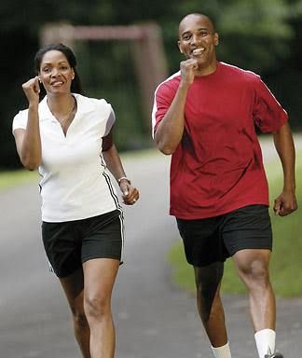
30 minutes of brisk walking benefits your health.
Regular exercise: reduces the risk of coronary heart disease, stroke, diabetes, hypertension, colon cancer, breast cancer, osteoporosis, and depression_____

It also burns excess calories and allows you to maintain _a healthy weight__________ which is important in preventing not only Coronary Heart Disease (CHD) but all other lifestyle disease as well.

- Avoid Alcohol______________________________
Alcohol __increases___ blood cholesterol levels and can damage arteries leading to plaque formation_____ and CHD. Alcohol has been implicated in the development of __ heart disease, stroke, cirrhosis of the liver and cancer.______________.
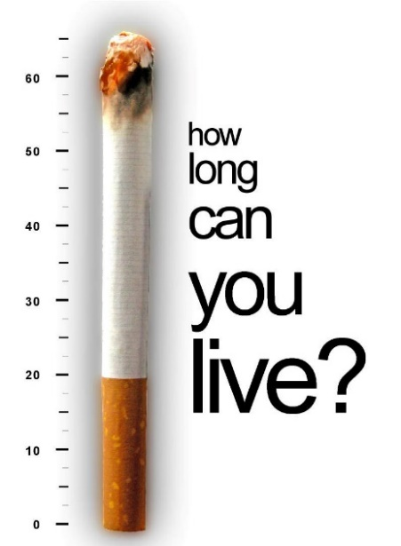
- Avoid cigarette smoking_______: This is a major risk factor for CHD and many different __cancers. Smoking can damage _blood vessels___________________, lead to __unhealthy cholesterol levels__________ and _raise blood pressure_____. It also limits how much oxygen__________________ reaches the _heart muscle____________ and other body tissues.

- Limit consumption of red meat and avoid processed foods
Animal flesh is the main source of _ LDL cholesterol.________________. Lamb flaps and chops especially are full of fats and therefore should be taken only in very small amounts (if at all!) _ Remove__________ all visible fat prior to cooking, but BEWARE – there is still much fat lurking in the tissues of the animal! Processed meats such as __ corned beef and sausages ______ are particularly dangerous – not only because of their high __ cholesterol content_________ but also because of a high amount of __cancer causing chemicals_________ found in them.
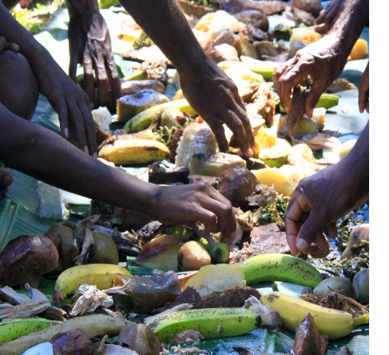
- Eat more plant foods such as fruits and vegetables. These foods are full of protective elements that the body needs to _ protect_ itself from ___ disease___. The best advice: return to our traditional diet.____ This diet was full of ___ root crops, fruits and vegetables.____. Avoid processed foods.____ as these are ______ high in fats, salt and calories___.

- Maintain a normal weight.___ Overweight/Obesity are major risk factors not only for CHD but for __ many cancers________________ as well.
- Trust in God_____________________________. Ask God to help you choose a healthier lifestyle. Only God through His Spirit can help you and I make the necessary changes to turn our life around.
Write out Philippians 3:18-21: For, as I have often told you before and now tell you again even with tears, many live as enemies of the cross of Christ. ¹⁹ Their destiny is destruction, their god is their stomach, and their glory is in their shame. Their mind is set on earthly things. ²⁰ But our citizenship is in heaven. And we eagerly await a Saviour from there, the Lord Jesus Christ, ²¹ who, by the power that enables him to bring everything under his control, will transform our lowly bodies so that they will be like his glorious body.

HIGH BLOOD PRESSURE (HYPERTENSION)
High blood pressure is sometimes referred to as the __silent killer___________ because it may have no outward symptoms for years. In fact _one_____ in __five_____ people with hypertension don’t even know they have it. _internally______, it can quietly damage the heart, lungs, blood vessels, brain, eyes and kidneys_____________ if left untreated.
WHAT IS BLOOD PRESSURE?
- Blood pressure is the force of blood pressing against the _walls__________ of your arteries when your _____heart beats______.
- Each time the heart beats and blood flows, a certain amount of pressure______________ is creased within the ____arteries___________.
- This pressure helps to __push__________ blood through the big arteries, small arteries and then on to very tiny arteries called ____capillaries______________ so that cells can receive _______oxygen_______ and __life sustaining nutrients___________.
- The Blood pressure must be kept at a certain __normal_____ level at all times – it mustn’t go too high OR too __low_________.
- Hypertension_________________ (“HIGH BLOOD PRESSURE”) can cause many major health problems.
- Low blood pressure_____________ (‘HYPOTENSION”) means the blood becomes stagnant________ and cannot flow to the cells and a person can die as a result of this.
- Blood pressure changes throughout the day. It is at its lowest when you are __sleeping and rises when you get up. It can also rise when you are _excited, nervous, stressed or active_____________________.
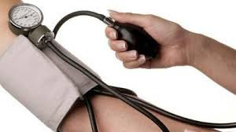
- Doctors or nurses use a special instrument called a _spygmomanometer____________ to record blood pressure readings.
- Your blood pressure is at its highest when _the heart beats_______________ and the pressure created is called the _systolic pressure__.
- When the heart is at rest (between beats) your blood pressure falls – this is called the _diastolic pressure. Both readings are important.

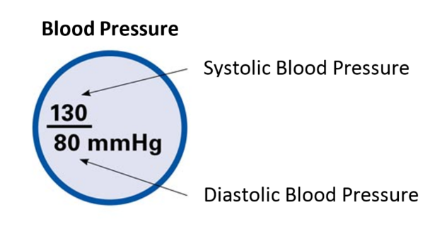
Normal blood pressure ranges between 90/60 to 120/70. Any reading over 130/80 (either number) and sustained over a long period of time is considered a sign of hypertension.

THE SILENT KILLER
Many people with hypertension fail to undergo _blood pressure checks_____________ and so are unaware of it. The only way to find out about your blood pressure is to have it checked regularly_________________ by a health professional such as a nurse or doctor.
Untreated hypertension KILLS by causing _severe internal damage___________________.
SOME PEOPLE may experience vague symptoms such as __headaches, dizziness, shortness of breath and in severe cases blurred vision__. Often the first sign may be a _heart attack, stroke or kidney failure______________________. By this time, it may be too late to do anything.
CAUSES OF HIGH BLOOD PRESSURE
- Heredity_________. If others in your family have it then your risk increases dramatically.
- Race____________. Dark skinned people are more likely to develop __high blood pressure.
- Age_____________. Usually occurs in people older than _35_____________ and chances of developing the disorder increases with age.
- Lack of physical activity_____. People who are active and who do regular exercise have a healthier _cardiovascular systems (heart and blood vessels) .
- Overweight/Obesity____________. Being overweight or _obese__________ is a MAJOR risk factor for high blood pressure. Being overweight places a strain __on your heart__________ and increases your risk of hypertension dramatically. The advice is to __cut out fatty foods and added sugars_______________ and increase _fruits, vegatables____________ and _fibre__________. Losing just a few kilograms can make a _huge difference________. A slender or thin person is much less likely to develop _hypertension____________________.
- High salt intake____________. __Sodium__________________, which is the major component of salt can raise blood pressure by causing the body to _retain fluid_______. This leads to a greater burden on the __heart______________. You should only have about a __one teaspoon_ of salt a day. But remember this isn’t just the salt you add to your food through the salt shaker. Large amounts of salt is also ____found________________________ in many popular foods such as __2 minute noodles, chips (hot and cold), stock, sauces, pizza, most take-away foods, and salted nuts. _____.
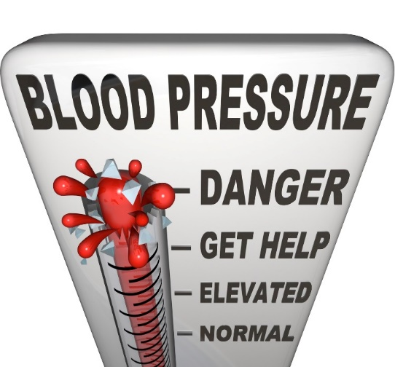
- Alcohol______. Like cigarette smoking, this damages the heart and blood vessels and so increases the risk of high blood pressure. Total abstinence________________ from alcohol is the most sensible thing to do.
- Cigarette smoking___. Nicotine found in cigarettes have been shown to increase blood pressure.
- Diabetes___. This destroys blood vessels in major organs thus increasing the overall blood pressure.
COMPLICATIONS OF HIGH BLOOD PRESSURE
High blood pressure can lead to serious health problems. Over time, uncontrolled high blood pressure increases the risk of disease in the heart, arteries (blood vessels), brain, eyes and the kidneys. With high blood pressure, the heart works harder, your arteries take a real beating, and your chances of a stroke, heart attack, and kidney failure are much greater.
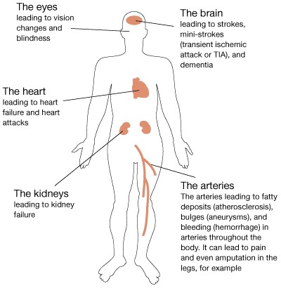
”But the fruit of the Spirit is love, joy, peace, longsuffering, gentleness, goodness, faith, meekness and temperance. Against such there is no condemnation
Galatians 5:22, 23

ISCHAEMIC HEART DISEASE: High blood pressure damages the heart and __Blood vessels__.
STROKE: Remember a Haemorrhagic stroke is caused by the __rupture_______________ of a blood vessel. The chances of this happen increase when the pressure is increased.
KIDNEY FAILURE: Each person has _two__ kidneys. They work to _filter______ or clean the blood from excess ___water_____________ and ___waste products_____ generated by the body. This process depends on __healthy blood vessels_ within the kidneys. High blood pressure can significantly injure blood vessels in the kidneys and can cause serious kidney disease leading to _____kidney failure_______________.
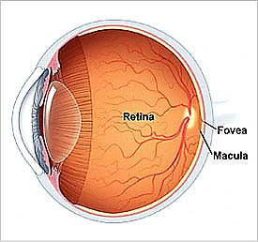
BLINDNESS: Hypertension can cause major damage to an area at the back of the eye called the __retina_____________. This is the part inside the eye that _senses light_______. The damage to the retina can be serious and lead to blindness if the high blood pressure remains untreated.
This picture illustrates damage created by high blood pressure to the retina. The retina has white and red discolouration all over. These represent inflammation. This patient’s vision or eyesight would be poor.

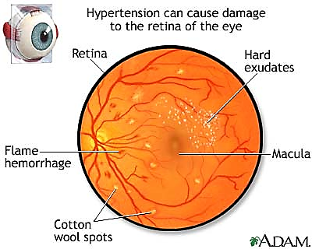
CONCLUSION
Many people in the South Pacific have high blood pressure. It is a serious health problem in our region. High blood pressure should be taken seriously because it is a major killer and because it is mostly silent in its effect on the body and causes very little symptoms, millions of people do not even know they have it. High blood pressure affects people of all ages, race and ethnic groups.

DISCUSSION QUESTION:
Blood pressure can increase when you worry about things. As Christians we are given many promises that should combat that. For example Matt 6:34, John 14:1, Prov 29:25, Phil 4:6.
Then discuss this statement:
‘CHRISTIANS SHOULD NEVER HAVE HIGH BLOOD PRESSURE’: _________________________ _____________________________________________________________________________________________________________________________________________________________________________________________________________________________________________________________________________________________________________________________________________________________________________________________________________________________________________________________________________________________________________________________________________________________________________________________________________________________________________________________________________________________________________________

CHD and HYPERTENSION
Complete the crossword below

_________________________
Name

Across | Down
4. Increased fat levels in the blood can do this to blood vessels. damage | 1. The common blockage in an artery. plaque
7. Symptom of high blood pressure. headaches | 2. Eating too much of this can lead to Hypertension. salt
9. Something that damages the heart muscle directly. alcohol | 3. Hypertension can damage this part of the eye. retina
10. Body part possibly effected by high blood pressure. eyes | 5. Very overweight. obese
12. Blood transports this. oxygen | 6. Found in all animal products and no plant products. cholesterol
13. The pressure when the heart beats. systolic | 7. What damages the internal lining of arteries? hypertension
15. The most dangerous form of meat. processed | 8. Haemorrhagic stroke can occur once this happens to a blood vessel. rupture
17. Recommended dosage of alcohol. abstinence | 11. Low blood pressure. hypotension
20. What week of pregnancy does the heart start beating? four | 14. High blood pressure is often called the silent______. killer
21. Particles that transport cholesterol in the blood. lipoproteins | 16. The likelihood of this disease in increased if you have hypertension. stroke
23. Where the heart is located. chest | 17. The major artery that leaves the heart.  aorta
26. The 'Bad cholesterol'. ldl | 18. Risk factor for CHD. smoking
27. The 4th leading risk factor for global death. inactivity | 19. Where dietary cholesterol comes from. animal fats
 | 22. The heart is a muscular ________. pump
 | 24. The 'Good cholesterol'. hdl
 | 25. Philippians tells us that for many people, this is their god. stomach

CANCER
Just the mention of the word cancer brings so much fear to the hearts of many people and rightfully so. Cancer is a terrible disease to have. Cancer has killed millions of people around the world and yet we still do not know exactly how it starts and why it behaves the way it does.
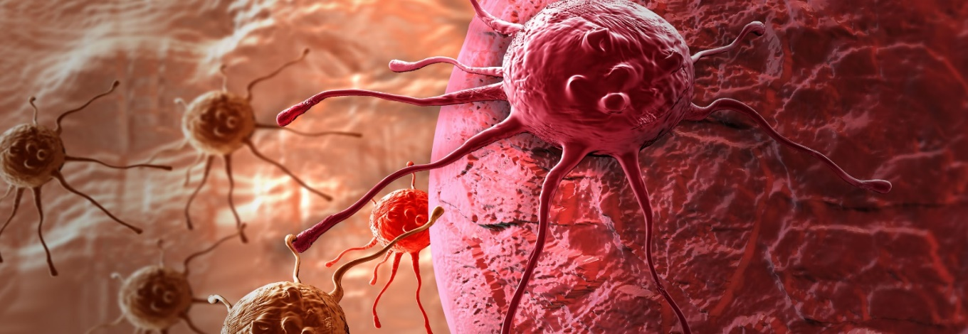
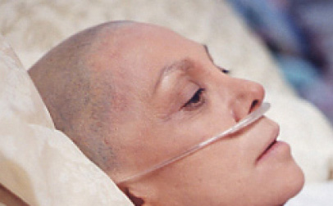
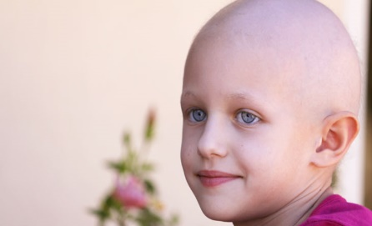
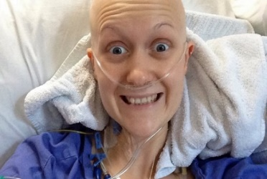
Cancer is a name used for a big group of diseases that can affect any part of the body. Other names used for cancer are malignant __tumours______________ or _________neoplasms_. One defining feature of cancer is its ability to grow rapidly, growing beyond their boundaries and spreading to other parts of the body – a cancer characteristic known as __metastasis_.
Cancer is a leading cause of death worldwide accounting for 7.6 million deaths in 2008 alone. Below is some information about cancer:
- Lung, stomach, liver, colon and breast cancer cause the most cancer deaths each year
- The most frequent types of cancer differ between men and women. About 30% of cancer deaths are due to the five leading behavioural and dietary risks:
  - Overweight/obesity
  - Low fruit and vegetable intake
  - Lack of physical activity
  - Tobacco use
  - Alcohol use
- Tobacco use is one of the most important risk factor for cancer causing 22% of global cancer deaths and 71% of global lung cancer deaths.
- About 70% of all cancer deaths in 2008 occurred in low- and middle-income countries like the countries of the South Pacific.
- Deaths from cancer worldwide are projected to continue rising, with an estimated 13.1 million deaths in 2030.
It is clear that cancer is a growing problem worldwide.
UNDERSTANDING CANCER
To understand cancer, one must understand the tiny cell which is the basic _building block__ of the human body. The human body contains approximately _100 trillion________________ cells. Examples include _liver cells, brain cells, skin cells, kidney cells, eye cells, bone cells, hair cells, finger nail cells, etc ___________________________________________________.

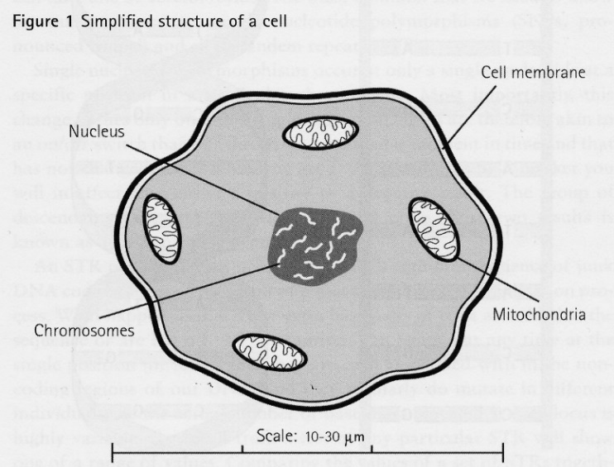
Note the various structures that make up a cell. These structures work together to enable the cell to _carry out its work properly and keep the cells alive_. Cells __divide__________ to replenish themselves and in this process, old cells die and new ones __replace them____. This process is always carried out in an orderly and coordinated way. Cells may differ in size and shape but they all have similar __structures and components.

CELL NUCLEUS
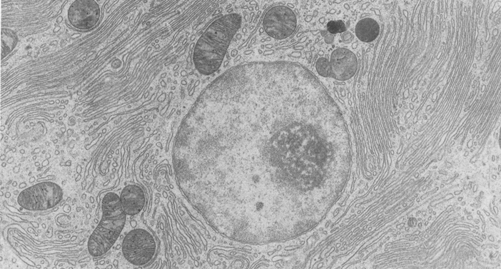
All cells have a control centre called the nucleus. The nucleus directs all _cell activity__. Placed within the cell nucleus is the genetic material called __deoxyribonucleic acid___ or DNA for short. The DNA has in it all the information that is required by the cell to do its work and to reproduce_______________. Think of the cell nucleus and the DNA inside it as the _brain of the cell__________. Sometimes the DNA can be damaged or changed due to injury. When the DNA is damaged, normal cell growth and division can be seriously affected and this can lead to the uncontrolled cell growth called _cancer____________.
Nucleus
This picture of a human cell shows the cell nucleus. The nucleus contains the genetic material, DNA. Any injury or damage to the nucleus or the DNA can lead to the development of cancer. This explains the fact that all cancers begin in the cell when there is damage to the DNA.
Normal cells: Normal cells are arranged in a neat and orderly manner. Each cell fits into its right space and respects its neighbouring cell. Below is a diagram that shows how normal cells make up the tissues in the body. Appreciate the orderly way in which the cells are arranged. It is amazing how God created each one of us - scripture tells us that we were created so “fearfully and wonderfully”.
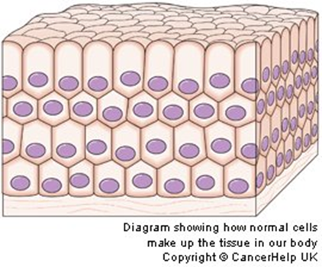
Note the neat arrangements of the cells of this particular tissue. Also note that each cell has a nucleus – the “brain” of the cell that controls its function and reproduction.

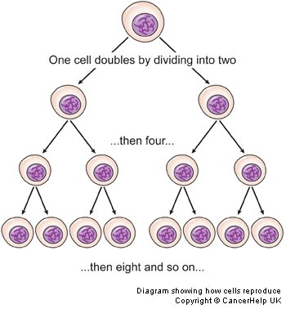
Under the careful control of the DNA, cells divide and multiply at the right time and stop dividing and multiplying at the right time.

Normally, cells grow and divide to form new cells __as the body needs them______. Old cells die, and new cells are formed to take their place. There is an inbuilt _control or safety mechanism__________ that safeguards this very important process. Sometimes however, this orderly____ process goes wrong and new cells are formed when the body does not need them. These news cells tend to grow _out of control____________, dividing and multiplying at their own will and disregarding all control mechanisms. This is basically what cancer__________ means – a cell or groups of cells disregarding the body’s control mechanism and growing out of control.
Example: When there is a cut on the skin, the cells at the site of injury start growing, dividing and multiplying. The aim is to fill and close the gap or the wound that has been created. One cell doubles by dividing into two and then four and then eight and then 16 and so on until the gap is completely filled. There is an inbuilt mechanism in each cell designed by God that tells it to stop growing and multiplying when the gap in the wound is completely filled and the wound has healed. This process can take days, weeks or months depending on the size and the type of the wound.
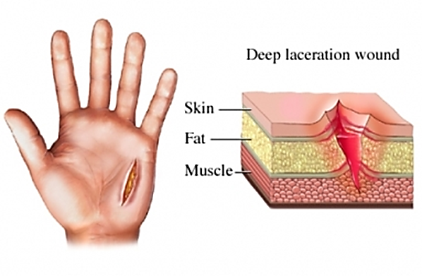
Cells at the area of the injury start dividing, growing and multiplying to close the gap created and heal the wound.

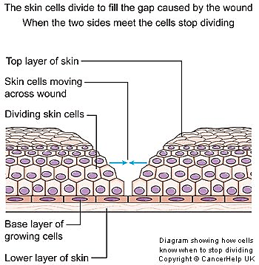
The diagram on the left illustrates a healing wound. There is a deep cut in the skin as illustrated, and the cells from the two sides and the base of the wound begin dividing and multiply to close the gap and heal the wound. In the normal situation cells stop growing and multiplying when the wound has healed.

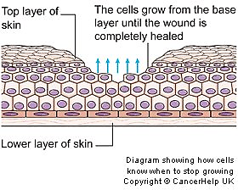
This next diagram illustrates the same healing wound as above. Cells have started growing from the bottom upwards and from the sides inwards. Cells stop growing when the healing process is complete. There is an inbuilt mechanism within the cells that tells them to stop growing when healing is complete. This mechanism is lost with cancer cells and so they keep growing and growing causing destruction and death.

Cancer starts in the cell when there is damage to the DNA
Cancer starts in the cell – it may be in one cell or a group of cells. This happens long before a person feels sick. Cancer starts when there is _damage or change_____________________ in the DNA of a cell. The cell affected by cancer behaves in a totally __abnormal__________ way. It does not listen to the rest of the body. It grows and grows, destroying normal cells and eventually kills by starving the body of essential __nutrients___________. Below are some of the characteristics of cancer cells:
- Cancer cells don't stop growing – they keep growing and growing and in the process invade and destroy normal cells.
- Cancer cells don't obey signals from other cells – they work independently with no control whatsoever.
- Cancer cells don't stick together – they can quickly spread to other parts of the body and keep growing, a situation called “metastasis”.
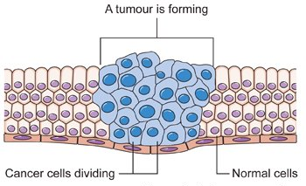
This diagram shows cancer cells (in blue) growing, multiplying, expanding and invading normal cells. This is how cancer cells form tumours or a hard mass for example in the abdomen, liver, chest or in other parts of the body. Note that the cells are bigger and abnormal looking and irregular in size and shape.

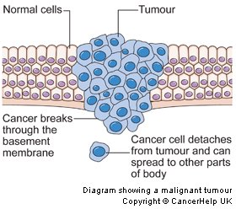
This diagram illustrates cancer cells (coloured blue) growing and expanding and breaking through normal boundaries as shown at the top and bottom section of the diagram.
Note a cancer cell breaking away from the rest. This cancer cell can travel to any part of the body and keep growing there. This is the commonest way cancer kills people. A cancer cell spreading to other parts of the body is called “metastasis”.
This diagram illustrates cancer cells (coloured blue) growing and expanding and breaking through normal boundaries as shown at the top and bottom section of the diagram.
Note a cancer cell breaking away from the rest. This cancer cell can travel to any part of the body and keep growing there. This is the commonest way cancer kills people. A cancer cell spreading to other parts of the body is called “metastasis”.
WHY?
Short answer – We don’t know why cancer behaves the way it does.
But, because of the vast amount of research that has been done, we do know certain _risk factors_________________ that increases the chances that a person will develop cancer.
A risk factor here is anything that increases the chances of _cell injury or damage_____ that may lead to cancer. This means anything that damages the cell nucleus and the DNA.
RISK FACTORS FOR CANCER:
- Growing older______________. The chances of developing cancer when a person is young is much lower than when a person reaches middle age or older.
- Tobacco___________________. Compared with non-smokers, cigarette smoking increases the risk of men developing lung cancer by _23 times_______ and in women by _13 times_______. Cigarette smoking is responsible for many cancers including:
    - Lung cancer____________
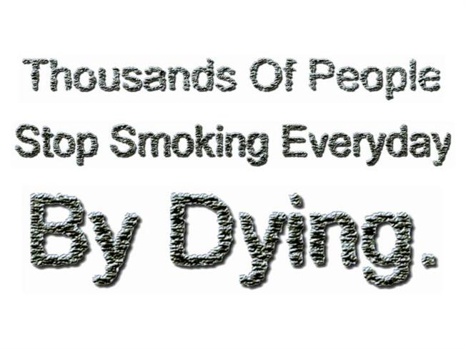
    - Cancer of the oral cavity (mouth)
    - Cancer of the Pharynx (throat)
    - Cancer of the larynx (voice box)
    - Cancer of the oesophagus
    - Stomach cancer
    - Kidney cancer
    - Bladder cancer
    - Cancer of the pancreas
    - Cancer of the blood (acute myeloid leukaemia)
    - Cancer of the cervix __
One cigarette contains __4000_______________ different poisons that can cause serious damage to lung cells. There are _43____________ major cancer-causing chemicals in one_____ cigarette. These cancer-causing chemicals are referred to as carcinogens____.
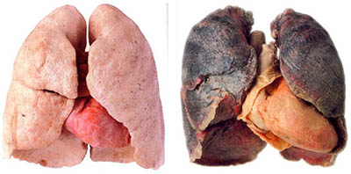
This photo shows a set of health, cancer free lungs (left) and lungs affected by lung cancer (right).

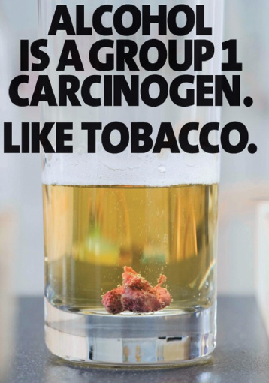
- Alcohol_____________________ - is a dangerous drug and responsible for several major cancers in the human body:
    - Cancer of the oral cavity (mouth)__
    - Cancer of the pharynx (throat)
    - Cancer of the larynx (voice box)
    - Cancer of the oesophagus (tube connecting mouth to the stomach)
    - Liver cancer
    - Cancer of the large intestine (colon)
    - Cancer of the rectum (part of large intestine)
    - Breast cancer
    - Cancer of the pancreas___

Alcohol is a dangerous carcinogen (_cancer producing chemical___). It causes cancer by damaging the cell nucleus of many cells in the body.
- Betel Nut_. Like cigarette and alcohol, betel nut is a major risk factor for _mouth cancer_. The mixture of betel nut with lime called the “_quid__” causes continuous irritation of the lining of the mouth, leading to cell damage and the development of mouth cancer__. This is a very common problem in __Melanesia__. In most cases, the cancer will present either as _an ulcer, a lump or a mass__.
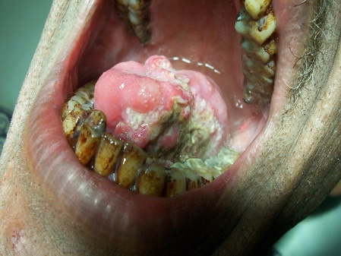
This is mouth cancer from betel nut chewing. Note the ulcer on the tongue. This tongue is stuck and cannot move because cancer cells have invaded normal surrounding cells and tissues.
In most cases, cancer presents either as an ulcer, a lump or a mass.
- Chemicals and other substances__________. Exposure to asbestos, ____benzidine, cadmium, ______nickel, or ________vinyl chloride in the workplace can cause cancer. The rule is to avoid _____inhaling fumes from these chemicals as they are all carcinogenic ____.
- Ionizing radiation __. This refers to a type of radiation created by x-ray equipment in medicine, radioactive substances like nuclear materials, rays that enter the _earth’s atmosphere____ from outer space like the _sun___ and other sources. At high doses, ionizing radiation increases _chemical activity_ inside cells and can lead to damage to the DNA which increases susceptibility to _cancer___.
- Viruses________. Certain types of virus cause cancer. The two most common are the human Immunodeficiency Virus_________ (HIV) (Commonly causes Kaposi Sarcoma in patients) and the _Human Papilloma Virus________ (HPV) (Most important cause of cervical cancer__ in women). These viruses damage the __cell nucleus________ and cause cancer.
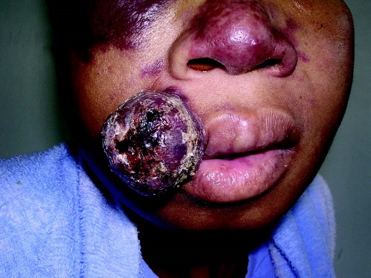
This is Kaposi Sarcoma in a patient suffering from AIDS.

- Family history of cancer______. Many people have someone in their family who has had cancer. It is not uncommon for more than one member of a family to have cancer. Cancer can occur in families:
- By chance, which is most often the case
- Because family members have environmental and lifestyle risk factors in common, for example alcohol intake or smoking in the family
- If you are a female and your mother or sister has had breast cancer, the chances of you developing breast cancer are high compared to those with no family history of breast cancer. _________
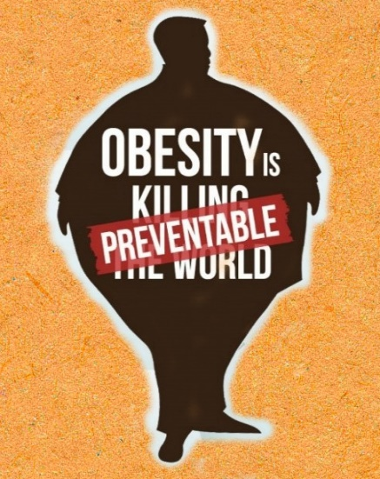
- Obesity/overweight______. This presents an increased risk for the following types of cancer and possibly others as well:
- cancer of the oesophagus_
- cancer of the pancreas
- cancer of the large intestine and rectum
- breast cancer (after menopause)
(2nd major killer of women in the South Pacific)
- cancer of the uterus (baby basket)
- kidney cancer
- thyroid cancer
- gall bladder cancer
- Poor diet_____________. The World health organization has reported that dietary factors account for at least __30/%_ of all cancers in Western countries and __20%__ in developing countries. Poor diet such as those __high in fats and calories__________ can lead to cancer by causing inflammation in tissues damaging the cell and its nucleus. A Healthy diet on the other hand, rich in fruits and vegetables have been shown to reduce cancer risk and other chronic diseases.

There are many advantages in eating plant foods, these are:
- Fruits and vegetables provide vitamins, phytochemicals, minerals, fibre, and other substances that are important for cancer prevention
- Most fruits and vegetables are naturally low in fats and calories and yet they are more filling than refined foods
- Concentrating on more fruits and vegetables helps to prevent overweight/obesity
- Meat, animal products, and other fatty foods are frequently found to increase the risk of cancer
- Meat does not have the protective effects of fibre, antioxidants, phytochemicals, and other helpful nutrients we find in plant foods. It contains high concentrations of saturated fat and cancer causing compounds increasing a person’s risk of developing cancer
- Physical inactivity. Lack of exercise is a significant risk for cancer. There is now convincing evidence that increased physical activity decreases the risk for colon, large bowel and breast cancers. Several studies have also reported links between physical activity and a reduced risk of cancers of the prostate, lung and uterus.

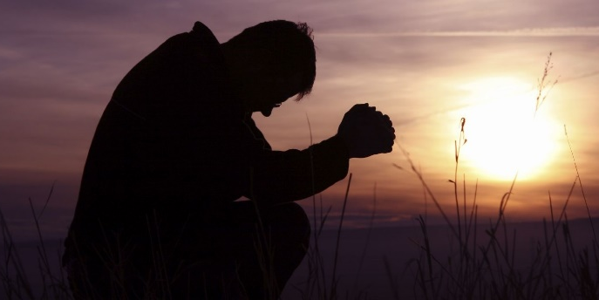
SO HOW DO WE REDUCE THE RISK OF CANCER?
There is no magic syrup, cocktail or tablet that can protect us from all the diseases found in our world today. However God in His love has given us some _important health guidelines______ as a means of protecting us.
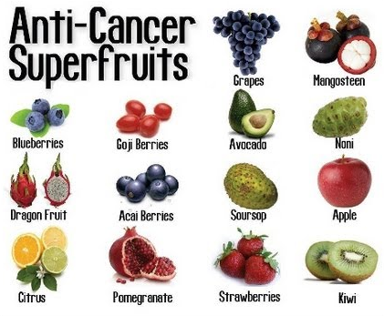
These include:
- Avoid cigarette smoking.
- Avoid alcohol.
- Avoid illicit drugs.
- Eat more plant based foods.
- Be physically active.
- Limit or avoid red and processed meats.
- Maintain a normal weight.
- Ask God for help.

CANCER
_________________________
Name
Make up the best questions to match the following answers - then share the puzzle with a friend or parent.
Created by Puzzlemaker at DiscoveryEducation.com

Across | Down. Down
1. chromosomes  4. betelnut  7. nutrients  8. mass  11. smoking  12. abnormal  16. neoplasm  19. divides  20. DNA  21. phytochemicals  23. alcohol  25. inactive | 2. obesity 20. damage  3. fumes 22. god  5. carcinogens 24. cell  6. viruses  8. membrane  9. quid  10. brain  13. noni  14. meat  15. trillion  17. orderly  18. metastasis

See if you can remember any of these quotes and texts by using the words in the
Texts, Quotes and Questions
“WORD BANK” to fill in the blanks

- “Medical missionary work is the _right hand__ hand of the gospel. It is necessary to the advancement of the _cause of God_____ of God. As through it men and women are led to see the importance of right __habits____________ living, and the saving power of the truth will be made known . . . . as the right hand of the third angels message, God’s methods of treating disease will open doors for the entrance of present truth
- I beseech you therefore, brethren, by the mercies of God, that ye present your bodies a living sacrifice holy, acceptable unto God, which is your reasonable service. (Romans 12:1)
- What? Know ye not that your body is the temple of the Holy Ghost which is in you which ye have of God, and ye are not your own. For ye are bought with a price therefore glorify God in your body, and in your Spirit which are God's. (1 Corinthians 6:19)
- Know ye not that ye are the temple of God and that the Spirit of God dwelleth in you? If any man defile the temple of God, him shall God destroy; for the temple of God is holy which temple ye are. (1 Corinthians 3:16,17)
- “If Seventh-day Adventists practiced what they professed to believe if they were sincere health reformers, they would be a spectacle to angels and to man” (Councils on Health p 575)
- “True temperance teaches us to dispense entirely with everything hurtful and to use judiciously that which is healthful. (Patriarch and Prophets, p.562 (1890)

- “Tea, coffee, tobacco, and alcohol we must present as sinful indulgences. We cannot place on the same ground, meat, eggs, butter, cheese and such articles placed upon the table. These are not to be borne in front, as the burden of our work. The former – tea, coffee, tobacco beer, wine, and all spirituous liquors- are not to be taken moderately, but discarded. (3 Selected Messages, p. 287)

defile | burden | angels | god | price | discard
entirely | coffee | you | professed | healthful | tobacco
sacrifice | hurtful | bodies | own | believe | coffee
beseech | health | alcohol | reasonable | mercies | glorify
sinful | disease | use | cause | spirit | meat
temple | habits | right | cheese | spectacle | holy

CHRISTS OBJECT LESSONS, P. 59
Medical Missionary work is the _right and_____ of the gospel. It is necessary to the advancement of the cause of god. As through it men and women are _led to see___________the importance of _right habits_______ of living, and the saving power of the truth will be made known … as the right hand of the third angel’s message, god’s methods of treating disease will open doors__ for the entrance of present _truth___.

Possible Questions for Discussion or Assignment Tasks
- Over 150 years ago, the Adventist church was given a powerful and unique health message. Have we paid enough attention to it? What might have been?
- What is the most powerful way for the church to use this health message?
- Many modern day foods and habits weren’t around in Mrs White’s days. What habits do you think she would address if she were here today – can you see the foundation of your arguments in any other of her quotes?
- Containing 8 out of the top 10 fattest countries IN THE WORLD, the South Pacific has a health crisis on their hands. What can be done to stop or even better – reverse - this?
- It has been said that Jesus healed more than he preached. How should that fact impact us as His disciples?
- What habits do you have now, or can you see might be a weakness of yours, that may lead to a Non-communicable disease? What steps can you take to change that outcome!
- Many verses tell us that our body is God’s temple. What exactly does that mean? What was/is the temple used for and how can that be likened to our physical body?
- Make up an acronym to cover the major lifestyle components that need to be addressed for a healthy, balanced, lifestyle. (You may already know one, but be creative and see if you can create a different one).
- WHO (World Health Organisation) recently said that the South Pacific is the ‘Epicentre’ of diabetes. Why? What impact would it be having on these countries? How can we change it?
- Write a letter to the Prime Minister of your country or the principal of your school on a NCD topic of your choice. What would you like to highlight to him? What suggestions would you like to make?

Cigarette smoking kills between _3-5 million people around the world each year. Manufacturers of cigarettes are very clever as they mostly target young people, because they know that if they can get the young __hooked_____ on the habit, they will have them for life_________ (and therefore they will keep making money from them!). Cigarette smoking is a major problem in the South Pacific. It is destroying the lives of thousands of people.
Listed below are some data on cigarette smoking in our region
- In Kiribati around 70% of males between the ages of 30 and 54 are regular smokers. 32% of young males aged 15-19 smoke (2005 census). The overall smoking rate is 45%. The gift of tobacco (Mweaka) remains closely tied to spiritual beliefs in the Outer Islands and, in urban areas, a gift of tobacco is considered polite.
- In Fiji, the overall prevalence rate of smoking is approximately 37.65 % of the population.
- In Nauru 48.2% of both genders smoke daily.
- In Samoa 40% of the total population are smokers: 56.3% of males and 21.8% of females.
- In Tokelau, 59.3% of the population smoke daily.
- In Papua New Guinea, approximately 45% of the population smoke.
- In Solomon Islands, approximately 45% of the population smoke.
- In Tonga, approximately 40% of the population smoke.
- In Tuvalu, approximately 41% of the population smoke.
- In Vanuatu, approximately 30% of the population smoke.
- In Niue, approximately 40% of the population smoke.
- In Samoa, 41% of the population smoke.

DISCUSSION
- Have you ever been tempted to smoke? Why?
- What needs to be changed in YOUR country to help minimize the number of young people taking up smoking?
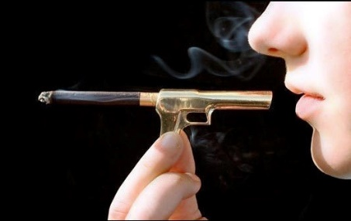
- What is the picture to the left telling you? How does it make you feel? Is it worth the risk?
- If someone smokes 5 cigarettes a day, what is the cost to them over a year? What would you like to buy with that money?
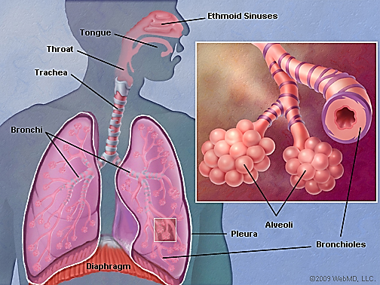
We have two lungs. They are located in the chest. Their main function is exchange of gases - oxygen and carbon dioxide. The body cannot survive without oxygen. Oxygen in the air enters the blood and the cells through the _lungs_____. Carbon dioxide is waste gas that is generated by the cells of the body. This gas must be removed_____ from the body. This important work is carried out by the lungs.

The lungs have many different parts some of which are shown below. The alveoli which are the round structures in the picture below are the sites where gas exchange takes place.

How Gas Exchange Takes Place
The diagram (see below) illustrates how gas exchange______ takes place in the lungs. When we breathe in air during _inspiration__, oxygen (O₂), the good air, passes through the air passages and reaches the _Alveoli________. When oxygen reaches the alveoli it passes through the thin wall of the alveoli and enters the _capillary_______. Capillaries are tiny________ blood vessels that transport________ blood. In the capillaries are _red blood cells_______. Oxygen from the lungs enters the red blood cells in the capillaries and gets distributed throughout the _body________. Carbon dioxide (CO₂) or bad air comes from the cells_______ of the body. It has to be removed from the body. The body forces carbon dioxide out of the capillaries into the __Aveoli_____ and we remove it from the lungs every time we breathe out___. This is the process that is called _respiration______________.

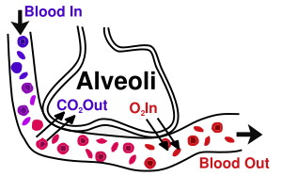
The diagram illustrates how Oxygen represented by the symbol O2 enters the blood from the lungs (alveoli) and how carbon dioxide represented by the symbol CO2 leaves the blood and enters the alveoli to be removed by the lungs.
Any rubbish or dirt in the lungs can interfere with this very important work and lead to lung tissues damage. Cigarette smoking introduces rubbish in the form of tar, dangerous chemicals and poisons into the lungs. These chemicals interfere with gas exchange by destroying the air passage and alveoli and can lead to lung diseases with numerous complications.

What is in Cigarette Smoke?
There are approximately __4000__________ different poisons and irritants in one cigarette alone. Out of these, there are 43 cancer causing substances. Found also in cigarette smoke is a deadly gas called ___carbon monoxide_________. Nicotine is the addictive component of cigarette.

Some examples of different poisonous chemicals found in cigarettes:
Acetone Urethane Mercury Arsenic
Lead Phenol Nicotine Formaldehyde
Cadmium DDT Carbon Monoxide Tar
Hydrogen Cyanide Ammonia Benzene Preservatives
More than 600 additives

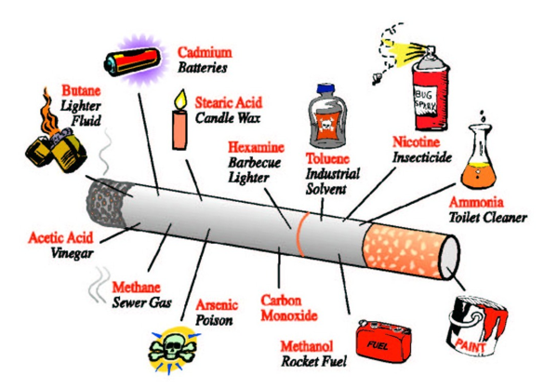

Nicotine

Nicotine is a powerful __drug of addiction________ found in cigarettes. One cigarette contains approximately _15-20mg___________ of nicotine. Approximately _1-2mg _____ of nicotine is inhaled from one cigarette every time a person smokes. Fifty to sixty milligrams of nicotine can ___kill a person.

Some important facts about nicotine are:
- Nicotine reaches the brain within seconds
- Each dose of nicotine causes the blood vessels to narrow down reducing blood flow especially to the brain, heart, arms and legs. If smoking continues this can leads to permanent damage
- Nicotine is addictive. This means nicotine makes you want to smoke very badly. The more you smoke, the more your body wants the nicotine and every time your body will tell you to smoke even if you want to stop smoking. You are addicted to smoking if you badly want a cigarette within 30 minutes after you wake up in the morning
- Addiction also involves the brain. Smoking for a long time changes the pattern of response in the brain so that you would always want to smoke
- Leading researchers say that nicotine is as addictive as heroin and acts on the brain like morphine, cocaine, marijuana and alcohol
- The body hungers for nicotine when you are addicted 7. Nicotine is addictive and takes away your self-control
Because nicotine causes blood vessels to constrict or narrow down, it can lead to:
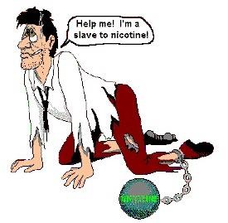
- High blood pressure (Hypertension)
- Increased heart rate
- Makes the heart work too hard
- Causes damage to the artery walls making it hard and stiff.

Nicotine also causes cholesterol buildup in the blood vessel wall causing narrowing of the blood vessels and a decrease in blood flow to the important tissues of the body.

Carbon Monoxide
Some important facts about carbon monoxide are:
- Carbon monoxide is a poisonous gas produced by burning tobacco
- It reduces the ability of the red cells to carry oxygen
- Carbon monoxide reduces the level of oxygen in the body leaving a smoker breathless
Tar
Some important facts about tar in cigarette smoke are:
- Male smokers are _22 times_______________ more likely to develop lung cancer than those who have never smoked.
- Female smokers are __12 times________________ more likely to develop lung cancer than those who have never smoked
- A person who smokes an average of 20 cigarettes a day for one year takes up to _one cup of tar_______ into his lungs
- Much of this tar remains, leading to __blackened lungs__________________ and the increased risk of lung cancer.
- This is a clean, healthy lung. This person had never smoked in his life.

This is a clean, healthy lung. This person had never smoked in his life.
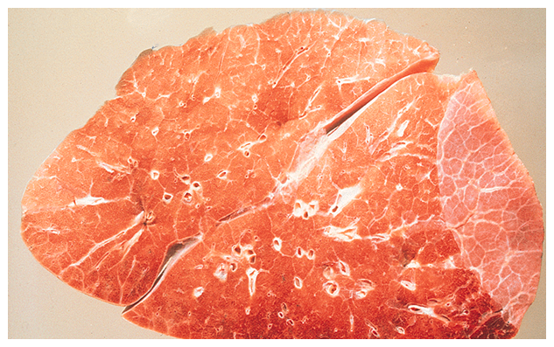
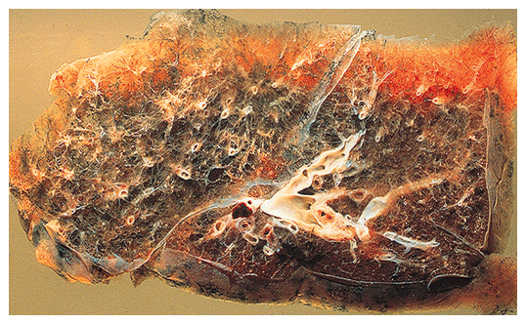
This lung is filled with tar. Notice the difference between this lung and the clean lung. Cigarette smoking destroys your lungs.
This lung is filled with tar. Notice the difference between this lung and the clean lung. Cigarette smoking destroys your lungs.

What Happens to Smoke in the Human Body?
As the smoke is sucked down it moves in a whirling spiral and particles are deposited on the walls___ of the air passage. As this happens, smoke fills the __air passages_________. As a result of this, small __hairs_______ lining the throat and airways called _cilia________ cannot work properly to keep the air passage ___clean_______ and ___clear____________.

Some important facts about the cilia in your air ways are:
- Cilia are small hairs that line the airways. They clear the air passage of _dust, dirt and mucous_________________.
- Repeated smoke stops the cilia __clearing the mucous________________ properly.
- Small __growths________________ often develop on the lining of airways.
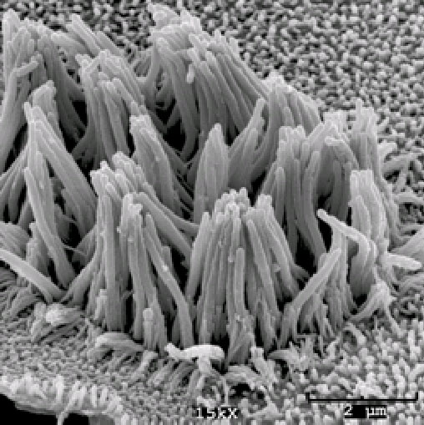
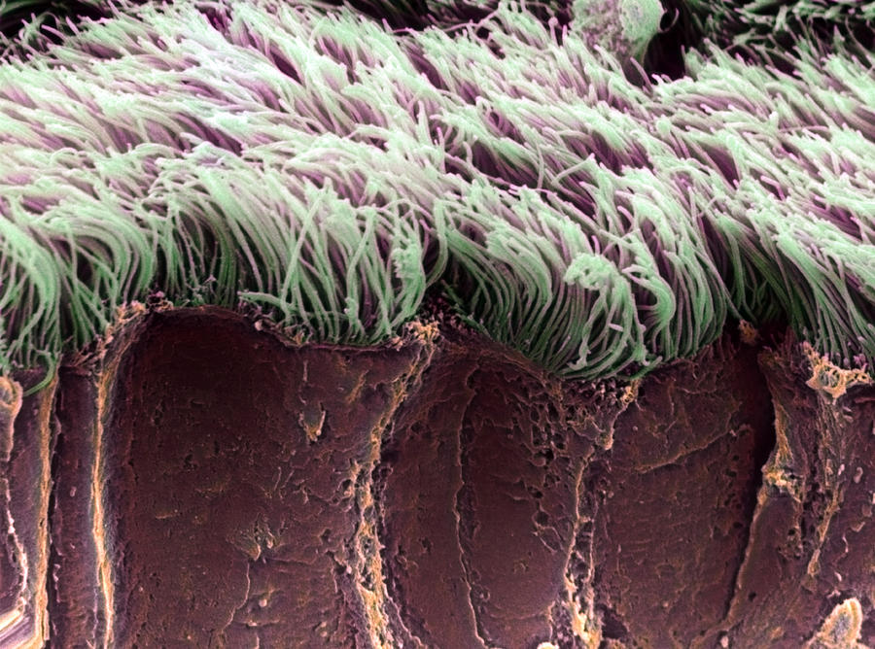
- Repeated and long term _coughing________________ lead to chronic bronchitis and emphysema (air trapping) because all the cilia are destroyed____.

Cilia are hair like structures that line the airways. Their main function is to remove dirt and dust from the airways and protect us from lung diseases like asthma and cancer. Cigarette smoking destroys the cilia.

Effects on Airways
Some important facts about the effect of smoke on your air ways are:
- Smoking increases _mucous___________________ in the large airways leading to more cough and spit_________________.
- It leads to __inflammation_________________ and then ___hardening___________ and narrowing of the small airways.
- It can lead to more ___asthma___________, more ______lung infections_____ and reduced lung function.

Effects on Lung Cells
Some important facts about the effect of smoke on your lung cells are:
- Smoking leads to more inflamed cells. The lung tissue becomes _black_________ with tar.
- The lung is less able to _carry out______________ its work.
- The lung is less able to __fight________________ infection.
- The lung tissue is _____destroyed________.

Overall Effects of Smoking on the Body
With all the effects of smoking discussed above, cigarette smoking causes far more damage to the body than many smokers realise:

Examples of diseases caused by smoking
- Heart Attack____________. (Myocardial infarction) and sudden death. Cigarette blocks blood vessels in the body including those in the heart
- Stroke__________________. Cigarette smoking is a major cause of stroke because it blocks blood vessels in the brain
- Death of limbs_________. (Mainly legs/feet/toes) called gangrene. This is because smoking destroys blood vessels and blocks blood flow to the legs, feet and toes
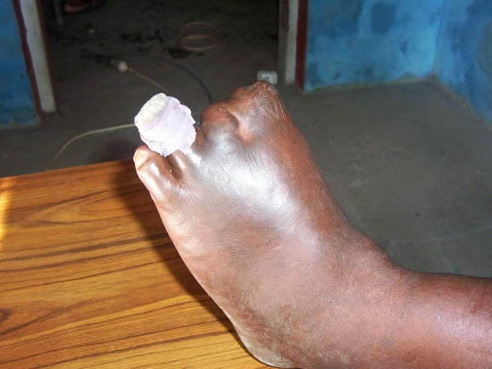
Dead toes due to cigarette smoking. The blood vessels supplying the toes have been destroyed by smoking cigarettes. - Photo: C Kuma

- It leads to _serious lung diseases_______
such as chronic bronchitis and emphysema and results in severe shortness of breath.

Cigarettes cause Cancer
Some important facts about the effects of smoking and cancer:
- Cigarette smoking causes lung cancer. Cigarette smoking is the number one cause of lung cancer in the World. This is because of all the poisons that it contains and their effects on the airways and the lung tissue
- Cigarette smoking causes cancer of the throat and larynx_____________.
- Cigarette smoking causes cancer of the oesophagus_____________ – the tube connecting the mouth to the stomach
- Cigarette smoking causes _cancer of the stomach___________________________.
- Cigarette smoking causes _cancer of the kidneys___________________________.
- Cigarette smoking causes _cancer of the pancreas__________________________.
- Cigarette smoking causes _cancer of the urinary bladder___________________.

Smoking can kill your unborn baby
Smoking in pregnancy can lead to some major complications:
- Women who smoke may not have children
- Smoking can result in abnormal babies being born
- Smoking mothers are 4 times more likely to have small babies
- Smoking mothers are 20% more likely to have their babies born early (premature babies)
- Smoking during pregnancy leads to a three or four times increase in low birth weight babies
- A baby can die in the mother’s womb if the mother is a smoker

Effects of smoking remains after birth
- New born babies whose mother smoke, have high levels of nicotine in their blood
- Children of smoking mothers have up to 6 times greater birth defects
- Children of smoking mothers have more problems with learning and behaviour at school
- Children of smoking mothers have up to 50% chance of retarded mental development

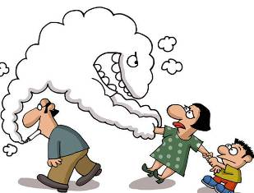
PASSIVE SMOKING
Side smoke – or passive smoking – occurs when non-smokers are exposed to cigarette smoke. In the Pacific Islands context, this commonly occurs in _work places__, at home or while using _public transport such as buses or taxis______. Passive smoking is dangerous____ because the chances of developing lung and other smoking related complications_______ can be very ___high__.

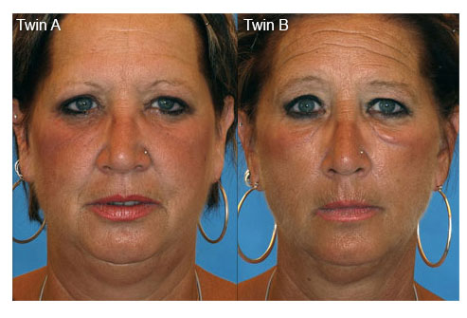
The twin on the right smoked ½ a pack of cigarettes a day for 14 years. See how many difference you can pick!

KAVA

Kava (Piper Methysticum) is a plant native to the Western Pacific Islands that is used to produce a drink popular among the Pacific cultures in Polynesia, Melanesia and even parts of Australia (kava is a member of the pepper family ‘piperceae’). Those growing this shrub distribute it by _cuttings_, with about _five years elapsing from planting until harvest. Its active elements are a series of _kavalactones______, which are found in the _roots______. As well as these psychoactive (_mind altering____) chemicals, kava is rich in potassium, nitrogen, phosphorus and magnesium. It is also known as Yungona in Fiji.
Traditionally kava had great __significance______ across many parts of the Pacific. A gift of Kava ___settled differences_______ and fostered good relationships, families shared plants for use on special occasions and no discussion of council began without ritual Kava drinking. First the presiding _chief_____________ took a few sips, then a server offered the drink to the other chiefs in order of _importance______________, and when the bowl was empty the talking began.
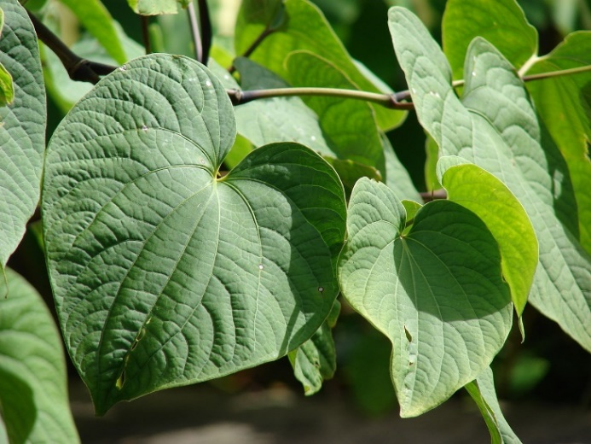
The use of Kava is spreading throughout the Pacific and is now grown in countries where Kava was never an issue in the past (such as Solomon Islands________________ and
Papua New Guinea_________________).
For kava to be effective, its roots must be mixed in _saliva____, _water__ or oil_ to release the natural ingredients. More water is then added to make a murky, unattractive_ beverage with a _peppery_ taste. Modern kava, prepared by pounding or grinding has _less physiological_ effect then the traditional chewed version.

Kava is a psychoactive drug, meaning that it is a chemical substance that can _easily enter the brain and affect its function_________________. This can result in changes in _perception____, __mood_______, _consciousness, cognition__ (learning) and _behaviour___________. When Kava is used in small quantities it produces a state of _happiness______ and __wellbeing________. The drinker is never unpleasant or even quarrelsome. If consumption is excessive the limbs are tired, muscles fail to respond, the drinker looks sleepy and tired and finally falls asleep for a long time before waking grudgingly.
John 10:10
“The thief comes only to _steal_ and _kill__ and destroy. I came that they might have _life___ and have it to the _abundantly__.
A strong intake of kava often causes _trembling___ before the rapid collapse into deep sleep. This is because kava affects the brain leading to a reduction in spinal activity. Kava also affects the _rhythm of the _heart________ and how it beats. It also affects _breathing____. It first stimulates more _rapid_____ breathing then then it slows breathing down. In fact, it has been likened to _alcohol_______ intoxication, with the noticeable difference that mental clarity and alertness is maintained.
Half a coconut shell____ (100 – 150 ml.) of kava can put a kava drinker into a dreamless sleep within _30 minutes______. Kava is prepared for drinking from freshly pounded drinks, or by adding water to powdered dry rootstock. It does not depend at all on fermentation. Heavy Kava drinkers usually suffer from apathy that prevents them from _eating adequately_____, and they sometimes have _eye_______ __problems__ and _dry, scaly skin__.
WARNING: Kava + __Alcohol____ = _Death__________
NEVER DISSOLVE KAVA IN ALCOHOL OR METHYLATED SPIRITS!

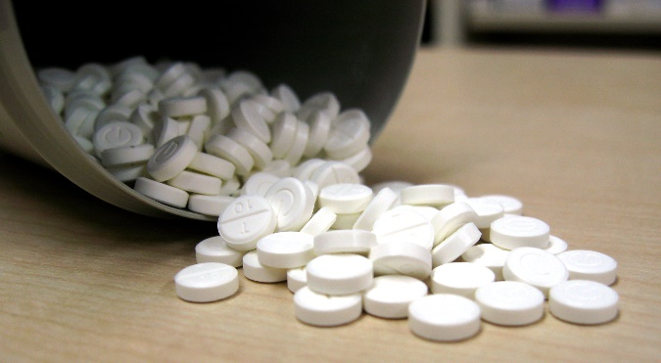
SIDE EFFECTS OF KAVA
- Liver damage__ has been promoted as being the most common side effect. Kava consumed in _tablet form___ as a health supplement has been proven to lead to severe liver toxivity_ and even _liver failure____. Because of these side effects it has been banned in various European nations such as _Switzerland, _France_and the Netherlands. The Liver damage is only experienced by those who take Kava in tablet form_ as opposed to those using the beverage prepared in the traditional way. This is because the drink is made from the __roots only_ whereas the tablets are prepared from the _stem and the _leaves_____ which contain a dangerous chemical called _pipermethystine_______. The liver-related side effects experienced among the Pacific communities are _mild_____ and _reversable_ and include _poor nutrition_______ and a rise in _liver enzymes_____.
- Most, if not all, Kava users are adversely affected by _skin related side effects. Regular kava consumers normally develop a _scaly______, _yellow skin rash.
- Another side effect includes _eye irritation and _sensitivity_ to light_______________________. This particular side effect is quickly corrected once one _stops drinking kava_______. These side effects will be felt by those taking Kava tablets AND drinking traditionally prepared Kava.
- Allergic reactions_________ can occur.
- Other possible side effects of Kava include slow _muscle movement___ and an increased _response time______________________. This makes it dangerous for kava consumers to _operate machinery__________________ or _drive a car____ since their impaired motor reflexes pose a threat to themselves and to others around them!

The internet promotes “Kava” as “The Ancient Mystical Drink – to control your stress.” It promotes kava as a 100% natural, healthful, sociable drink. It said, “Just steep in water and acquire a taste for relaxation!” _How false that statement is! With so many young people using the Internet to shop, some serious kava problems could be just ahead!

As Christians we have spiritual resources for handling stress and the “golden rule” to keep us kind and reasonable in our dealings with others. We should not need to rely on _substances__________ to feel happy and relaxed, especially where over-use can be harmful. We must continue to be positive in promoting a healthy, balanced lifestyle, free of any _recreational drugs____________.

It is important to realize that _any drug use__________________ threatens _mind and _body____ and offers users a false sense of security in place of their __spiritual dependence________________ on _God______________, which brings true _peace______ and ____happiness___________.

CONCLUSION
Kava is a drug and not safe for the body!!_________________

Abstinence from alcohol and tobacco has always been required for SDA church membership. It should be the same for _Kava__, __tea____ and _coffee______. These are not good for our health. Our members should be given information about it and warnings as to the effect it can have on health and spirituality, and they should be urged to _abstain_________. If we can foster a positive attitude to the thought that we are the “temple of God, and that the spirit of God dwells in us” so that we are not to “defile the temple of God” (1 Cor.3:16, 17 and 2 Cor. 6:16) it may help our people make wise decisions on this delicate issue.

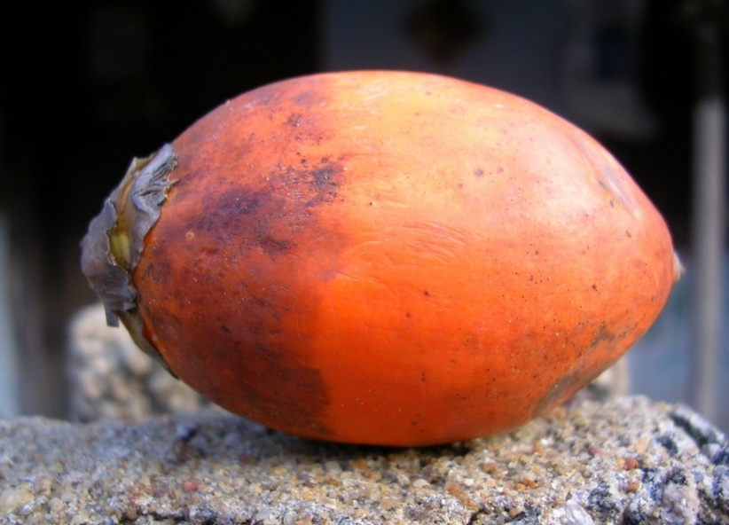
BETEL NUT

The betel nut is the seed of the __Areca Palm______________ (Areca catechu), a very common plant in the Pacific, Asia, and parts of east Africa. Chewing the mixture of Betel nut and betel leaf is a tradition which dates back thousands of years. It is not known how and when the areca nut and the betel leaf were combined together into one _Psychoactive drug.
In Papua New Guinea and the Solomon Islands, fresh areca nut, betel leaf or 'fruit leaf' ("daka" in PNG) and _lime_________________ are sold almost everywhere. Betel nut chewing has recently been introduced into __Vanuatu_________________ where it is growing in popularity, especially in the northern islands. In ___Guam_____________, betel and areca nut chewing is a social pastime and used as a means of extending friendship, and can be found in many, if not most, large gatherings as part of their food display.

Chemical Composition
Betel nut contains several strong chemicals including _tannin_______, _gallic acid__, a fixed oil gum, terpineol, _lignin__________, various saline substances and three main alkaloids: arecoline_____________ _arecaidine________________ and _guvacine______________. These chemicals can cause narrowing of the blood vessels by stimulating the contraction of the muscular wall of the blood vessels like an _artery__________________. These chemicals alone can have significant side effects on the body.
The only safe course is to touch not, taste not, handle not, tea, coffee, wines, tobacco, opium and alcoholic drinks. The redeemer of the world came from heaven to help man in his weakness, that, in the power which Jesus came to bring him, he might become strong to overcome appetite and passion, and might be victor on every point.”
(3 Testimonies, pp 485-488)
Steps used in chewing the betel nut
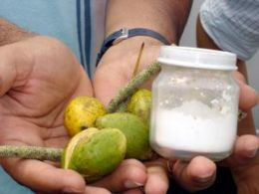
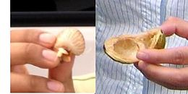
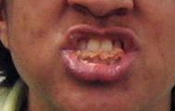
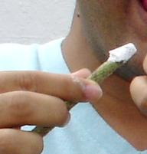
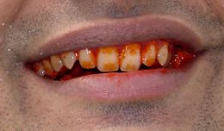
Step 1
Ingredients are collected. This includes the green betel nut (buai), a jar of lime powder (kambang) and a bean-like green fruit called mustard (daka) or mustard leaf.

Step 2
The betel nut husk is opened with the teeth and the inside flesh is removed from the shell and chewing commences.

Step 3
The betel nut is chewed for 2-5 minutes or until it forms a wad in the mouth.

Step 4
The mustard seed is now introduced. It is moistened with saliva and dipped into a jar of lime powder.

Step 5
The betel nut wad is moved to the side of the mouth and a piece of the mustard seed with the lime on it is introduced into the mouth. Direct contact of the inner lining of the mouth with lime will cause a burning sensation. As the mixture is chewed a chemical reaction takes place that makes the teeth and the lips go red and gives rise to a mild high.
Immediate Effects of Betel Nut Chewing
The effects of betel nut can be seen after chewing begins and can last for a _couple of hours_. The effects appear to depend on the amount being chewed and whether the person is an occasional____ or a _regular_______ chewer. It is generally chewed to help _reduce__ tension________, produce a feeling of wellbeing and facilitate social interactions. What people do not understand is that chemicals from the nut enter the __brain___ and actually alter_____ __brain___ __function_. This results in a change in _perception____, mood_______, _consciousness__, and even __behaviour___________. This makes betel nut a _drug____________.
Some of the reported immediate effects of chewing areca nut and betel quids include:
- Mild euphoria and a sense of well being
- Feelings of general arousal and increased alertness
- Increased heart rate
- Increased blood pressure
- Sweating
- A warm sensation in the body.
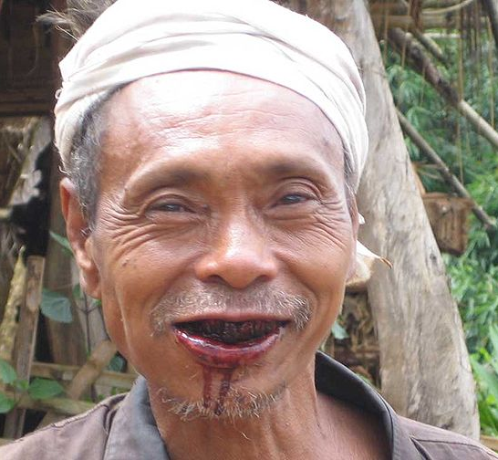
Other effects of betel nut chewing include:
- Tremor
- Dizziness
- Diarrhoea
- Upset stomach
- Vomiting
- Acute psychosis
- Asthma exacerbation
- Hypertension

It has been claimed that chewing betel nut suppresses feelings of hunger, stimulates the appetite, aids digestion, reduce feelings of nausea and acts as an anti-diarrhoeal. The truth is, ___There is currently little or no evidence to support these claims_______.
“Now may the God of _peace_____ Himself sanctify you __completely; and may your whole spirit, soul, and __body__ be preserved _blameless_______ at the coming of our Lord Jesus Christ”
1 Thessalonians 5:23
Long-Term Effects
Excessive and long-term use of betel nut and lime had been associated with a number of significant health-related problems. These include:

- Discolouration of teeth and gums
- Mouth ulcers and gum disease
- Mouth, throat, oesophagus and stomach cancers
- Stomach ulcer
- Increased risk of cardiovascular disease and diabetes
- The risk of developing mouth and throat cancers increases when betel nut is chewed with tobacco.

Betel Nut and Cancer
The chemicals involved with Betel Nut chewing can cause cancer (these are carcinogens) a carcinogen is any substance that is involved in causing cancer. Regular chewers of betel nut with lime carry a significant risk of damaging the inner linings of their mouth, throat, and oesophagus,rendering them more susceptible to developing cancer of the mouth, tongue, pharynx, oesophagus and stomach. Studies have also found that tobacco and lime increase the risk of cancer from the betel nut preparations (quids).

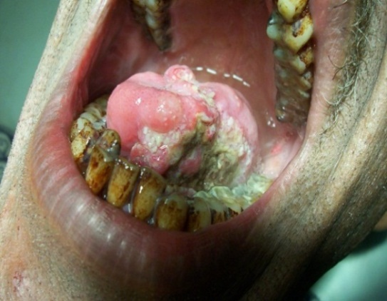
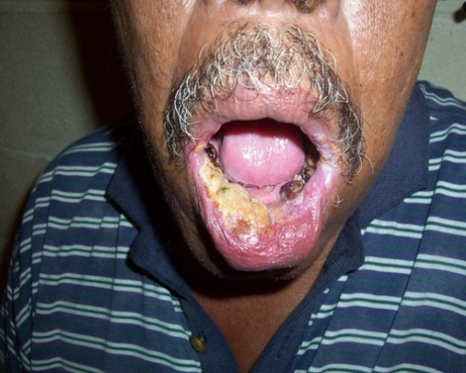
This patient had been a betel nut chewer for 10 years. He had developed a white lesion or patch on his lower lip. This is called “Leukoplakia”. Leukoplakia is a pre cancer lesion. The lesion will go away if the chewer stops chewing betel nut but if he continues, cancer will develop. Photo: C. Kuma

This patient was a betel nut chewer for many years. He has end stage mouth cancer affecting the tongue and the floor of the mouth on the left side. There was also history of associated cigarette smoking. Photo: C. Kuma

People who chew large amounts of betel nut on a regular basis may become dependent on it and may experience withdrawal symptoms if they stop chewing. The withdrawal symptoms are generally mild and include:
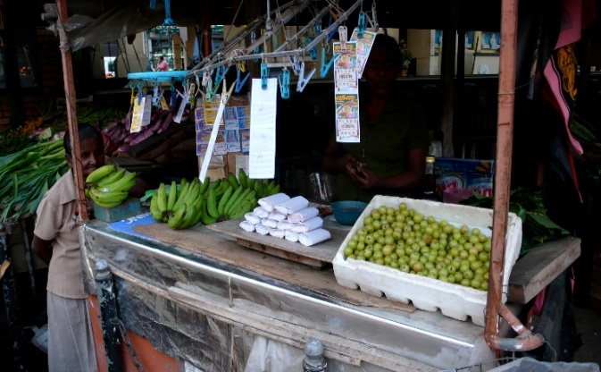
- Mood swings
- Feelings of uneasiness, anxiousness, irritability, and even paranoia
- Poor concentration
- Lack of energy
- Sleep disturbance Increased appetite.

Betel Nut and Diabetes
Many Pacific Islanders believe that betel nut helps control _diabetes_____. A study conducted in Papua New Guinea in 2002 revealed that Betel nut in actual fact, _____worsens diabetes control_________ in those who suffer from the disease. Based on the balance of evidence, betel nut is a contributing factor to _poor blood sugar__________ control in diabetic patients and may even contribute towards the ____development______________ of diabetes in chewers.

Death from Betel nut chewing
Betel nut chewing is a __dangerous__ ___habit_________. Mouth cancer from betel nut chewing kills approximately _2000_____ people every year in Papua New Guinea according to the PNG Medical Society. In the Solomon Islands, mouth cancer cases are on __the rise. Statistics reveal that approximately _25____ people die from mouth cancer every year in the Solomon Islands___________. Mouth cancer from betel nut chewing is now the __most common________________ cancer affecting the male population in both Papua New Guinea and Solomon Islands.
Apart from its significant contribution to the development of _mouth_________, _throat____ and _stomach______ __cancers_, betel nut chewing with lime contributes to _poor oral hygiene_____, _inflammation of the _gums_______ and _inflammation of the throat____________ and _oesophagus____________________. It also contributes to the development of acute _gastritis___ and _peptic ulcer disease______________ (stomach ulcer) in chewers.

Betel nut chewing and Public Health and hygiene
Betel nut chewing is a major health issue not only as it relates to specific clinical diseases but also in terms of public _health and hygiene_____________. The betel nut spit from chewers significantly contributes to a ___dirty and unhealthy environment__________. Red stains along streets, on walkways, and walls of building convey a very unsightly picture of our towns and communities and reflect an _attitude______ of __carelessness________. Additionally, rubbish from betel nut dumped around urban centers, in homes and villages contribute to the spread of __infectious diseases_______________.

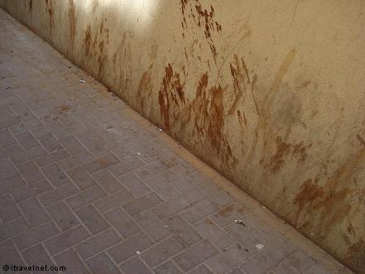
Betel nut chewing is a dirty habit. Chewers spit all the time and are not conscious of where they spit. A lot of our streets in towns and cities are stained by the red betel nut stain. This situation paints a negative picture about people’s attitude towards cleanliness and the environment. Photo: C. Kuma

Conclusion
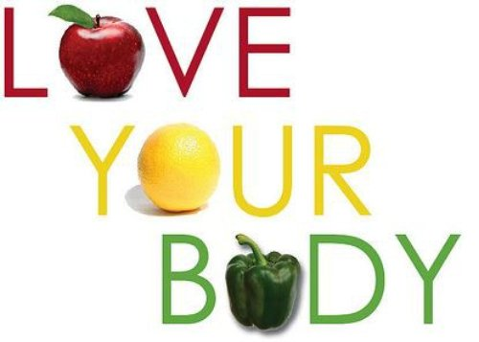
Scripture clearly states that our body is the _temple of the Holy Spirit___ (1 Corinthians 3:16, 17). We are to take good care of it and not introduce _poisons_________ into it that can cause damage. Betel nut chewing is often regarded as a cultural practice. What we need to be reminded of is the fact that there are certain cultural practices in the South Pacific that are clearly health destroying_________ and should be avoided______________. Betel nut chewing is one such practice. We are responsible for the maintenance of our health____________ and God will hold us accountable____________ for how we care for and respect our body and our environment (1 Corinthians 6:19, 20).
MARIJUANA
Marijuana is an illegal and a dangerous drug made from the plant called _cannabis sativa__ and it is available almost everywhere in the Pacific. Marijuana contains 421 different chemicals_____________, 61 of which are found in __no other plants___________. Delta-9-tetrahydrocannabinol (THC) is the main ingredients or chemical which is believed to be responsible for the high feeling_____________ that marijuana gives. Others include Cannabidiol and Cannabinol (CBN).
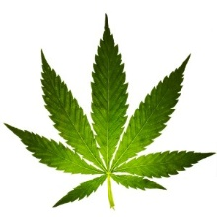
Other Chemicals in Marijuana
- Hydrocarbons-50 different types
- Terpines-103 different types
- Acids
- Steroids
- Nitrogen compounds
- Carbon monoxide
- Ammonia
- Acetone
- Benzene
- Cancer-inducing benzathracene
and bezopyrene
50% greater than in tobacco

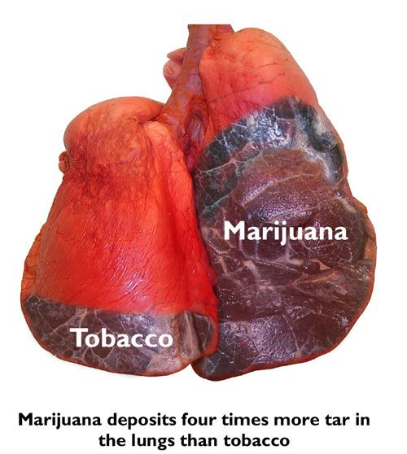
EFFECTS OF MARIJUANA
The prolonged use of Marijuana has serious effects on the body systems including the organs of the body. _Death__ is usually the end result.
- Affects the immune system_: Marijuana suppresses or weakens__________ the body’s _immune system____. It interferes with the immune________ cells______ that destroys _invading viruses or bacteria__. Therefore users are vulnerable to _infections such as bronchitis_, _pneumonia________, etc.

Marijuana deposits more tar in the lungs than tobacco because users breathe deeper to inhale the smoke and hold their breath longer.

- Affects the respiratory system. It interferes with the cleaning mechanism of the respiratory system by destroying tiny hair like structures called cilia lining the airways. Because of this marijuana users are vulnerable to lung problems such as bronchitis. Also, marijuana contains more than 150 complex hydrocarbons some of which are known to cause precancerous growths in the lungs. With continued irritation these growths can result in lung cancer.
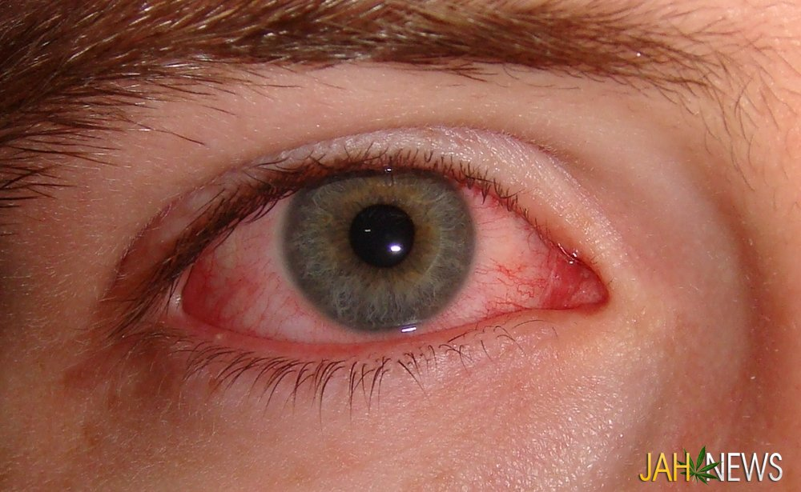
- Affects the cardiovascular system. Marijuana increase the heart rate. This increased stress on the heart can cause severe chest pain in those with narrowed coronary arteries. If you have, high blood pressure, diabetes, or a family history of heart problems, marijuana is risky for you. It also dilates or enlarges the blood vessels resulting in a decrease in blood pressure. This is specially seen in the user’s bloodshot eyes because the tiny blood vessel in the eyes dilate and become large enough to be noticeable - that is why some marijuana users try to hide their eyes by wearing sunglasses. It also increases blood pressure and causes an irregular heartbeat.
Blood shot eyes of a Marijuana user
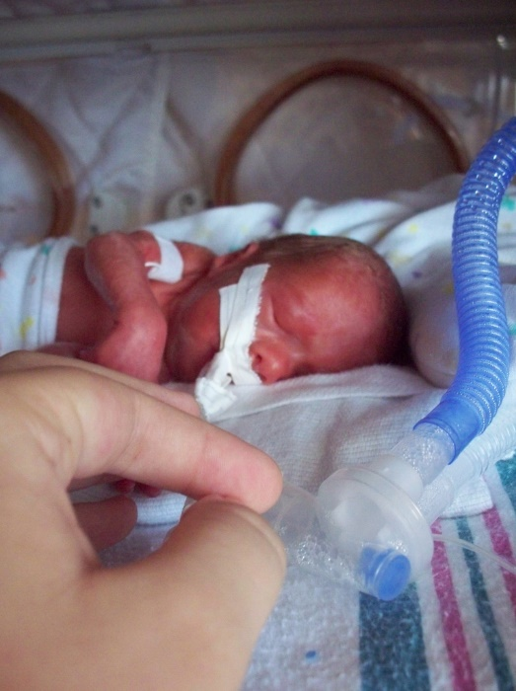
- Affects the reproductive system
A drug effected premature baby
- In males, marijuana reduces the male sex hormone called testosterone and can affect sexual function and reproduction. It reduces the number of sperm produced by the testes sperm will not be as mobile (active) as the normal sperm cell and will not be capable of fertilising an egg. The likelihood of birth defects is greater in marijuana users because of the risk of abnormal chromosomes.
- In females marijuana seems to reverse the effect it has on men – testosterone increases. This causes women to develop body body hair, facial hair and acne. It also disrupts normal menstrual cycle and may interfere with ovulation. It also can interfere with the development of the fetus. There are high chances of birth defects and low birth weight babies and a greater chance of miscarriage. Breast feeding mums can pass active marijuana poisons in pure form to their infants and damage them for life.
Marijuana affects the nervous system in a big way
Marijuana has serious effects on the brain by interfering with the function of the brain cells called the __neurons_______________. It therefore affects how we __think_______ and communicate_______________.
Marijuana impacts our _behaviour, performance and personality_________________.
Behaviour
Appearance becomes _sloppy__________. Start missing school or work. You will back away from your ___family and friends_________________, and become isolated. Your thinking becomes __confused_______. You don’t care much about anyone or anything.

Performance
Your skill on the job slips. Your boss wonders why your work is full of mistakes. You have trouble __learning anything new______________. You can’t seem to make passing grades in school. Your reactions slows considerably, and you become a danger to others. __Accidents at home, at school or on the road are likely_.

Personality
You become _suspicious______ and _afraid________ of others. Your moods swing widely from _sadness to happiness and back again_. Often, you are _short-tempered__________. You lose the ability to deal with everyday problems. Now and then, you suffer a __panic attack__________. Your _good judgement_________, _self-confidence______ and _self-respect all slip away. You are now a marijuana burnout.

DISSCUSS the real life article on the next page, found in the Baltimore. Although humorous to read, how frightening must it have been for Binns! What does this sort of insight do for those who choose to smoke weed to ‘be cool’ or to ‘look tough’? Do you know of any stories that support the above points?

MR. BINNS TRIES HASHEESH
From the Baltimore Sun, March 6
A well-dressed young man, who gave the name of Binns, came to the City Hospital. He yielded to a strange desire to enjoy a dose of hasheesh, a drug that produces curious results. He told the doctor that he had some doubts as to the locality of his face, which to him seemed situated at least two feet from where it really was. Then he was dubious whether he had any legs or was simply walking on his chin. The latter idea seemed to have a firm hold on him, for he stamped his feet on the ground a dozen times. His request to be relieved was pitiful. He feared that someone would steal an arm or leg from him. After medical treatment Binns began to feel better.
How to stop Using Marijuana (for marijuana users)
- First admit that you have a serious drug problem______. No matter how popular marijuana is, it is still an active drug________. Don’t tempt yourself - throw away all the marijuana you have__.

- Get professional help__________. Talk with a drug counselor, or a mental health professional about quitting marijuana and developing some healthy patterns in your life. Work through the problems that caused you to turn to marijuana in the first place___________.

- Getting off Marijuana will be difficult and uncomfortable. You won’t die from marijuana withdrawet_______________________, but you should expect to suffer sleep disturbances_____, irritability______, weight loss______, _nausea___________, diarrhea____________ and depression___________. Because the active ingredients of marijuana are stored in the body fat, it will take a long time for your body to clean out the effects of marijuana use. You will slowly feel healthy again if you stop. The unpleasant withdrawals will stop within a month____. Clear unclouded thinking may take up to __6 months_ or so to return.

IT MAY BE HARD, BUT DO NOT GIVE UP HOPE – YOU CAN BEAT MARIJUANA
“I can do _anything_____ through Christ who strengthens me.”
Philippians 4:13

How to keep away from Marijuana
Respect yourself and treat yourself well. Stay away from people who use and sell________ marijuana. Don’t get into situations where you think marijuana will be _available_______ – certain parties, some music concerts and particular gathering spots.

Get involved with, ___drug-free people______________. Talk openly with them about marijuana use and how to avoid it. Promise yourself and _one other important person__________ in your life that you will not use marijuana ever again. You will learn better ways to deal with problems and difficulties you face. Develop _other interests_____________________ or activities that don’t allow room for marijuana use.

DRAW A STRAIGHT LINE IN PENCIL FROM THE CLUE ON THE LEFT TO THE ANSWER ON THE RIGHT
(Be careful, there may be more than one correct answer!)

Clue | Answer
Waste generated by cells | Infertile
Where gas exchange occurs in the body | Death
Carcinogen | Carbon Monoxide
Addictive compound | Oesophagus cancer
Found in Cigarettes and the sewer | Temple
Hypertension | Psychoactive drug
Marijuana often leaves men | 1 cup
Cilia | Narrowing of blood vessels
Smoking increases this | Kava tablets
A disease caused by smoking | Dilates
Smoking is the numbers one cause of this | Lung Cancer
Also causes lung cancer | Passive smoking
Kava is a | High blood pressure
Kava + Alcohol = | Alveoli
Common problem for a Kava drinker | Depression
May lead to Liver failure | Mucous
Betel nut can cause | Small hairs that line the airways
Immediate effect of chewing Betel nut | Increased blood pressure
A long term effect of chewing Betel nut | Nicotine
Found in cigarettes | Cancer forming substance
Our body is a | Methane
Number of chemicals in Marijuana | Neurons
A chemical usually found in Marijuana | Acetone
Part of the body attacked by Marijuana | Immune system
Marijuana does this to blood vessels | Death of limbs
How much tar an average smoker inhales/year | Carbon Dioxide
Brain cells destroyed by Marijuana | 421
A common withdrawal complaint | Eye problems
ALTERNATIVE
In the table below, in the MATCH column, write the number from A, next to Column 1 that matches with the number from B next to Column 2.
A | Statement – Column 1 | MATCH A with B | B | Item – Column 2
 | Waste generated by cells | 7 |  | Infertile
 | Where gas exchange occurs in the body | 14 |  | Death
 | Carcinogen | 20 |  | Carbon Monoxide
 | Addictive compound | 19 |  | Oesophagus cancer
 | Found in Cigarettes and the sewer | 21 |  | Temple
 | Hypertension | 13 |  | Psychoactive drug
 | Marijuana often leaves men | 26 |  | 1 cup
 | Cilia | 17 |  | Narrowing of blood vessels
 | Smoking increases this | 16 |  | Kava tablets
 | A disease caused by smoking | 25 |  | Dilates
 | Smoking is the numbers one cause of this | 11 |  | Lung Cancer
 | Also causes lung cancer | 12 |  | Passive smoking
 | Kava is a | 6 |  | High blood pressure
 | Kava + Alcohol = | 2 |  | Alveoli
 | Common problem for a Kava drinker | 28 |  | Depression
 | May lead to Liver failure | 9 |  | Mucous
 | Betel nut can cause | 8 |  | Small hairs that line the airways
 | Immediate effect of chewing Betel nut | 18 |  | Increased blood pressure
 | A long term effect of chewing Betel nut | 4 |  | Nicotine
 | Found in cigarettes | 3 |  | Cancer forming substance
 | Our body is a | 5 |  | Methane
 | Number of chemicals in Marijuana | 27 |  | Neurons
 | A chemical usually found in Marijuana | 23 |  | Acetone
 | Part of the body attacked by Marijuana | 24 |  | Immune system
 | Marijuana does this to blood vessels | 10 |  | Death of limbs
 | How much tar an average smoker inhales/year | 1 |  | Carbon Dioxide
 | Brain cells destroyed by Marijuana | 22 |  | 421
 | A common withdrawal complaint | 15 |  | Eye Problems

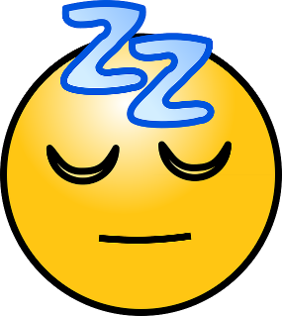
REST AND SLEEP
- Life is busy! Every day seems to come with new demands and problems. Often we find that there is little time to just sit back and relax.

My favourite way to relax is: ____________________________________________________
- Rest and relaxation is very important. In fact, it is vital for good health.
- Rest can come as a short break from hard labour, relaxing in the outdoors or as eight hours of restful sleep at night.
- Rest replaces weariness, exhaustion and fatigue with peace, energy and hope.
“Come to me all you who are weary and burdened and I will give you rest.”
Matt 11:28
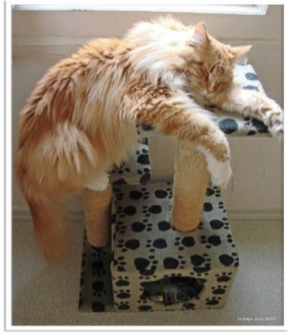

Jesus knew we needed our rest!

What Happens in the Body When We Sleep?
When we sleep, the body heals itself. In fact, it has been discovered that the immune system actually triggers the type of sleep best for healing. Called “Delta” or slow wave sleep, it is the deep, restful sleep you need to awaken feeling refreshed and energized. During this stage of sleep, the body releases a special chemical called growth hormone. Growth hormone stimulates the growth, repair and replacement of damaged tissues and cells of the body. Growth hormone also stimulates the formation of lymphocytes (white blood cells) which are needed to fight disease causing germs - an important step in healing brought about by the immune system. Listen to your body; when you start to feel tired, it may be your immune system signalling the need for healing sleep.

Let us summarize what Sleep is
Sleep is an important form of rest. Sleep has a number of stages to it:
- STAGE ONE - this is the first 10 MINUTES of light sleep when one is drifting off to sleep from being awake.
- STAGE TWO - this period lasts 10 – 20 MINUTES where a person goes into deeper sleep but bodily movements continue. We lose awareness of our surroundings, the HEART RATE SLOWS and the brain is doing LESS COMPLICATED TASKS.
- STAGE THREE AND FOUR - these are types of deep sleep.
- Deep sleep is the part of sleep that our body and brain needs to RECOVER FROM THE DAY. It is sometimes called Delta sleep after the delta waves the brain generates. We don't dream during this time. During this stage the body temperature and blood pressure decrease. This is when the body makes repairs needed by releasing the chemical, growth hormone.
- STAGE FIVE - rapid eye movement (REM) sleep.
After about 90 MINUTES rapid eye movement (REM) sleep begins. During this stage there is increase in the contraction of eye muscles, EYES MOVE, MIND IS ACTIVE, AND HEART RATE QUICKENS. Breathing, blood pressure, and temperature all INCREASE IRREGULARLY. It is during this stage that you may wake up, sometimes remembering a dream. Most dreams occur during this stage. REM or Rapid Eye Movement sleep REVITALISES THE MEMORY. In this stage, brain activity is VERY HIGH. During a normal night, people usually cycle through these last stages SEVERAL TIMES.

Diagram: Stages of Sleep
Move to stage 2 after ten minutes

Move into stage 5 of sleep 90 minutes after first feeling sleepy
Sleep enters stage 3+4 (after 15 minutes), which is the stage of deep sleep
The sleep cycle

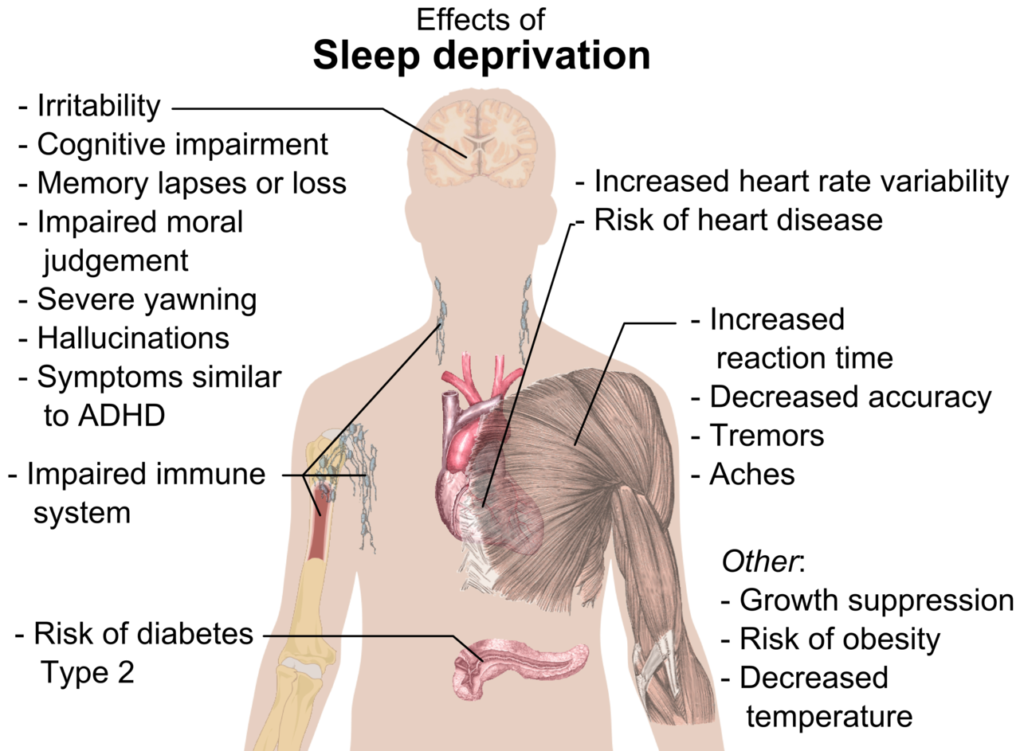

Look at the diagram above. What diseases might someone be diagnosed with that may in fact simply be a lack of good quality sleep? ___________________________________________
___________________________________________________________________________
___________________________________________________________________________
Other complications due to lack of sleep include: depression, lack of energy, frequent exhaustion and a decline in the ability to cope. Because the immune system is affected a person could develop diabetes, heart disease and even cancer.
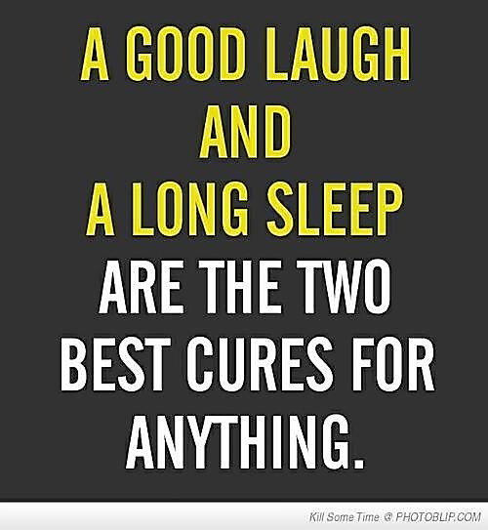
Persistent lack of sleep can ultimately lead to death!!
Research shows that those who regularly slept 7 – 8 hours each night had lower death rates than those who averaged less than 7 hours or who slept longer. During the day our body experiences “wear and tear” as a result of the work we do. This means tissues and cells in the body get broken down and need replacing. Having adequate rest enables the body to replace the dead cells and injured tissues and rejuvenate itself.

Tips to having better sleep: (summarise the following)
- Try not to sleep during the day. If you must have a rest take a nap (short sleep) at about lunch time. As this is less likely to interfere with your sleep at night.
- Avoid being bored during the day. Be active in the day and have something to do.
- When you have breaks during your work day, take a walk outside in the fresh air and do some deep breathing.
- Exercise for 30 minutes or more daily. This will relax you, restore energy and clear the mind. Your body will be ready for a good night’s sleep.
- A nice warm bath before sleep relaxes the body.
- Have your last meal 3 – 4 hours before going to bed.
- Avoid caffeinated drinks, alcohol and nicotine (cigarette smoking).
- Avoid working into the night.
How much sleep are you getting each night??
Eight hours of restful sleep each night is strongly recommended
Seven hours is acceptable

God and Rest
It is interesting that God, at the time of creation created light and separated light from darkness and He called the light day and darkness night (Genesis 1: 3 – 5). It is no secret that God wants us to enjoy work and the blessings of labour during the day and enjoy rest during the night and all the benefits that comes with that. And then to bring it all together, He created the Sabbath where we can all rest from our labours. Rest is indeed a marvellous blessing from God.
Genesis 2: 1 – 3 NIV says: “Thus the heavens and the earth were completed and all their vast array. By the seventh day God had finished the work He had been doing; so on the seventh day He rested from all his work. And God blessed the seventh day and made it holy, because on it He rested from all the work of creating that He had done”.
Section Source: Adventist Health HPCI Documentation (South Pacific Division) 2012

Sunlight
Human beings and plants cannot survive without the beneficial effects of sunlight.
In fact without sunlight, there would be NO FOOD OR OXYGEN on planet earth. ENERGY from the sun, CARBON DIOXIDE from the air and WATER from the environment help plants produce FOOD and OXYGEN that we need every day. This process known as PHOTOSYNTHESIS takes place in all green leaves.

The Benefits of Sunlight:
- Sunshine can cheer you up. The sun can actually alter your mood chemically, alleviate stress and even prevent depression.
- Production of Vitamin D. Sunlight helps our body generate Vitamin D. This vitamin strengthens our bones and muscles and helps protect us against many diseases by strengthening our body’s defence system.
- Sunlight kills germs. Sunlight not only kills germs on our skin, but it also kills germs on your clothes, bedding, mats, mattresses and cushions that you put out in the sun to dry. Germs like growing in dark, dirty, damp places – so open your windows and let the sunshine in!
- Sunlight stimulates the brain. The pineal gland is a small part of the brain that produces chemicals called tryptamine. One type of tryptamine is called melatonin and this keeps the body clock working properly so that we know when it is night and when it is day – it gives us a sense of the time and seasons. This is all due to the suns actions on the brain.
- Sunlight makes a happy heart. It’s almost as good for the heart as exercise! Both lowers the resting pulse rate. Sun also tends to normalise blood pressure and helps the blood carry more oxygen. Sunlight enhances the immune system and increases the number of white blood cells that protect us.
- Sunlight helps prevent diseases. Not only does sunlight kill germs, but it even helps to prevent certain types of cancers.

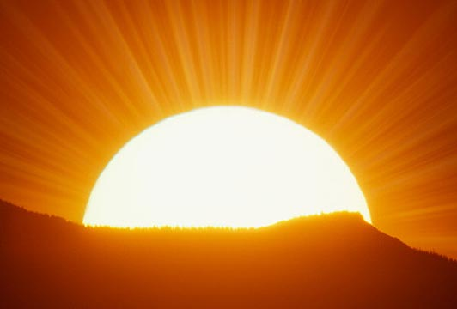
Dangers of Too Much Sunlight
We are blest in the Pacific Islands with generous amounts of sunlight to keep us healthy and strong. Too much sunlight on the other hand can be bad for you. It is important to realise that as with everything else, too much of one thing can make a person sick.
Problems that can develop due to too much exposure to sunlight
- SUNBURN – sunburn occurs quite frequently in fair-skinned people such as Caucasians and Polynesians. It is rare in dark skinned people
- HEAT STROKE – when the sun is too hot, people can faint and fall. Heat stroke is not uncommon
- SKIN CANCER – excessive exposure to sunlight increases the risk of a person developing skin cancer especially in fair skinned people such as Caucasians / Europeans. Skin cancer is a very common cancer in countries like Australia. Skin cancer is fortunately rare in the countries of the South Pacific
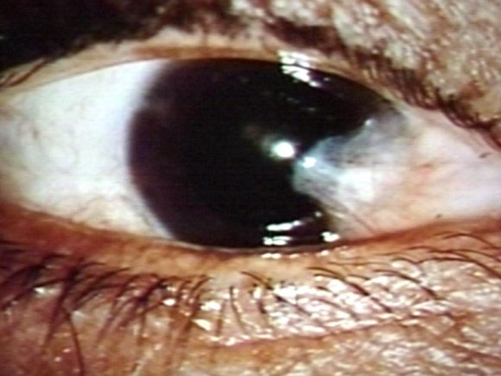
- EYE PROBLEMS - exposure to too much sunlight increases the risk of a person developing cataracts - the world’s leading cause of blindness. A cataract is a cloudy or opaque area in the lens of the eye
Pterygium
http://www.tedmontgomery.com/the_eye/eyephotos/Pterygium.html

- PTERYGIUM - is a fleshy tissue that grows in a triangular shape over the front of the eye ball. It may grow large enough to interfere with vision. This is a very common problem in the Pacific Islands because of our exposure to excessive sunlight.

Water

We often hear people say “drink plenty of water every day.” We read health posters saying “drink 8 glasses of water every day” and we might wonder why they are saying to drink that much water! The answer is simple: water is critical to life. Water is a complex substance that is vital for our physical existence. Without water, life as we know it WOULD NOT EXIST!
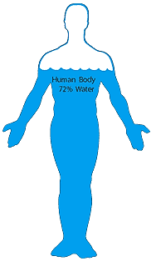
The
body is
approx-
imately
72%
water

Water is one of the most abundant elements in nature. The surface of the earth is approximately 75% WATER. The human body is approximately 72% WATER. This translates into approximately 42 LITRES IN AN AVERAGE MALE and slightly less in a female. A loss of just 10% OF BODY WATER through diarrhoea for example, can kill a person. That is how important water is to all of us.

Water’s effect on the body
- Water contributes to the overall FORM AND APPEARANCE OF A PERSON. A dehydrated man would have SUNKEN EYES, DRY AND WRINKLED SKIN, DRY MOUTH and would be sick looking.
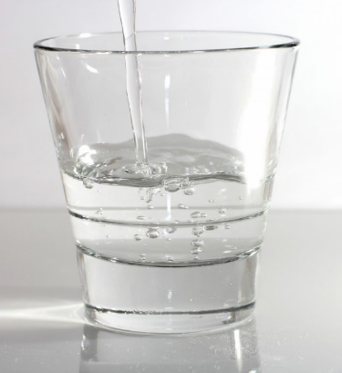
- Water is the main TRANSPORT medium of the body. NUTRIENTS, WASTE PRODUCTS and important body chemicals are all transported throughout the body through water found in the BLOOD. In fact, Blood is 98% WATER. Nutrients such as GLUCOSE, AMOINO ACIDS, FATTY ACIDS AND ELECTROLYTES are absorbed into the blood from the digestive system and are transported to all the CELLS OF THE BODY. Waste or unwanted products produced by the body are transported to the KIDNEYS in the same way and are removed THROUGH THE URINE.
- Numerous lifesaving CHEMICAL REACTIONS that occur in the body occur in the PRESENCE OF WATER. These chemical reactions keep us ALIVE. Without water, these chemical reactions could not take place. Lack of adequate amount of water in the body can seriously affect or hinder these important chemical processes from taking place. This can lead to DISEASE AND EVEN DEATH.
- REGULATION OF BODY TEMPERATURE. Water transports heat from the INSIDE of the body to the SKIN where it can be released into the external environment through SWEAT.
- BREAKDOWN OF FOODS. Water helps in the breakdown of foods into small particles that can be DIGESTED and then absorbed into the blood. In addition, water aids in BOWEL MOVEMENTS and helps prevent CONSTIPATION.
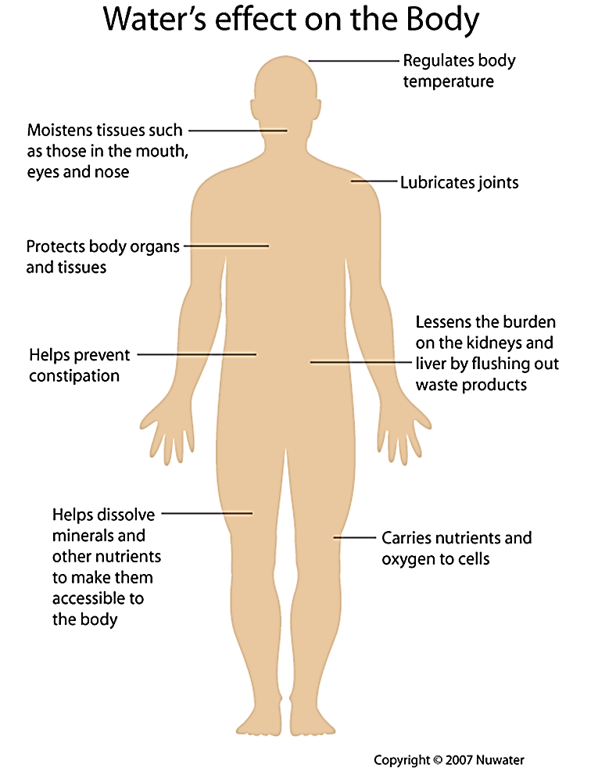
- Water helps to LUBRICATE JOINTS for easy, free MOVEMENT. Water in the brain called “Cerebral spinal fluid” CUSHIONS THE BRAIN and “amniotic fluid” (water in the pregnant uterus) protects the DEVELOPING BABY in the mother’s womb. In addition, water moistens tissues such as MOUTH, EYES AND NOSE.

Ministry of Healing p237
“In health and in sickness, pure water is one of heaven’s choicest blessings. Its proper use promotes health”

Water is vital in all body functions - http://www.nuwater.ca/

Internal use
Drinking
Our body is 70% water. Water cleanses our INTERNAL ORGANS it helps to transport and remove DANGEROUS WASTE PRODUCTS, it enables important CHEMICAL REACTIONS to take place and enables the blood to FLOW FREELY through the action of the heart. A loss of 5% body water can make a person very sick. A loss of 10% body water can kill a person. An average person needs to drink at least 8 GLASSES (OR 2 LITRES) every day to maintain normal hydration. Lack of an adequate amount of water in the body is called DEHYDRATION. Common causes of dehydration include: INADEQUATE INTAKE, DIARRHOEA, FEVER, AND VOMITING.
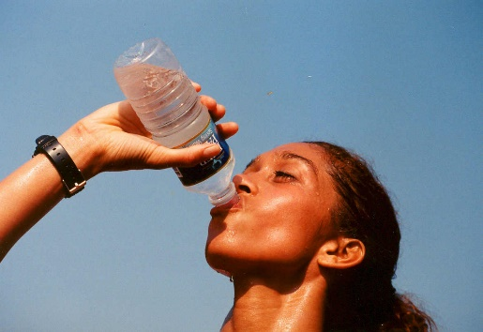
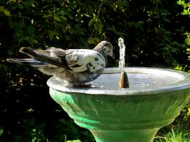
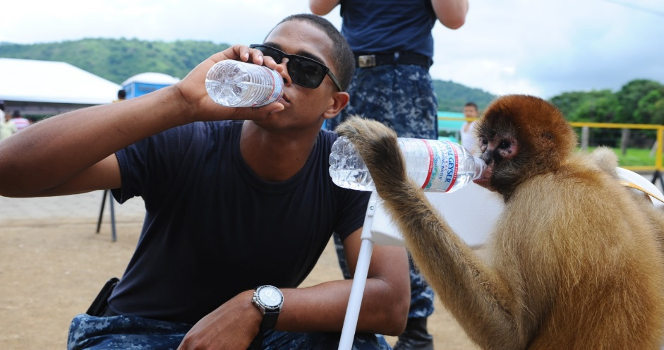
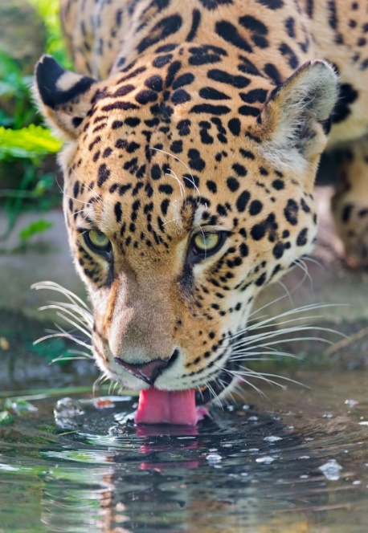
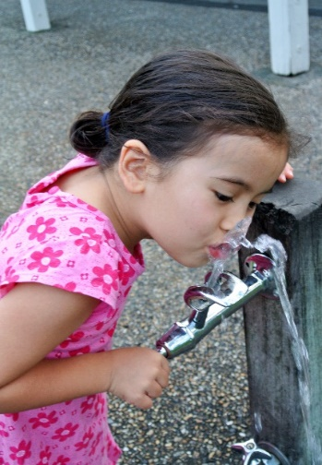
Nothing beats a cup of cool refreshing water. Unfortunately many people today replace water with SWEET DRINKS SUCH AS CORDIAL AND SOFT DRINKS. Water is the juice of life. Pure, clean water SUSTAIN LIFE. Make water your favourite beverage because water is what your body really needs.
All of God’s creatures need water to survive

External uses
Bathing/Shower
It is important that we have a shower at least TWICE A DAY - in the morning and evening. Regular cleansing of the body protects us from all kinds of DISEASES including BACTERIAL AND FUNGAL diseases and ensures that you smell right. Cleanliness is important. Keep your BODY CLEAN, YOUR HOUSE CLEAN, YOUR CLOTHES CLEAN, AND YOUR YARD CLEAN. A clean body and environment promotes health.
- WASHING - water is used for cleaning and washing purposes. Clothes need to be washed with soap REGULARLY. Eating and cooking utensils should be WASHED, DRIED AND STORED AWAY or covered after every meal. Unwashed eating utensils can PROMOTE DISEASE. Anything that is dirty can be washed with water for cleansing. These are good practices that help to PROTECT us from a wide range of diseases.
- COOKING - water is used for cooking purposes. It is essential that clean water is used at all times.
- REMEDIAL THERAPY - water is a good MEDICINE and can be used in many ways to help alleviate illness. For head ache sufferers, put your feet in a nice WARM FOOTBATH. A cold wet face cloth placed on the BACK OF THE NECK and forehead at the same time as having the foot bath is helpful. Continue topping up the footbath with hot water until head ache eases. Finish by pouring a COOL JUG OF WATER over your feet before drying.
Daily water loss
We constantly lose water every day. This is called “daily water loss”. It is lost through the following ways:
- Through Skin: 350 MLS
- When we breathe in and out (respiration) 350 MLS
- Through Urine 1400 MLS
- Through Sweat 100 MLS
- In faeces 100 MLS
When we add the numbers up we get to a figure of 2300 MLS. This is the total amount of water we lose over a 24 hour period. We replace this loss by drinking adequate amount of water.
How much water should we drink?
The best way to maintain the balance is to drink at LEAST 8 CUPS OF WATER EVERY DAY – the cup used should hold at least 250mls of water.
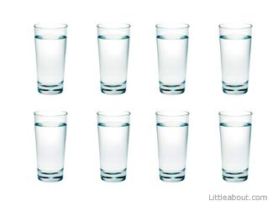
- 2 cups of water an hour before breakfast
- 2 cups of water before lunch (10am)
- 2 cups of water at around mid-afternoon (3pm)
- 2 cups of water before going to bed.

One simple way of checking whether you are taking enough water is to look at the COLOUR OF YOUR URINE - if it is clear and you are passing good volume of urine then your hydration is good, but if it is brownish in colour and you are passing only small amounts than you need to drink more water because you may be dehydrated.
The Need for Extra Water
The body needs extra water when there is excessive loss:
- The body needs extra fluids or water in situations where there is excessive sweating. This may be due to exercise or fever. In both these situation there can be excessive loss of body water.
- Anyone who has diarrhoea or gastroenteritis can lose a lot of body water. Children are particularly prone. Anybody with diarrhoea must drink plenty of water. If a person does not drink enough water, and is vomiting at the same time then they must be taken to the hospital for an intravenous drip – which is water being introduced straight into the blood stream in the form of a saline solution.
- Vomiting is a common medical problem but it can be a sign of some important underlying disease processes both in children and adults. A lot of body water and some special minerals from the body called “electrolytes” are lost when a person vomits or has diarrhoea. Replacing the water is crucial.
Healthy Tips (Summarise)
- Start each day by drinking two glasses of pure water (500mls).
- Try not to drink during meals. Water with foods slows down digestion.
- Drink only clean water. Boil the water if you are unsure if the water is safe to drink.
- If water is from a stream or spring, keep animals away from the source by visiting the site regularly.

Alcohol
Alcohol is everywhere - in shops, in little canteens and even in very remote villages of the South Pacific. There are many reasons why people drink alcohol…they say it makes them feel good or it makes them forget about their problems. Some even take it thinking that it is good for their health; THEY COULDN’T BE MORE WRONG! The truth of the matter is alcohol is a powerful addictive drug and it kills. In fact, Alcohol kills about 2-3 million around the world every year. It kills through accidents and by destroying people’s health.
What is Alcohol?
In order to understand alcohol's effects on the body, it is helpful to understand the nature of alcohol as a chemical, so let's take a look:
Here are several facts:
- Alcohol is a clear drink that is made from corn, barley, grain, rye and yeast.
- Alcohol is produced by several methods but the most popular is fermentation.
- Alcohol is a clear liquid at room temperature.
- It is less dense and evaporates at a lower temperature than water (this property allows it to be distilled. By heating a water and alcohol mixture, alcohol evaporates first).
- Alcohol dissolves easily in water.
- Alcohol is flammable (so flammable that it can be used as fuel).

The alcohol found in alcoholic drinks is ethyl alcohol or ethanol the molecular structure of ethanol looks like this:

H
H₃ C - C - O - H
H

Alcoholic drinks come in various categories and with various brand names. Examples include wine, beer, gin or whisky. They all contain ethanol in different concentrations.
For example:
Beer contains approximately 4% to 6% of ethanol (average of about 4.5%)
Wine = 7% to 15% (average of about 11%)
Champagne = 8% to 14% (average of about 12%)
Distilled spirits (e.g. rum, gin, vodka, whiskey) = 40% to 95%.
In the South Pacific, illegally brewed alcoholic drinks such as “home brew” and “Kwaso”, developed from fermentation of yeast are found almost everywhere. These are considered to be illegal and dangerous.
How Alcohol enters the Body
When a person takes alcohol, about 20% of it is absorbed into the blood from the stomach and about 80% from the small intestines. How fast the alcohol is absorbed depends on several things:
- The concentration of alcohol in the drink - the greater the concentration, the faster the absorption.
- The type of drink - carbonated beverages tend to speed up the absorption of alcohol.
- Whether the stomach is full or empty - food slows down alcohol absorption.
When alcohol is absorbed, it enters the bloodstream and the blood carries the alcohol throughout the body. Alcohol in the blood then enters the tissues of the body. Once inside the tissues, alcohol exerts its effects on the body.
How Alcohol leaves the body
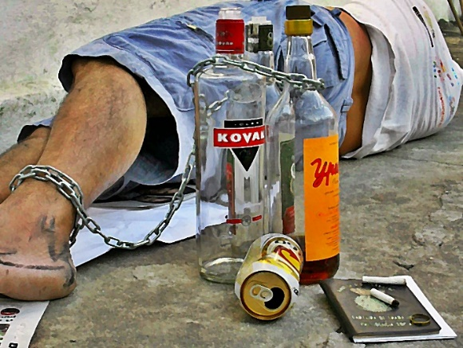
Once absorbed into the bloodstream, alcohol leaves the body in three ways:
- The kidney eliminates 5% of alcohol in the urine
- The lungs exhale 5% of alcohol when breathing out
- The liver chemically breaks down the remaining 90% of alcohol into carbon dioxide and water.

The Effects of Alcohol
The observed effects of alcohol depend directly on the Blood Alcohol Concentration (BAC), which is related to the amount of alcohol a person drinks.
Most of us have seen someone who has had too much to drink and we notice the way they perform and behave. The body responds to alcohol in stages, and that corresponds to an increase in blood alcohol concentration (BAC):
- Euphoria (BAC = 0.03% to 0.12%)
- They become more self-confident or daring
- Their attention span shortens
- Their judgement is not as good - they may say the first thought that comes to mind, rather than an appropriate comment for the given situation
- They have trouble with fine movements, such as writing or signing their name.
- Excitement (BAC = 0.09% to 0.25%)
- They become sleepy
- They have trouble understanding or remembering things
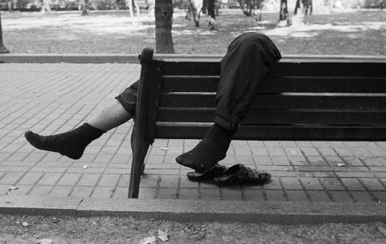
- They do not react to situations as quickly (if they spill a drink they may just stare at it)
- Their body movements are uncoordinated
- They begin to lose their balance easily
- Their vision becomes blurry
- They may have trouble sensing things (hearing, tasting, feeling, etc.).
- Confusion (BAC = 0.18% to 0.30%)
- They are confused - might not know where they are or what they are doing
- They are dizzy and may stagger
- They may be highly emotional - aggressive, withdrawn or overly affectionate
- Their ability to make right choices and decisions is severely affected
- They cannot see clearly
- They are sleepy
- They have slurred speech
- They have uncoordinated movements (trouble catching an object thrown to them)
- They may not feel pain as readily as a sober person.

- Stupor (BAC = 0.25% to 0.4%)
- They can barely move at all
- They cannot respond to stimuli
- They cannot stand or walk
- They may vomit
- They may lapse in and out of consciousness.
- Coma (BAC = 0.35% to 0.50%)
- They are unconscious
- Their reflexes are depressed (i.e. their pupils do not respond appropriately to changes in light)
- They feel cool (lower-than-normal body temperature)
- Their breathing is slower and more shallow
- Their heart rate may slow.
- They may die.
- Death (BAC more than 0.50%) - The person usually stops breathing and dies.

DISCUSSION QUESTIONS: (Share your thoughts on these with the class)
  - In Australia, the limit Blood Alcohol Concentration limit for driving is 0.05%. Would you agree that it is safe to drive at that limit? If you could, would you raise that limit? Why or why not?
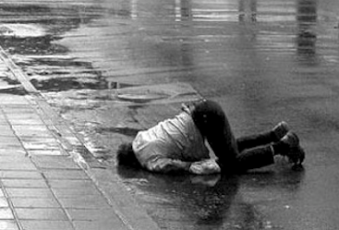
  - Have you seen a very drunk person? Which BAC level do you think they were operating at?
  - I once witnessed a young lady who had drunken too much alcohol stand up at a train station and urinate. As the urine was running down her legs and pooling around her nice, quite expensive shoes, I asked myself: ‘if people drink because they think it makes them look and act cool, did it work for this poor lady’? Have you seen anyone act in a terrible way when they were drunk that would disgust them if they were sober? Remember these when you are tempted to follow the crowd into having alcohol to drink and choose to stay in control!
  - Looking at the side effects of the different BAC levels, why do you think it’s important as a Christian to stay away from Alcohol?

Problems Caused by Alcohol
Alcohol impairs mental and physical functions
Alcohol is clearly both addictive and destructive. There are many adverse mental and physical effects resulting from exposure to alcohol. The following are a few examples:

LIVER CIRRHOSIS
Alcohol can lead to serious liver damage called cirrhosis of the liver. Prolonged alcohol consumption is usually the cause of this.
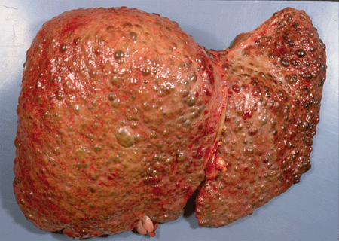
http://www.olympus-sis.com/en /6900_6927.htm
Alcohol destroys liver cells and gives rise to a very hard and irregular liver tissue. Patients with cirrhosis of the liver are very sick people.

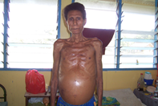
Patients with alcoholic liver cirrhosis lose a lot of weight, develop big swollen abdomen and yellow eyes because the liver cannot perform its work effectively. Photo: C. Kuma

Alcohol’s Effect on the Brain
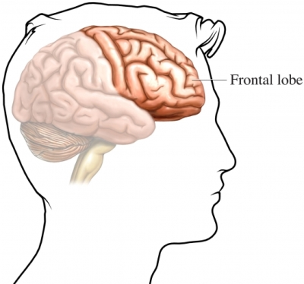
Alcohol interferes with the function of the brain cells and eventually destroys them. Especially affected are the frontal lobes of the brain. The frontal lobes enable us to make good judgement, prompt inhibition, maintain self-control and enable learning and memory functions. The brain is the seat of our conscience, decision making and choice. It is also regarded as our spirituality centre. Alcohol interferes with all these important functions.

Drinking alcohol can lead to confusion, disorganization, lack of inhibition, impaired ability to learn new things, memory loss and permanent brain damage.
“Wine is a mocker strong drink is raging and whosoever is deceived thereby is not wise”
Proverbs 20:1
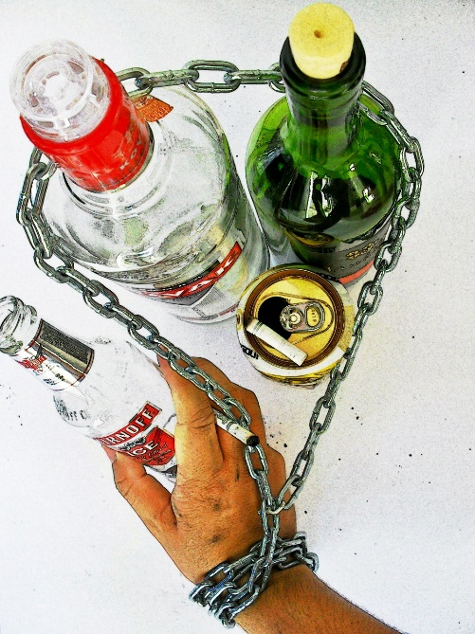
Stomach and Intestines: constant alcohol use irritates and degrades the linings of the stomach and intestines, causing ulcers.
Alcohol and the Heart: alcohol seriously damages your heart muscle and blood vessels. It can lead to a weak heart and heart failure. Alcohol causes an increase in blood pressure and bad fats in the blood increasing the risk of heart attacks and strokes.
Alcohol and the male Sex-cell (sperm): Sperm production decreases due to effects of alcohol on the brain and the testes.
Alcohol and the developing foetus: It damages the baby’s developing brain and can mean lifelong problems for both the mother and the child. There is no safe time in pregnancy to drink alcohol.
Alcohol and Nutrition: Too much alcohol can lead to poor nutrition, malnutition with decreased levels of iron and vitamin b and can result in anaemia (lack of blood).
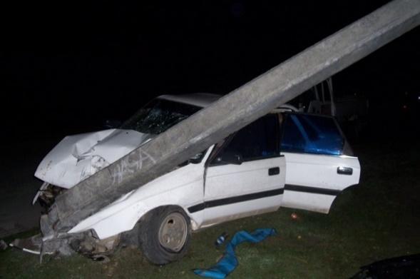
Alcohol and Accidents: Alcoholics fall down a lot and therefore suffer many breaks and bruises. Alcohol has also caused more car accidents/deaths than any other drug. Drunks can’t make good judgement and crashes are more likely to happen.
Photo: C Kuma
Alcohol and Cancers: It increases risk of mouth, throat, oesophagus, pancreas, bladder, kidney and breast cancer.
Social Impact of Alcohol: It can lead to significant emotional and social problems. Alcoholics can become anxious, depressed and even suicidal. This leads to marital and family problems including domestic violence. It also effects employability
PAY ATTENTION
Alcohol is one of Satan’s most powerful weapons to destroy lives today. He makes it look so attractive with the aim of enticing people into the habit of drinking. He gets them addicted, breaks up their family, steals their money, robs them of their integrity and eventually lands them in a hospital bed either as a result of an accident or a diseased liver, heart or cancer. Alcohol can snap out a life so suddenly. DON’T LET IT BE YOURS!!!

Ellen White Comments on Social Impact of Alcohol
“Every year millions upon millions of gallons of intoxicating liquors are consumed. Millions upon million are spent in buying wretchedness, poverty, disease, degradation, crime and death. For the sake of gain the liquor dealer deals out to his victims that which corrupts and destroys mind and body.” Temperance p28
Alcohol abuse has destroyed more lives, broken apart more families, caused more diseases and contributed to more auto car accident fatalities than any other drug in the world. And it is the major contributing factor in the growing epidemic of domestic violence.

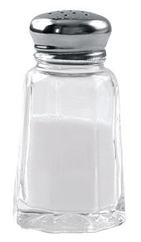
Salt
Most people love salt. We use salt every day – in our cooking. Salt is one of the oldest food seasonings and the most important food preservative in human history.
What is Salt?
Salt comes in different forms but the most common is iodized table salt. This means that iodine is added to the salt you buy from the store and every time you add salt to your food, you’re taking in salt plus some iodine which protects you from developing goitre or enlarged thyroid gland.
Chemically, salt is comprised of two important electrolytes or ions namely sodium (Na) and chlorine (Cl). Both these electrolytes are needed, in only small quantities by all living creatures including humans. They are responsible for several important body functions including nervous system function and water balance in the body.
How much salt does the body need on a daily basis?
The body only needs a little amount of salt on a daily basis. To be more specific, the body only requires about 4 grams or 1 teaspoon of salt a day – not two or three! Only one teaspoon of salt! But BEWARE: Most of the salt you intake will be hidden in the food you eat. Sauces, processed foods, soups, stocks and takeaway foods are all commonly loaded with salt.
What are some risks associated with salt?
Salt raises the blood pressure. Too much salt can give rise to high blood pressure or hypertension. How much salt are we consuming today? The answer is about 5 to 10 times more than we need. We are seeing a huge increase in hypertension, stroke and heart disease as a direct result of this behaviour.
- Did you know that 9 out of 10 people, eating a western diet, will develop high blood pressure before they are considered to be old? This is because the western diet uses a lot of salt! Almost all processed foods we buy from the shops have a very high salt content. Evidence shows that eating a low salt diet reduces blood pressure.
- High blood pressure, caused by salt, contributes to kidney damage because of the harm it does to blood vessels. Once kidney damage has occurred, high blood pressure accelerates further damage and can lead to kidney failure.
- High salt intake may play an important part in the development of stomach cancer. A High salt diet irritates the lining of the stomach and can result in long term infection and the development of stomach cancer
- A high salt diet can lead to the formation of kidney stones.
- Having too much salt can contribute to weak bones, a condition known as osteoporosis.
- Obesity: When we eat too much salt, we can get very thirsty. Where thirst is relieved with high-sugar or high-calorie drink such as soft-drinks, cordial or alcohol, it will also contribute to weight gain.
How does salt increase blood pressure? As the salt content of our blood increases, kidneys retain more water to try to keep the salt concentration balanced. This extra water increases the volume of blood in the blood vessels resulting in increased or high blood pressure.

Why is this so bad for our Health?
- High blood pressure puts a lot of strain on the heart and blood vessels and can lead to significant damage to these structures. This can lead to heart failure and can increase our risk of having a heart attack or stroke.
- High blood pressure narrows the size of the blood vessels. Because of the increased pressure, blood vessels thicken, become narrowed and hardened. When this happens, the blood flow is reduced and organs receive less oxygen and nutrition. Ongoing high blood pressure is the leading risk factor for strokes, heart attacks and heart failure. High blood pressure is also the second leading cause of chronic kidney failure.

Ideas to reducing your salt intake
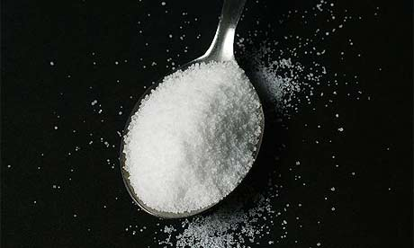
- Buy and eat foods low in salt (ie < 120mg of sodium per 100g)
Your body only needs about one teaspoon of salt a day.
- Avoid high salt processed foods and salty snack and takeaway foods.
- Start the day with no added salt foods such as cereals.
- Remove processed foods from your diet and buy mostly Fruits and vegetables.
- Avoid adding salt during cooking – including garlic salt, onion salt, etc.
- Use herbs and spices to create flavour – not salt.
- Buy wholemeal or wholegrain foods – these tend to be low in salt.

COMMUNICABLE DISEASES
Achieving Good Health
Good health is not merely the absence of disease; it includes the social, mental and spiritual wellbeing of individuals and communities. Thus, to achieve the goal of providing health for all, health improvements in a community should not simply be targeted at reducing disease, but also to address social tensions, mental illness and spiritual health.

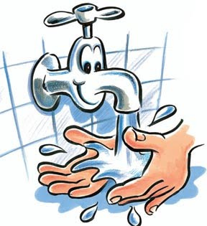
Factors that Influence Health
Factors that influence health can be grouped as follows:
- The environment
- The awareness of individuals and communities about health
- Personal hygiene
- Health care
- Disease

Environment - The environment includes both the physical environment we live in and the social environment of the community - both significantly influence health. The physical environment plays an important role in many ways. For example a clean environment can prevent the spread of disease and may even reduce depression. Safe and adequate water supplies, sanitation, drainage and solid waste disposal all benefit health by removing disease risks from human contact. A dirty environment, by contrast, encourages the spread of disease and may also adversely influence the mental and emotional status of individuals.

Equally important is the home environment. When the home environment is dirty, sickness can still easily spread through a family and on through the rest of the village. Poor housing quality can lead to poor lighting resulting in early eyesight failure or poor ventilation resulting in lung disease. The social environment also has a major impact on health. If people are marginalized because of gender, income status, or ethnic/religious affiliation, they are more likely to be prone to anxiety and depression and to suffer other mental health problems. In particular, the status of women in the community is important. In communities where women are discriminated against, they are more likely to suffer both physical and mental ill health. By contrast, in communities that live in harmony, accept differences and promote resolution of conflict through dialogue, the people would usually be healthier.
DISCUSSION QUESTIONS
- How do you feel when your belongings are unorganised and messy? Does it affect you or your performance at school at all?
- When a group of people ignore you (such as family, friends, church family, or sporting team), how does it make you feel? If it continued, could you imagine it impacting your health? How?
- Are you good at conflict resolution? What do you think is the hardest thing about it? What’s the most successful way that you have found to stop or resolve a fight?
- Have you ever been a subject of discrimination? (you may have been discriminated against because of your race, sex, age, religion etc.) How did it make you feel? How did you respond? Is discrimination inevitable? Are there any forms of discrimination you think are ok? Discuss.
LINKS BETWEEN FACTORS THAT AFFECT HEALTH
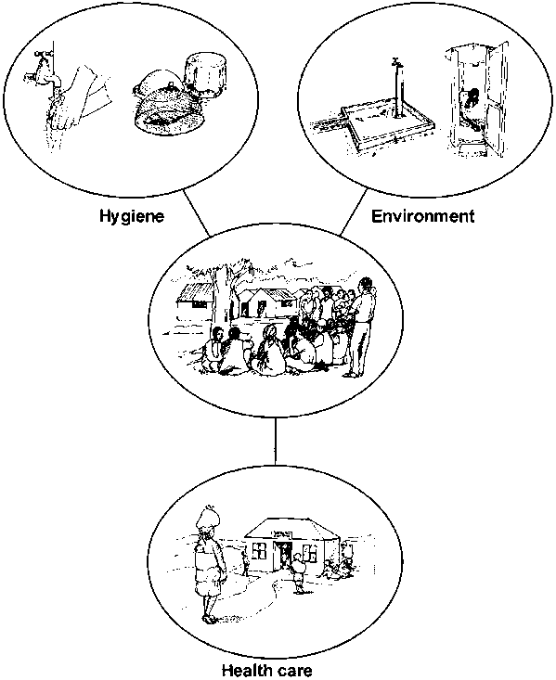
Community cooperation
Our environment (e.g.: standard of water supply, and sanitation), hygienic practices, health care and community participation and cooperation, all impact on health in a significant way.

Awareness of health issues - The awareness of individuals about health is important to promoting a healthy village. If people do not understand the causes of ill-health or sickness and how they can improve their health, they cannot make decisions about investing resources and time to improve their village. Such awareness should be developed in all areas that influence health because the different influences are often interrelated. Unless people accept the fact that they need an improved environment, better personal hygiene and better access to adequate health care, investments aimed at improving health may have only limited impact. It is also essential that community members are aware that improvements in their environment such as hygienic practices need to be sustained to achieve long-term benefits. Both community leaders and governments play an important role in developing this awareness.

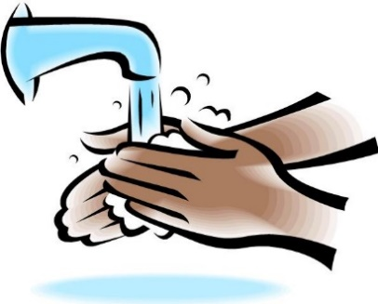
Personal hygiene - Personal hygiene is essential for improving health. For example, if injuries and minor cuts are not kept clean they may become infected and lead to further health problems. And even though water supplies and sanitation facilities may be constructed in a community, unless people use these facilities properly and wash their hands after defecating, store water safely, bathe, and clean their clothes and utensils, diseases caused by poor water and sanitation may still exist.

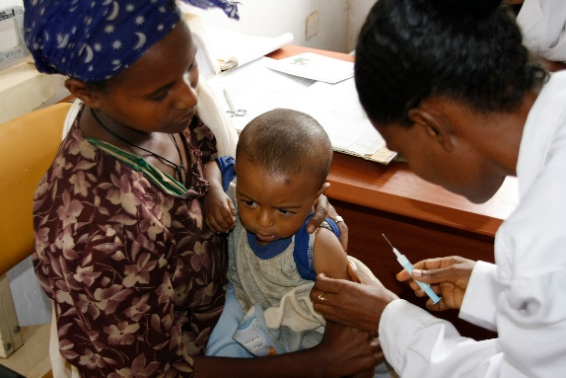
Health care – All people suffer from diseases at some point in their lives and may need to seek medical advice and treatment. Small children in particular may be prone to illnesses that can be life threatening. In all cases, health outcomes are profoundly affected by whether health care facilities are available to the people. Community leaders should therefore lobby national and regional service providers to establish health care facilities as close to the communities as possible.
Vaccinations are an easy and very important way to prevent diseases in a community.

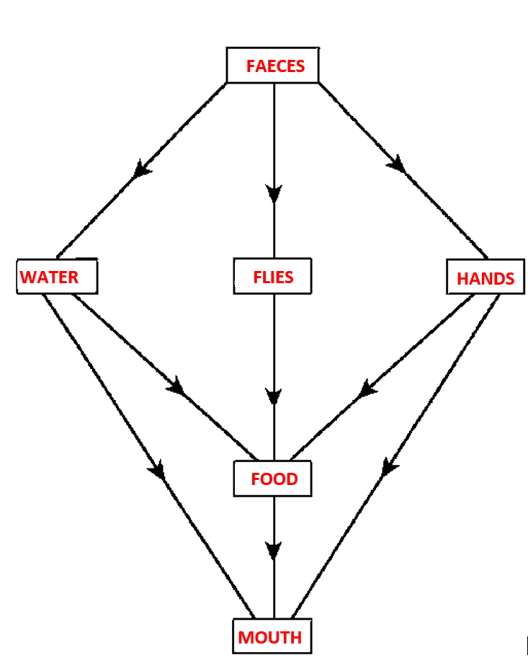
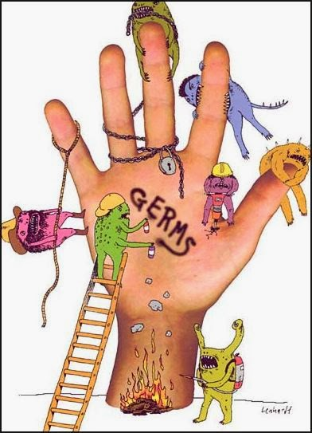
Faecal–oral diseases – Many diseases are caused by food, water and hands that are contaminated by disease-causing germs. Human waste (faeces) is usually one of the main sources of contamination. Diseases caused by these germs are called faecal-oral diseases because faecal material is ingested leading to the illness. Some of these diseases include dysentery, cholera, giardiasis, typhoid and intestinal worm infections. . These are responsible for much sickness and deaths each year. Many infectious diseases are spread through poorly prepared and stored food, and many epidemics start with the consumption of poor quality food or from drinking CONTAMINATED WATER. Good quality water and good personal hygiene helps with SAFE FOOD PREPARATION AND HANDLING and are therefore of utmost importance in preventing the spread of these diseases.

We don’t always realise how easily contaminating human faeces can be. Our hands, our water supply and eventually our food can be very easily contaminated with faeces, and flies which are everywhere, can be a constant source of faecal contamination of unprotected food. This diagram illustrates the faecal-oral route of disease transmission.

Vector–borne diseases – Vector borne diseases are diseases spread by insects such as mosquitoes, fleas, lice, biting flies and bugs. In the south pacific, vector borne diseases include malaria, filariasis (elephantiasis), dengue fever and other viral diseases. These diseases place a heavy burden on individuals as well as communities and are often closely linked to the kind of environment people live in, their behaviour (e.g. sleeping without a mosquito net) and their capacity to maintain a clean environment. Communities can make substantial contributions towards making their villages healthy by properly managing their environment and by using simple vector control principles such as drainage of stagnant water, cleaning up drains and cleaning the village and its surroundings.
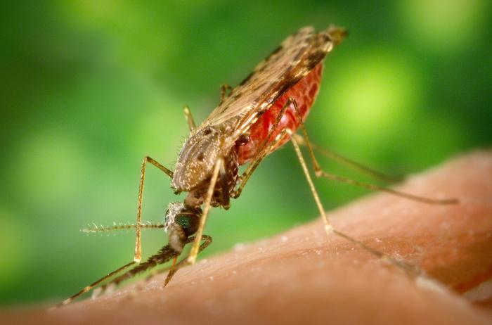
Malaria is an important vector-borne disease in the South Pacific. It is transmitted by the anopheles mosquito. This is a picture of the anopheles mosquito.
See: http://www.mustreads. info/10-deadliest-insects/.

Source
- Healthy villages: A guide for communities and community health © World Health Organization 2002.
- www.who.int/water_sanitation_health/hygiene/.../healthvillages/en/

Personal, Domestic and Community Hygiene
Looking at the pictures below, describe how each item can and must be used to benefit the health of an individual, family or/and community.
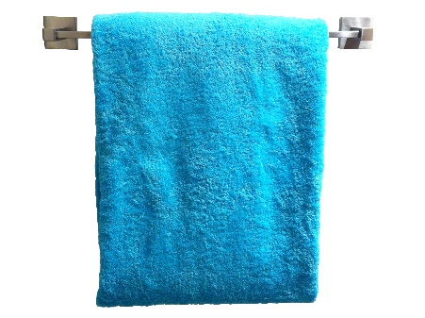
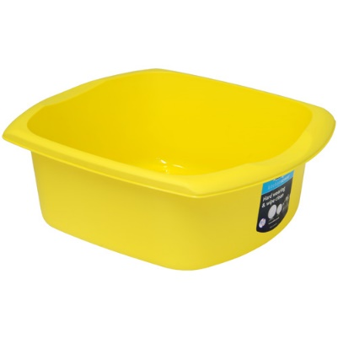
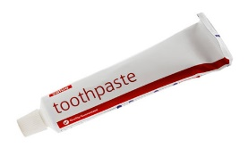
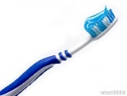
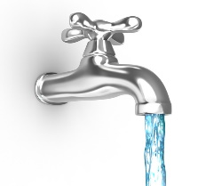
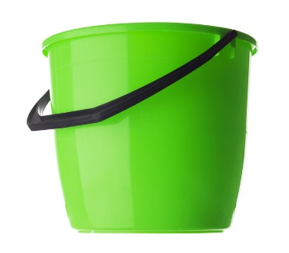
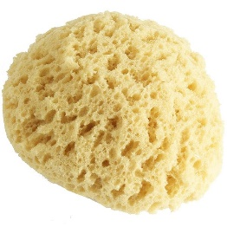

Good hygiene is an important barrier to many infectious diseases. Let’s look at the different ways we can improve our Hygiene.

Personal and domestic hygiene
Handwashing
Proper hand washing is one of the most effective ways of preventing the spread of diseases Germs cannot be seen on hands, and water alone is not always sufficient to remove them. Soap is a cleansing and disinfecting agent when used with water and can be used to kill germs on hands and utensils.
Correct technique: Lather your hands with soap for the time it takes to sing your local “birthday song” (about 15 seconds) and then rinse with clean water. Dry hands with clean cloth if available (moist hands can breed bacteria – but so can a dirty towel/cloth. Paper towel that is discarded after one use is ideal).

Wash your hands with soap and water:
- After going to the toilet.
- After cleaning a child who has defecated.
- Before eating or handling food.

All education programs need to make sure the community understands how important it is to keep clean.
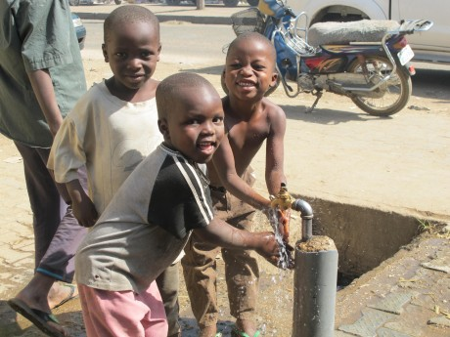
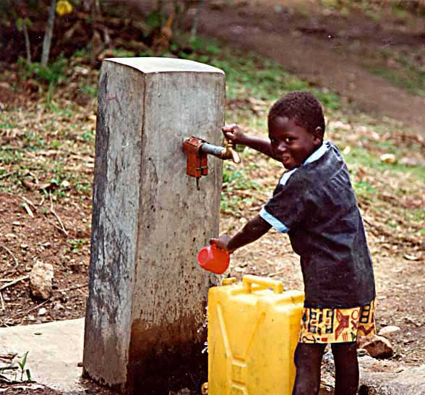
One way to encourage regular hand washing is by providing suitable hand washing facilities located near toilets and kitchens where they will be needed most.
Water stand pipes located near toilets can encourage people to wash their hands after using the toilet.

If running water is available, the facilities should include a tap, sink and soap. If running water is not plentiful, a bucket fitted with a tap is a simple way of providing hand washing facilities; the larger the container, the less frequently it will need filling. Another approach involves a suspended container that, when tipped, pours water onto the hands of the user. The system can easily be made from plastic cooking oil containers. Soap itself can be kept clean by suspending it above the ground on a string.

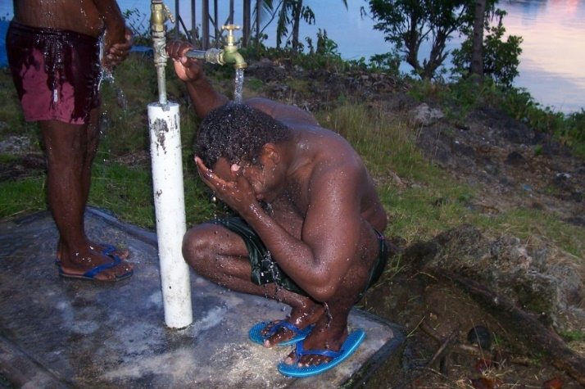
Bathing
Regular bathing and washing of clothes are important practices for cleanliness and good personal appearance and hygiene. They also help prevent poor hygiene-related diseases such as scabies, ringworm, eye infection and louse-borne diseases. Health promotional activities can encourage people bathing more and washing their clothes more regularly. However, increasing the number of washing facilities and locating them conveniently may be an effective improvement.
Bathing with soap is an important means of preventing the transmission of disease. For people to bathe thoroughly they must use sufficient water, but it may be difficult to promote the use of more water for washing if water supplies are distant and water must be collected by hand. Also, traditional bathing practices do not use water efficiently and ensuring cleanliness may be difficult. By changing existing practices, such as encouraging the use of water containers with taps, it may be possible to improve the efficiency of water use.
A lot of water can be wasted by using the method of bathing illustrated in the picture above. Using a bucket can lessen water wastage. This is especially important in areas where water is scarce. Photo: C. Kuma
“Purify me from my sins, and I will be clean; wash me, and I will be whiter than snow”

Write on the T-Shirt Ps 51:7 (NLT)

Laundering (washing of clothes)
To promote regular washing of clothes and bedding, laundry slabs or sinks can be constructed near water points. They should be large enough to wash bedding and other bulky items and be situated so that water drains away from the laundry area and away from the water source. In many villages in the Pacific, laundering is done in nearby rivers or streams and that is fine as long as it does not contaminate the drinking water supply.
The important thing to remember is that regular washing of clothes is important for personal hygiene.
Community Hygiene
Some corrective health measures can be undertaken only by the community as a whole; these include:

- Water source protection
- Proper disposal or solid waste and human waste
- Wastewater drainage
- Controlling animals
- Market hygiene.

Individual community members can play an important role in community hygiene, and have a responsibility to their neighbours and to the community to promote good health and a clean environment. For example:
- Everyone in the village must keep their houses and compounds clean, because one dirty house can affect many health conscious neighbours and contribute to the spread of disease.
How do you think this would happen? _____________________________________
_____________________________________________________________________
_____________________________________________________________________
_____________________________________________________________________
- Community leaders can promote cleanliness in the home by regularly checking on village households and by using rules (by-laws) to encourage household maintenance.
What sort of rules do you think community leaders should enforce? List five of the most important ones ________________________________________________ ______________________________________________________________________________________________________________________________________________________________________________________________________________________________________________________________________________________________________________________________________________________________________________________________________________________________

Markets
Markets often represent a health hazard because foodstuffs may not be stored properly and the markets may lack the basic services to ensure a hygienic safe environment.
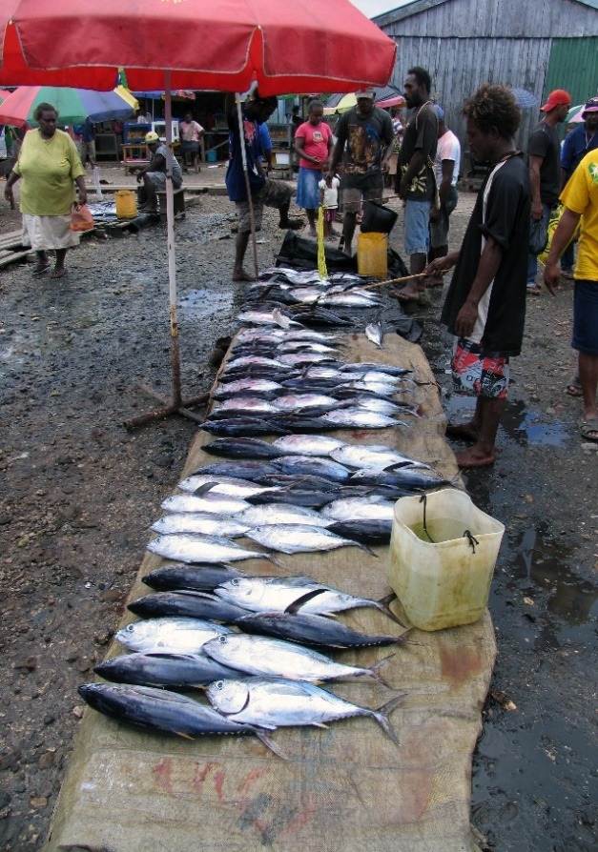
- Several taps should be available to provide traders and customers with ready access to safe water for drinking and washing.
- Sufficient toilets need to be provided; both male and female.
- Food sold at the markets should be inspected daily by health officials. This is particularly important for meat and fish.
- To prevent rats and insects from feeding and breeding, solid waste needs to be disposed of properly. This needs to be done at least daily. Strategically located waste bins or even concrete bunkers, can make this more effective. Market areas also need to be properly drained to prevent flooding and insect breeding.
- Markets function most effectively when they have a committee that runs and coordinates them. With proper legal status and recognition from the village council, markets can charge fees and attract proper supervision. Money collected as fees can be used for improvement projects within the market itself. If markets are held regularly, community members should seek advice and support from local health staff on issues such as setting up an association, establishing trading standards and the penalties for those who break rules.

Animal rearing
In many communities animal rearing is a means of generating food and for generating additional income. However, if it is not practised safely, animal rearing can have negative effects on the health of the community.

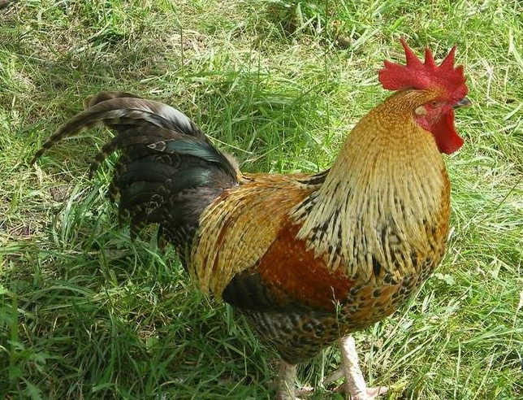
- Animals should always be kept in compounds, at least 10m from households and cooking areas, and 100m from drinking water sources, since their wastes contain germs that can contaminate food and water
- Animal waste should be disposed of properly away from homes and water sources
- It is also best that animals are slaughtered away from households and water sources since animal wastes may introduce contamination
- Animals can transmit disease. Pigs and dogs for example, can transmit germs that can affect the brain and other parts of the body.

Food hygiene
Contaminated food represents one of the greatest health risks to a population.
It is a leading cause of disease outbreaks and transmission. Food that is kept too long can go bad and generate toxic chemicals and germs, and food items that are eaten raw, such as fruits or vegetables, can be contaminated by dirty hands, unclean water or flies. Food not properly prepared can also cause chemical poisoning. For example, cassava leaf that has not been properly pounded and cooked may contain dangerous levels of cyanide. To promote good health, food should be properly stored and prepared.

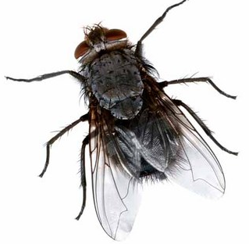
Flies
Flies transmit germs. They are attracted to almost anything – good or bad. Flies have many tiny hairs and when they land on dirty things like human faeces, tiny portions of faeces and many germs get stuck on the hairs on their body. When they land on unprotected food or surfaces such as the tables both faeces and germs are deposited. Germs are introduced into the digestive system when contaminated food is eaten and the person infected can develop serious illness.

Food preparation in the home
As most food is likely to be prepared in the home, it is important that the family understands the principles of hygiene and know how to prepare food safely.

- Before preparing food, hands should be washed with soap. Raw fruit and vegetables should not be eaten unless they are first peeled or washed with clean water. It is also important to cook food properly, particularly meat. Both cattle and pigs have tapeworms that can be transferred to humans through half cooked meat; for this reason, raw meat must never be eaten.
- Eggs, too, must be cooked properly before eating, since they may contain salmonella: a very dangerous germ.
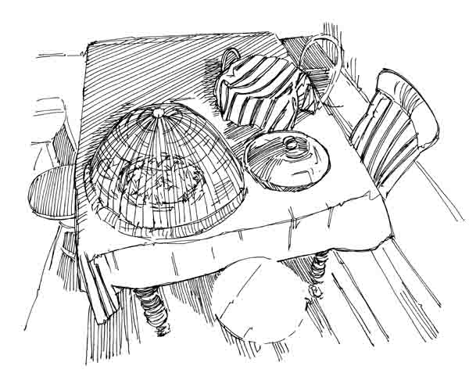
- The kitchen itself should be kept clean and waste food disposed of carefully to avoid attracting rats, mice and cockroaches. Keeping food preparation surfaces clean is important because germs can grow on these surfaces and contaminate food.
Always protect your food from flies and insects.

- Fresh meat should be cooked and eaten on the same day unless it can be stored in a refrigerator if not, it should be thrown away.
- Cooked food should be eaten while it is still hot and should not be left to stand at room temperature for long periods of time, since this provides a good environment for disease-causing germs to grow. Food that is ready to be eaten should be covered to keep flies away and should be thrown away if not eaten within 12-16 hours. If food must be stored after cooking, it should be kept covered and in a cool place such as a refrigerator. Food that is already prepared, or food that is to be eaten raw must not come into contact with raw meat because meat contains bacteria that can contaminate other foods.

Some of the riskiest behaviours to personal, family and community health include:
- The unsafe disposal of faeces or human waste
- Not washing hands with soap after defecating
- The unsafe collection and storage of water
- Food left uncovered.

It is important that the community understands the importance of proper disposal of faeces, washing of hands with soap and water after defecating and the safe storage of food and water. Remember, faeces, dirty hands, flies and dirty or contaminated water are the most common ways in which germs are transmitted.

Source:
- Healthy villages: A guide for communities and community health © World Health Organization 2002.
- www.who.int/water_sanitation_health/hygiene/.../healthvillages/en/
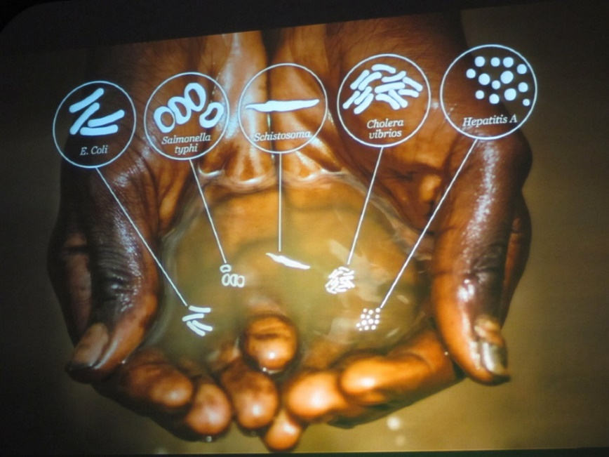

“Dirty water kills more people every year than all forms of violence
including war”
(UN Secretary – General Ban Ki-moon)
Sanitation
What is Sanitation, and Why Does it Matter?
Sanitation is any system that promotes sanitary, or healthy living conditions. It includes systems to manage waste water, storm water, solid waste and household refuse and it also includes ensuring that people have safe drinking water and enough water for washing.
What do we mean by "good sanitation"?
Good sanitation refers to the appropriate behaviour and practices of the people living in a specific environment. The people must:
- Know how to avoid contact with human excreta and how to hygienically dispose of it.
- Be responsible towards the hygiene of their families, community, and the environment. This makes sure you DO NOT spread diseases.
Why does good sanitation matter?
Disease epidemics such as cholera, typhoid and diarrhoea has focused attention on the importance of good sanitation in breaking the cycle of these diseases spread by human excreta.
Poor sanitation
- Promotes the spread of disease - including chronic diarrhoea, intestinal worms, Cholera, typhoid, viral hepatitis A and scabies. These can lead to malnutrition and stunting, especially in small children.
- Has a major negative impact on the quality of life of people within a community.
Sanitation matters for a range of other reasons:
- Privacy, dignity, convenience and safety for individuals.
- Poverty reduction, through reducing vulnerability to disease and allowing low-income people to make better uses of their resources.
For all these reasons good sanitation is an essential part of community development.
What is needed to achieve improved sanitation?
- Good sanitation is achieved when everyone in a community understands the importance of safe excreta disposal, and takes the necessary practical steps to promote good personal hygiene and public health. This includes access to, and consistent use of, a safe and hygienic toilet
- A sanitation improvement programme starts with a strong local health team that can identify local sanitation-related health problems and work with the community to remedy them
- Key issues are poor hygiene practices, such as open defecation; contamination of water sources; malnutrition caused by worms or ongoing diarrhoea, lack of safe and hygienic toilet facilities, lack of facilities for hand washing and inadequate waste removal
- It is crucial to promote understanding of the linkages between water, sanitation, hygiene and health.

What are the advantages of good sanitation behaviour?
- Increased life expectancy with reduced sickness and child death.
- Savings in health care costs.
- Reduced sick leave and higher worker productivity.
- Better learning capacities among school children – increased school attendance.
- Community and national pride.

Sanitation, Health and Hygiene
There are six key tasks that face any community setting out to promote improved sanitation:
- Identifying what problems poor sanitation is causing and developing a plan to address them.
- Ensuring effective collaboration between the community and government who have traditionally managed sanitation.
- Ensure that the environmental health service has the resources to work with in communities.
- Often government officers appointed to assist a community with sanitation needs do not have access to transport and this severely limits their ability to be effective.
- Identifying and organising training opportunities for communities. This includes training in sanitation promotion and in new skills such as community education and research. Visiting successful sanitation projects in other areas is an excellent way of learning.
- Ensuring that community education happens - either by providing training for village health leaders and other community level workers.

What is health and hygiene promotion?
Without safe hygiene practices, health benefits from better water and sanitation services will be limited. Hygiene promotion has a positive impact on health even without improvements in water and sanitation services. Hygiene promotion is mostly about changing people’s hygienic behaviour, a difficult and often slow process. It begins with working with local communities to understand their beliefs, practices, and problems and raising awareness of the impact of good sanitation. Communities must work with support teams from the local government to plan appropriate remedies.

Hygiene behaviours can be divided into five main areas:
- Safe disposal of human waste (faeces).
- Protection and use of water sources.
- Home and environmental hygiene.
- Water and personal hygiene.
- Food hygiene.

Education about how to maintain and care for toilets is an important part of hygiene education.

Key elements of a good hygiene promotion programme include:
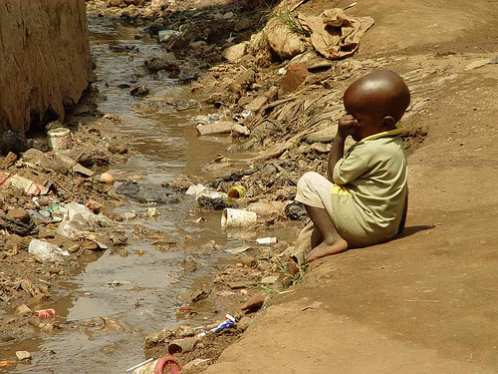
- Close interaction between local communities and support teams from the local government to identify a specific local problem as the priority target e.g: poor toilet usage
A child in Uganda next to an open sewage drain.
- Household participation in identifying problems and needs and in finding solutions for those problems and needs.
- Development of an effective communication or education campaign.
- Evaluating the impact of the programme.

The Problem
Safe disposal of human waste (faeces) is very important for health reasons. This prevents environmental contamination including our water supply, food, hands and our village environment. This can be accomplished in several ways, some requiring water, others requiring little or none. Regardless of the method, the safe disposal of human faeces is one of the most important ways of breaking the transmission cycle of disease.
Plans for locating sanitation facilities and for treating and removing waste, must consider cultural issues, particularly as sanitation is usually focused on the household. Human waste (excreta) disposal may be a difficult subject for a community to discuss because:

- It may be taboo, or people may not like to discuss issues they regards as personal and unclean.
- People may feel that sanitation facilities are not appropriate for children, or that children’s faeces are not harmful.
- There may be a need to build separate facilities for men and women and ensure that they need to be positioned so that no one can be seen entering.
- If the toilets smell and are a breeding ground for flies, people may not use them.
Proper use of the sanitation facilities can lead to health improvement. The danger is: toilet use may be abandoned if its construction or location does not meet the social and cultural views of the community and if they are too expensive to build. Within a community, several different sanitation options may be required. This will depend on preference, location, and costs.

The Solution
Methods for Proper Disposal of Human Faeces
In this chapter will look at a few different methods used in the Pacific Islands to safely dispose of human waste. Each have their advantages and disadvantages so it will be up to the various communities to decide which better suits their wants and needs.

- Simple Pit Latrine
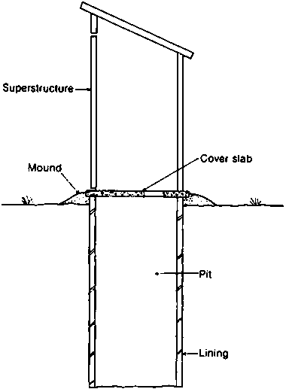
The simplest form of pit latrine is a hand dug pit that is unlined and covered with a series of wooden logs strapped together allowing the user to defecate into the pit.

Seehttp://helid.digicollection .org/en/d/Jh0210e/3.2.2.html

Advantages | Disadvantages
- Construction costs are low (Householders can perform a large part of the work themselves) | - Possible groundwater contamination if the pit is not completely lined.
- Technology is simple and understandable. | - Not easy to make in rocky or unstable ground.
- Allow range of anal cleansing materials. | - Fly and smell is a major problem
- Do not require water to operate.

Other types of simple pit latrines
Raised Latrines - When the ground water is high or the ground is too rocky to excavate by hand there is a case for using a raised pit latrine (other latrine types can also be raised although it is more common for simple pit latrines to be raised). One major disadvantage is the lack of privacy afforded to the users of the latrines.
Slab type – Many types of slabs that can be used for a latrine, each with different benefits. The purpose of the slab is to hold to weight of the user over the pit, provide a clean surface for the user’s feet and drain liquids into the squat hole. A variety of materials can be used such as timber, reinforced concrete and un-reinforced concrete slabs.
Cover – flies and smell can be the biggest problems associated with simple pits which can be controlled to some extent with a drop-hole cover or stopper.
- Ventilated Improved Pit (VIP) Latrine
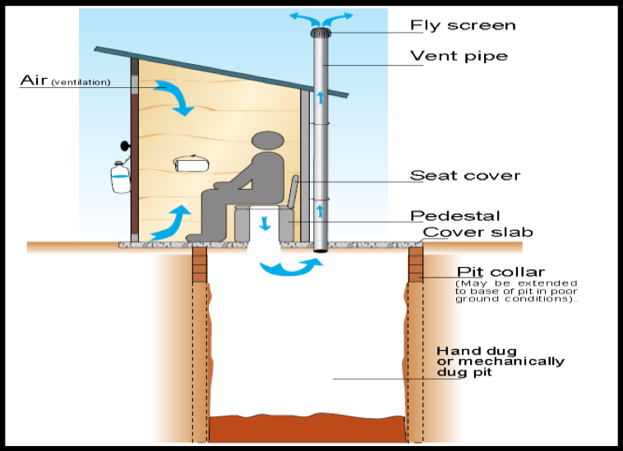
The VIP latrines are similar to simple latrines but the big difference is they have a vent or a chimney that allows bad smell to escape so that the toilet is almost smell free. There are two main reasons for this design and that is to address the problem of flies and smell. VIP latrines enable the flow of air through the system.

http://www.thevossfoundation.org /sanitation-technology-ventilated-improved-pit-vip-latrines/

Advantages | Disadvantages
- Construction costs low as house-holders can do a lot of the work themselves. | - Possible groundwater contamination if the pit is not completely lined.
- Technology is simple and understandable. | - Not easy to make in rocky or unstable ground.
- Allows for the use of a range of anal cleansing materials. | - Does not control Mosquitoes.
- No water needed. | - Vent pipe increases costs and can make construction more difficult.
- Controls smells and flies. | - Need to keep inside dark to attract flies towards the vent.
 | - Increased odour outside.

- Pour-flush Latrine
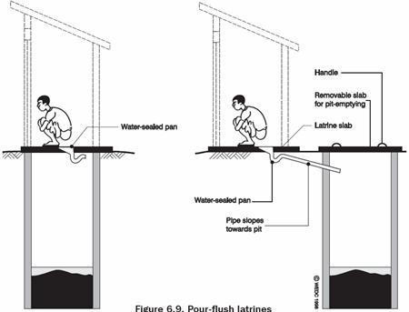
Where water is more widely available or traditionally used for anal cleansing a pour flush latrine may be appropriate and can bring a number of further benefits on top of simple or VIP latrines. A water-seal is created by a plastic u-bend which prevents bad odour and flies affecting the user. The system only requires a few litres of water and so should not put a strain on water resources.

(Source: Harvey et al, 2002)
A pour-flush latrine set over a pit latrine (left) and discharging to an offset pit (right)

Advantages | Disadvantages
- Effectively reduces levels of flies, mosquitoes and odour. | - Requires a water supply.
- Can have an offset pit and so can be installed into a house. | - No solid anal cleansing materials allowed.
- Easy to clean. | - Plastic requires skill to produce.
- Construction is easy. | - More expensive than simpler types.
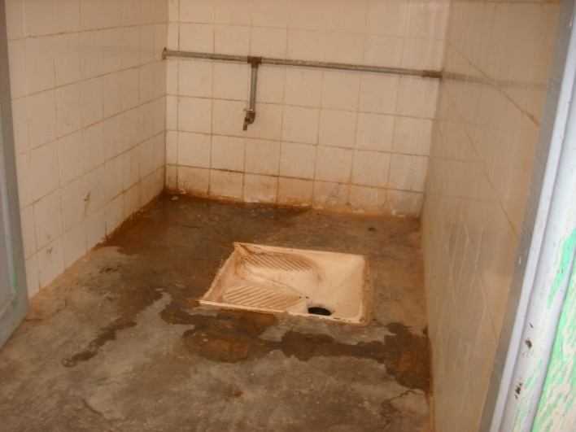
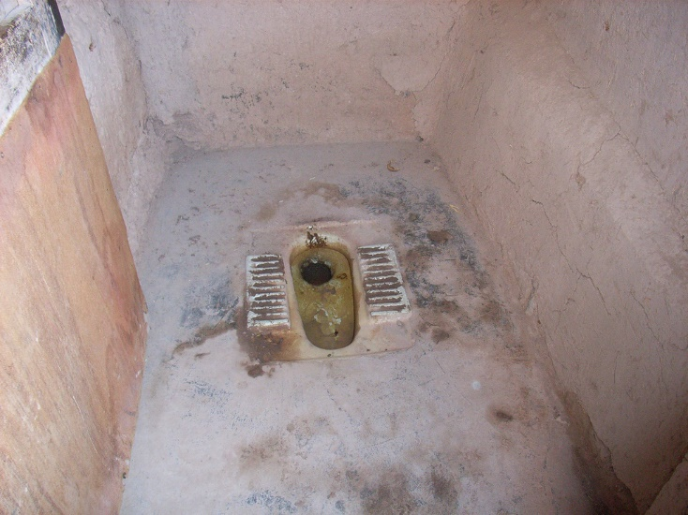

- Septic Tanks
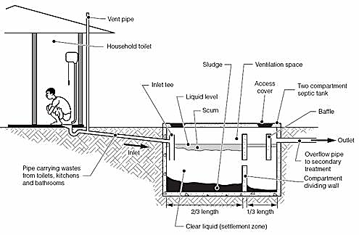
(Source: Harvey et al, 2002)
A septic tank is a water tight tank that typically receives waste from a flush toilet. They are useful in areas with a high water table and when a reliable water supply is present. The system provides some level of treatment to the waste through the separation of solids. The tank will need emptying if full to ensure wastes does not contain unsafe levels of germs and that the wastes does not occupy too high a proportion of the tank. Ideally the effluent from the septic tank should be attached to a sewerage system.
Advantages | Disadvantages
- The system reduces the level of odour and flies. | - Cost is high – including the cost of the extra land needed.
- May be conveniently located indoors. | - Water is required (both in quantity and reliability)
 | - Permeable soil needed for drainage.
 | - Requires regular emptying.

Drainage
There are many reasons why stagnant water and household water needs to be successfully and constantly removed.
- Stagnant pools provide breeding sites for disease transmitting insects such as mosquitos. (This makes the wet season a high risk time!)
- Household waste water may contain germs that can pollute groundwater sources which will increase the risk of disease.
- Poor drainage can lead to flooding, which can lead to loss of property and even life!
- In areas where drainage and sanitation are poor, water can run over ground and pick up faeces and contaminate the water source. This spreads diseases such as typhoid, cholera and Hepatitis A.
- People are more likely to contract worms from soil contaminated by human waste (which is deposited through contaminated water).
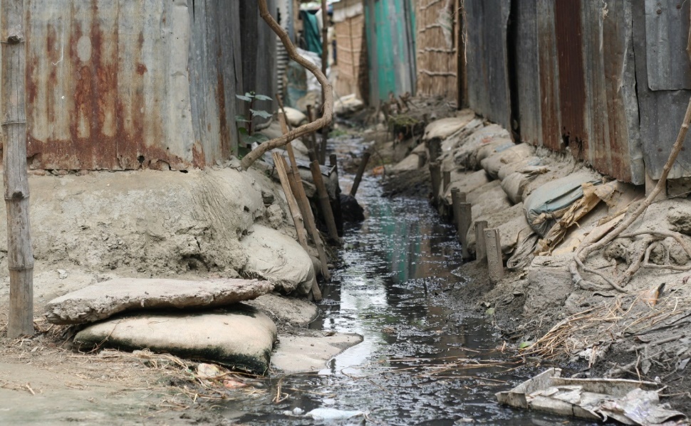

The Solution
- The best drainage system ensures that water flows away quickly and smoothly.
- Drainage installed by one community should never create problems for other communities downstream.
- Environmental considerations should be given adequate attention when planning for drains.
- It is important to know where floods occur, or have occurred in the past.
- Storm water drains should collect water from all parts of the community which then leads to a main drain, which then empties itself into a local river.
- The size of the drain should be calculated on the amount of water it would be expected to carry in a storm.
- Stormwater drains are best constructed using a concrete lining. Earth drains are more likely to become clogged and overgrown which will cause problems during minor floods. This can lead to the formation of stagnant pools and result in breeding sites for disease carrying insects, like mosquitos.
- The drains must be properly maintained and cleaned. It is common to find that new drains become dumps for solid waste or even sewage because of inadequate maintenance. Someone therefore needs to be chosen to be responsible for the maintenance of the drains. However, the best solution is for the community members themselves to take responsibility.
- Village folk may agree to clean the drains in front of their houses every day with inspections to be carried out once or twice a week – Maintaining the drains needs to become part of the daily routine for responsible community members.
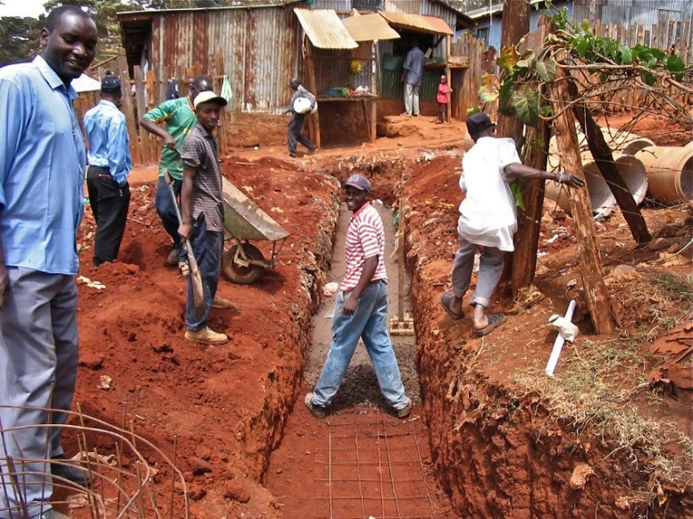
Notice community participation in drain construction. Commu-nity participation is even more crucial in the upkeep of the drainage system in any village or community.

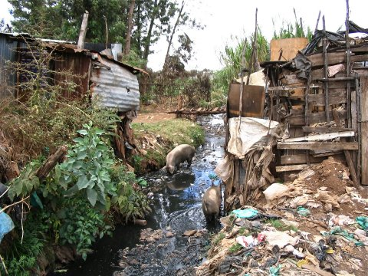
DISCUSSION QUESTIONS
Take a good look at the picture (right).
- What needs to change in this village?
- Why?
- What does it say about those that live in the village?
- In your discussion think about the leaders, the families, the community members, the government, and any church groups.
- Make a list of concerns that need to be addressed.
(NOTE: The small buildings next to the drain are toilets)

Solid Waste (rubbish) Management
Solid waste management
Solid waste means paper, plastic, empty cans and tins, food scraps and other household wastes.
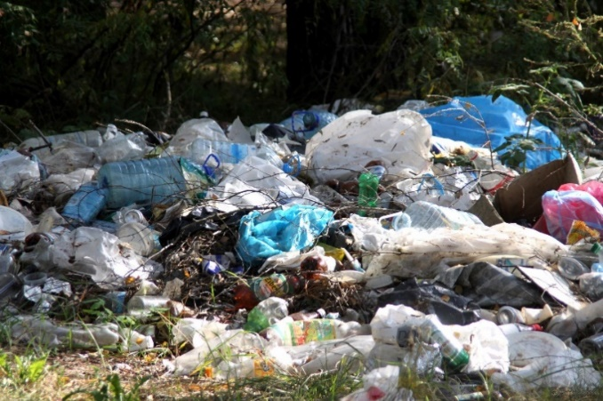
- To keep the household and village environment clean and to reduce health risks, solid waste or rubbish should be disposed of properly.
- Rubbish lying around everywhere is unsightly and smelly and destroys both the quality of the environment and the quality of life in the community. It also provides breeding ground for disease carrying pests such as mosquitoes, flies and rats.
- If waste is not properly disposed of, animals can bring it close to the home where children and adults can come into contact with germs.

To be effective
- The village or community must develop and encourage a solid waste disposal program
- It will require participation and action of everyone at both household and community levels. If only a few households dispose of waste properly, the village environment may remain dirty and contaminated. Everyone must be involved.
- Community members should realise how important solid waste management is and think of the best ways to deal with it
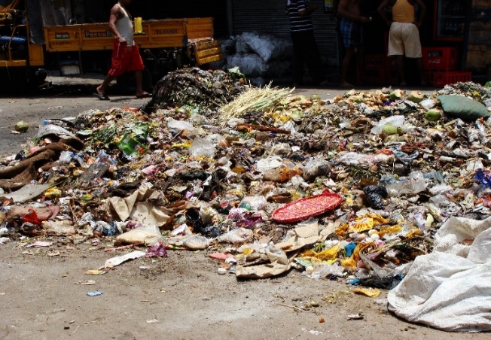
List the common things in rubbish that can be:
Recycled: (read p176 of the manual for a better understanding) glass, clothes, cans, etc
Composted: fruit and vegetable waste, leaves and bark from trees, unwanted food of any kind.
Buried: Metal items, bones, and broken glass should be buried in a pit that will not be used again in the future.
Burned: Any paper or cardboard containers. Rags or materials and dry leaves, sticks and bark etc. Remember plastic gives off a poisonous smoke and should not be burned. (As do batteries)

Housing Quality
Look at the two pictures below. List all the improvements you can see in the second picture in the space provided: (Teacher - Look at the next page and make sure most of the ideas are covered in their answers)
HOME 1
__________________________________________________________________________________________________________________________________________________________________________________________________________________________________________________________________________________________________________________________________________________________________________________________________________________________________________________________________________________________________________________________________________________________________________________________________________________________________________________________________________________________________________________________________________________________________________________________________________________________________________
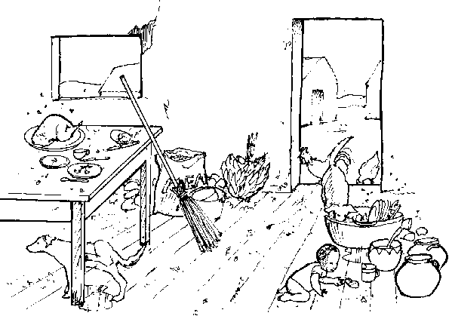
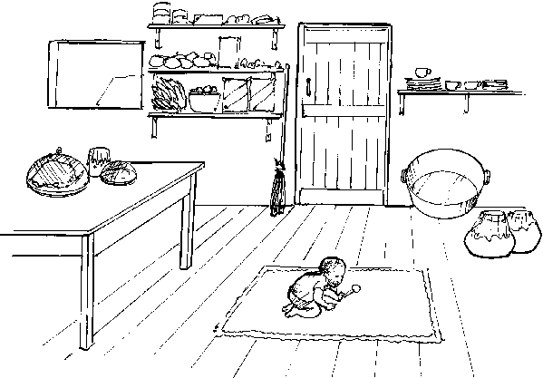
HOME 2

Housing Quality
Good-quality housing promotes health. Poor housing can lead to many health problems, and is associated with infectious diseases (such as tuberculosis), stress and depression. Everyone should therefore have access to good-quality housing and a pleasant home environment that makes them happy and content.

Characteristics of a dirty house
- There is rubbish everywhere on the floor
- The door is wide open with animals and chicken having free access into the house - eating whatever they can find. Notice dog urinating under the table
- The food is left on the table unprotected from flies and other insects
- There are dirty eating utensils on the table
- A child is crawling on the floor amidst all the dirt
- The water containers are unprotected
- There is no fly screen on the window allowing flies and insects to have easy access into the house.

Characteristics of a clean house
- The floor is very clean – there is no rubbish lying around on the floor
- The table is clean and there are no flies around
- The food is well covered
- The door is closed preventing animals straying into the house
- The eating utensils are clean and stored nicely
- All food items are carefully stored away
- The water containers are covered
- The baby is sitting on a nice clean mat
- There is a pleasant feeling about the house

COMMON PROBLEMS ASSOCIATED WITH POOR HOUSING
- Cramped and crowded conditions give rise to poor hygiene
- Overcrowding provides opportunity for rats and cockroaches to breed and transmit disease. Also, insects such as Fleas, ticks and other disease transmitting insects to flourish
- Poor household hygiene leads to food and water contamination within the home.
- Poor indoor air quality leads to lung problems and inadequate lighting leads to eyesight problems
- Stress is higher for individuals living in poor housing.

SOME SOLUTIONS
- Ventilation
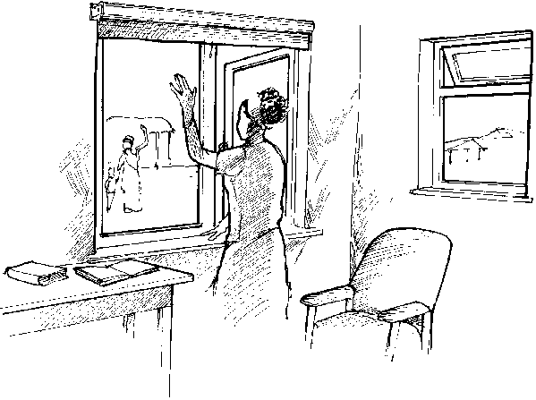
Adequate home ventilation is particularly important where wood or charcoal are used for cooking or heating, since these fuels give off smoke that contains harmful chemicals. This can lead to lung problems like bronchitis and asthma and make tuberculosis transmission easier. Women and small children are particularly at risk from poor ventilation if they spend long periods within the home or around cooking areas. Where cooking is done indoors, it is essential that smoke and fumes be removed from the house quickly and efficiently. Ventilation may be improved by constructing houses with sufficient number of vented windows, particularly near cooking areas. Sleeping with fresh air circulating through the house is very important. It is the time when your body is renewing and recharging and pure oxygen plays a big part in this process.

- Lighting
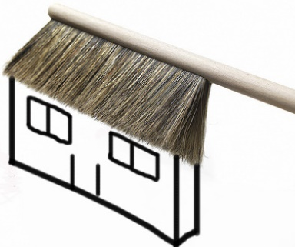
Poor lighting in a house can lead to eyesight problems and increased depression. Sufficient natural light, through large, well placed windows, kills germs and improves the cleanliness of the house (it’s hard to see dust and dirt in a dark home!). Wherever possible windows should be covered with screens for added protection.

- Clean homes
- Insects like flies and mosquitos can be reduced by covering food and properly disposing of water. A Mosquito net should be used at night if needed.
- Clearing and maintaining drains near and around the house will reduce insects breeding and entering the house.
- Grass needs to be kept short around the house to reduce snails, snakes, frogs, rats, ants and cockroaches. All of which can cause sickness to a family.
- Bed bugs are common in the South Pacific and found in homes that are not clean and tidy. They are parasites that feed on blood. Their bites are irritating and people can develop allergic reactions to it. Careful cleaning of the home – scrubbing the floor and bed frames (including all cracks and crevices) and washing, scrubbing and sunning the linen can help control or eradicate this insect.
- Germs like to live in dirty, damp, warm places so keep your home cleaned, dusted, swept, dry and well aired – this will give your family the best chance of great health.

- Overcrowding in homes
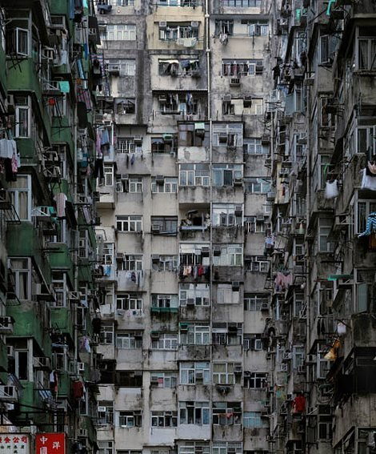
Overcrowding promotes ill-health. This is because it makes disease transmission easier and contributes to a lot of stress. Disease such as tuberculosis spreads very quickly in crowded homes. Overcrowding is related to socioeconomic levels and the poor often have little choice but to live in cramped conditions. In principle, increasing the number of rooms in a house should improve the health of the people who live there, but increasing house size is often difficult. Careful planning of family size will help in reducing overcrowding. Providing more land to build houses can also allow everyone to have access to houses adequate for their family size.
The Pacific Islands isn’t the only place that struggles with overcrowding. This is a picture of apartments in Hong Kong.
Healthy Village
Many factors determine the health of individuals and the communities in which they live. These factors include:
- Income
- Social relationships
- Individual responsibility
- Access to basic services like water supply and sanitation
- Availability of quality health services
- Quality of the environment

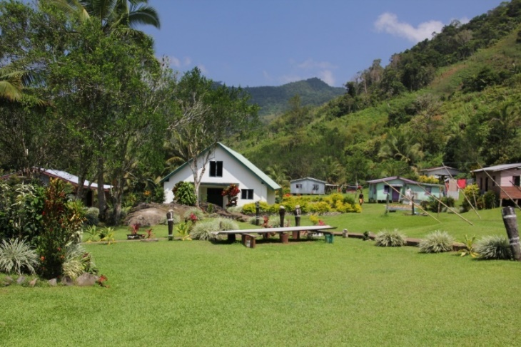
What is a Healthy Village?
A village or a community can be considered healthy when the number of people suffering from diseases is low; when community members have access to basic services such as water, sanitation and health care; when the community lives in a healthy environment and when the people live in harmony with each other and with God.
A healthy village is a clean village and where people love to live harmoniously together. There is co-operation and people are willing to work together with their leaders to ensure the community is a clean and healthy place to live. Photo: C. Kuma
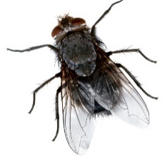
Characteristics of a Healthy Community
- The physical environment is clean and safe. A clean environment helps prevent diseases. E.g.: safe water supply, sanitation, drainage and proper disposal of rubbish and solid waste all remove the agents that spread disease like germs, mosquitos, flies and cockroaches.
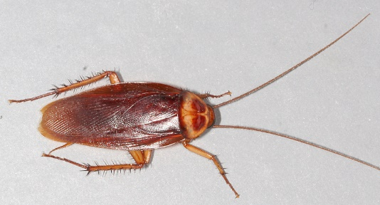

- The environment should meet everyone’s basic needs. A healthy village should have in place the basic services that people need to be healthy. This includes: A clinic or aid post, a school for education, money earning opportunities like a market, good water supply, good toilets, land for gardening and ability to meet people’s social and spiritual needs.
- The environment promotes social harmony.
There needs to be no discrimination due to race, colour, gender, tribe, income status or religion as this leads to increased anxiety, depression and mental health problems.
- There is an understanding of the local health and environmental issues. This will lead to a community that is motivated to seek answers and solutions to the needs.
- The community participates in identifying local solutions to local problems. An important indication of a healthy community is cooperation! A healthy community works together and participates in identifying solutions to addressing local needs. Working together and reducing the need for depending on others for handouts, strengthens the community’s pride and ownership of their village.
- Community members have access to varied experiences, interactions and communications.
Every single person can contribute something worthwhile towards their community. Most communities would have people skilled in different trades such as carpentry, mechanical skills, painting, nursing, chain saw operating and farming etc. These people can be of a great assistance to the community.
Make a list of people who live in your area (village or local neighbourhood) that have important skills that impact you or your family. (Remember to thank them!!)
(Each student will have their own list of names)
___________________________________________________________________________________________________________________________________________________________________________________________________________________________________________________________________________________________________________________________________________________________________
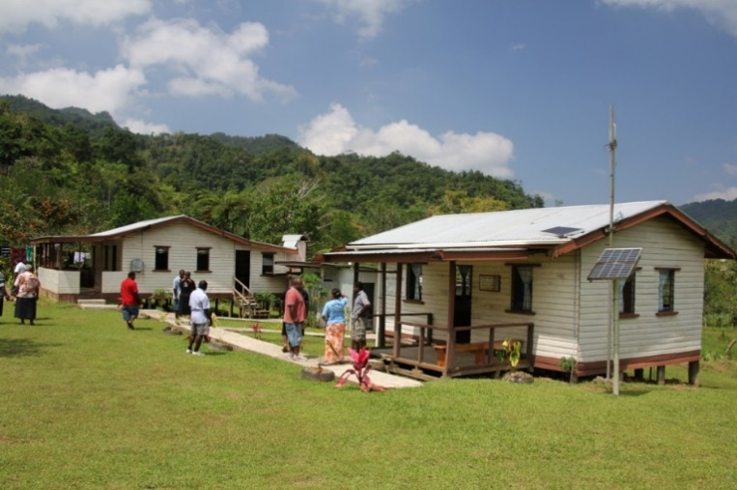
- Health services are of good quality and accessible.
Access to a medical facility such as an Aid-post or health clinic is vitally important. It is important that the nurse is always available at the clinic to treat patients.
This is a rural health clinic in a village. Notice the clean and healthy surroundings. Photo: C. Kuma

- The historical, cultural and religious heritage is promoted and celebrated.
Every community has its own historical, cultural and religious heritage. These help create, shape and define values that are of relevance to that particular community. Most importantly these entities create for the community its identity and self-worth.
- Income generation.
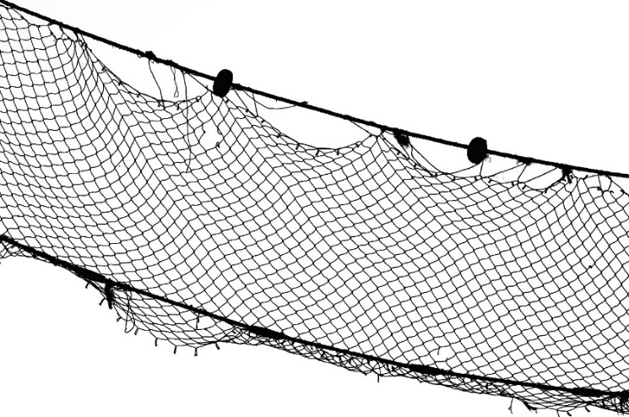
Earning a good income in a rural setting can be challenging, but is vital! The following are income generating projects that have proven successful in many villages and communities in the South Pacific:
- Fishing
- Farming
- Cattle
- Coconut
- Cocoa
- Timber
- Pearl farming
A HEALTHY COMMUNITY USES ITS RESOURCES IN A SUSTAINABLE WAY.
EXCESSIVE USE OF RESOURCES, ESPECIALLY NATURAL RESOURCES CAN LEAD TO DISASTROUS EFFECTS ON COMMUNITY HEALTH.

Below are some examples.
- Example one - over-fishing has led to the depletion of fish resources in many areas of the Pacific. One contributing factor is the uncontrolled use of fishing nets in reefs resulting in over harvesting and fish depletion
- Example two - unsustainable logging activities as in Melanesian countries are depleting trees for local use and trade. Also, land and rivers are destroyed through soil erosion and flash floods due to logging. Logging activities create community infightings and arguments over land rights and ownership. This has the potential of destroying relationships and harmony in a community
- Example three - water is always a valuable commodity in many communities. Its use must be guarded especially during periods of low rainfall in areas where water is scarce

- Example four - Rural health clinics in isolated communities often run out of medical supplies and drugs. This could be due to problems of transport or too many people becoming sick due to an unhealthy village environment. Strictly adhering to personal hygiene, drinking clean water and cleaning up the village can prevent many people becoming sick. This can lessen the burden on the clinic and its medical supplies.
ASSESSMENT
Choose one of the above examples and construct a poster, poem, song, or skit to warn your school about it. Display it or share it at a school or local community gathering.

- Respect for God.
It is important to know that health is a principle that comes from God. It is God’s greatest desire that we should all be healthy and successful in life.

When we love God
- We will be motivated to love one another – there will be social harmony
- We will see the importance of working and planning together
- We will understand that our body is the temple of the holy spirit and that we will want to take good care of it
- We will understand the importance of keeping and maintaining our villages clean and healthy
- We will appreciate the importance of our environment and that we will endeavour to take good care of it.

Common Human Parasites in the South Pacific
Parasite 1 | Description | Prevention | Pictures
HOOK WORM | - Most common worm infection of the intestines.  - Are blood sucking worms that affect nearly 740 million people worldwide.  - Widespread where people defecate on ground or in the bush.  - Hookworms have strong teeth that grip on to the intestinal wall - this allows them to suck blood from the intestines.  - Through the faeces (human waste) hookworm eggs are left on the soil. These hatch and the larvae matures and penetrates the skin of humans.  - Hookworm is therefore mainly acquired by walking barefoot on contaminated soil or grass. | - Build proper latrines or toilets.  - Avoid using the bush, river or sea as toilet.  - Exercise strict personal hygiene.  - Avoid bare foot contact with soil contaminated with human faeces.  - Avoid pollution of soil with human excreta.  - Protect yourself from pets. (And treat them with a worming tablet regularly if possible.) | An adult hookworm (below, left) enters the body through the skin and causes irritation and itchiness (below right)  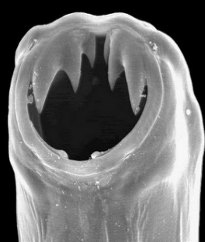  An adult hookworm with its mouth open. See the strong, sharp teeth used to attach itself to the intestinal wall.

Parasite 2 | Description | Prevention | Pictures
ASCARIES LUMBRICOIDES | - The largest intestinal worm to infect humans.  - Can reach up to 35cm!  - Survive by eating food and water passed through the intestines.  - When infected, people may complain of fever, jaundice (yellow eyes), wheezing (Shortness of breath) and stomach pains  - Rarely deadly but can interfere with the growth of children.  - Very common in South Pacific, reflecting the unhealthy conditions a lot of people live in. | - Build proper latrines or toilets.  - Avoid using the bush, river or sea as toilet.  - Exercise strict personal hygiene.  - Wash hands after using the toilet and before preparing food.  - Keep fingernails short.  - Prevent animals straying into the house. | This is a true picture of Ascaris Lumbricoides or the “giant round worm”. It is easily transmitted by hands, food and water contaminated with human faeces.  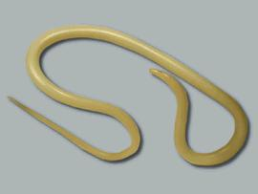

Parasite 3 | Description | Prevention | Pictures
ENTEROBIUS VERMICULARIS (PINWORM) | - The most common parasitic worm infection in the Pacific.  - Pinworms are easily transmitted from human to human through contaminated hands and food and are particularly common in children.  - Humans get infected by swallowing or inhaling microscopic pinworm eggs from human faeces.  - Once inside the small intestine the larvae hatch from the eggs, move to the end of the intestine and mature.  - During sleep when the body temp is low and there is less movement the female adult pushes out from the anus and lays eggs on the outside. The eggs get stuck on skin, underwear or bedding and survive for up to 3 weeks.  - This causes itchiness around the anus. | - Avoid defecating in the bushes or near the house.  - Build proper latrines or toilets.  - Wash hands after using the toilet and before preparing food.  - Exercise strict personal hygiene.  - Treatment to eradicate worms.  “God is more glorious than the moon; he shines brighter than the stars. In comparison, . . . . we mortals are mere worms” Job 25:5,6 | 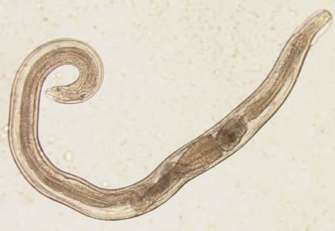  The main complication of Enterobius Vermicularis is itchiness around the anal region. This can be quite distressing especially for children.

Parasite 4 | Description | Prevention | Pictures
TRICHURIS TRICHIURA  (WHIPWORM) | - Whipworm infects 500 million humans in tropical countries including the South Pacific Island countries.  - Female lays eggs in the large intestine.  - Eggs are passed out in faeces.  - If this lands on warm moist soil, after 2-3 weeks the eggs have been fertilized and are infective ready to be eaten.  - Eggs get inside you if you eat uncooked vegetables that are unwashed.  - Large numbers of Whipworm inside you will lead to Bloody diarrhoea or dysentery. Lack of blood due to blood loss, Vitamin and iron loss, possible rectal prolapse (your rectum comes out of your body if you push hard) | - Avoid defecating in the bushes or near houses.  - Build proper latrines or toilets.  - Wash hands after using the toilet and before preparing food.  - Exercise strict personal hygiene.  - Wash and cook your local foods and vegetables properly. | 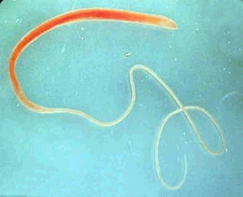  This is what a Whipworm looks like. These eggs are passed through faeces into the environment where they hatch into young worms. We get infected when we eat contaminated, uncooked vegetable.

Parasite 5 | Description | Prevention | Pictures
ENTAMOEBA HISTOLYTICA  (AMOEBIASIS) | - Causes Amoebiasis.  - Occurs in large intestine and causes infection.  - Parasite is passed onto the soil through faeces.  - We get infected by ingesting parasite through contaminated water, food or hands  - 10-20% of infections can be serious and even cause death.  - Serious infections cause damage to the lining of the large intestine.  - Parasite can penetrate the intestinal wall and travel to organs such as the liver causing liver disease. | - Avoid defecating in the bushes or near the house.  - Build proper latrines or toilets.  - Wash hands after using the toilet and before preparing food.  - Exercise strict personal hygiene.  - Wash and cook your foods and vegetables properly. | 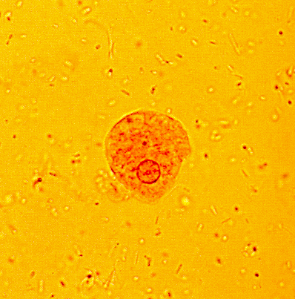  This picture shows the parasite Entamoeba Histolytica. It is spread though food, water or hands contaminated by human faeces.

Parasite 6 | Description | Prevention | Pictures
GIARDIA INTESTINALIS | - Can cause serious disease in the small intestine.  - Parasite attaches to the lining of the intestines and survives on nutrients passing through them.  - Common where sanitation is poor  - Parasite is passed into environment by faeces. It develops into tiny cysts.  - We become infected when we ingest the cysts by eating contaminated uncooked vegetables.  - Also spread through contaminated water, food or hands.  - People infected complain of stomach pain, bad breath, diarrhoea, tiredness, loss of appetite, weakness and weight loss  - Children infected may lead to malnutrition and the child may not grow well. | - Build proper latrines or toilets.  - Avoid using the bush, river or sea as toilet.  - Exercise strict personal hygiene.  - Wash hands after using the toilet and before preparing food.  - Fingernails must be short.  - Prevent animals straying into the house.  - Have clean surroundings at home.  - Wash and cook your foods and vegetables properly. | 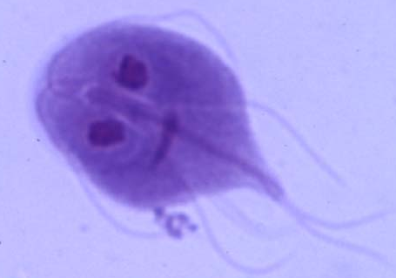  This is a picture of Giardia Lamblia. It is passed through ingestion of uncooked vegetables and food, water and hands contaminated by faeces.
What can you do around your village, community and home to ensure these parasites are kept under control? Think of how you can encourage cleanliness and increase awareness. BEWARE: Once these parasites are in a community it is very difficult to remove them unless the entire community becomes actively involved. Why is this? What would happen if only one family began to follow the prevention rules? What would happen if all but one family followed the prevention rules? If you could get your community to change one thing to ensure safety from these parasites, what would it be?

SAMPLE QUESTIONAIRE TO DETERMINE THE HEALTH OF YOUR VILLAGE (OR COMMUNITY)
Highlight the areas of concern. What needs to be done to make your home a “Healthy Village”?
(All of these questions may not apply to where you live. Put a line through irrelevant ones and brainstorm with your class to develop your own or add to these)

SAMPLE QUESTIONS | YES | NO | COMMENTS
- Is diarrhoea common among children?
- Are worm infections common?
- Are respiratory (breathing) problems common?
- Are eyesight problems common in women?
- Are eyesight problems common in men?
- Is Malaria common?
- Are other vector-borne diseases common?
- Do many people have fevers?
- Has there been recent outbreaks of disease lately?
- Are children undernourished?
- Are there health workers in the community?
- Do any children or adults have mental health problems?
- Is the water source protected/treated?
- Is water always available?
- Does everyone have access to water?
- Does the community know the quality of the water?
- Are there special places for bathing and laundry?
- Do households have some form of sanitation?
- Is there a toilet for every family?
- Are there separate facilities for women?
- Is solid waste disposed of (or does it build up?)
- Are there stagnant/still bodies of water?
- Is there a good system of drainage?
- Is there a market place?
- Is the market cleaned every day?
- Is the market area dirty?
- Is there meat sold at the market?
- Is the meat or fish fresh daily?
- Are people selling food careful with personal hygiene/ do they have clean hands?
- Does the market have toilets and fresh water?
- Do houses have many windows?
- Are houses kept in good condition?
- Is the village clean?
- Are animals fenced / kept separate from homes?
- Is food easily available in the village?
- Are mosquitoes, flies, cockroaches common?
- Are there many rats or mice?
- Are the same bodies of water used for washing, laundering and receiving human or animal waste?
- Is cooking fuel readily available?
- Is there a spirit of cooperation in the village?

Answers that contain two words are written with no space between.

ACROSS
2 An important practice for cleanliness. BATHING
6 A dangerous germ found in eggs. SALMONELLA
7 A solution for the vast majority of intestinal worm problems. TOILETS
11 This parasite might cause blood filled diarrhoea. WHIPWORM
12 Giardia can be caused by eating unwashed ______________. VEGETABLES
14 These grow on the legs of flies and trap germs. HAIRS
16 A faecal-oral disease. DYSENTERY
17 The largest intestinal worm to infect humans. ASCARIESLUMBRICOIDES
20 A good way to generate income. FISHING
21 A necessary place in a village that has the potential to be powerfully
good OR bad for your health. MARKETS
22 In a healthy village there is none of this. DISCRIMINATION
23 A common type of latrine. PIT
24. These should be kept at least 100m from water sources. ANIMALS
25 A solid waste product that should be buried. GLASS
26 The major difference introduced into a VIP latrine. CHIMNEY
27 A water tight tank that typically receives waste from a flush toilet. SEPTIC
30 Poor drainage can lead to this. FLOODING

DOWN
1 Responsible for most worm infections and diseases such as cholera. FAECES
3 Food sold at markets should be inspected daily by. HEALTHOFFICIALS
4 A clean environment can actually reduce this. DEPRESSION
5 The lining of the best storm water drains. CONCRETE
8 One of the most effective ways of preventing the spread of disease. HANDWASHING
9 Example of a solid waste product. PLASTIC
10 Good health is not merely the absence of this. DISEASE
13 A vector-borne disease. MALARIA
14 A personal responsibility that improves one’s health. HYGIENE
15 A factor that influences the health of an individual. ENVIRONMENT
18 _______ for God will improve our health and that of our community. RESPECT
19 Water that can lead to breeding mosquitos. STAGNANT
27 A cleansing and disinfecting agent. SOAP
28 Parasite with strong teeth that grips on to the intestinal wall. HOOKWORM
29 Heritage creates this in individuals and communities. IDENTITY
30 Insects responsible for spreading disease. FLIES

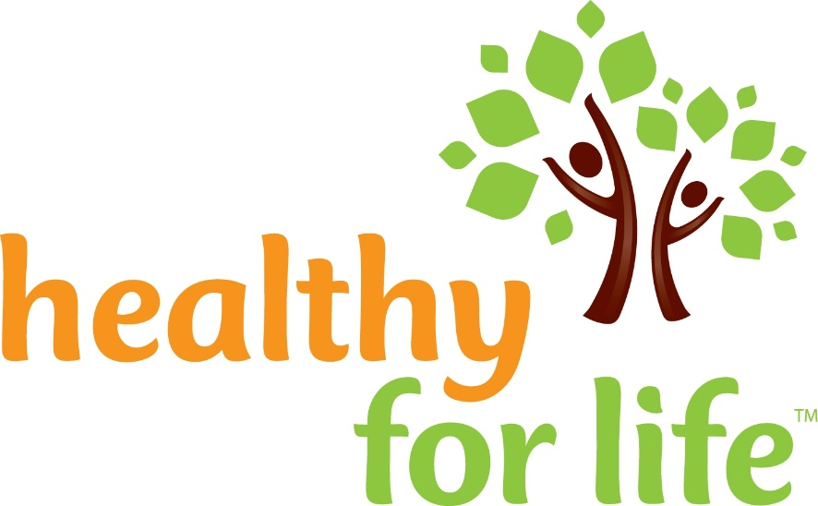
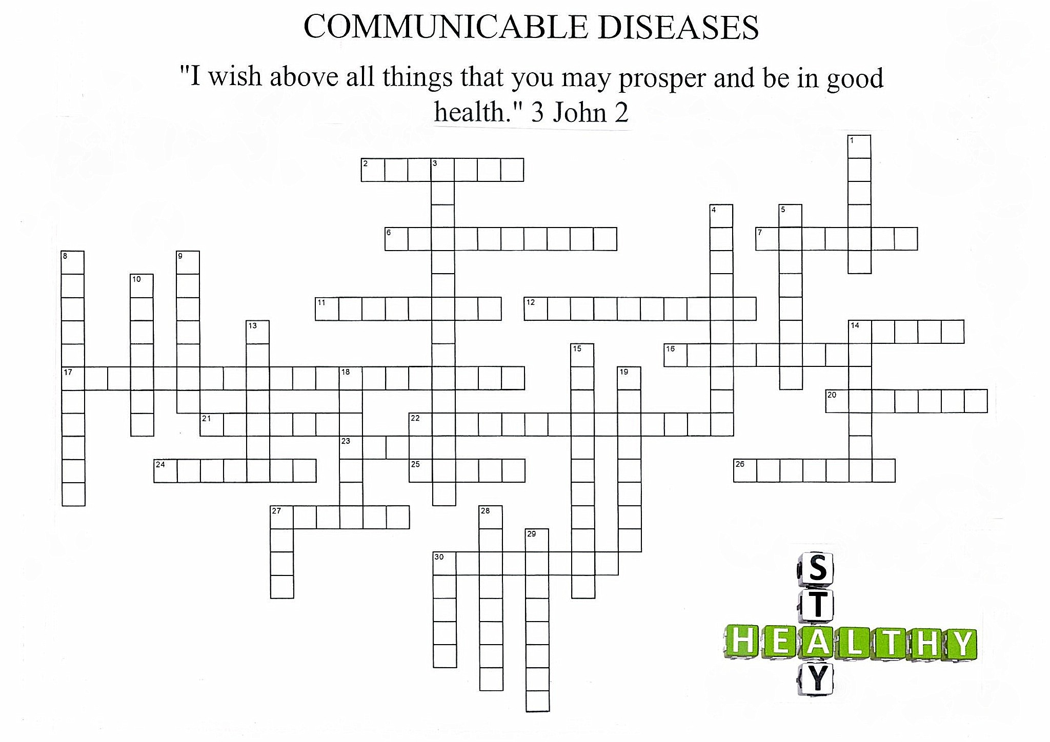
TEXTS + QUOTES

Over our journey to health we have read, discussed and memorized many powerful words from the Bible and Mrs White’s writings. See how many of them you can remember. Can you connect where they are found? They are indeed words to live by!
- Dear ______________, I ____________ that you may enjoy ___________ health and that all may go ___________ with you, even as your ____________ is getting along well.
- I beseech you therefore ___________________, by the ________________ of God, that ye present your bodies ___________________________________________________, holy, acceptable ___________________________________________, which is your ______________________________________________________________________.
- What? Know ye not that your ________________ is the ________________ of the Holy Spirit which is in you, which ye have of ______________________, and ye are ____________________________? For ye are _________________________________: therefore glorify God in _____________, and in your __________________, which are God’s”
- True temperance teaches us to _________________________________________ with everything __________________ and to use _________________________________ that which is healthful.
- For, as I have often told you before and now tell you again _____________________ __________________, many live as ______________ of the _______ ______________. Their destiny is _______________, their god is their _______________, and their glory is in their _________________________. Their mind is set on __________________ __________________________. But our _______________________________ is in _____________________________. And we eagerly await a Saviour from there, the ___________________________________, who by the power that enables Him to bring everything _______________________________, will __________ our lowly bodies so that they will be like ________________________________________.
- But the fruit of the spirit is ________________________________________________ ______________________________________________________________________. Against such there is _____________________________________________________.
- Medical missionary work _______________________________________________. It is necessary for the ______________________________________________. As through it men and women are led to see the _________________________________________ living, and the ___________________________________ or the truth will be ________ ______________________ . . . . . . as the __________________________ ___________, God’s methods of treating disease will ________________________________________ ______________________________________________________________________.
- The thief comes only to ______________________________ and destroy. I have come that they may ___________________ and have it _____________________________.
- The only safe course is to touch not, taste not, handle not; _______________________ _______________________________________________________________________ The redeemer of the world came from heaven to help man in his ___________________ that in the power which Jesus came to bring him, he might become strong to _________________________ and ____________________ and might be a victor on _________________________________.
- Now may the _______________________ Himself sanctify you ____________________ and may your whole spirit, soul _________________________________ be preserved ___________ at the coming of our __________________________________________.
- I can do _______________through Christ _____________________________________.
- Come to me all you who are weary ___________________________________, and _______ _______________________________________.
- Thus the heavens and the earth were completed and all their vast array. By the seventh day ___________________________________________________________; so on the seventh day ___________________________________________. And God blessed the seventh day and ____________________________, because on it He rested from all the work of creating that He had done
- In health and in sickness __________________________________ is one of heaven’s choicest blessings. It’s ____________________________________________________.
- Every year millions upon millions of gallons of _______________________________ are consumed. Millions upon million are spent in buying ___________________________ _______________________________________________________________________ For the sake of gain the liquor dealer deals out to his victims that which __________ _______________________________________.
- Purify me from my sins, and I will ____________________________; wash me, and I will ___________________________________________________.
- The Lord will guide you _______________________, He will satisfy your needs in a sun-scorched land and will strengthen your frame. You will be like a ____________________ _______________, like a spring whose waters _________________________________
Galatians 5:22, 23 Romans 12:1 Philippians 4:13 Christs Object Lessons p59
Matthew 11:28 3 John2 John 10:10 Patriarchs + Prophets p562
Philippians 3:18-21 Psalm 51:7 Temperance p28 1 Corinthians 6:19, 20
Genesis 2:1-31 Isaiah 58:11 3 Testimonies p485-488
Thessalonians 5:23 Ministry of Healing p237

10 Ways to Love
- Listen without interrupting (Proverbs 18)
- Speak without accusing. (James 1:19)
- Give without sparing. (Proverbs 21:26)
- Pray without ceasing. (Colossians 1:9)
- Answer without arguing. (Proverbs 17:1)
- Share without pretending (Ephesians 4:15
- Enjoy without complaint. (Philippians 2:14)
- Trust without wavering. (Corinthians 13:7)
- Forgive without punishing. (Colossians 3:13)
- Promise without forgetting. (Proverbs 13:12)

