Introduction
This curriculum framework is a brief statement that provides the foundational worldview from which an Adventist teacher delivers the Australian National Curriculum. It is a concise statement of principles, values and threads that undergird and guide what we consider to be real, true and good. This worldview is shaped and permeated with our belief that Jesus is “the Way, the Truth, and the Life.” John 14:6.
We also believe strongly that each teacher must teach from within their own authentic Christian journey and that their experiential relationship with Jesus will permeate all they say and do. This framework endorses the notion that rather than being Christians who happen to teach, we are wanting to teach Christianly. We wish to reveal a God who loves unconditionally.
“To think Christianly is to accept all things with the mind as related, directly or indirectly, to man’s eternal destiny as the redeemed and chosen child of God.” Harry Blamires, The Christian Mind: How Should a Christian Think?, p. 44
Teaching is more than imparting information. Effective Christian teaching is transformational. It will take Romans 12:1-2 as its focus and try to nurture a discipleship response to God’s love in the lives of our students. This provides the basis for the term “threads” used in the Values and Action Response sections. ‘Threads’ are simply the qualities or characteristics we desire as responses from our students. They help provide cohesion and linkage to everyday living. These Action Responses, like Values, will often overlap in various subject areas, and provide a discipleship response to God’s love.
This document is intended to be practical and succinct with a clear focus on the transforming role that the Adventist teacher can play in the lives of their students. It contains:
- A challenge to maximise the transforming teachable moments.
- An overview Adventist curriculum statement.
- A subject-specific rationale followed by the objectives for that KLA.
- A section focused on just how values and action responses, with appropriate essential questions, can challenge the teacher to maximise an Adventist worldview and seek transformational experiences for their students.
- Suggestions where the units from the Adventist Encounter Curriculum link with values and action responses. No sample units are provided in this document as all schools are provided with the units and resources to use from the syllabus.

- The Transformational Teaching documents are designed to assist teachers in being intentional in including an Adventist Worldview in their Learning Areas. The suggestions included in each framework can also support teachers in achieving the following Adventist Identity Teaching Standards (Supplement to the AITSL National Professional Standards for Teachers). Further elaborations of these standards can be obtained from your principal or your Director of Education. They can also be found on the ASA website http://asa.adventist.edu.au
Adventist Identity Teaching Standards | Proficient Standard
1.7 Understand how students learn about God | Design and implement teaching programs to promote and support students’ learning about God.
2.6 Knowledge of the content of the Bible and its teachings | Use effective teaching strategies to integrate Bible stories and themes into specific content in appropriate and meaningful ways.
2.7 Reflect an Adventist Worldview | Understand and differentiate the various worldviews to integrate a genuine Adventist Christian Worldview into classroom and school activities.
3.8 Integrate Faith and Learning | Plan and implement effective strategies for the integration of Faith and Learning to engage students in their learning about God.
A Challenge
While these curriculum documents have been put forth as suggestions of how topics of faith, God, and values might be interwoven into Biblical Studies classes, anecdotal research indicates that when people are asked about their “best" teacher, by far the most influential aspects for 70-80% of responses relate to the kind of person the teacher was, and how his/her personal faith and experience with God was talked about, lived, modelled and shared with students. This idea is backed by one Valugenesis report that recommends that since young people are wanting a deeper personal relationship with God, “church leaders need to consistently model life lived in relationship to God, and teach that religion is basically a matter of relationships with God and fellow humans rather than a system of beliefs or a code of behaviour.” With the current generation’s desire for authenticity, they want to know how this ‘God thing’ works and to see how it is lived out in everyday life.

Examples of Powerful and Transforming Teachable Moments
In STORIES, teachers share ways that God works and is at work through…
- Object lessons, metaphors, word pictures, illustrations
- Teachers or students provide own personal stories involving understandings of God, His intervention, His answers…
- Teacher exemplifies values in his/her own life which students might model – e.g. patience, perseverance, joy of learning, humility, wonder of God’s ways, fairness, equity, mercy, and grace for the challenging students.

In FAITH EXPERIENCES in which…
- Teachers and students have opportunity to share aspects of their personal walk with God with each other (e.g. sharing with a student how God had directed your thinking in certain ways).
- Students and teachers explore ways of building relationships with other people through community work, cooperation and service.
- Class activities/assignments that include opportunities for students to communicate God’s message through writing, speaking, audio-visual presentations and other appropriate ways.
- Whole-school events such as Chapel, special Weeks of Spiritual Emphasis, School Dedication Nights all contribute to shaping the students’ faith.
- Students are able to participate in small-group events like after-school Bible studies and service activities.

In the SCHOOL SETTING, opportunities to acknowledge God exist in…
- What is written in words, official policies, documents, newsletters, and signage.
- What is visually displayed in terms of bulletin boards, displays, neat and tidy classrooms without rubbish on the floor, manicured lawns and gardens, large posters with a Bible text, inspirational quotation … etc
- The ‘hidden curriculum’ – what is ‘felt’ when one comes into the school – warmth, belonging, sharing; how discipline and deviant issues are solved, a caring community that looks out for each other and rallies around in disaster and need…

Curriculum in an Adventist School
This statement represents the heart of Adventist Curriculum in Australia, providing a context and orientation for the learning areas that make up the full curriculum.
Seventh-day Adventist education begins with recognition of the eternal, loving and personal God who has always existed, is all powerful, and is the source of all life, truth, beauty and what is of value. It is based on the premise that God has provided insights into His character and what He has created. It believes that as created beings, humans are dependent on God for such insights in order to know how to grow, function and develop in keeping with His ideal for mankind. This need is because of humanity’s separation from God through sin, and God’s initiative in re-establishing a relationship with humanity through the coming of Jesus Christ, the perfect expression of what God is like.
Adventists believe that humans were created by God to be perfect and in His image, but people exercised their God-given powers of choice and rebelled against God. Mankind is now naturally depraved, dependent on the divine initiative of God for salvation and the restoration of former God-man relationships. Mankind’s true value is only found in his relationship with God and not in isolation from Him. This view asserts that an infinite God, through Christ, created this world as part of a perfect Universe which He continues to sustain by His power, through the law He has ordained. Although created perfect in God’s likeness, humanity’s free choice led to alienation from the Creator. This broken relationship resulted in a fallen nature out of harmony with God, and a blighted creation. Through His infinite love, God instituted a plan of salvation through the life, death and resurrection of His Son, Jesus Christ. This plan provides for the restoration of a harmonious relationship between humanity and the Creator, and gives hope of eternal life.
The curriculum in Adventist schools is seen as contributing to the restoration process towards God’s ideal. It is, therefore, a needs-based curriculum, covering a range of knowledge, skills, attitudes, behaviours and values through teaching and learning experiences designed to facilitate holistic development – spiritually, mentally, physically, emotionally, creatively and socially. It endeavours to provide this foundation through a comprehensive range of learning areas. These learning areas (or LAs) represent the various facets of God’s creation, how each aspect functions, and how created elements within them interrelate. Although they stand with their own distinctive form and character, and may be studied as such, they also allow for integration with one another, thus acknowledging holism in God’s created order. These learning areas, therefore, are like ‘windows’ in two senses – windows through which students may gain views of God’s character and action, and windows of opportunity to respond to God in ways that reflect His character and the values that are part of His Kingdom.
God’s design for enjoyment of a full and abundant life is realised in acceptance of His laws and values as revealed in the unselfish life of Christ and is expressed in His teachings. These values impact on all people’s cultural activities and reflect their relationship with God, other people and the natural world entrusted to their care as well as providing a foundation for an eternal life lived in God’s presence. Related aesthetic values shape their appreciation of beauty and creativity. From this perspective, the development of Christian faith pervades all of life, so every activity within every learning area has spiritual significance.

The Purpose of Teaching and Learning Biblical Studies in an Adventist School

The Bible is the portal by which students come to know God who is the central focus of the Christian life – “In Him we live and move and have our being” Acts 17:28.
Adventist Christians accept that humans can develop a relationship with God, when led by His Spirit. Biblical Studies emphasises that Man's true value is only found in his relationship with God and not in isolation from Him. Commitment and application are essential to gaining a vision of God in both Old and New Testaments, reflecting on the Christ of the Gospels and allowing His Lordship and Presence in their lives. Ultimately, Biblical Studies should encourage a sound understanding of the Bible and emphasise how to apply biblical principles to one’s life.
From Foundation to Year 10, this learning area is taught using the Adventist Encounter Curriculum which encourages each student to experience a deep relationship with Christ. This curriculum is innovative, accepting and positive in approach. It has been developed to show how spirituality is living out belief, how it is developed in relationships, how it gives meaning to life and how it brings about changes of one’s life direction. The Adventist Encounter Curriculum has a focus on Spiritual Growth* and uses the Transformational Planning Framework**. (* and ** see Page 8 for more details.) It supports teachers in sharing a series of learning experiences with their students. Transformation is the goal.
In the senior secondary years Biblical Studies courses vary according to state curriculum requirements and emphasise several Christian perspectives. These all need to be taught from an Adventist worldview. Units for Years 11 and 12 from the Adventist Encounter Curriculum are also available as an alternative to the state-endorsed courses.
Biblical Studies classes are where all students can encounter God through exploring stories of Bible events and themes, are provided with opportunities to develop a relationship with Him, are challenged to construct a set of personal Bible-based beliefs and are supported in putting these beliefs into practice in their own lives and through service activities. Biblical Studies seeks to build for eternity.

“And this is the way to have eternal life – to know you, the only true God,
and Jesus Christ, the one you sent to earth.”
John 17:3 NLT
Biblical Studies Objectives
The study of KLA in a Seventh-day Adventist school will…

*The Four Lenses | Creation | The Fall | Redemption | Restoration
The Symbol
The Focus | Purpose | Problem | Response | Hope
The Descriptor | The meaning of a particular learning concept and God’s purpose. | What went wrong because of rebellion? | How to respond, using learning for God’s purpose in everyday life. | Points to the future when “all will be made new”  i.e. present actions being shaped by the future ideal.
KLA  Objectives | God created a perfect world and intended humans to flourish and care for His creation. | God’s purpose for creation was distorted by disobedience and, as a result, everything has a fractured relationship with God. | We have been reconciled to God and redeemed through Christ’s sacrifice.  Christ is the example of how to live and respond to others and care for God’s creation. | When Christ returns, Creation will be restored to what God intended. God has plans for an eternity with His people. This gives us hope for the future.
*Note: “Connecting Learners with God’s Big Story” from Christian Schools Australia, 2015. This book suggests four ‘lenses’ through which to view the world. These align with our understanding of the Great Controversy and provide a useful tool to assist with integrating faith and learning.
Guidelines for Biblical Studies in Adventist Schools Australia
The primary aim of Adventist education is to lead young people to Christ. It is through deep and considered engagement with God’s word, the Bible, that they learn of Christ and the principles of His Kingdom. To achieve this goal in the market place of ideas that surround young people and their families in society it is vital that the key learning area of Biblical Studies is core to each school’s academic program.
God’s Word is to be at the heart of every Adventist school. Teachers skilled and passionate about sharing God’s word are to be supported with appropriate resources and time allocations to ensure that young minds in our schools can know Christ and form strong Biblical worldviews.
For these reasons, the National Board of Education has endorsed these recommendations for implementation.
Recommended that:
- The term Biblical Studies be used to identify Bible classes from Foundation to Year 10.
- Biblical Studies and the sharing of God’s Word is core of the academic program in all schools within Adventist Schools Australia. The Bible is the textbook for these classes.
- The required syllabus for Biblical Studies from Early Childhood to Year 10 in Adventist Schools Australia is the Adventist Encounter Curriculum.
  - When using the Adventist Encounter Curriculum, it is appropriate to adopt the program but adapt it to suit the local situation.
  - The Scope and Sequence of the Adventist Encounter Curriculum is to be followed but may require modification to suit the local circumstance and teaching style (e.g. using a two-year cycle for multi-grade classrooms etc.).
  - Elements from each of the eight phases of the Transformational Planning Framework are to be included when teaching each unit.
  - The Outcomes / Achievement Standards of the Adventist Encounter Curriculum will be used to assess the units taught.
  - Biblical Studies will be reported on as a part of regular reporting processes.
- Biblical Studies, or its equivalent ATAR subject is a mandated subject for all students in Years 11 and 12 in Adventist Schools.
- For NSW, the BOSTES-Stage 6 endorsed course, Biblical Studies, be an interim option to Studies of Religion until Encounter Years 11/12 is fully available.
- State-endorsed senior Biblical Studies courses [Studies of Religion; Studies of Religion and Society / Texts and Traditions / Comparative Religions etc.] be offered on an ongoing basis. Further that all senior students be required to complete at least a unit one course of sixty hours of study and that academically-able students be supported in studying a unit two level course which will involve another sixty hours of study.
- For schools offering Year 12 (two unit) Studies of Religion or its equivalent, the two religions studied in depth be
  - Christianity and Judaism OR
  - Christianity or Judaism plus one other world religion.
- Allocated minimum times for Biblical Studies be
  - For Early Learning settings = daily using the Early Encounters with Jesus curriculum.
  - For Foundation to Year 6 = 80 hours per year to include Adventist Encounter Curriculum lessons with weekly Chapels and class worship times to be additional to these hours.
  - For Years 7 to 10 = 100 hours per year to include Adventist Encounter Curriculum lessons with weekly Chapels and class worship times to be additional to these hours.
  - For Years 11 and 12 = 100 hours (unless studying a 1-unit option) per year with class worships and Chapel times to be additional to these 100 hours.

Philosophical Underpinnings
The Community of Faith and Learning model developed by Adventist Schools Australia (Foundation – Year 12) explains the Special Character of Adventist Schools. It includes three domains – Belonging, Believing and Becoming. The parallel model for Early Childhood Education and Care includes a fourth domain of Being which aligns with government requirements. Note that both these models include the domains of Believing and Becoming which are significantly impacted by the students’ involvement with the Biblical Studies learning area and associated events at the school.
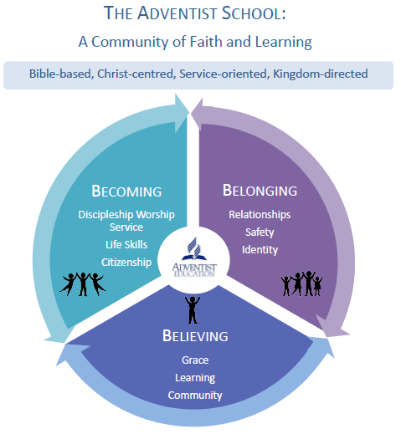
Adventist Schools Australia has also chosen nine core Values based on 1 Corinthians 13. These Values are founded in Love and are demonstrated in Service. More details and implementation ideas are shared in the booklet “Values for Adventist Schools” available on the ASA website.
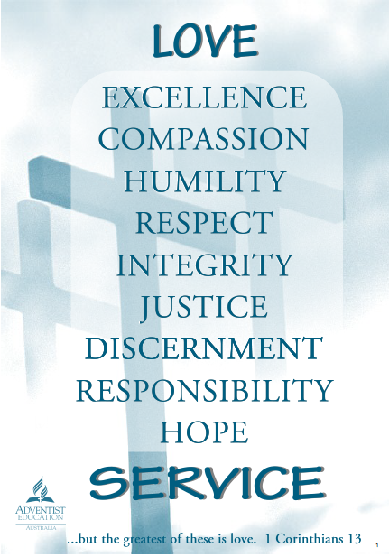
The Adventist Encounter Curriculum is underpinned by two philosophies. One is the Spiritual Growth model developed by Ben Maxson and this has greatly influenced the Scope and Sequence of the program.
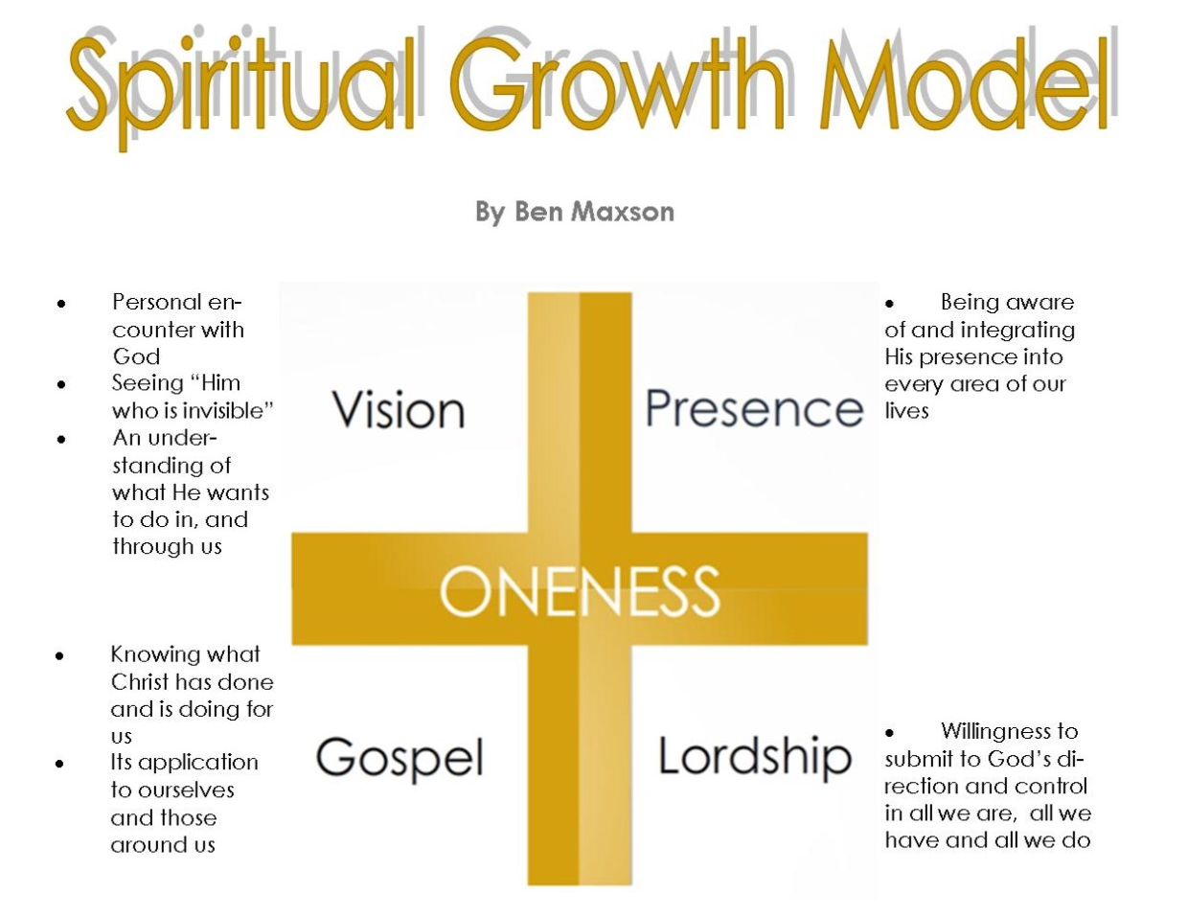
The other is the Transformational Planning Framework which was developed by Lanelle Cobbin. Each of the units written for Foundation to Year 12 uses this framework and is written with the intention of providing experiences during which the students may encounter Jesus and get to know Him – not just about Him.
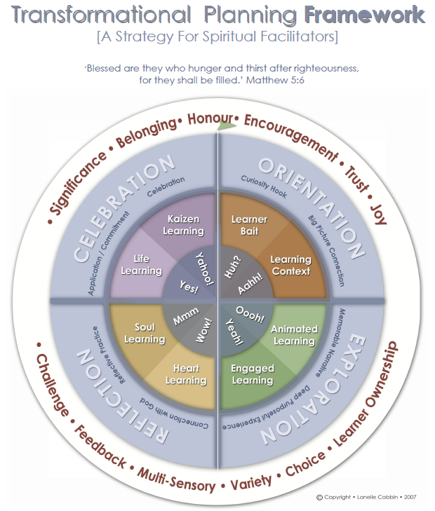
The Early Encounters with Jesus syllabus, developed for use in all Early Childhood Education and Care centres, has a simpler planning framework. The 28 units in this program share familiar Bible stories and relevant Bible messages while providing educators with a wealth of activities, resources and ideas to accompany the child-focussed curriculum, being guided by the students’ capabilities and lines of enquiry.
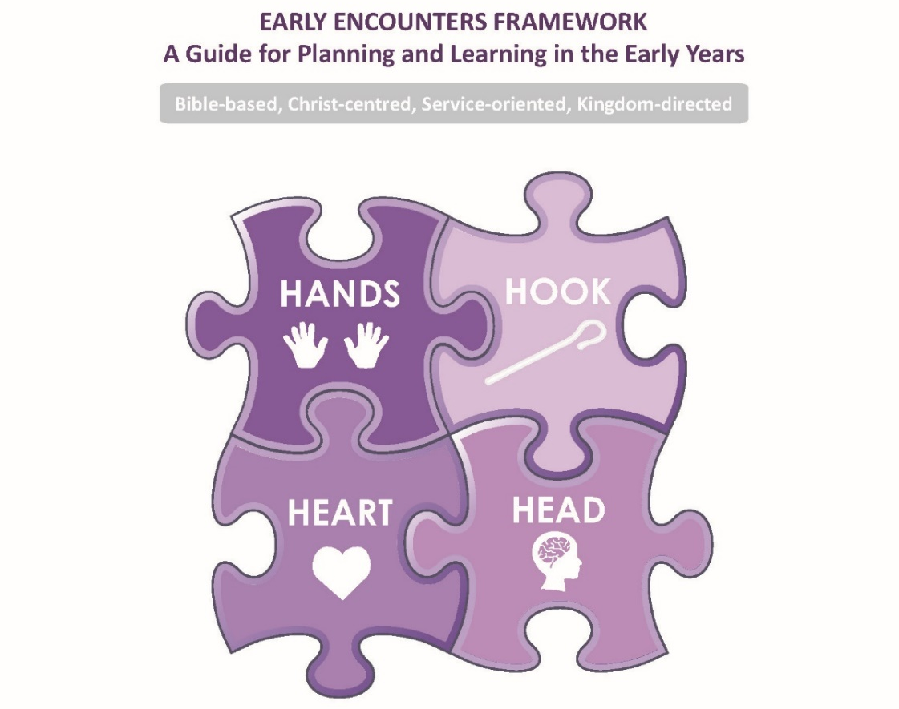
The Scope and Sequence for units in the Early Encounters with Jesus curriculum links the four domains with the concepts of Grace, Community, Worship and Service. Centres are encouraged to use the curriculum in the way that best suits the needs of their current students. It can be used over a one-year cycle or as flexible, stand-alone units.
Linking Values for Adventist Schools and Action Responses
Values for  Adventist Schools | Action Response  (Thread Number) | Description of Action Response | Biblical Foundation | Key Essential Questions  for Students  Adapted from Transformation by Design | Further Questions  for Teachers  Adapted from Transformation by Design | Examples  Adventist Encounter Curricula units
Love* | Loving God (1)  PONDERING  CREATION (13) | Students respond to God’s love by loving God and their neighbour as themselves.  Students contemplate both the Creator and His handiwork and respond in delight and praise. | Matt 22:37-39  Matt 7:12  1 John 3:16; 4:19  Ps 19  Rev 4:11  Matt 6:25 -31 | - What does God’s love look like?  - How do we respond to God’s love?  - What does it mean to love God with all your heart, soul, mind and strength?  - Where can we see the fingerprints of God in creation?  - If God created the whole universe, why does He care about us? | - What does love look like in your classroom?  - How do we know God loves us besides Jesus’ work on the cross?  - What opportunities are there for students to appreciate and express love for God in this unit / in your classroom?  - How do you learn more of the nature and character of God?  - How are you recognising God’s supreme artistry in Creation?  - While pondering creation, what do you learn about your relationship with your Creator?  - How can you create opportunities for your students to ponder and respond in their own learning style? | EE: God creates the world  EE: Baby Jesus is born  _.1A Salvation units each year  _.1D Easter units each year  _.4C Christmas units each year K.1B Creation  3.3B Jesus [Friend to the Friendless]  6.2C Jesus’ Sacrifice  7.1B Creation and the Fall  7.2A The Cross  8.3A Prodigal Son  9.1A The Reality of God  9.1B the Character of God  9.3A The Gift of our World  9.3B The Gift of the Sabbath  9.3C The Gift of Grace
Service* | CARETAKING EARTH (3)  IMITATING HUMILITY (11)  PRACTISING HOSPITALITY (14)  Understanding Vocation (22)  UNWRAPPING GIFTS (23) | Students actively respond to God’s call to carefully manage all creation.  Students gratefully accept God’s grace and respond by humbly serving Him.  Students welcome and accept others, and use their gifts to embrace others into community.  Students discover the vocational task in which God has called them to serve.  Students enrich theirs and others’ lives through developing and using their gifts. | Gen 1:28  Ps 8:5-8  Gen 2:15  Rom 12:3  Col 3:12-13  John 13:12-17  1 Peter 4:8-10  Heb 13:2-3  Luke 14:12-14  Rom 12:4-8  1 Cor 4:4-11 | - What does obedient caretaking of the earth look like?  - How can we explore and make use of the world God has given us without spoiling it?  - What is Christian humility? Is it the opposite of pride?  - What is the cost of humility?  - Why should we spend time, money and effort on hospitality?  - How do we choose who to share hospitality with?  - Why should we work? Should everyone work?  - What is our ‘job’ as students?  - How do we reflect our Creator in our work?  - Am I truly unique?  - What do we learn about God from the gifts He gives us?  - Do all gifts enrich others? | - What whole-school/classroom/individual practices promote caretaking earth?  - What do you need to stop doing in order to care for God’s world?  - How do you affirm the hope in a loving and sustaining God in the face of a decaying and despairing world?  - How can you foster a spirit of humility in your classrooms?  - How do you challenge students towards thoughtful contemplation of God’s love shown in the cross of Jesus?  - In what ways does humility stand in contrast to a sense of rugged Australian identity and individuality?  - Do all students feel welcome in your classrooms?  - How do you cultivate a spirit of generosity in your students/teachers/school?  - If we are called by God to have a vocational response, is there only one job for us?  - How are you preparing students for responsive discipleship if/when they enter the workforce?  - How are your teaching practices helping to uncover all different types of student gifting? | EE: Samuel  EE: Little Maid and Captain Naaman  EE: Zacchaeus meets Jesus  K.3A Jesus: Our Loving Gift  K.4B Helpfulness  2.1B God Protects Moses  3.4A Generosity  6.3B The Church Together  6.3C The Church Grows  7.4C Learning to Serve: Serving to Learn  8.3C The Good Samaritan  9.4A The Gift of Identity
*Denotes the addition of Love and Service to the Values for Adventist Schools in the table below. Love overarches these values and Service is the active evidence of God’s Love and Kingdom Values. For the purpose of keeping this at the forefront in our thinking, Love and Service have been included along with the values listed below.
Values for  Adventist Schools | Action Response  (Thread Number) | Description of Action Response | Biblical Foundation | Key Essential Questions  for Students  Adapted from Transformation by Design | Further Questions  for Teachers  Adapted from Transformation by Design | Examples  Adventist Encounter Curricula units
Excellence | DISCOVERING PATTERNS (6)  GETTING WISDOM (9)  REFLECTING CREATIVITY (16) | Students explore and discover God’s patterns and designs for delighting in and/or using for the benefit of all.  Students go deeper than understanding and knowledge to seek the insight of God.  Students praise God by reflecting their Creator in making expressive and inspiring things and ideas. | Isa 25:1  Gen 8:22  Prov 4:7  James 1:5  Prov 2:6-9  Col 2:2,3  Gen 1:26-27  Ps 139:13-14 | - How can you identify a wise person?  - Does wisdom change with the times?  - Do we have to know God to be truly wise?  - Does everyone have the gift of creativity?  - How did God make me creative?  - How do we judge the value of an artwork? | - What do patterns and order reveal about the character and nature of God?  - What patterns and structures are you deliberately shaping in your classroom?  - What is the relationship/connection between knowledge, understanding, experience, common sense and insight?  - How are you ensuring that you are ‘in step with the Spirit’ so that you are a wise leader in your classrooms?  - How does artwork reflect the artist’s worldview?  - In what ways is reflecting creativity both service to God and service to others? | EE: God takes care of Elijah  EE: The lost sheep  EE: The lost son  EE: The lost coin  1.4B – 5.4B; 6,4A The Bible  2.2C God Provides for Needs  2.2D God Provides His Presence  4.1C David  4.3C Teach Us to Live  4.4A Godly Greatness  5.1B Elijah  5.1C Elisha  5.2A Good Kings  8.1A Joseph  8.2B Elijah  8.3E The Ten Bridesmaids  9.1B The Character of God
Compassion | BUILDING COMMUNITY (2)  EMBRACING DIVERSITY (7)  EXPRESSING WORDS (8)  PURSUING PEACE (15)  SHOWING MERCY (20) | Students are active contributors and encouragers of others as the community is built up.  Students respect and celebrate the built-in differences between cultures and peoples given for the enhancement of all.  Students use words to build up, make choices, and express life.  Students bring healing and restoration to people and areas of brokenness.  Students respond to God’s mercy by likewise being merciful to others. | Col 3:12-14  Rom 12:9-13  Eph 6:7  Col 3:22-25  Rev 7:9-10  Gal 3:26-29  1 Cor 9:19-23  Acts 17:24-27  Col 4:6  Eph 4:29  James 3:3-9  2 Cor 13:11  Col 3:15  Rom 12:18  Luke 6:36 | - What makes a community?  - Who is our neighbour?  - Can we live without others?  - Why should we serve others with our gifts?  - What good comes out of diversity?  - What do all cultures/people have in common?  - What is the connection between what we think, what we feel and what we say?  - How do you know when it is time to speak and when it is time to be silent?  - If we promote ‘freedom of speech’ does this mean that we can say whatever we like?  - What is ‘world peace’ and is it our goal?  - Can all broken relationships be restored?  - Is there always a peaceful approach towards conflict?  - What is mercy? How is it different from justice and grace?  - Why does empathy encourage us to show mercy? | - In what ways can your classroom be a rich community?  - How can you encourage your students to build each other up and to share burdens?  - What opportunities are you providing for students to enhance their local and global communities?  - How does the cross bring God’s people together in community?  - What opportunities are you giving students to explore the richness of other cultures?  - How would you describe the culture of your classroom? Does it embrace diversity?  - How can there be unity in Christ where there are such vast differences in culture and people?  - As words are so powerful, how are you challenging your students to use them to speak life into common situations?  - Are you educating your students on how to speak truth in love, when to speak and when to keep silent? What strategies are you using?  - Do your classrooms allow more enriching student conversation rather than teacher talk?  - Do the processes in your school/classroom promote the resolution of broken relationships and the restoration of peace?  - How can you be an agent of peace in a hurting world?  - How do you teach your students to forgive an offence, and show mercy to others? | EE: Abraham shares with Lot  EE: Baby Moses  EE: Jesus calms the storm  EE: The good Samaritan  EE: The ten lepers  K.3B Jesus Teaches  K.3C Jesus Heals  K.4A Friendliness  1.3C Shining Lights  2.3A Jesus Protects  2.3B Jesus Provides  2.3C Jesus Heals  3.3A Jesus [Friend of Children]  6.3A A Church is Born  7.3A Transforming Whoever  8.3B the Unforgiving Servant  9.2B The Week of the Cross  9.3C The Gift of Grace
Values for  Adventist Schools | Action Response  (Thread Number) | Description of Action Response | Biblical Foundation | Key Essential Questions  for Students  Adapted from Transformation by Design | Further Questions  for Teachers  Adapted from Transformation by Design | Examples  Adventist Encounter Curricula units
Humility | EMBRACING DIVERSITY (7)  IMITATING HUMILITY (11) | Students respect and celebrate the built-in differences between cultures and peoples given for the enhancement of all.  Students gratefully accept God’s grace and respond by humbly serving Him. | Rev 7:9-10  Gal 3:26-29  1 Cor 9:19-23  Acts 17:24-27  Rom 12:3  Col 3:12-13  John 13:12-17 | - Are all cultures equally valued?  - What do other cultures do better than we do?  - What is Christian humility?  - Does humility mean that you are a doormat?  - What might be the cost of humility? | - What are examples of different insights and offerings from different peoples and cultures that contribute to the richness of mankind?  - Often, we are described as living in a narcissistic culture. How do we teach students to view themselves in ‘sober judgement’, while not taking away their sense of identity and meaning? | EE: Jesus prays  1.2A Isaac  2.1C God Prepares Moses  3.3C Jesus [A Special Friend]  4.3B Teach Us to ‘Be’  5.3A Set Apart  7.3D Zacchaeus  8.1C My Journey  9.2A God on Earth  9.2B The Week of the Cross  9.2C God: From Death to Life
Respect | BUILDING  COMMUNITY (2)  CARETAKING  EARTH (3)  EMBRACING DIVERSITY (7)  EXPRESSING WORDS (8) | Students are active contributors and encouragers of others as the community is built up.  Students actively respond to God’s call to carefully manage all creation.  Students respect and celebrate the built-in differences between cultures and peoples given for the enhancement of all.  Students use words to build up, make choices, and express life. | Col 3:12-14  Rom 12:9-13  Eph 6:7  Col 3:22-25  Gen 1:28  Ps 8:5-8  Gen 2:15  Rev 7:9-10  Gal 3:26-29  1 Cor 9:19-23  Col 4:6  Eph 4:29  James 3:3-9 | - Why should we serve others with our gifts?  - How can we resolve conflict?  - Have humans gone too far in their use of earth’s resources?  - Why are we all different?  - What good comes out of diversity?  - Can words alone ever capture what we truly wish to express? Explain.  - How can words be used to heal rather than hurt? | - How do your practices ensure that your classrooms are inclusive spaces where each student has a role to play?  - How does the cross bring God’s people together in community?  - How do you ensure you do not lose sight of the centrality of God in your call to be responsive caretakers?  - What do you learn about the character and nature of God through other cultures?  - How would you describe the culture of your classroom? Does it embrace diversity?  - What are examples of different insights and offerings from different cultures that contribute to richness of mankind?  - How are you exposing your students to a rich vocabulary so that they may carefully select the most apt words to use in their written and verbal expressions?  - Do your classrooms allow for more enriching student conversations rather than teacher talk? | EE: God’s special rules  EE: Jesus loves children  EE: Abraham shares with Lot  K.4A Friendliness  1.2A Isaac  1.2B Jacob  2.4A Thankfulness  3.2D Samuel  4.3A Teach Us to Pray  6.2B Esther  8.1B Moses  8.4A Disciples Making Disciples  9.3A The Gift of Our World  10.4A Living in the Waiting

Values for  Adventist Schools | Action Response  (Thread Number) | Description of Action Response | Biblical Foundation | Key Essential Questions  for Students  Adapted from Transformation by Design | Further Questions  for Teachers  Adapted from Transformation by Design | Examples  Adventist Encounter Curricula units
Justice | CELEBRATING LIFE (4)  EXPRESSING WORDS (8)  SEEKING JUSTICE (18)  TRANSFORMING THINKING (21) | Students embrace the full suite of God’s provisions in life and live in such a way that all may flourish.  Students use words to build up, make choices, and express life.  Students act as agents of change by identifying and responding to injustice.  Students let every thought be captive to Christ so that their thinking is transformed by the renewing of their minds. | Gen 1:26-31  Ps 90:14, 17  Ps 16:8-11  Col 4:6  Eph 4:29  James 3:3-9  Is 1:17  Ps 101:1  Is 61:8  Matt 12:18  Rom 12:2  2 Cor 5:17  Isa 55:8-9 | - Why do some people flourish and others don’t? What does it look like to flourish?  - How is it possible to suffer and be joyful at the same time?  - How do you know when it is time to speak and when it is time to keep silent?  - If we promote ‘freedom of speech’, does that mean we can say whatever we like?  - What is true justice?  - How do justice, mercy and grace differ?  - Who has the right to judge?  - How do we respond to injustice?  - Does a sense of justice come naturally to people?  - What is wrong with the world?  - What makes bad thinking bad? Good thinking good?  - How do patterns of thinking shape our attitudes and behaviour?  - What impact does our thinking have on others? | - Can you truly flourish without knowing God?  - How does God turn defeat into victory?  - How can you turn defeat into victory?  - How are you encouraging your students to celebrate gifts and the Giver?  - As words are so powerful, how are you challenging your students to use them to speak life into common situations?  - How are you intentionally encouraging your students to use words in the wider arena e.g. promoting justice, challenging distortions etc.?  - Are you educating your students on how to speak the truth in love, when to speak, and when to keep silent?  - How does God’s view of justice compare to our legal system’s version of justice?  - Our students have a very strong sense of fairness and justice. How do you help shape this understanding and lead them to a Godly view of justice?  - Justice and righteousness often come together in the Bible. How and why are they so closely linked?  - How can you show God’s love to others through the action of justice?  - How do you encourage your students to think about their thinking?  - How do you challenge and shape their worldview?  - How often are you opening the Scriptures in your classrooms to seek Godly counsel from the Word?  - How does the cross of Jesus reframe the ways in which you think?  - How does a renewed mind help to test and approve or discern and critique? | EE: Adam and Eve disobey  EE: Noah builds the ark  EE: Daniel and his friends choose healthy food  EE: Dorcas  K.1C God’s Plan to Save  1.1B Noah  1.1C Abraham  1.2B Jacob  1.2D Joseph in Egypt  2.2A God Frees His People  3.1B Wilderness  6.2A The Exiles Return  LS2 Words [A Bridge to Others]  7.1A War in Heaven  7.1B Creation and the Fall  7.3D Zacchaeus  8.2A Jericho  9.2A God on Earth  9.2B The Week of the Cross  9.3C The Gift of Grace

Values for  Adventist Schools | Action Response  (Thread Number) | Description of Action Response | Biblical Foundation | Key Essential Questions  for Students  Adapted from Transformation by Design | Further Questions  for Teachers  Adapted from Transformation by Design | Examples  Adventist Encounter Curricula units
Integrity | EXPRESSING WORDS (8)  GETTING WISDOM (9) | Students use words to build up, make choices, and express life.  Students go deeper than understanding and knowledge to seek the insight of God. | Col 4:6  Eph 4:29  James 3:3-9  Prov 4:7  James 1:5  Prov 2:6-9  Col 2:2, 3 | - Can words alone ever capture what we truly wish to express? Explain.  - How can words be used to heal rather than hurt?  - Why are words so powerful?  - What is the connection between what we think, what we feel, and what we say?  - How can we identify a wise person?  - Does wisdom change with the times?  - What is needed to make a wise decision? | - How are you exposing your students to a rich vocabulary so that they may carefully select the most apt words to use in their written and verbal expressions?  - Do your classrooms allow for more enriching student conversations rather than teacher talk?  - Are you educating your students on how to speak the truth in love, when to speak, and when to keep silent?  - Can wisdom be taught? Assessed? Studied?  - Is it reasonable to expect a child to show wisdom?  - How are you practising wisdom in your classrooms? Has it been intentionally included as a shared understanding/practice/repertoire? | EE: God protects Noah  EE: Daniel in the lions’ den  1.1C Abraham  1.2C Joseph  1.2D Joseph in Egypt  1.4A Trustworthiness  3.2C Ruth  4.2A King David  4.2C Solomon’s Wisdom  5.4A Integrity  6.1C Daniel  8.1A Joseph  10.2A God: Sovereign King [Daniel]
Discernment | CHALLENGING DISTORTIONS (5)  EMBRACING DIVERSITY (7)  GETTING WISDOM (9)  SHAPING CULTURE (19) | Students identify and critique areas impacted by sin and then discern God’s purposes.  Students respect and celebrate the build-in differences between cultures and peoples given for the enhancement of all.  Students go deeper than understanding and knowledge to seek the insight of God.  Students understand their cultural context, discern its errors and its virtues, and seek to ‘shake and shape’ it for the Kingdom. | Rom 12:2a  Acts 17:22-24  Rom 1:25  Rev 7:9-10  Gal 3:26-29  1 Cor 9:19-23  Acts 17:24-27  Rev 7:9-10  Gal 3:26-29  1 Cor 9:19-23  Prov 4:7  James 1:5  Prov 2:6-9  Col 2:2, 3  James 2:12, 13  Rom 12:2 | - Why do we love things that are bad for us?  - How can we tell the ‘good guys’ from the ‘bad guys’?  - Who is telling us what to believe?  - What do all people/cultures have in common?  - What do other cultures do better than we do?  - How can you identify a wise person?  - What makes a wise leader?  - Do we have to know God to be truly wise?  - What is needed to make a wise decision?  - What does it mean to live counter-culturally?  - How do we discern what is good and what is bad in our culture?  - How can we be others-centred in our culture? | - How do you identify the idols of this world? Your own idols?  - Are your students challenged to appropriately critique the culture they are immersed in?  - How do you highlight the goodness of God’s way of doing things?  - Are you aware of the ideas that have shaped your thinking/teaching practices/unit content?  - If the gospel is not transforming our students, then what is transforming them?  - What do you learn about the character and nature of God through other cultures?  - How can there be unity in Christ when there are such vast differences in culture and people?  - How are you practising wisdom in your classrooms? Has it been intentionally included as a shared understanding/practice/repertoire?  - What opportunities for culture shaping are you providing your students?  - Do your classrooms foster an environment that stands up for the oppressed, puts others first and celebrates the successes of others?  - What does it mean to ‘swim against the tide’ in this unit?  - How can you as a teacher, develop your ability to critique cultural movements and ideas?  - In what ways do you think it may be God’s plan that by living out your God-given gifts, you inevitably shape culture? | EE: Jesus prays  EE: The ten lepers  EE: Zacchaeus meets Jesus  EE: Abraham shares with Lot  EE: Daniel and his friends choose healthy food  EE: Daniel in the lions’ den  K.3B Jesus Teaches  K.4A Friendliness  1.1C Abraham  1.2A Isaac  1.2B Jacob  1.3B Strong Foundations  3.2B Era of the Judges  4.2B King Solomon  5.2B Boy Kings  5.3B Tempted  LS1 Questions for God  7.2C My Response  8.3E The Ten Bridesmaids  8.4A Disciples Making Disciples  9.4A The Gift of Identity  10.1A The Bible: Trustworthy and Enduring  10.4A Living in the Waiting

Values for  Adventist Schools | Action Response  (Thread Number) | Description of Action Response | Biblical Foundation | Key Essential Questions  for Students  Adapted from Transformation by Design | Further Questions  for Teachers  Adapted from Transformation by Design | Examples  Adventist Encounter Curricula units
Responsibility | BUILDING COMMUNITY (2)  CARETAKING EARTH (3)  UNDERSTANDING VOCATION (22) | Students are active contributors and encouragers of others as the community is built up.  Students actively respond to God’s call to carefully manage all creation.  Students discover the vocational task in which God has called them to serve. | Col 3:12-14  Rom 12:9-13  Eph 6:7  Col 3:22-25  Gen 1:28  Ps 8:5-8  Gen 2:15  Rom 12:4-8 | - In what ways can you contribute to developing community in our classroom?  - Who is your neighbour?  - Why should we serve others with our gifts?  - How can we explore and make use of the world God has given us, without spoiling it?  - Why should we work? Should everyone work?  - What is the right job for me? Is there only one vocation for every person?  - How do we reflect our Creator in our work? | - In what ways can your classroom be a rich community?  - How can you encourage your students to build each other up and to share burdens?  - How does the cross bring God’s people together in community?  - What whole-school/classroom/individual practices promote caretaking earth?  - Is it fair to label your students as ‘the next generation’, or do they have an important role in society right now? How do you promote these ideas in the way you speak to them and about them?  - How are you preparing students for responsive discipleship if/when they enter the workforce? | EE: A boy shares his lunch  EE: The great catch of fish  K.1B Creation  1.1B Noah  3.1C Jericho  3.2A Canaan  4.1B Saul  5.2C Jonah  5.3C Discipled  6.1B The Prophets  8.1B Moses  8.2B Elijah  8.4A Disciples Making Disciples  9.3A The Gift of Our World  9.4A The Gift of Identity  10.4A Living in the Waiting
Hope | IMAGINING INNOVATIONS (10)  OVERCOMING SETBACKS (12)  RELISHING PLAY (17) | Students innovate and renew for good purposes and thereby praise the Master Designer.  Students overcome setbacks through the strength of the Spirit and live in hope and faith.  Students have an attitude of joy-filled play as they respond to what God has provided and Christ has restored. | Rev 21:1, 5  John 1:1-3  Ps 33:6-9  Rom 5:4  James 1:3-5  James 5:11-12  Matt 5:7  Prov 8:27-31  Eph 5:20  Job 38:4,7  Job 38:32,35,37 | - Are innovations always improvements? Who decides?  - What is progress / change?  - Can an innovation have no purpose?  - Where do new ideas come from?  - Why does a loving God allow evil and suffering?  - What does perseverance look like?  - Can any good come out of suffering?  - How do the hard things we face shape us?  - How do we respond to setbacks?  - How do we support others who are going through difficult times?  - Does play have a purpose? Why is play important?  - Should everyone live a flourishing life?  - Did God really say, ‘go and play’?  - Does playfulness/play really honour God? Is He interested in such frivolousness? | - How do you ensure your innovations/changes are aligned with God’s will?  - How do your innovations demonstrate love for others?  - What role does relationship/community/empathy play when creating innovations?  - What opportunities are you giving students to explore and create through innovations?  - What influence does a positive growth mindset have on your response to setbacks?  - How can you encourage your students to develop perseverance in the classroom?  - How can knowing God build resilience and emotional strength? Are you intentionally embedding these ideas into your curriculum/teaching practices?  - What perspectives do you gain from learning about the trials and sufferings of others less fortunate than ourselves?  - How do you learn from the responses of others who have experienced trials and suffering?  - How do you find a balance between work, rest and play?  - Discuss whether play should be kept for pre-schooling and emphasis be given to serious learning once compulsory schooling starts.  - Does God still interact and play with His creation? Explain | EE: Jesus heals the blind man  EE: The ten lepers  EE: Jesus dies and lives again!  EE: Jesus is coming again  K.1C God’s Plan to Save  K.2A Heaven  K.2B God saves Moses  K.2C God saves David  K.2D God saves Daniel  1.3A Lost and Found  2.2B God Provides a Way  6.4B The Adventist Church  7.2B Heaven  7.3B Calming the Storm  7.3C The Demoniac  8.3A the Prodigal Son  9.3B The Gift of the Sabbath  10.2B Jesus: Worthy Conqueror [Revelation]  10.3A Holy Spirit: Leading Guide [Adventist Heritage]
Key Values of the scriptural story can be woven through the curriculum and thereby ‘draw together’ meaning and purpose in learning.
These numbers in the Action Response column correspond to the Threads in ‘Transformation by Design” by the National Institute for Christian Education, 2015

The material contained in this document was developed by the
Curriculum Unit, Adventist Schools Australia, 2017

