PROGRESS REPORT ON STRATEGIC PLANS
SPD Education Committee, October 2024
Strategy 1: Ensure Adventist Identity remains a key part of Adventist Education
Strategy | Progress | Outcome Metrics | Follow up | Impact Assessment & Future Outlook
1. Adventist Ethos Workshops | - Training completed in TPUM & PNGUM | - Train the trainer a success  - Programs very well attended | Follow-up to embed training into school policy and practice. | https://record.adventistchurch.com/2023/04/24/200-educators-attend-workshop-on-adventist-identity-and-ethos/?fbclid=IwAR0xfUF5msvGFFs3aikv_RhbOzSO5f2v2fu5C8b2-KBVk89gZZDgo7FQCdg
2. Faith Development and School Climate Research | - Student data collection  - School focus groups | - Data to be analysed  - Project balance: $247,000  - Tamar Aiono, PhD candidate, joined the research team | Complete the research phase and create an instrument to assess and report on faith development & school climate indicators. | - Faith Development-School Climate Dashboard*  - Substitution of this research for components of Insight SRC school climate data collection and analysis*
3. Adventist Ethos Project | Production of short ethos videos | Project balance: $106,000 | Videos to be completed by Q2, 2024
4. Pacific Bible Curriculum | Preparing for re-printing | Project balance: $5100 |  | Ascertain the need for re-printing of hardcopy volumes.
- Book of Faith & Science conference presentations Q3-4, 2023
- Abide Bibles – AUC Project; Q4 2023
- Abide Presentations – Adelaide teachers October, 2023
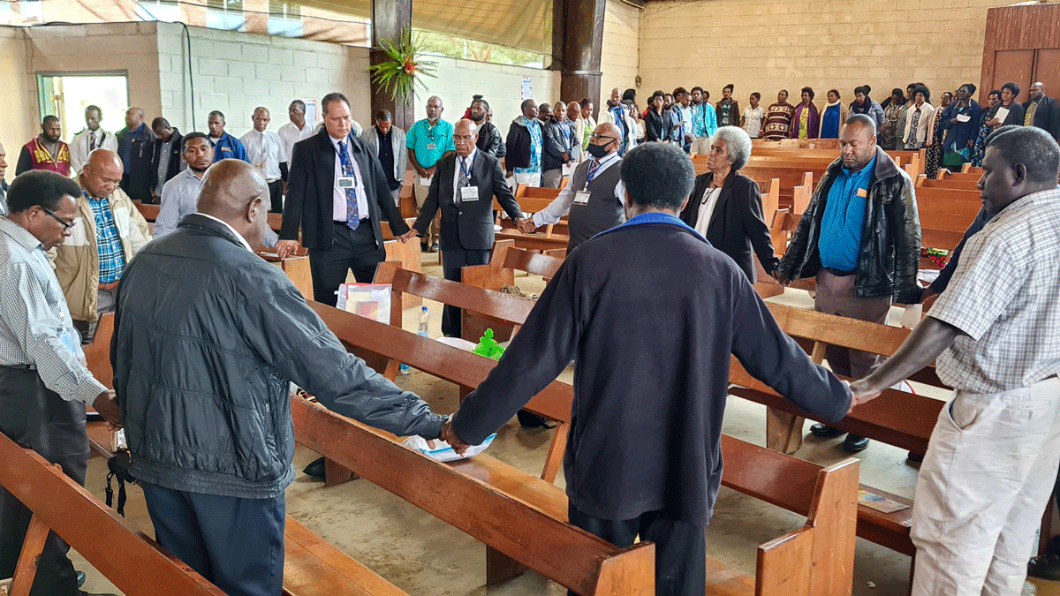
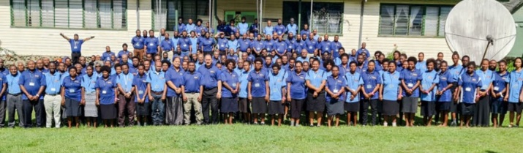
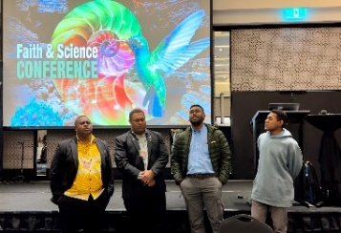

Strategy 2: Develop and Grow our education leadership team.
Strategy | Progress | Outcome Metrics | Follow up | Impact Assessment & Future Outlook
1. Increasing pool of potential leaders | - Advanced Study Committee:  - Collating of all sponsorships | - Wide range of sponsorships  - Informs Succession Plan | Succession planning has identified key staff needing doctoral studies etc. | - BMTE committee development of Pacific-wide delivery of MMin* to be circulated by February 2024.  - Identify future specialisations needed by church entities – for 2024 advisories*
2. Succession Planning | - Construction of a single Succession Plan document | - Identification of doctoral candidates.  - Identification of PD | - Refer doctoral candidates to ASC.  - Advisories to plan PD programs in PARL, system leadership.  - System-wide appraisal program is not in place. | - Advisories to discuss emerging leaders’ programs in Pacific*  - Seek project funding to develop a Pacific-wide appraisal and leadership development program*
3. Support emerging leader  programs | - VM Education Conference  - NZPUC Leadership Hui | - Address form Director of Education Services for the Vanuatu Ministry of Education presented data and affirmed success of high schools | 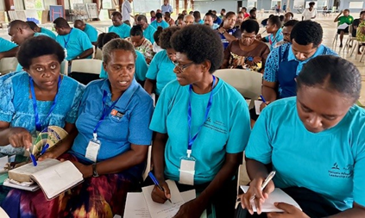 | - Prospect of moving to a Pacific version of AUC’s Quality Adventist Schools Framework
4. Include PD into SPD Advisories /EdCom | PD presentations as part of the BOE agenda | - Sabbath Gift promotion  - AI as a learning support tool presentation |  | Encounter presentation

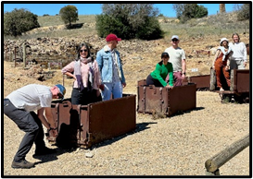
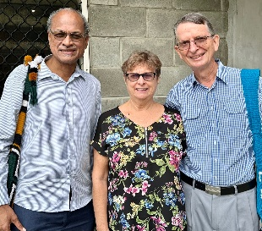

Strategy 3: Educational Improvement.
Strategy | Progress | Outcome Metrics | Follow up | Impact Assessment & Future Outlook
1. Review AAA processes | Conduct AAA reviews across the SPD Higher Ed  institutions | AAA Completed for:  - Fulton – 4 yrs  - Sonoma – 4 yrs + midterm  - PAU – 4 yrs  - Avondale - 2025 | Review institutional boards to ensure AAA recommendations are regularly reviewed and addressed. | Collate a AAA response register at SPD for inclusion at SPD Education Committee*  ** For discussion at SPD Ed Committee March 2024.
2. Implement  school improvement tools | 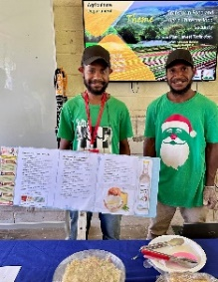 | QAS Cyclic Review Visit to Betikama, SIM, DEC 2023  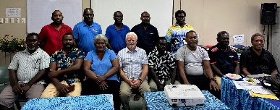 | 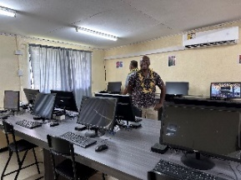  Create and implement school and system appraisal resources. | - Pacific QAS modifications to include revision of rating criteria and training of school and system leaders: Q1-2, 2024  Participant on AAA teams in India for:  - METAS – Surat / Nuzvid / Ranchi  - North East Adventist University
Strategy 4: System Support.
1. Review MOUs |  |  |  | Establish MOU register at SPD*
2. Pacific Partnerships | PTC SMS Project | - Staff from Montemorelos at Fulton then the PNG institutions  Grace Paulson now at PAU | Suggestion from SPD to utilise Luke Pannekoek to improve PTC SMS Project governance. | Exploring capacity building across research training, research projects, curriculum devt, benchmarking, governance training for the tertiary entities.
 | 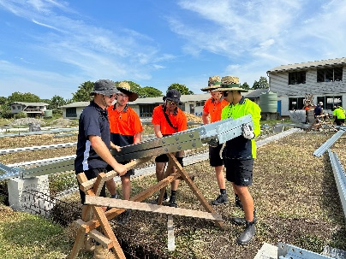 | 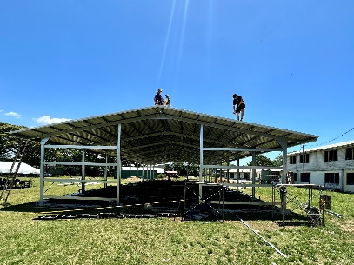 | - Assisting Avondale with TEQSA Submission  - Participated in Hills Adventist College service trip to SIM.  - Collate higher education sector grad destination survey data.  - Collate data to review staff turnover patterns esp. mid-career teachers.  - Collate higher education sector graduate numbers. | 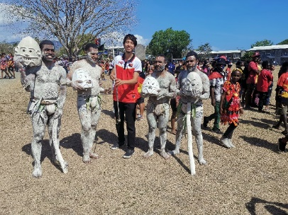

Final Comments:
At the last SPD Education Committee, the risk created by mid-career teachers leaving the professional was highlighted. With that in mind, to assist with focussing any potential resolutions, please review the following:
Teachers-Perceptions-of-their-Work-2022.pdf (monash.edu)
In preparation for discussion of future strategic goals for the SPD Education Department please also familiarize yourself with these documents:
Spotlight_Vol_15_Issue_1.pdf (pngnri.org)
Remote PNG school students abandoned as village violence stops teachers showing up, headmaster says - ABC News
